Session 2025-2026

Vision: To be a well-known centre for pursuing computer education through innovative pedagogy, value-based education and industry collaboration | Mission: To establish learning ambience for ushering in computer engineering professionals in core and multidisciplinary area by developing Problem-solving skills through emerging technologies.
Program Educational Objectives of the program (PEO): (broad statements that describe the professional and career accomplishments)
PEO1 | Preparation | P: Preparation | Pep-CL abbreviation pronounce as Pep-si-lL easy to recall
PEO2 | Core Competence | E: Environment  (Learning Environment) | Pep-CL abbreviation pronounce as Pep-si-lL easy to recall
PEO3 | Breadth | P: Professionalism | Pep-CL abbreviation pronounce as Pep-si-lL easy to recall
PEO4 | Professionalism | C: Core Competence | Pep-CL abbreviation pronounce as Pep-si-lL easy to recall
PEO5 | Learning  Environment | L: Breadth (Learning in  diverse areas) | Pep-CL abbreviation pronounce as Pep-si-lL easy to recall

Program Outcomes (PO): (statements that describe what a student should be able to do and know by the end of a program)

Keywords of POs:
Engineering knowledge, Problem analysis, Design/development of solutions, Conduct Investigations of Complex Problems, Engineering Tool Usage, The Engineer and The World, Ethics, Individual and Collaborative Team work, Communication, Project Management and Finance, Life-Long Learning
PSO Keywords: Cutting edge technologies, Research
“I am an engineer, and I know how to apply engineering knowledge to investigate, analyse and design solutions to complex problems using tools for entire world following all ethics in a collaborative way with proper management skills throughout my life.” to contribute to the development of cutting-edge technologies and Research.

Integrity: I will adhere to the Laboratory Code of Conduct and ethics in its entirety.

Name and Signature of Student and Date
(Signature and Date in Handwritten)

Session | 2025-26 (EVEN) |  | Course Name | JAVA FSD Lab
Semester | IV |  | Course Code | 23ADS1407
Roll No | 03 |  | Name of Student | Deval Tarar
Practical Number |  | 01
Course Outcome |  | Understand the fundamentals of Java programming language.
Aim |  | Write a study assignment on Java Programming.
Problem Definition |  | To study and understand the basic concepts, features, and platform characteristics of Java programming language.
Theory  (100 words) |  | Java is a high-level, object-oriented programming language used to develop secure and platform-independent applications. It follows the principle of “Write Once, Run Anywhere” using the Java Virtual Machine (JVM). Java supports features like automatic memory management, exception handling, and robustness. Object-oriented concepts help in organizing programs efficiently. Java is architecture-neutral and provides good performance. It is widely used in web, mobile, and enterprise applications.
Procedure and Execution  (100 Words) |  | Algorithm: 1) Start the program.  2) Understand the definition and purpose of Java programming language.  3) Study the Java platform components such as JDK, JRE, and JVM.  4) Learn the history and features of Java including object-oriented concepts.  5) Analyze Java characteristics such as platform independence, robustness, and architecture neutrality.  6) Compare Java with other languages like C++ to understand differences.  7) End the program.

Code:
class DataTypes {
public static void main(String[] args) {

int rollNo = 8;
float per = 98.5f;
double marks = 5.9;
String name = "Madhuri";
boolean isStudent = true;

System.out.println("Roll Number: " + rollNo);
System.out.println("Percentage: " + per);
System.out.println("Marks: " + marks);
System.out.println("Name: " + name);
System.out.println("Is Student: " + isStudent);
}
}

Output:

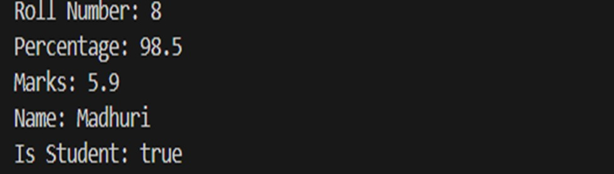
Output Analysis | The program executes successfully and displays the values of different Java data types on the output screen. It prints the integer value as Roll Number: 8, the float value as Percentage: 98.5, and the double value as Marks: 5.9. The String value is displayed as Name: Madhuri, and the boolean value is shown as Is Student: true. This output verifies that various data types in Java are properly declared, initialized, and printed using the System.out.println() method.
Link of student Github profile where lab assignment has  been uploaded | https://github.com/Aastha-Hukre/ClassAndObjectJava
Conclusion | This practical helped in understanding the basic concepts and features of Java programming language. It demonstrated the use of different data types and the output statements in Java. The experiment also provided knowledge about Java’s platform independence, object-oriented nature, and robustness. Overall, this practical builds a strong foundation for learning advanced Java concepts and full stack development.

Plag Report (Similarity index < 12%) | 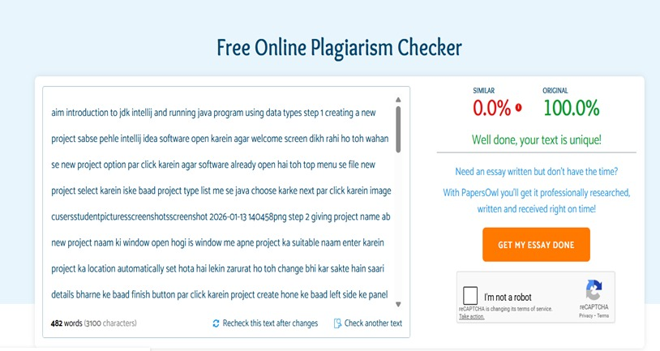
Date | 20-01-2026

Paste here Faculty signed observation page.

