Session 2025-2026

Vision: To be a well-known centre for pursuing computer education through innovative pedagogy, value-based education and industry collaboration | Mission: To establish learning ambience for ushering in computer engineering professionals in core and multidisciplinary area by developing Problem-solving skills through emerging technologies.

Program Educational Objectives of the program (PEO): (broad statements that describe the professional and career accomplishments)
PEO1 | Preparation | P: Preparation | Pep-CL abbreviation pronounce as Pep-si-lL easy to recall
PEO2 | Core Competence | E: Environment (Learning Environment) | Pep-CL abbreviation pronounce as Pep-si-lL easy to recall
PEO3 | Breadth | P: Professionalism | Pep-CL abbreviation pronounce as Pep-si-lL easy to recall
PEO4 | Professionalism | C: Core Competence | Pep-CL abbreviation pronounce as Pep-si-lL easy to recall
PEO5 | Learning Environment | L: Breadth (Learning in diverse areas) | Pep-CL abbreviation pronounce as Pep-si-lL easy to recall

Program Outcomes (PO): (statements that describe what a student should be able to do and know by the end of a program)
Keywords of POs:
Engineering knowledge, Problem analysis, Design/development of solutions, Conduct Investigations of Complex Problems, Engineering Tool Usage, The Engineer and The World, Ethics, Individual and Collaborative Team work, Communication, Project Management and Finance, Life-Long Learning
PSO Keywords: Cutting edge technologies, Research
“I am an engineer, and I know how to apply engineering knowledge to investigate, analyse and design solutions to complex problems using tools for entire world following all ethics in a collaborative way with proper management skills throughout my life.” to contribute to the development of cutting-edge technologies and Research.

Integrity: I will adhere to the Laboratory Code of Conduct and ethics in its entirety.

Name and Signature of Student and Date
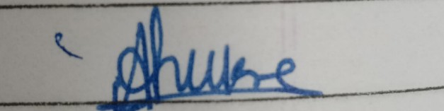
(Signature and Date in Handwritten)

Session | 2025-26 (EVEN) |  | Course Name | JAVA FSD Lab
Semester | IV |  | Course Code | 23ADS1407
Roll No | 03 |  | Name of Student | Deval Tarar
Practical Number |  | 03
Course Outcome |  | After completing this program, the student will be able to:  - Apply Java control structures like switch-case and  do-while loop.  - Use the Scanner class to take user input at runtime.  - Implement basic arithmetic operations using conditional logic.  - Develop a menu-driven Java application with proper input validation.
Aim |  | To write a program to design simple calculator using  control statement.
Problem Definition |  | To design and implement a menu-driven calculator program in Java that performs basic arithmetic operations such as addition, subtraction, multiplication,  and division based on user input.

Theory  (100 words) | Java is an object-oriented programming language widely used for developing reliable and secure applications.  In this program:  - The Scanner class is used to read user input from the keyboard.  - A do-while loop is used to repeatedly perform calculations until the user decides to stop.  - A switch-case statement is used to select the arithmetic operation based on the operator entered by the user.  - Division by zero is handled using a conditional check to avoid runtime errors.  - The program follows a structured approach, making it user-friendly and efficient.  This calculator demonstrates the use of loops, conditional statements, and input/output handling in Java.

Procedure and Execution  (100 Words) | Start  Create a Scanner object to take input from the user. Repeat the following steps using a do-while loop:  - Read the first integer number.  - Read the second integer number.  - Read the operator (+, -, *, /).  - Use switch-case to perform the selected operation:  - If +, perform addition.  - If -, perform subtraction.  - If *, perform multiplication.  - If /, check if the second number is zero:  - If not zero, perform division.  - Else, display an error message.  - If operator is invalid, display an error message.  - Ask the user whether they want to continue.  Stop the loop if the user enters no. Close the Scanner.  End

Code: | .
Code: | import java.util.Scanner;  class SimpleCalculator {  public static void main(String[] args) {  Scanner sc = new Scanner(System.in);  System.out.print("Enter first number: ");  int a = sc.nextInt();  System.out.print("Enter second number: ");  int b= sc.nextInt();  System.out.println("Choose an operation:");  System.out.println("1. Addition");  System.out.println("2. Subtraction");  System.out.println("3. Multiplication");  System.out.println("4. Division");  System.out.print("Enter your choice: ");  int choice = sc.nextInt();  switch (choice) {  case 1:  System.out.println("Result = “ + (a + b));  break;  case 2:  System.out.println("Result = “ (a - b));  break;  case 3:  System.out.println("Result = “ + (a * b));  break;  case 4:  if (b != 0) {  System.out.println("Result = “ + (a / b));  } else {  System.out.println("Division by zero is not possible");  }  break;  default:  System.out.println("Invalid choice");  }  case 4:  if (b != 0) {  System.out.println("Result = “ + (a / b));  } else {  System.out.println("Division by zero is not possible");  }  break;  default:  System.out.println("Invalid choice");  }  sc.close();  }  }



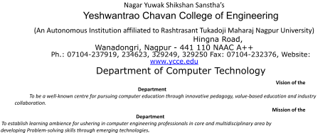

Output:  Output Analysis: | 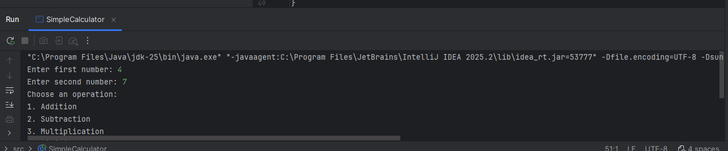  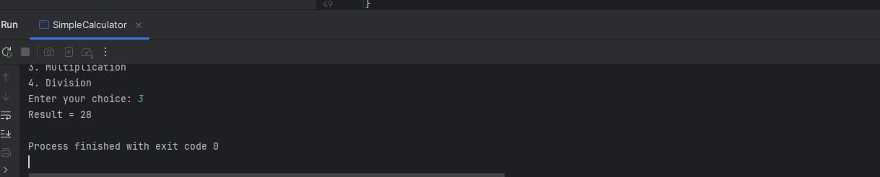  The program correctly accepts two numbers and an operator from the user.  Based on the operator, the corresponding arithmetic operation is performed.  If division by zero is attempted, the program safely displays an error message.  The loop allows repeated calculations without restarting the program.  The program terminates only when the user chooses not to continue.

Link of student Github profile where lab assignment has been uploaded  Conclusion: | Thus, the Java calculator program was successfully implemented using the Scanner class, switch-case statement, and do-while loop. The program efficiently performs basic arithmetic operations such as addition, subtraction, multiplication, and division. It also handles invalid input and division by zero, making it reliable and user-friendly. This program helps in understanding fundamental Java concepts like input handling, control flow, and looping, which are essential for developing real-world applications.
Plag Report (Similarity index < 12%) | 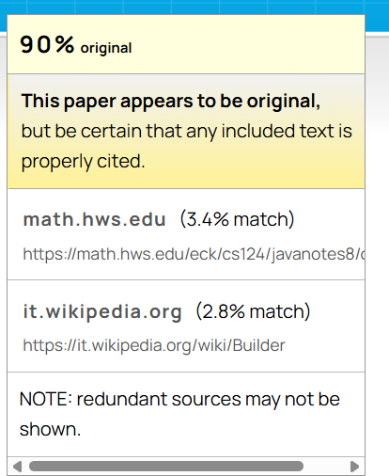
Date | 27-01-2026

Paste here Faculty signed observation page.

