**OUTPUT**

Enter the folder path to organize:

D:\examine

Log file created: D:\examine\organizer_log.txt

Do you want to delete duplicate files? (yes/no):

yes

Operation completed

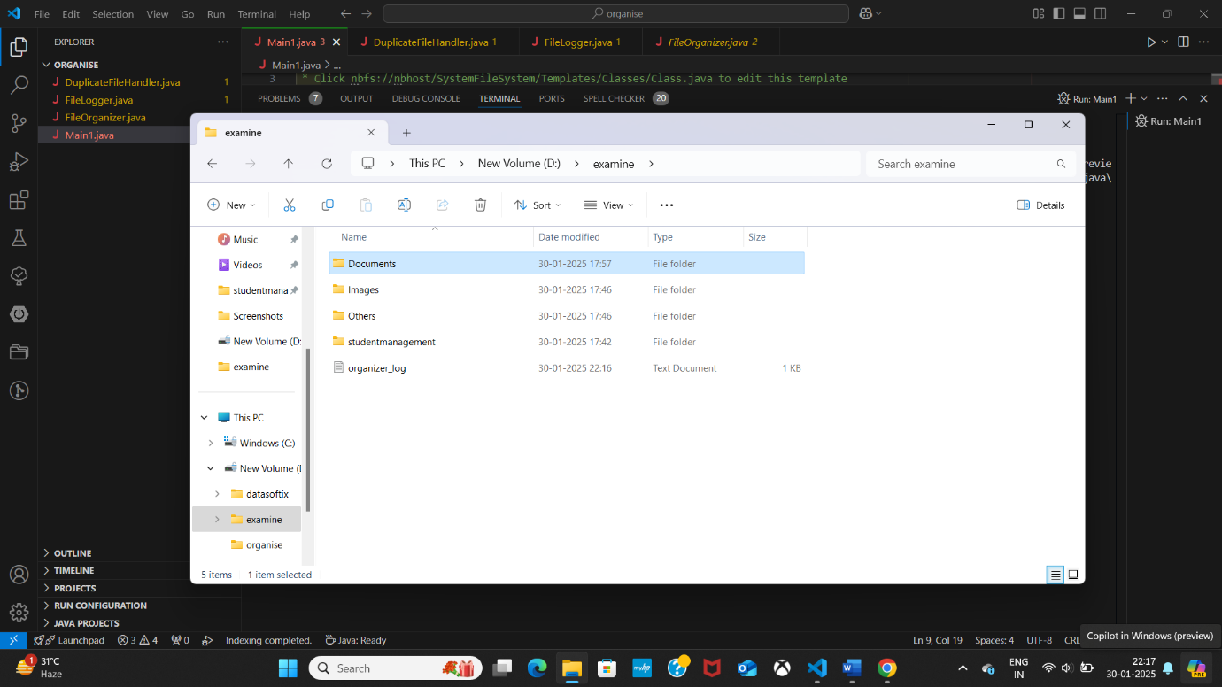 successfully.