Optimal Number of Clusters - Elbow Method Analysis

Method
The elbow method was used to determine the optimal number of clusters (k) for K-Means. For each value of k from 1 to 10, a K-Means model was trained on the scaled training data, and its inertia (the sum of squared distances of each point to its assigned cluster center) was recorded. Lower inertia means tighter, more well-defined clusters, but inertia always decreases as k increases the goal is to find the point where adding more clusters stops giving a meaningful improvement.
from sklearn.cluster import KMeans
inertia_values = []
k_range = range(1, 11)
for k in k_range:
kmeans = KMeans(n_clusters=k, random_state=42, n_init=10)
kmeans.fit(X_train_scaled)
inertia_values.append(kmeans.inertia_)

Inertia by Number of Clusters
Table 1: Inertia by Number of Clusters
k | Inertia
1 | 19,845.7
2 | 14,844.2
3 | 12,178.4
4 | 10,700.9
5 | 10,152.7
6 | 9,713.0
7 | 9,382.5
8 | 9,011.4
9 | 8,826.3
10 | 8,594.3

Elbow Chart
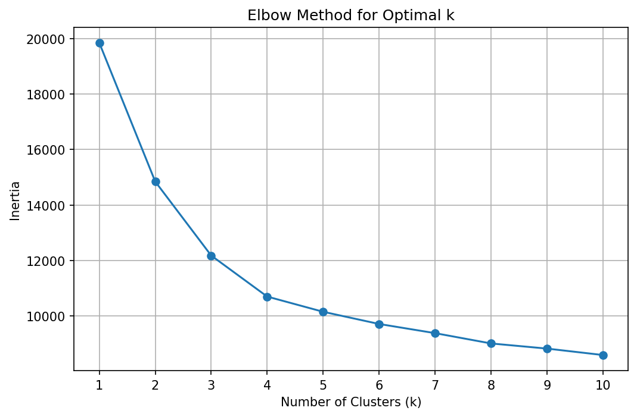
Figure 1: line chart of inertia vs. number of clusters

Choosing k = 4
Looking at the drop in inertia between each step:
Table 2: inertia vs. number of clusters
From k to k+1 | Inertia Drop
1 → 2 | 5,001.5
2 → 3 | 2,665.8
3 → 4 | 1,477.5
4 → 5 | 548.2
5 → 6 | 439.7
6 → 7 | 330.5
The drop size shrinks sharply after k = 4 (from a 1,477.5 drop going into k=4, down to 548.2 going into k=5 and smaller after that). This flattening point the "elbow" indicates that k = 4 captures the main structure in the data; additional clusters beyond this mostly split existing groups into smaller, less meaningful pieces rather than revealing genuinely new segments.

Conclusion
Optimal number of clusters: k = 4, used for the final K-Means model.

