TASK 21

1. Selenium Script to Automate

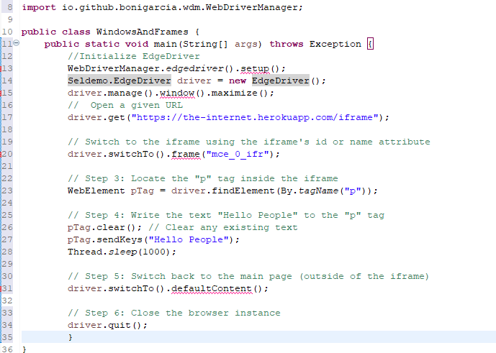

1. Selenium Script to Automate

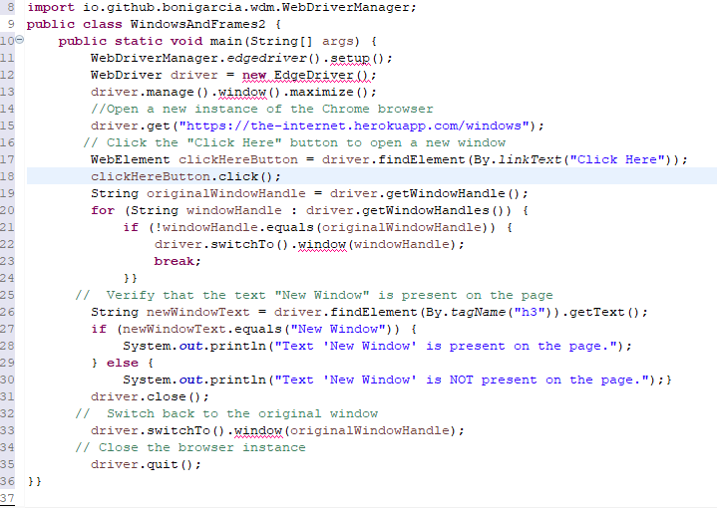

1. Selenium Script to Automate

