**ACI Assignment 1 – Group 11**

**Path Finding Agent**

Contents

Answer 1 3

PEAS Environment 3

Algorithm Selected 3

Answer 2 3

What is Eular Path? 3

Is Eular Path Exist Snippet: 4

What is Eular Graph? 4

Eular Graph Snippet: 5

Answer 3 6

BFS Algorithm Selection 6

DFS Algorithm Selection 9

Answer 4 10

BFS and DFS Comparison based on Space and Time Complexity. 10

Space Complexity 10

Time Complexity 10

# Answer 1

## PEAS Environment

Performance Measure:

* Robot clear all the roads in Chennai for traffic.
* Identify shortest route from source city to destination city using BFS and DFS
* Show Euler circuit existence and graph

Environment:

* Roads (Connections or edges)
* Cities (all city points in the graph)
* Algorithms (Euler, BFS and DFS)

Actuators:

* Cities as Node or Vertices
* Roads as Connections for Cities
* Euler circuit existence check
* Selection of source and destination city
* Selection of shortest path algorithm either BFS or DFS

Sensors:

* Costs of road
* Euler Path existence and Euler Circuit
* Shortest path existence comparisons

## Algorithm Selected

BFS: Breadth First Search

DFS: Depth First Search

# Answer 2

## What is Eular Path?

Eulerian Path: Traversing in graph for every connection as once and possibly for single or multiple visits on vertices.

Eulerian Circuit/Garph: Eulerian Path which starts and ends on the same vertex.

## **Is Eular Path Exist Snippet:**

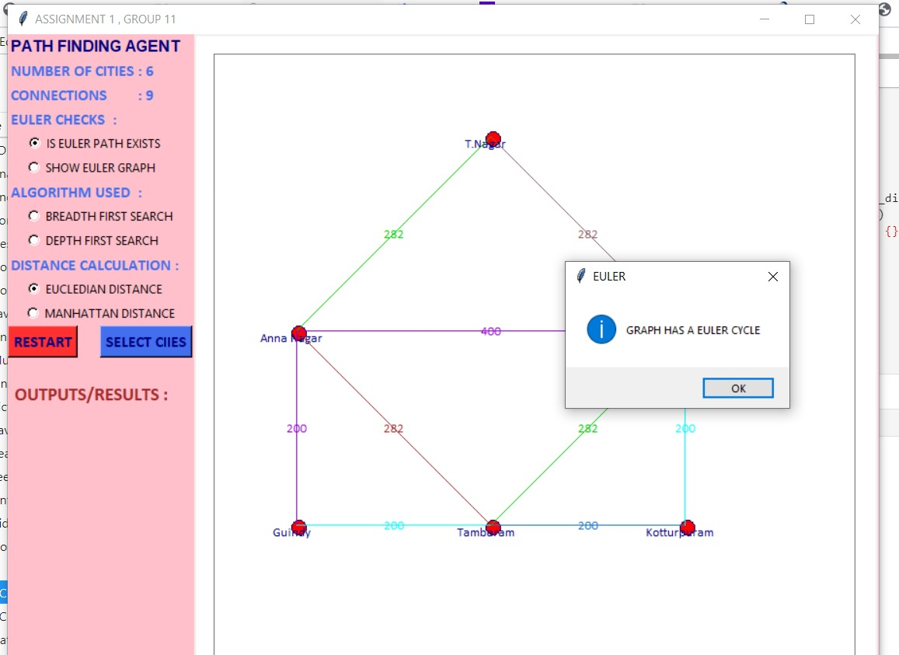

## What is Eular Graph?

Any connected graph is called as an Euler Graph if and only if all its vertices are of even degree.

As per this graph, Agent will start from Central Station and then returns to Central Station by covering all roads (Edges) only once.

The Euler Circuit path is given below.

* Central Station 🡪 Tambaram 🡪 Anna Nagar 🡪 Guindy 🡪 Tambaram 🡪 Kotturpuram 🡪 Central Station 🡪 Anna Nagar 🡪 T. Nagar 🡪 Central Station

## Eular Graph Snippet:

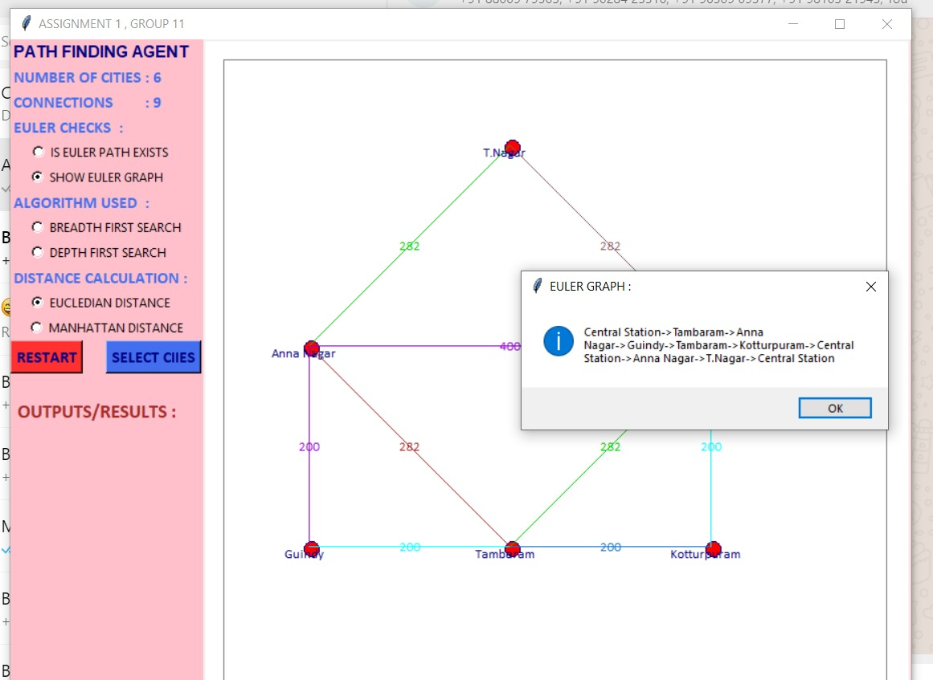

# Answer 3

## BFS Algorithm Selection

Procedure:

* Select the BFS algorithm in the input screen, then it provides messages as “Select Source And Destination City”
* Select Source City which gives a message as “Source City Selected”
* Select Destination City which gives a message as “Destination City Selected”
* Will display consolidated result of BFS with below details
  + Total Distance covered
  + Total Time
  + Number of vertex (cities covered)
  + Covered Path
  + Pops

1. Select Algorithm.  
   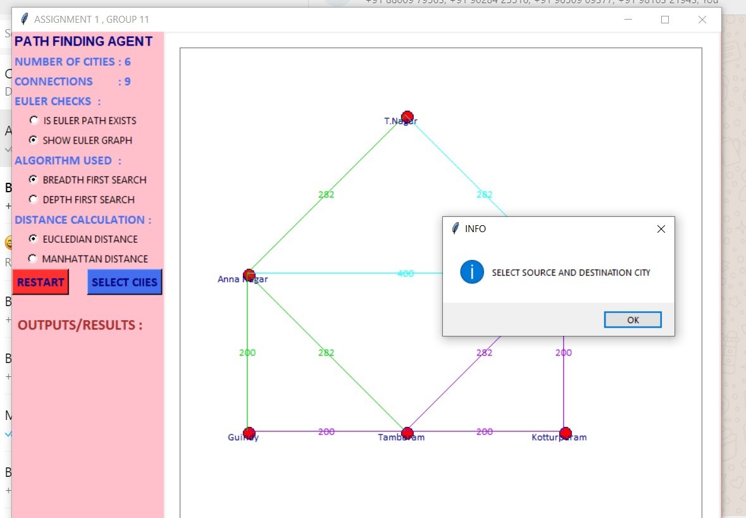
2. Select Source.  
   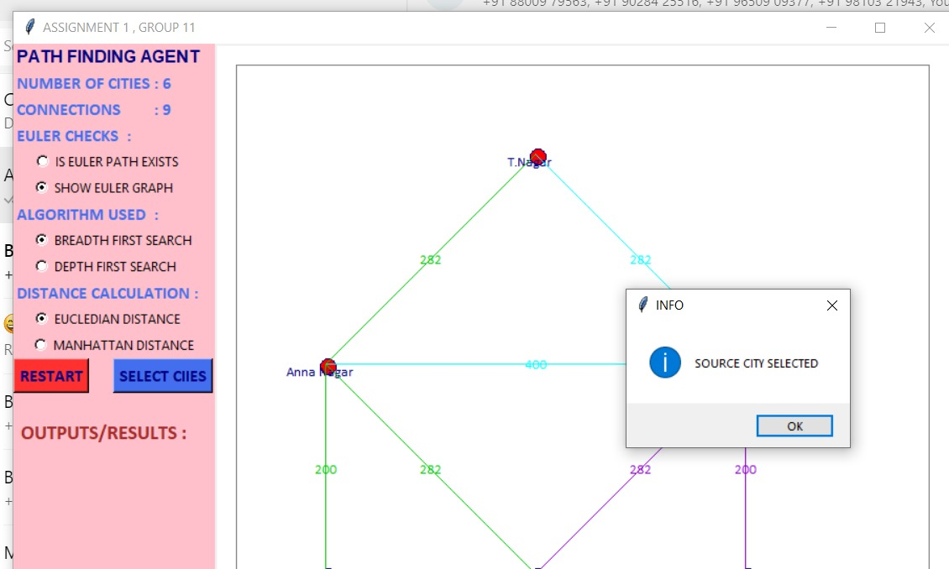
3. Select Destination.  
   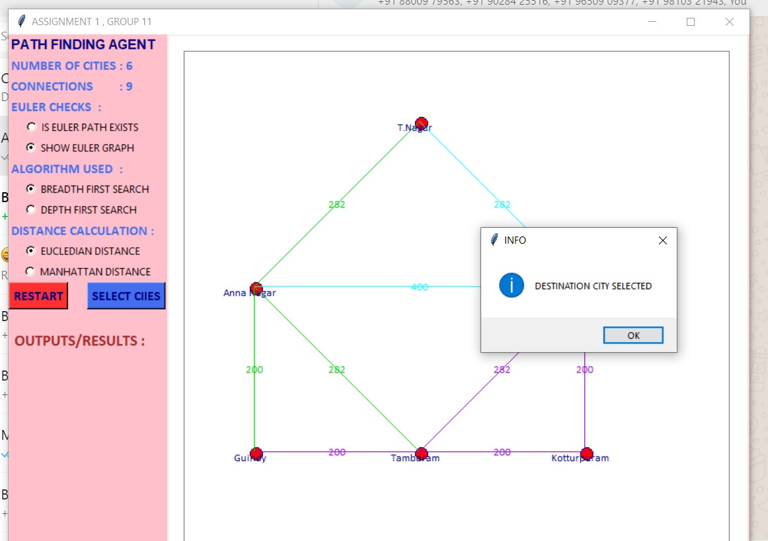
4. Output.  
   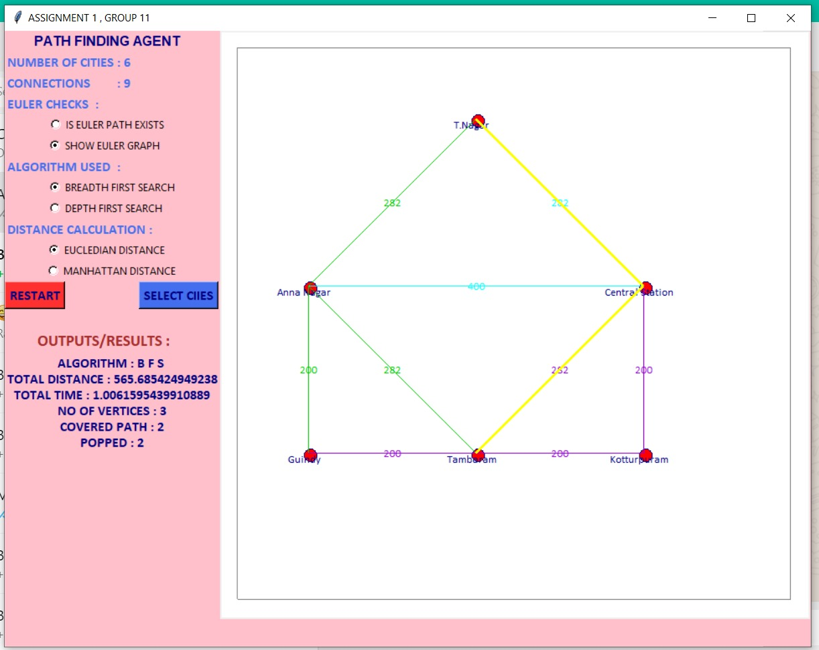

## DFS Algorithm Selection

1. Follow the same steps explained in BFS as above for DFS algorithm
2. The results shown as below screenshot

Additional Output:

1. Comparison of time for BFS and DFS
2. Comparison of space for BFS and DFS
3. Output.  
   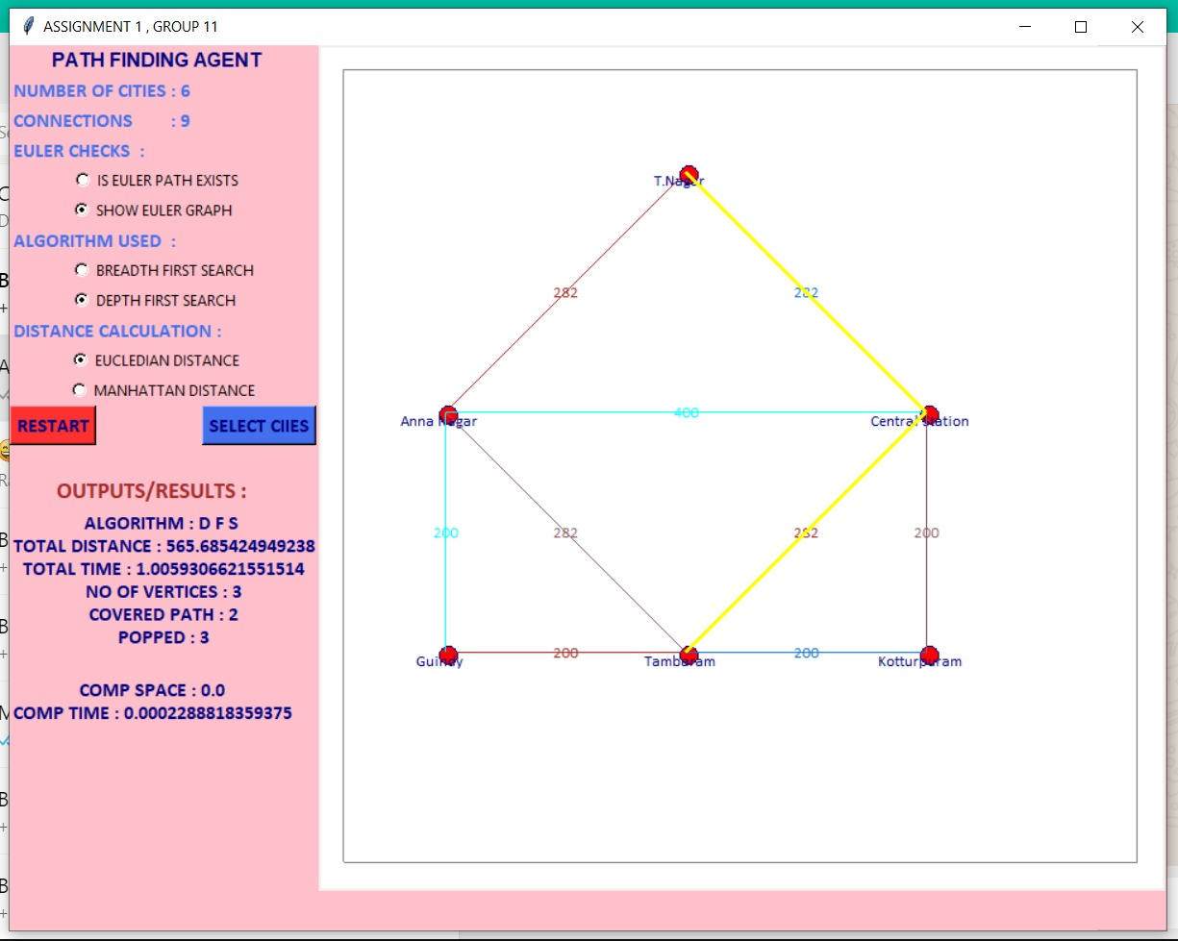

# Answer 4

## BFS and DFS Comparison based on Space and Time Complexity.

Procedure for BFS and DFS Comparison:

1. Run BFS as explained above in Answer 3
2. Click restart button again to refresh canvas and old data of BFS
3. Same Run DFS as explained above for the same Source and Destination.

Output/Results Comparison:

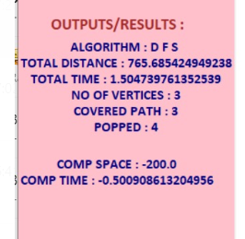

### **Space Complexity**

For **BFS**, which traverses all nodes at a given depth in the tree and uses a queue implementation, the width of the tree matters. The space complexity for BFS is **O(w)** where w is the maximum width of the tree.

For **DFS**, which goes along a single ‘branch’ all the way down and uses a stack implementation, the height of the tree matters. The space complexity for DFS is **O(h)** where h is the maximum height of the tree.

### **Time Complexity**

Time complexity is the same for both the algorithms. In both BFS and DFS, every node is visited but only once. **The big-O time is O(n) (for every node in the tree).**

