Question 1

1. Pipeline configuration

Created a pipeline

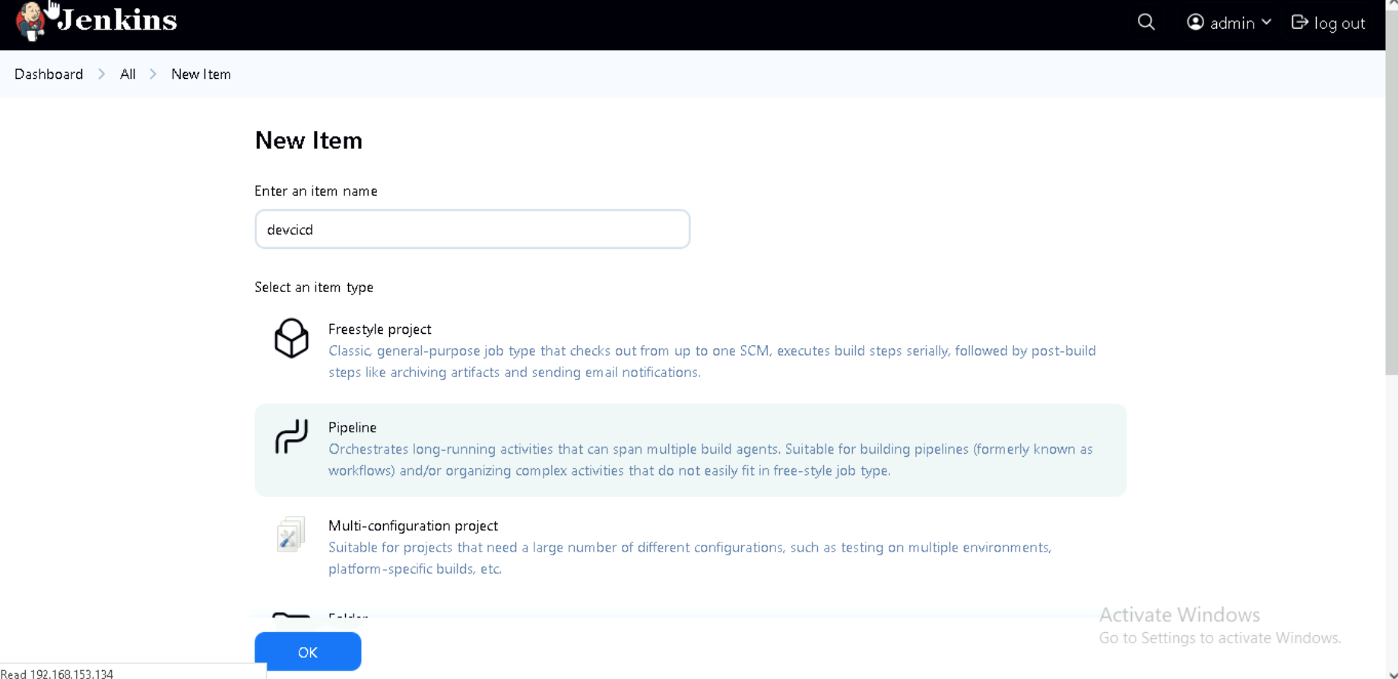

Given github project url

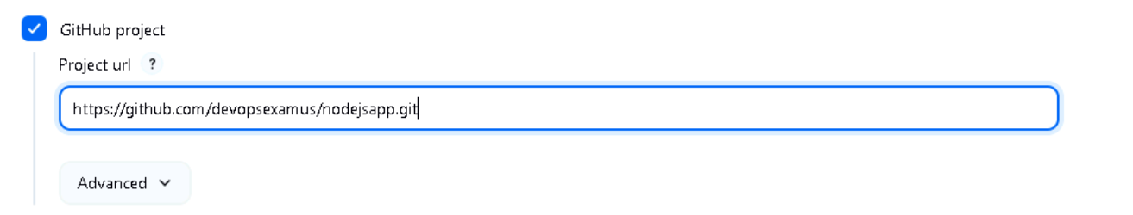

Git is configured

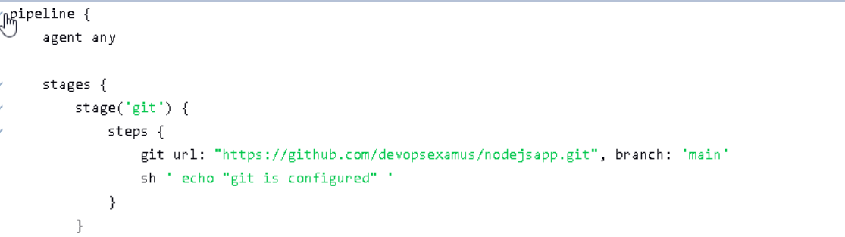

Console output of git config

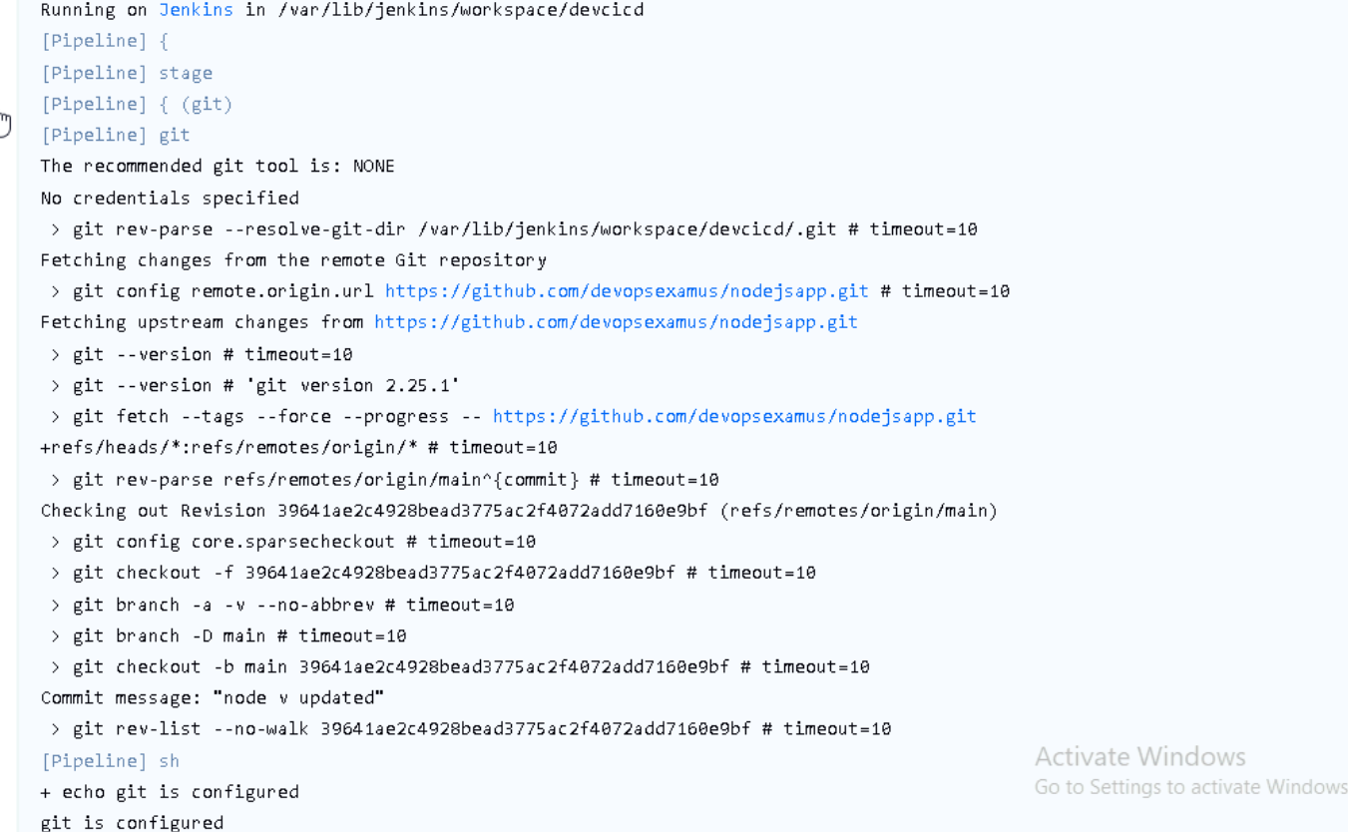

Here git is configured and it will pull into folder /var/lib/Jenkins/workspace/devcicd

1. Build

Created credentials for docker login

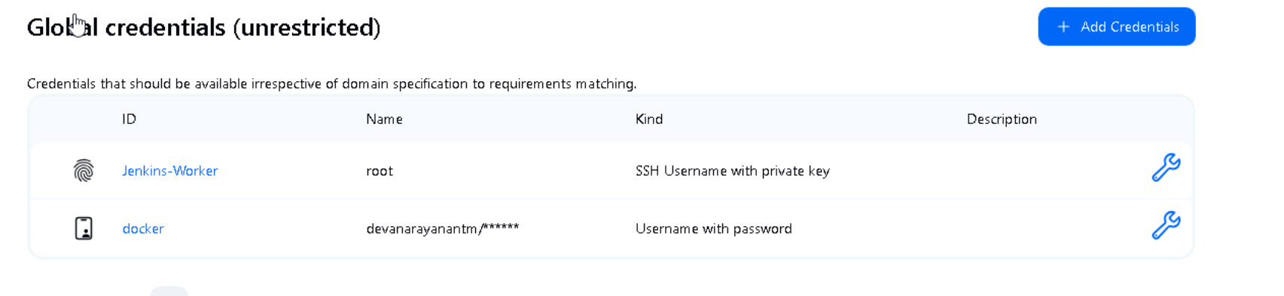

Docker login succeeded based on the docker credentials we have given

Docker image created based on the “dockerfile”

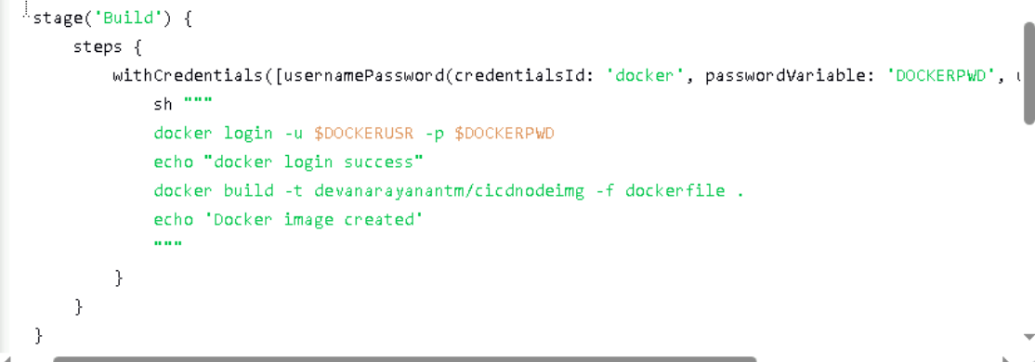

Login worked

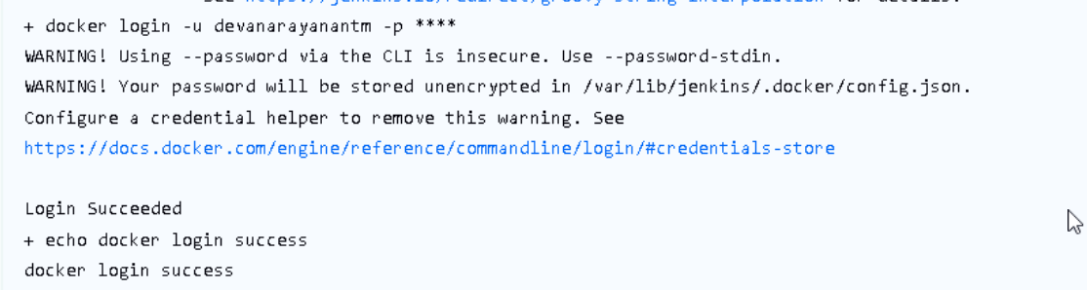

Docker image created

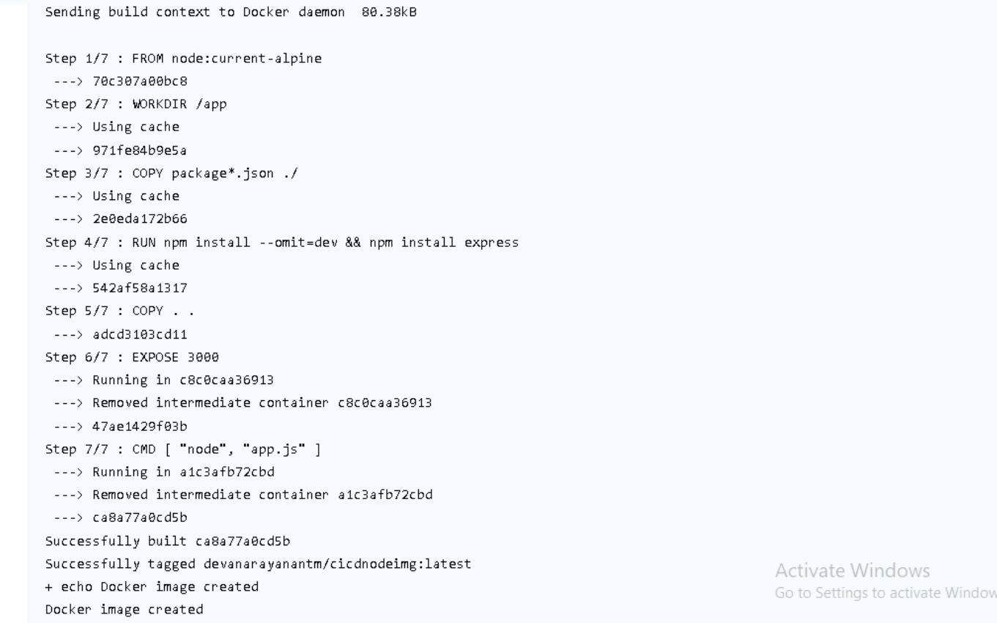

1. Test

Checked whether any container with this name exist or not, if yes then stopped and removed

Then that image is pushed to our docker hub

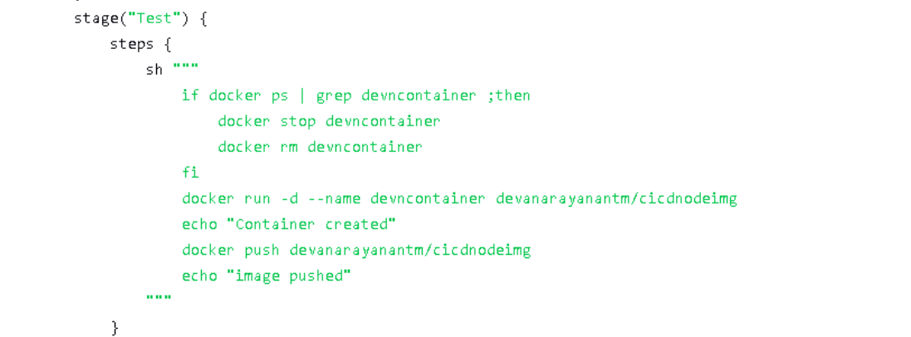

Console output: -

Container created and image pushed

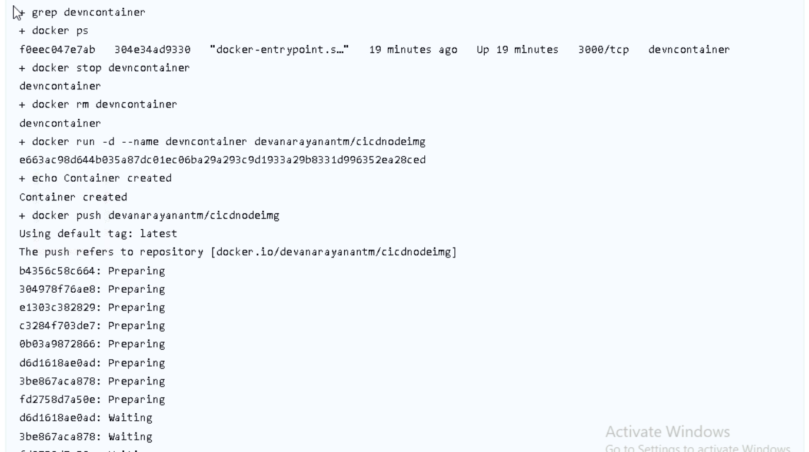

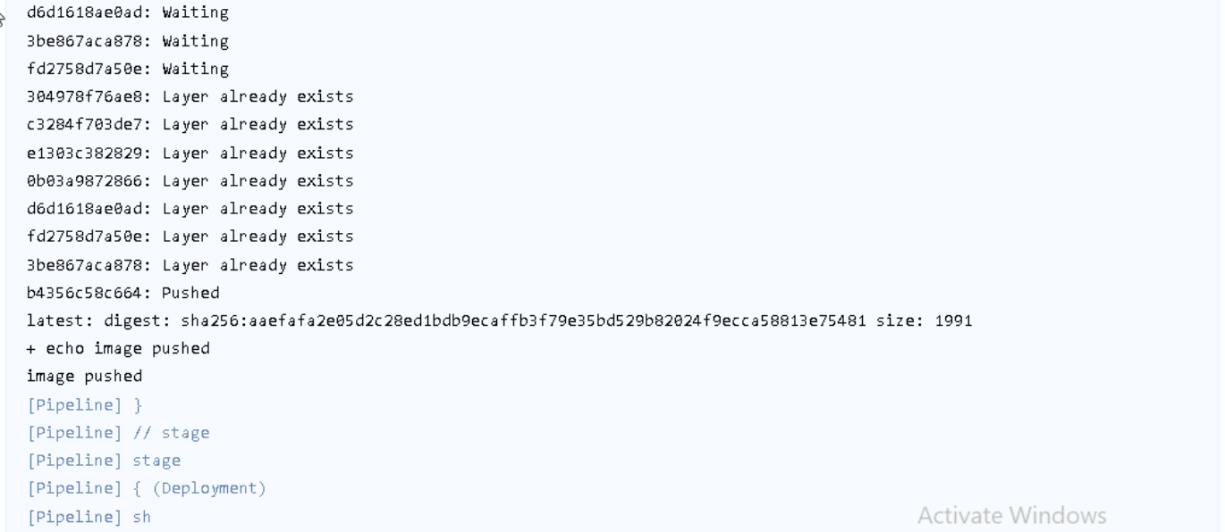

1. Deployment

There was no Kubernetes permission for Jenkins user so authentication error occurred, so copy the .kube file into /var/lib/Jenkins and make jenkins as the user and owner

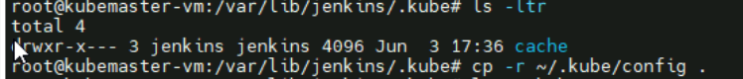



Checked whether the same deployment name exists or not if yes deleted then create the deployment for the “devanarayanantm/cicdnodeimg” image

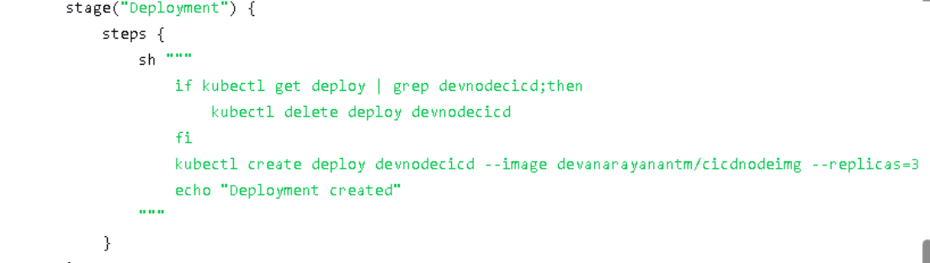

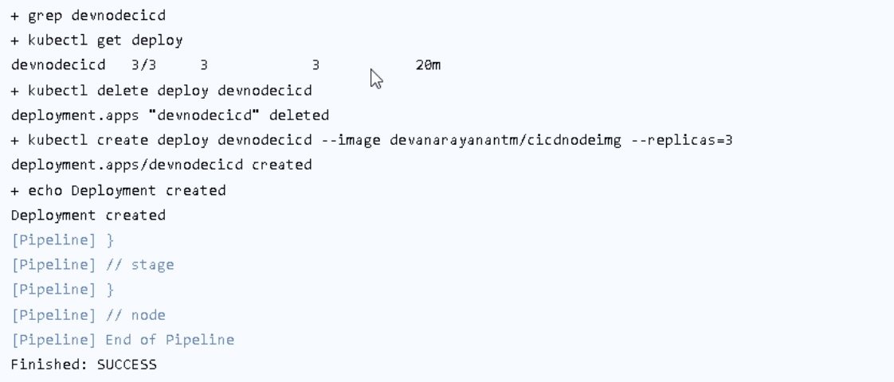

So here it created the deployment

-----------------------------------------------------------------------------------------------------------------------

From the host machine:-

Docker image



Docker container



Kubernetes deployment

