Question2 – Docker Image

1. Docker Ubuntu image pulled

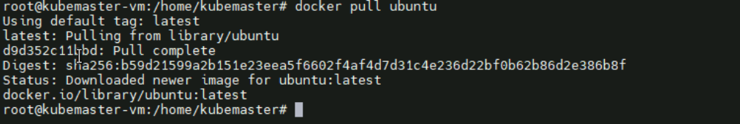

1. Running the container





1. Getting inside the container

Get inside of the container using docker exec command

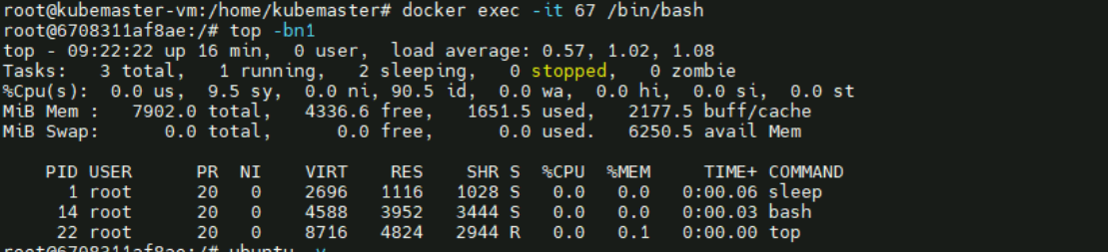

Checked cpu uptime



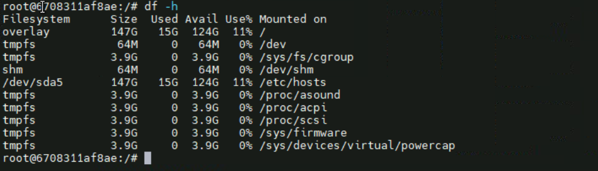

Memory usage of filesystems

Checked the version inside the container

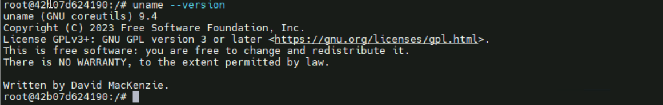

Checked container version ubuntu latest

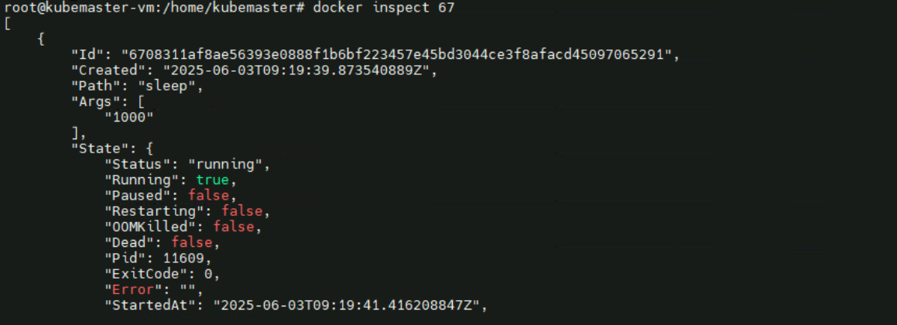

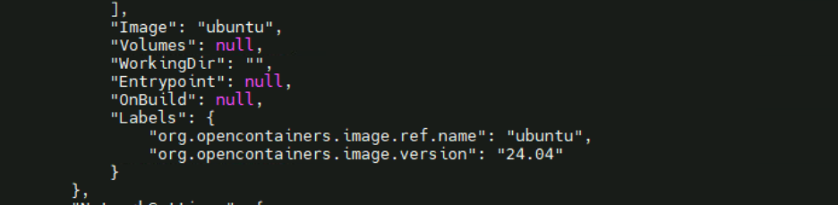

1. Docker stopped and remove

