Question 3

1)

Yaml for the pod

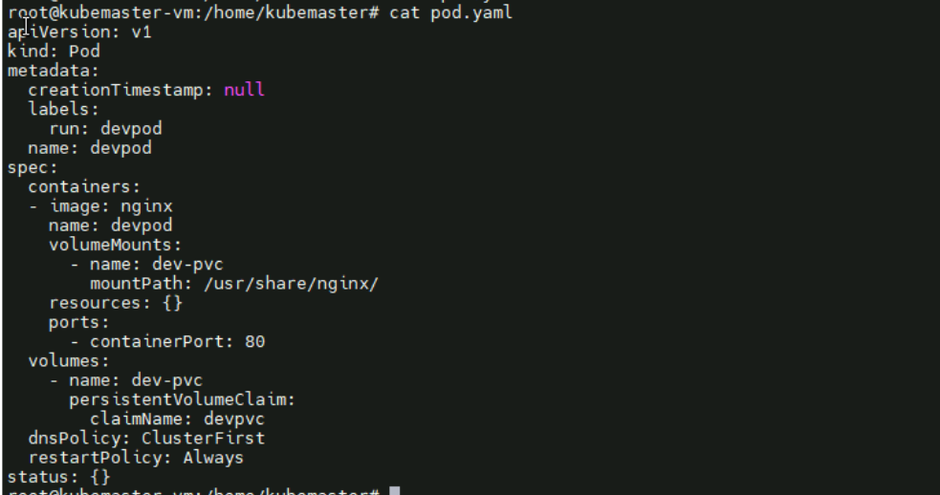

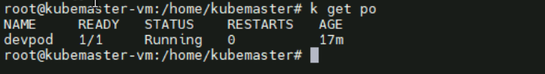

Pod is running

2)

Persistent volume yaml

Here created using hostpath and path is “/usr/share/nginx/”

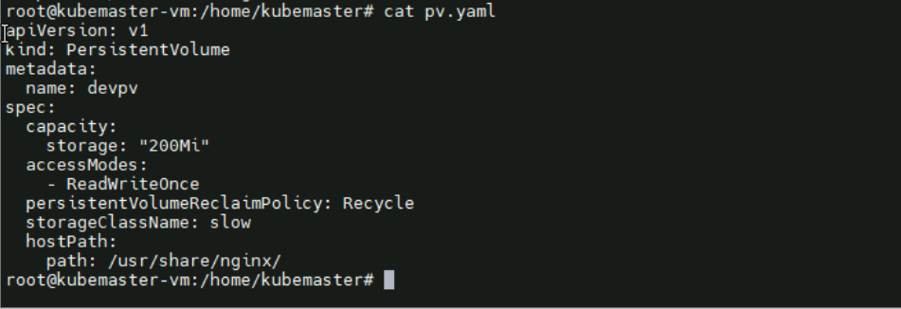

Persistent volume claim yaml

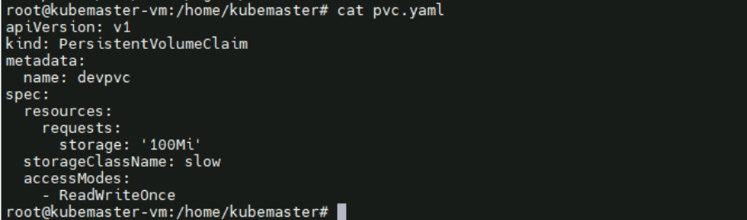

Applied

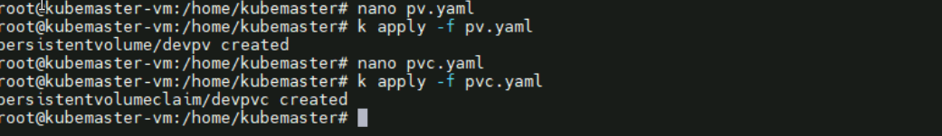

Working

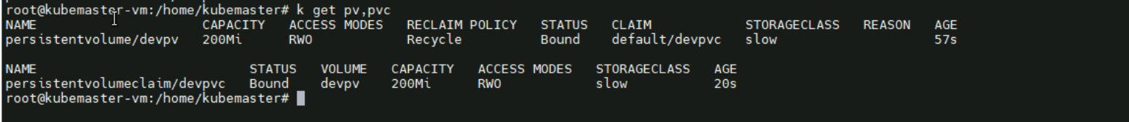

3)

Inside the host machines /usr/share/nginx/ created a file index.html

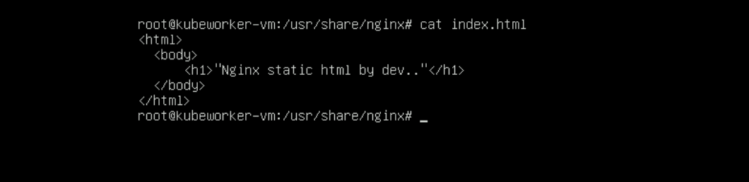

Checked whether it is in the container or not

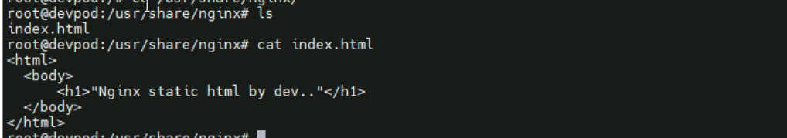

Yes index.html is present in container also

4) Validation

Yes pod is running and curl the static page of nginx

