**Ansible**

User creation yaml file

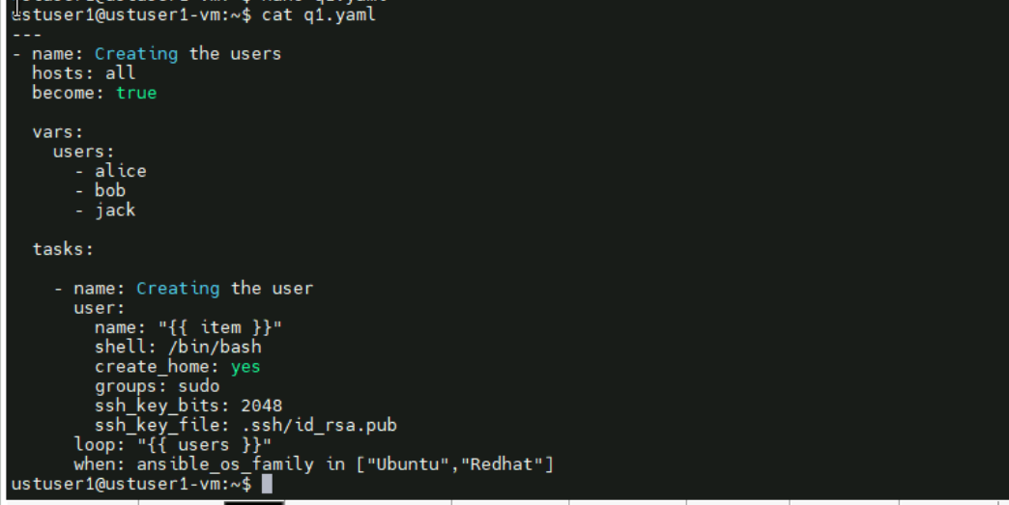

Running

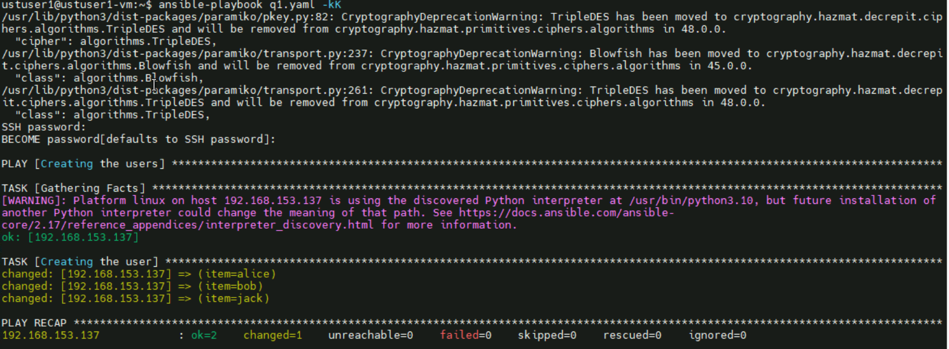

Created users like alice bob jack

Getting inside without the passwordless authentication

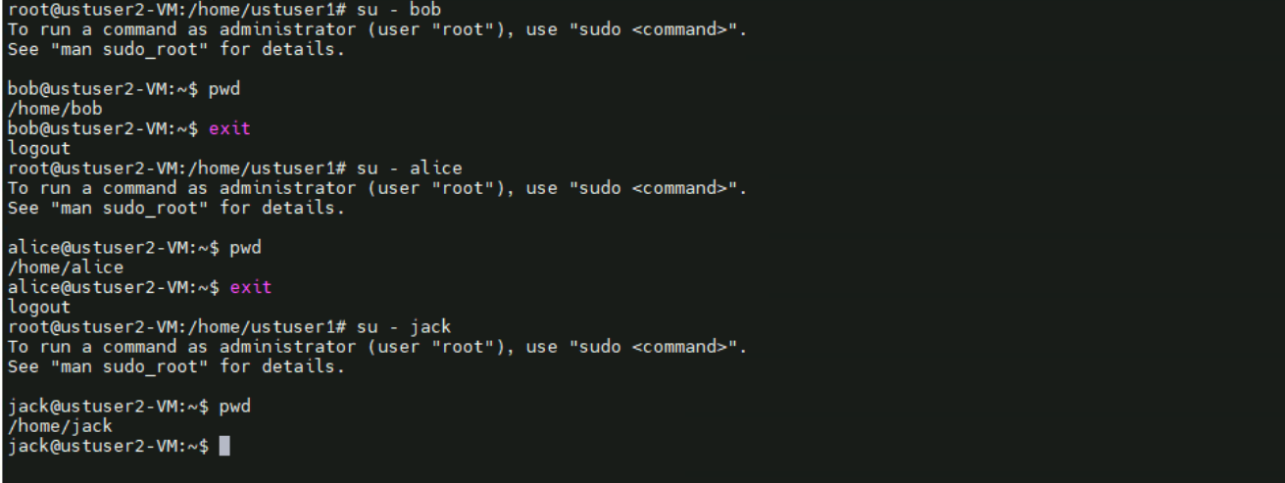

groups

