Name: Devanarayanan T M

**Create a new repository**

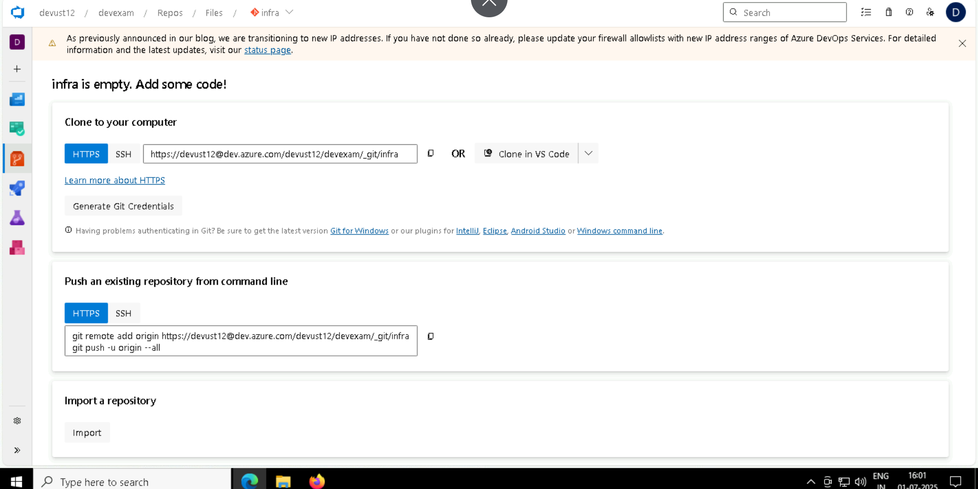

Create an variable to store the subscription, used when executing terraform because version > 4

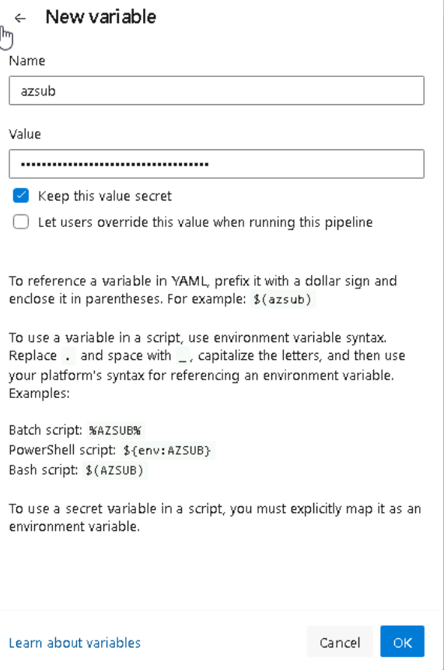

Like this

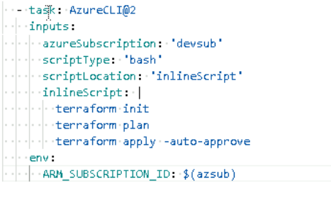

**Terraform installed**

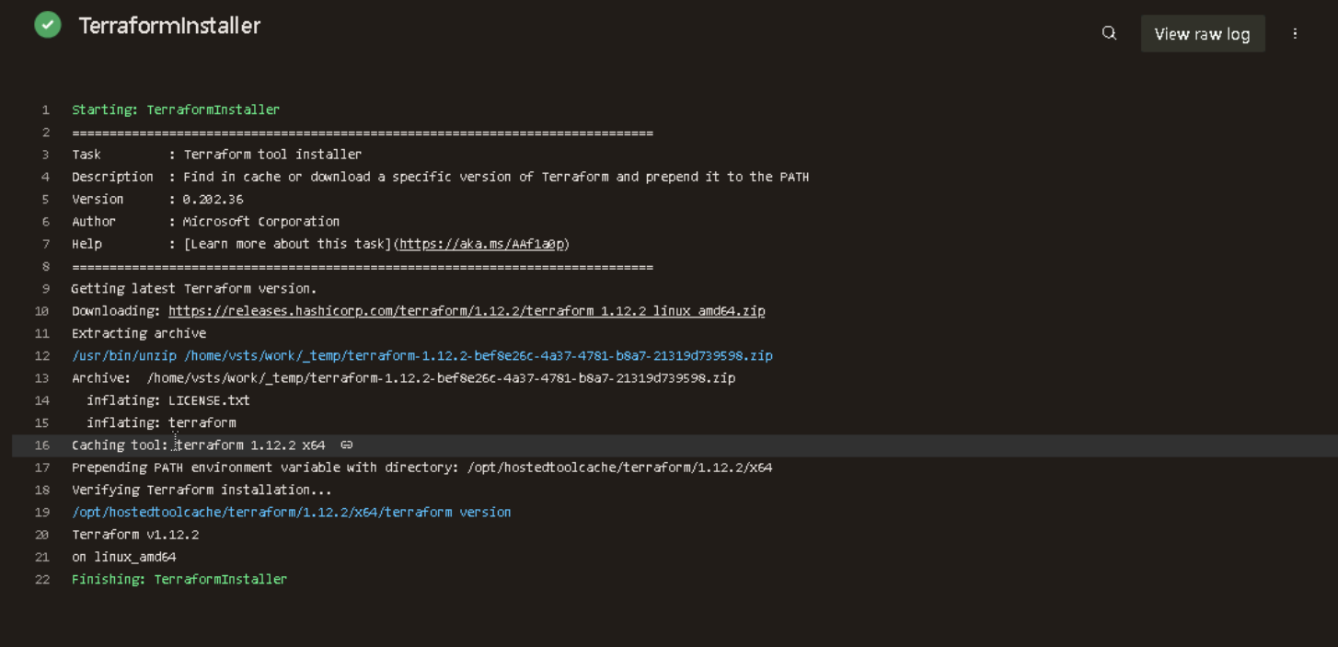

1. **Initialize terraform and provider**

I have created an storage account and create an container for terraform.tfstate file to store remotely

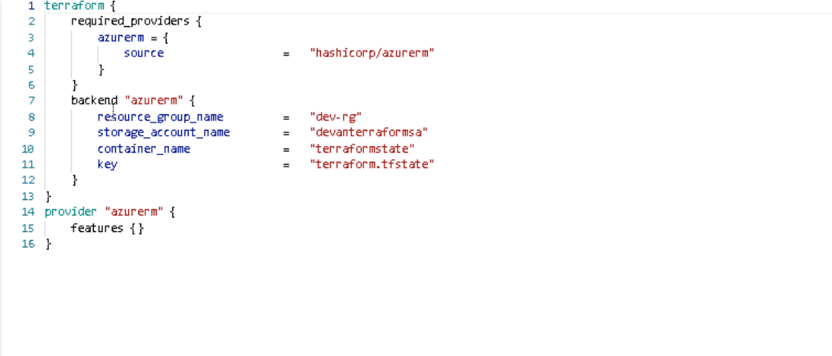

**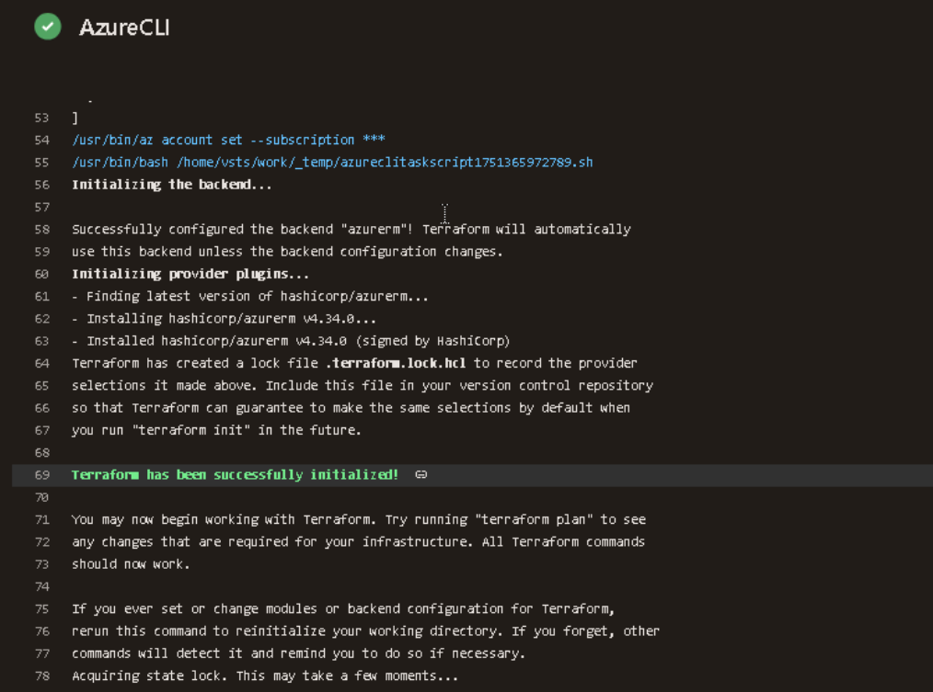  
  
2) Store all terraform scripts in azure repo**

Created a directory

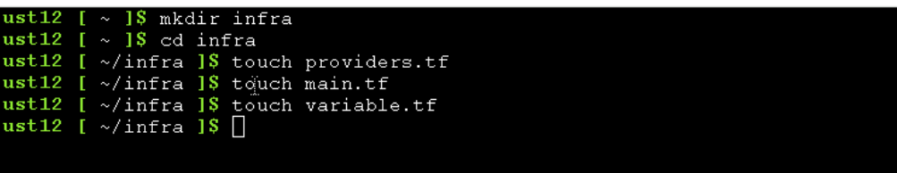

Initialize the repo and push all files into azure repo

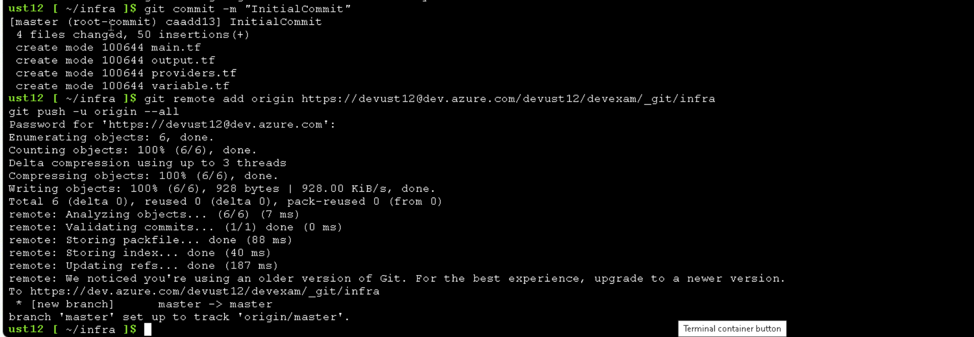

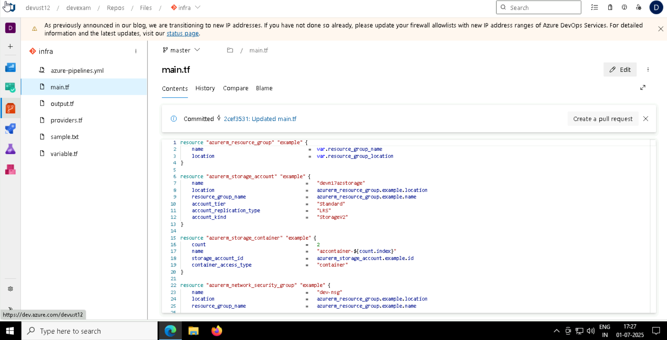

1. **Azure pipeline**

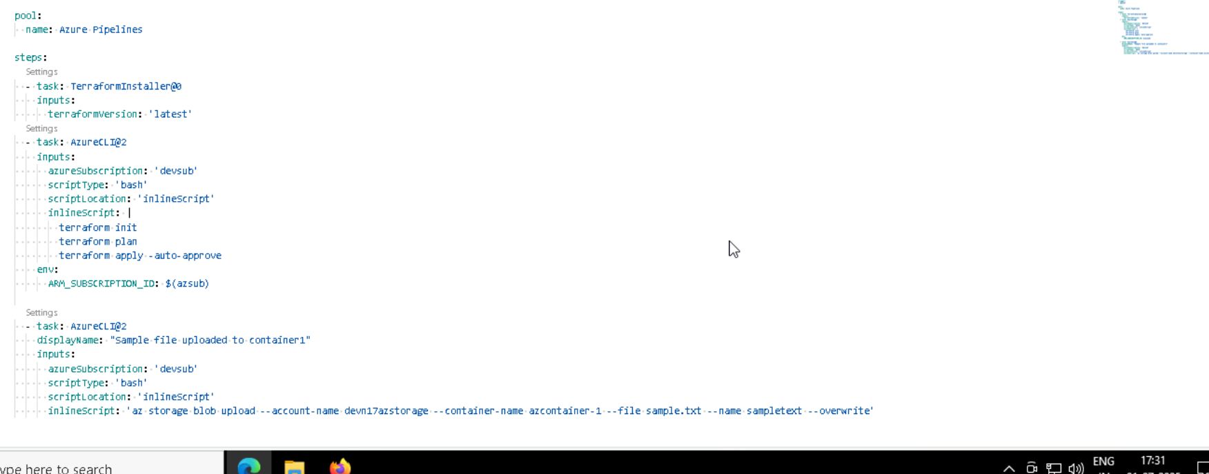

Create an variable to store the subscription, used when executing terraform because version > 4



Like this



1. **Created resource group and storageaccount**

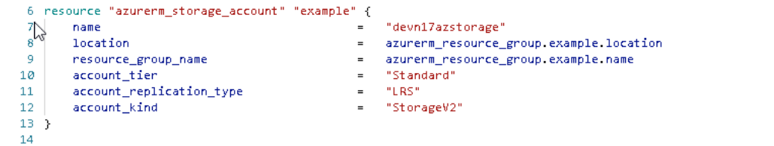

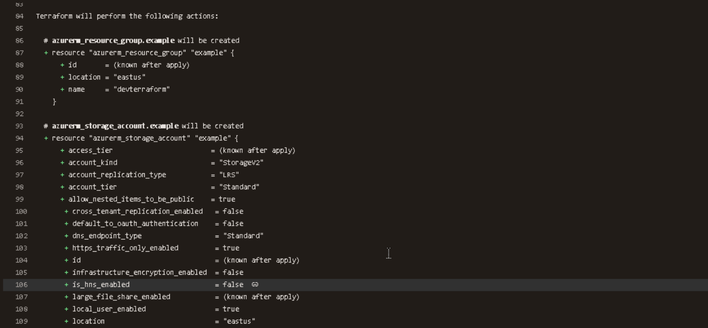

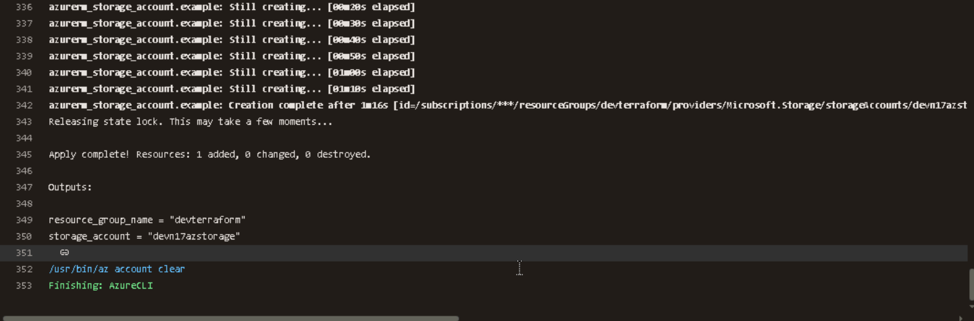

1. **Created 2 containers**

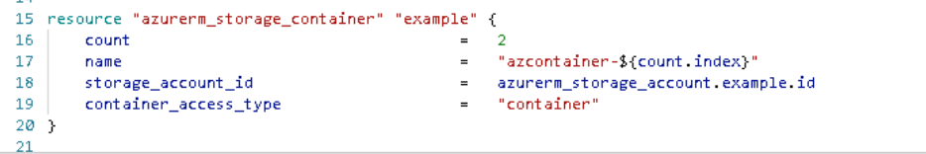

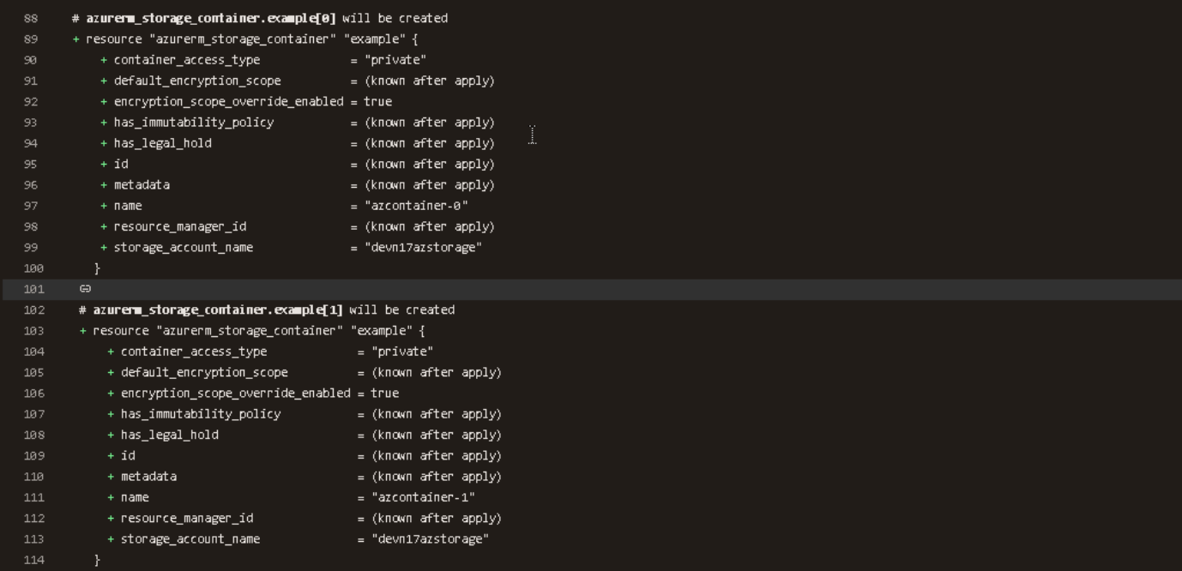

Updated container_access_type to “container”

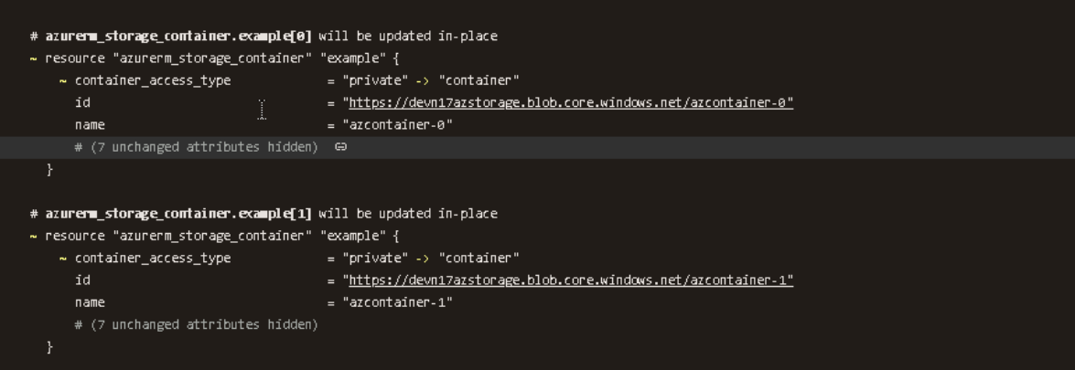

1. **Upload an sample text file into container1**

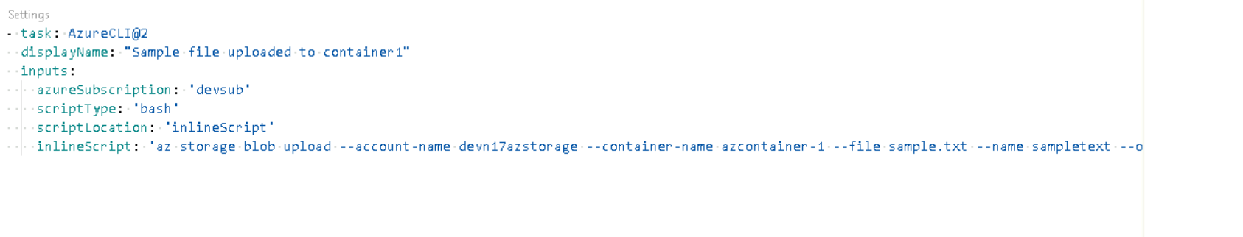

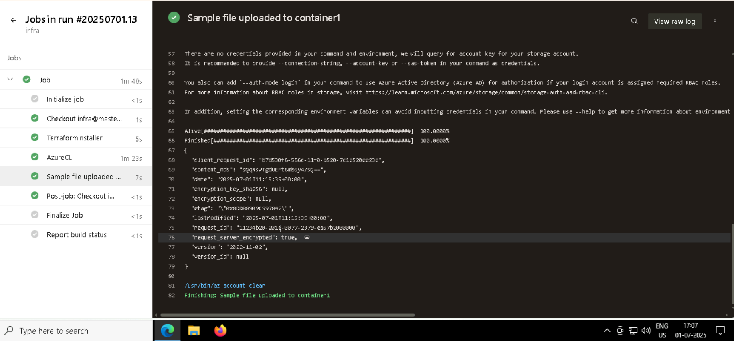

The file is uploaded

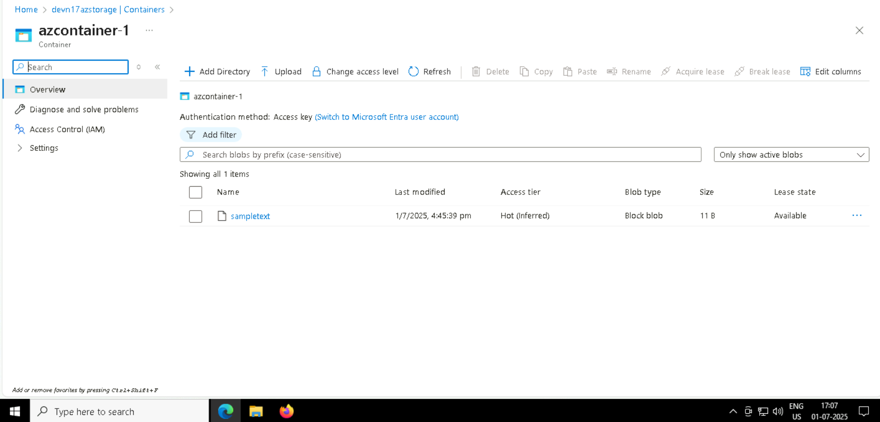

1. Network security rukes created 