Created a repo and done git init

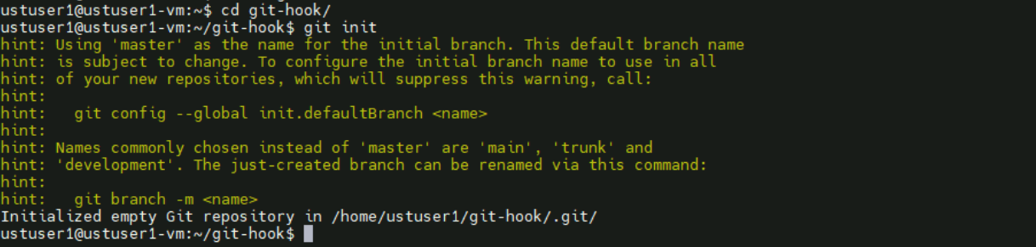

Inside git hooks create a pre-commit

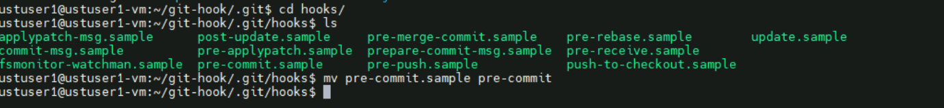

Created a rule by saying need in this format:

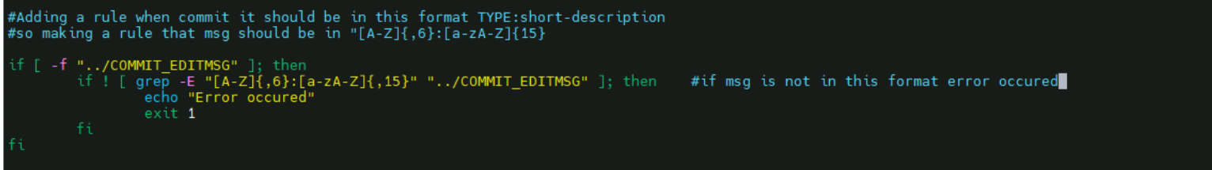

Git commit worked

