1)

Yaml for deployment

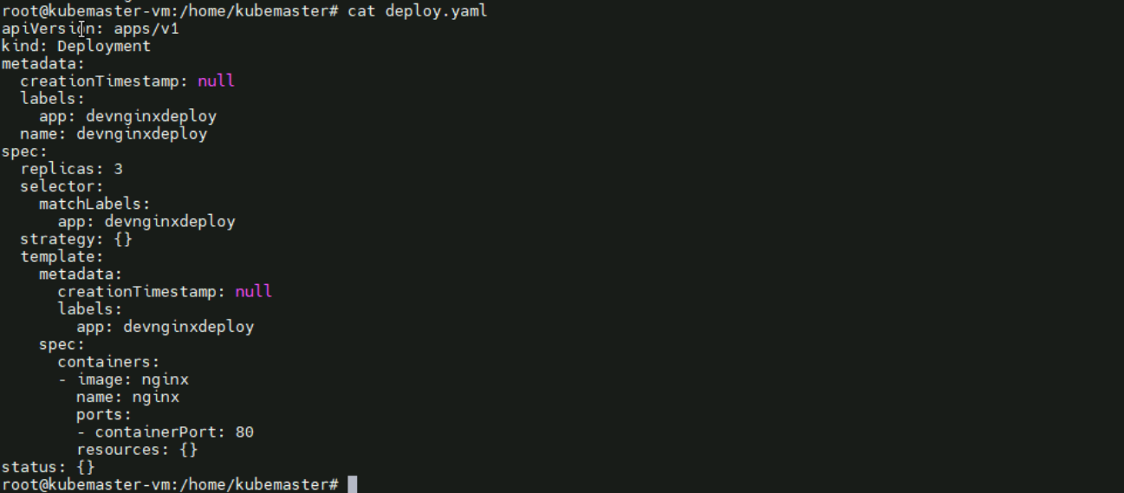

Deployment created

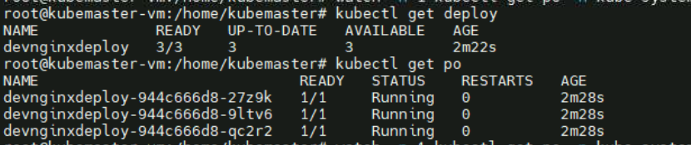

Created a Nodeport service

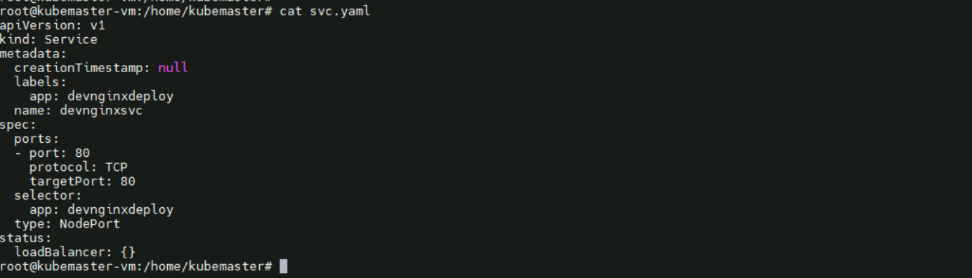

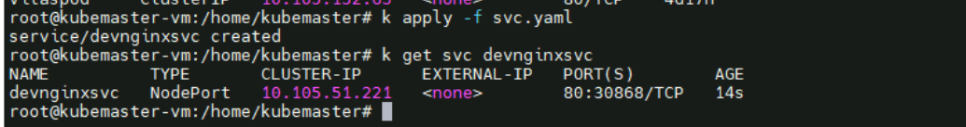

External port: 30868

Checked whether service is working or not

