2) Hpa test

Clone the repository

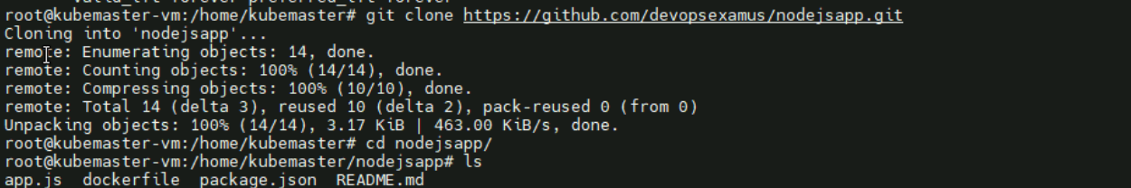

Image is created using the dockerfile

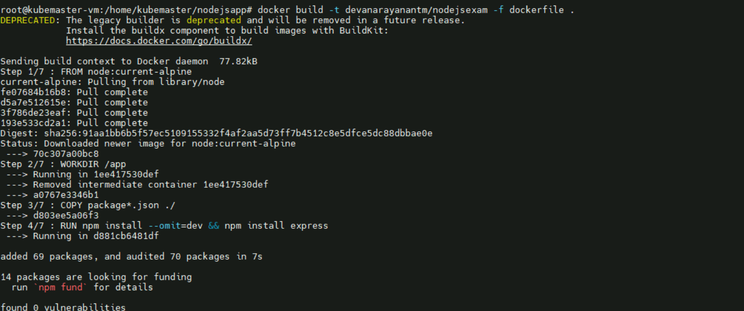

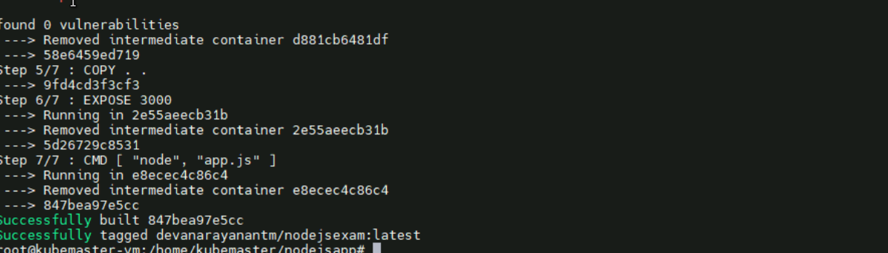

Docker login succeeded

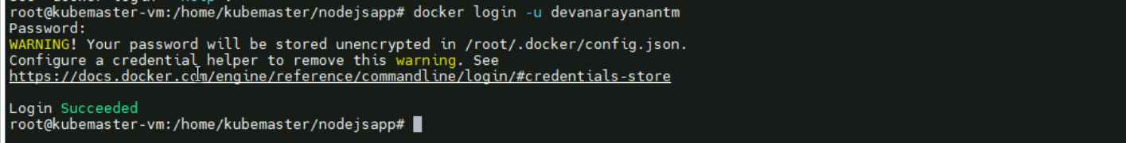

Docker image pushed to docker registry

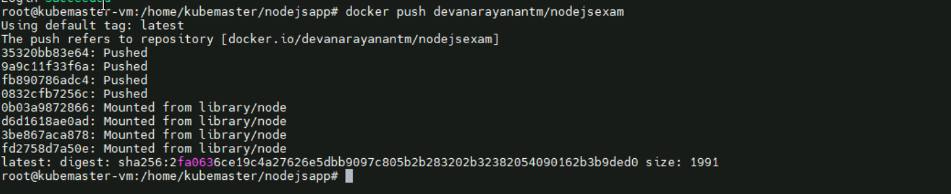

From the image pushed to docker we create a Kubernetes deployment

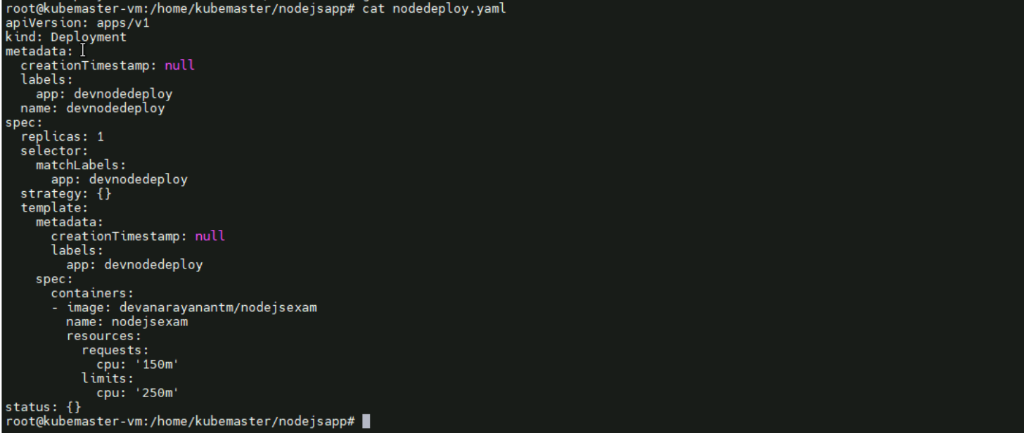

Then it is applied and running

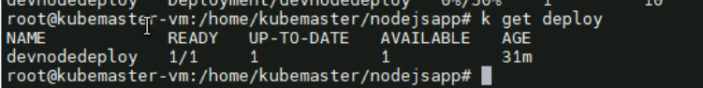

Pods also running

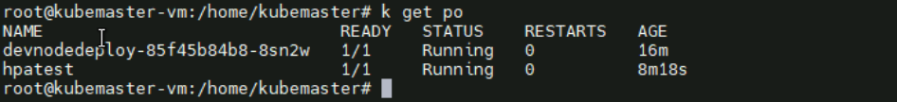

Created a svc

A service is created for testing the horizontal pod allocation.

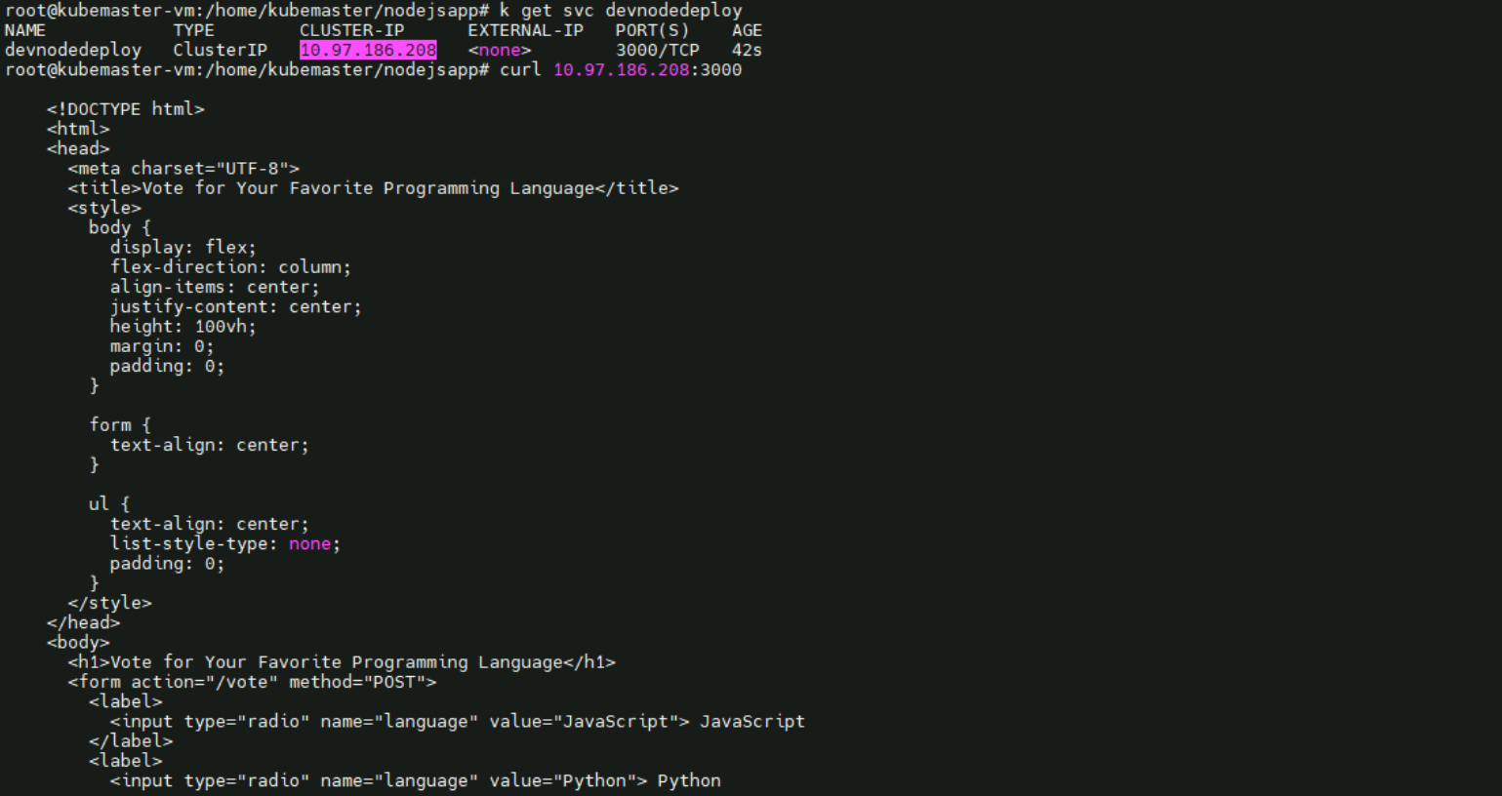

Created horizontal pod allocation

“kubectl autoscale deploy devnodedeploy --min=1 –-max=10 –-cpu-percent=50”

//Forget to take sc of creation



Then created a pod for giving the stress for the pod

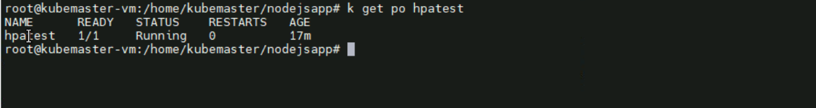

Then from the pod given the stress to the deployment through the created service:-

(next page)

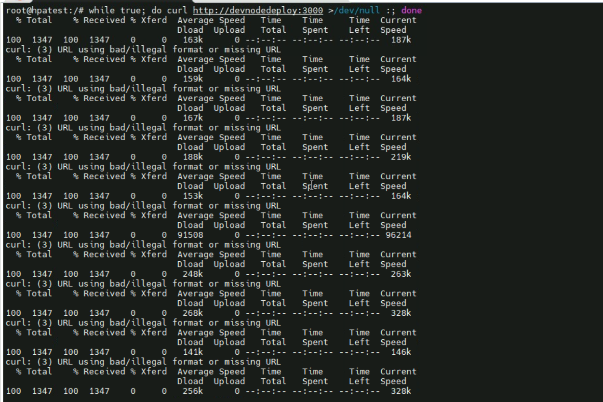

After giving the stress, the pods are auto scaled

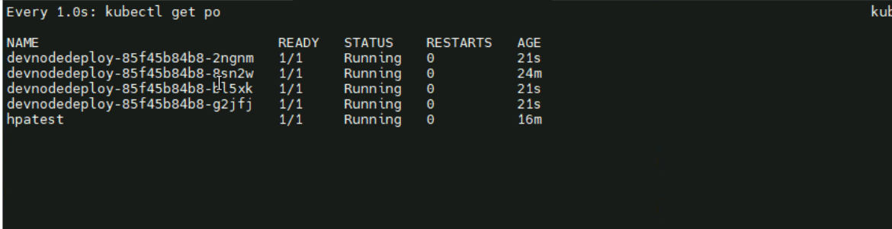

Hpa:-



After removing the stress :-

(next page)

