Repo: https://github.com/devanarayanantm/hello1springboot

1. Clone the repo

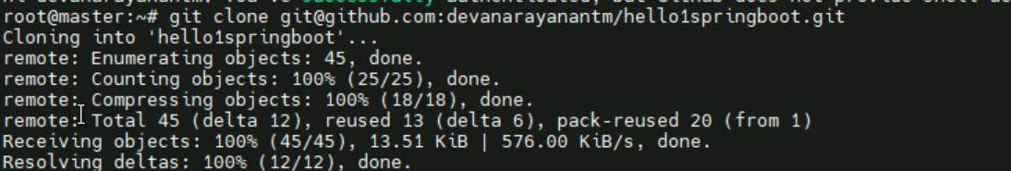

1. Created the docker file

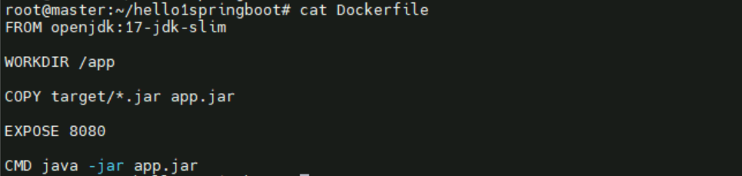

1. Pushed Dockerfile

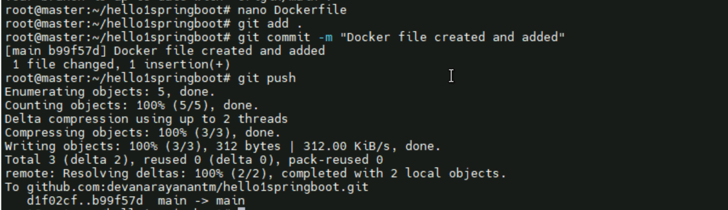

1. Created feature branch

Nb: Don’t know about sonarqube so created a branch greeting and with simple message



1. Create a greeting txt filr



1. Then push it



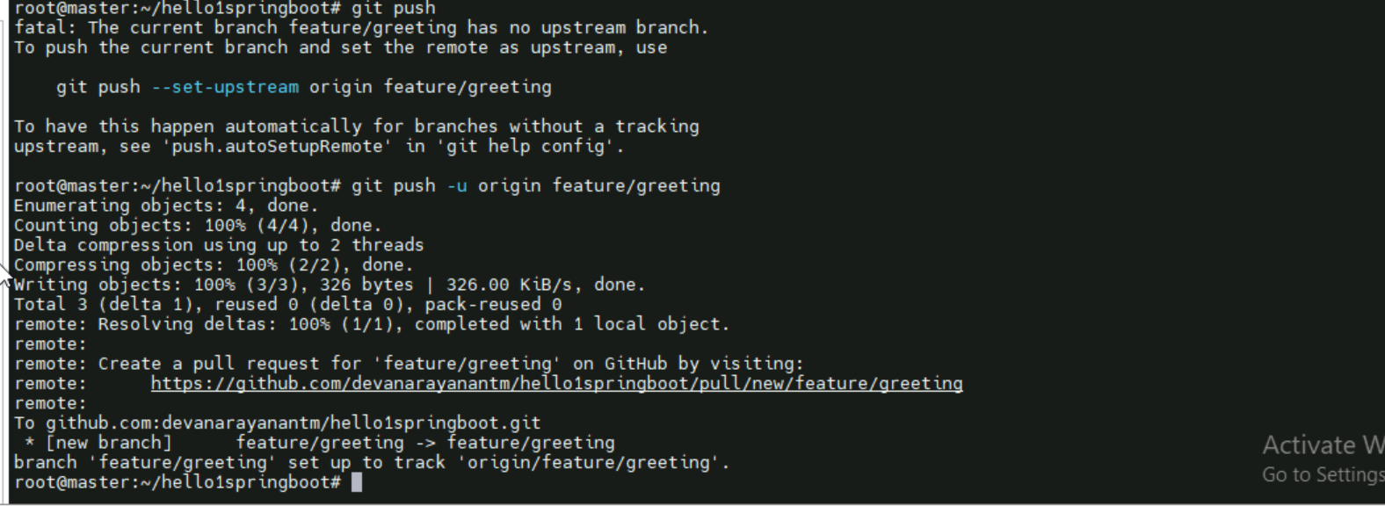

1. Created deployment.yaml then it pushed it



1. Create service and pushed

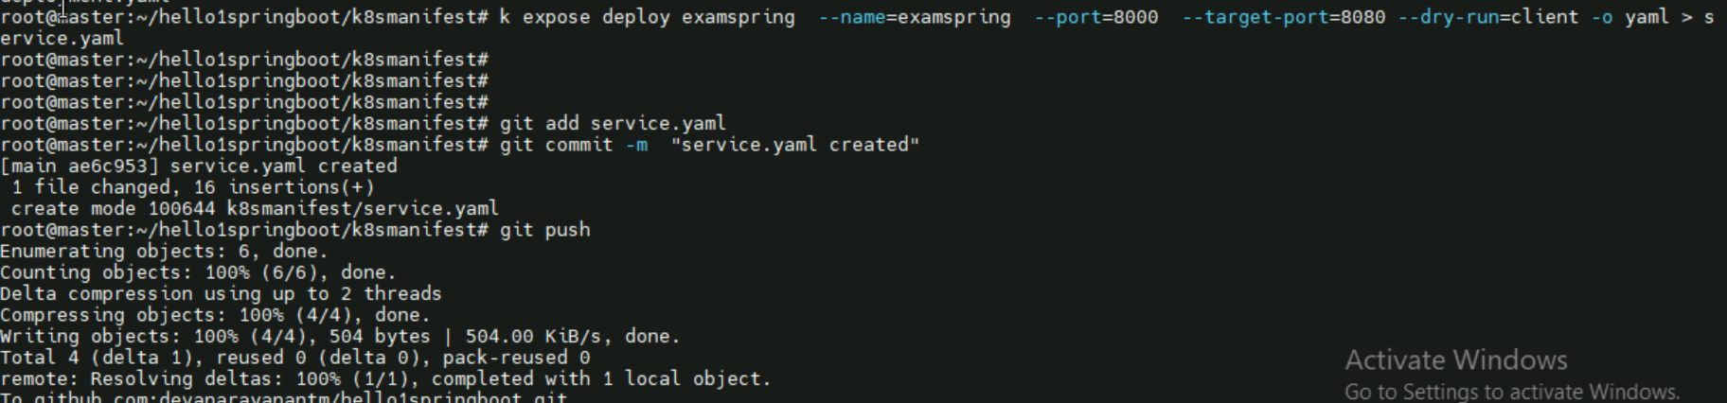

1. Created Webhook

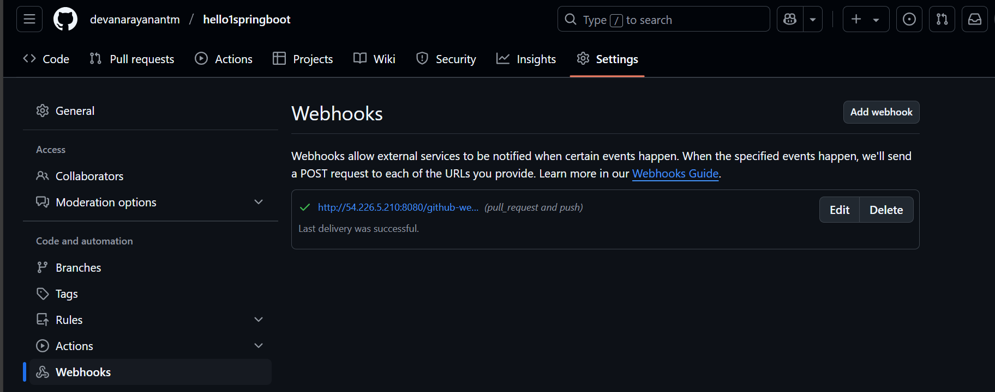

1. Created Jenkinsfile

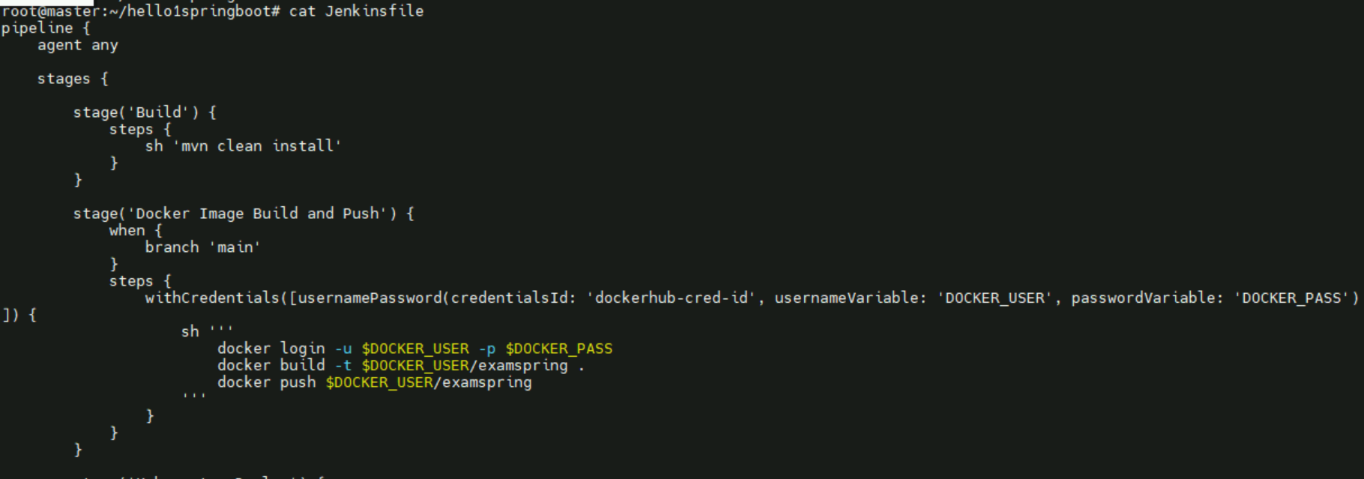

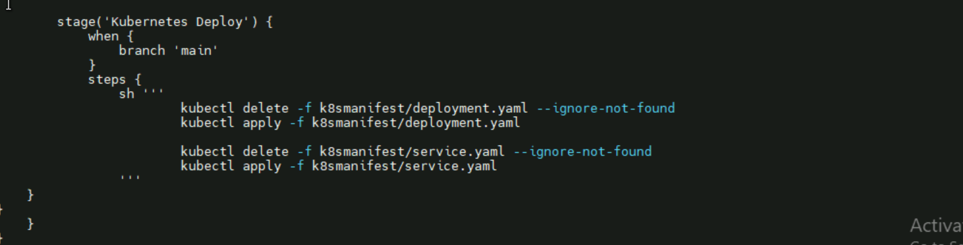

Jenkins

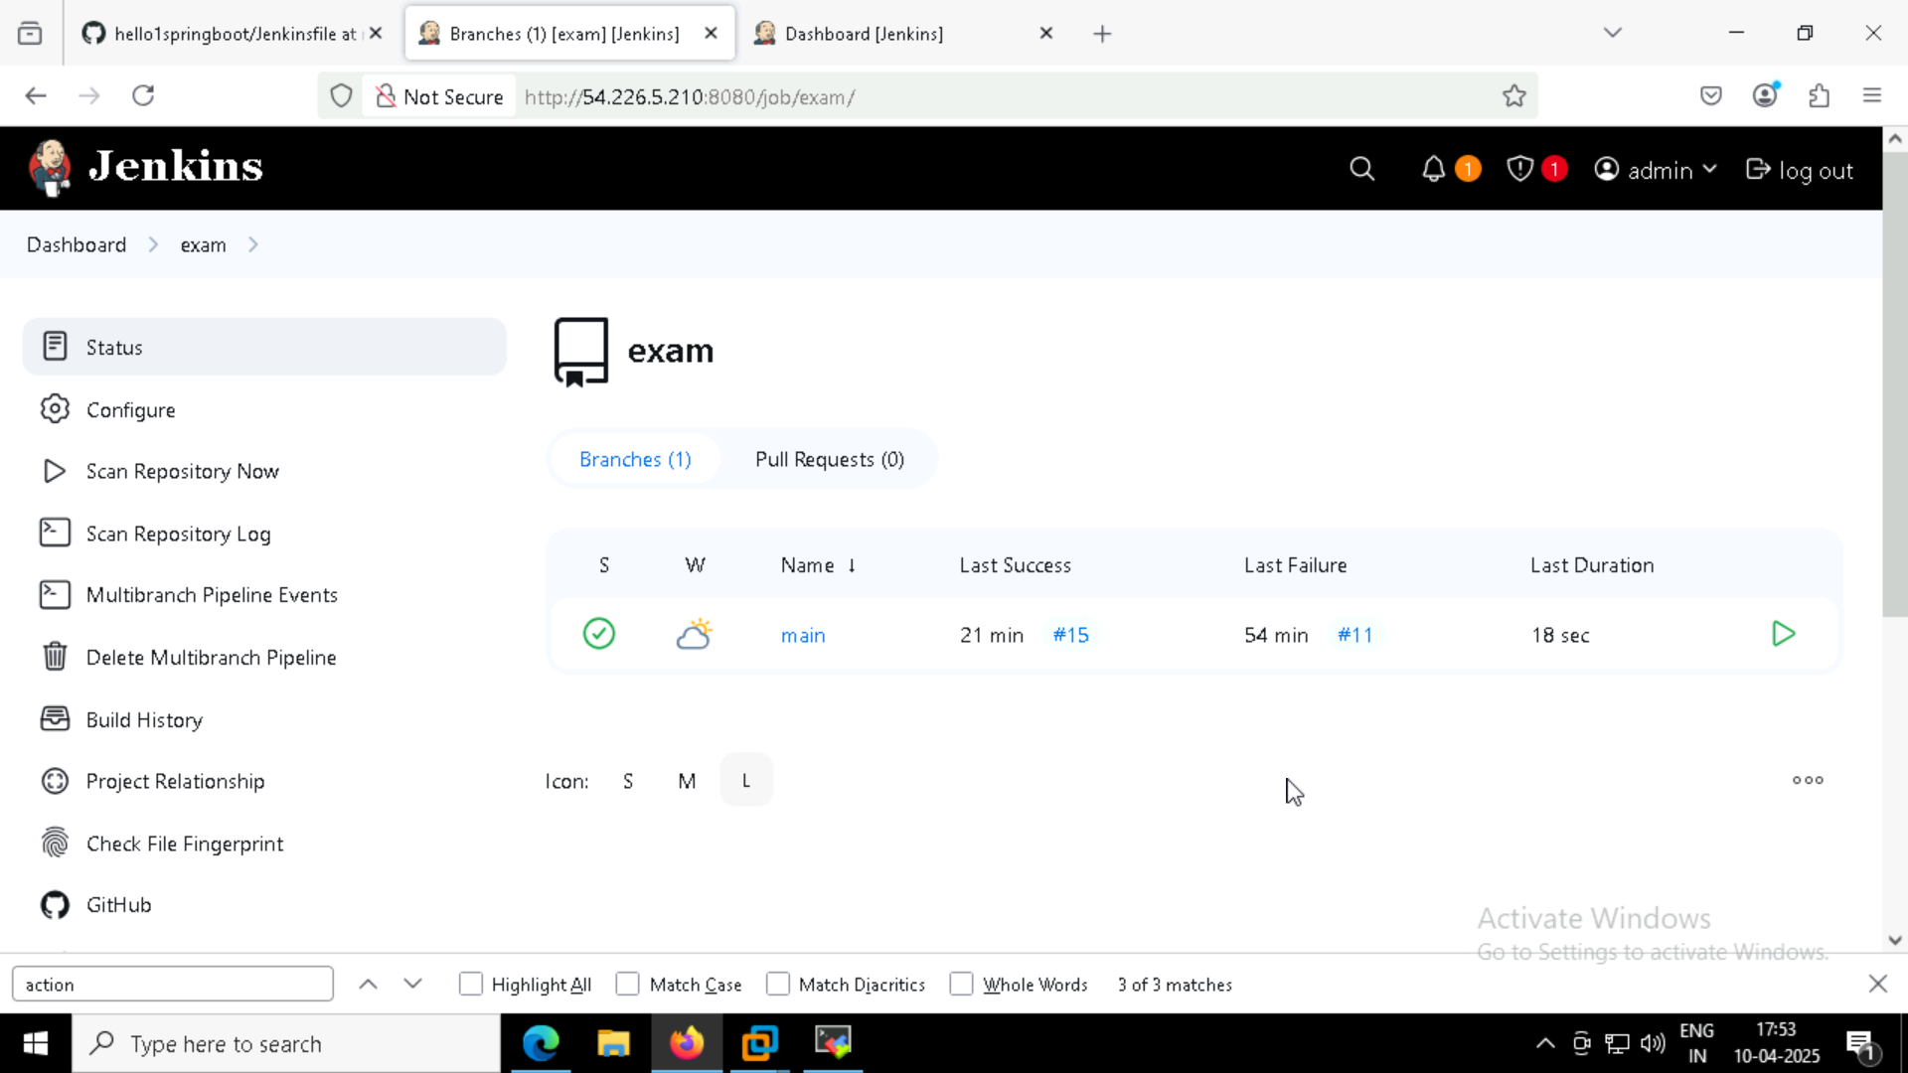

Working successfully and creating deployments and service

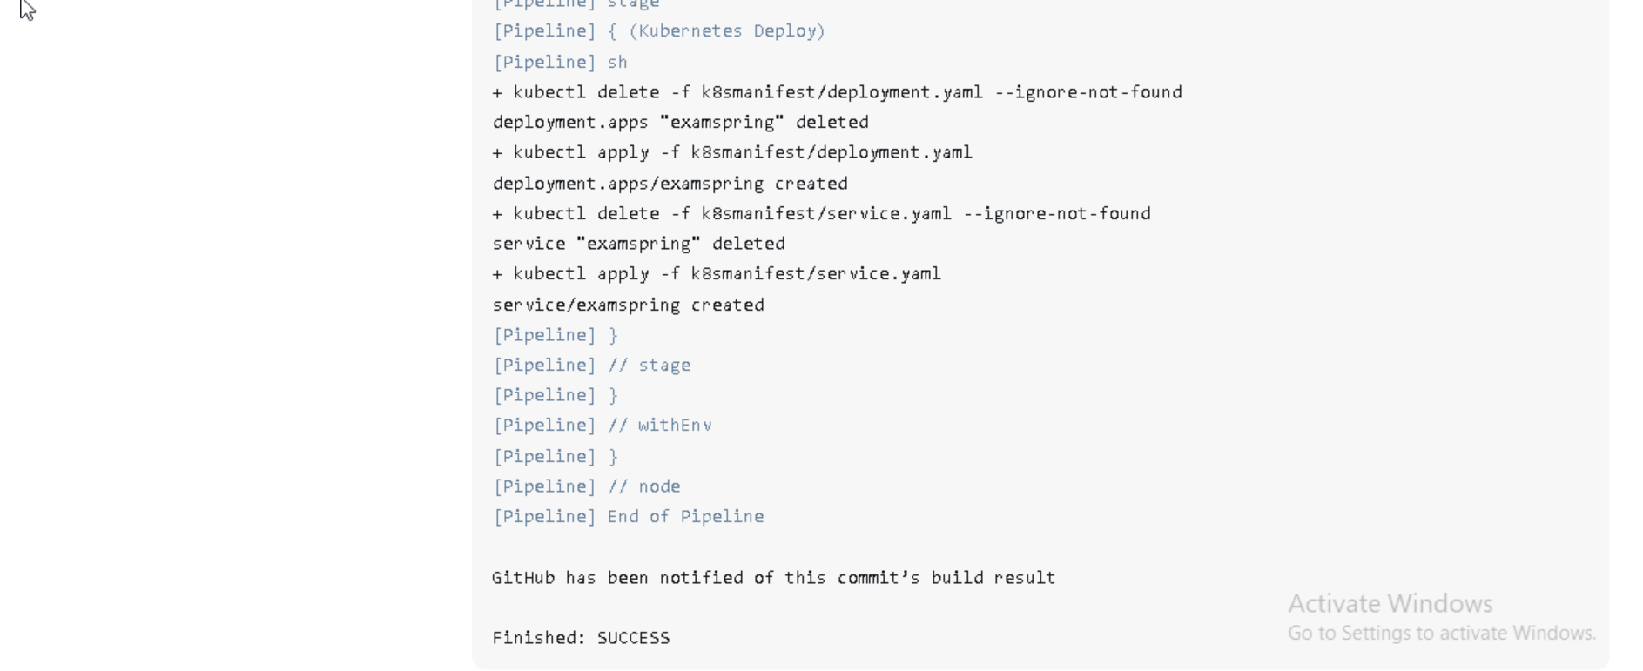

Running every pods

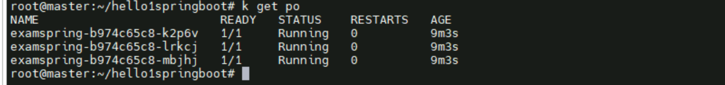

Service also working

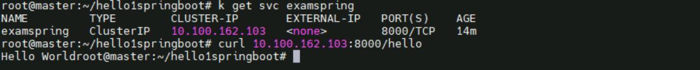

“After curl it print Hello World”

All service pod deployment and replicaset

