Shell scripting

CREATING VARIABLES

CREATING VARIABLES WHICH READ INPUT FROM USER

**IF CASE WITH SINGLE BRACKET**

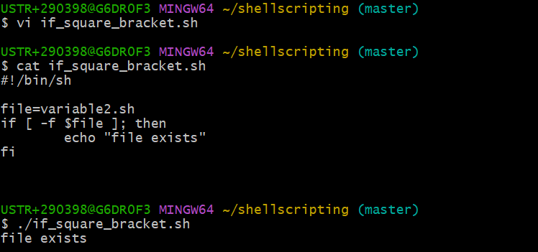

**-f is used to search the file**

**IF DOUBLE QUOTE [HERE WE ARE MORE BETTER ADVANCED] HERE WE CAN USE ONLY IN BASH**

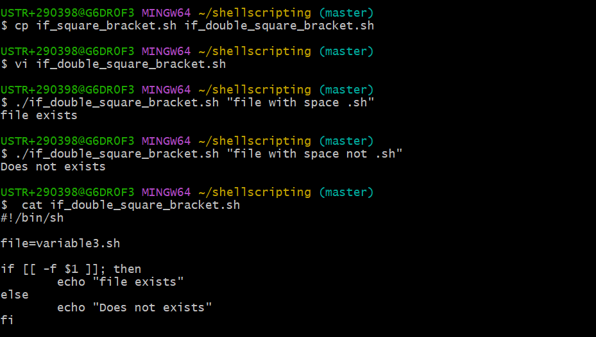

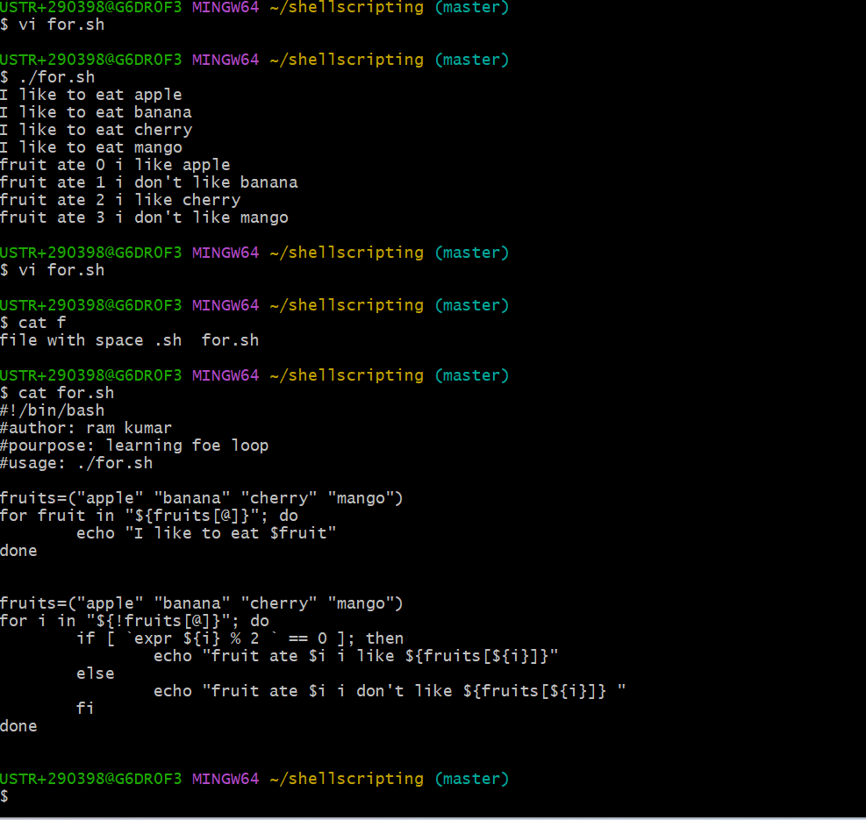

**29-01-2025**

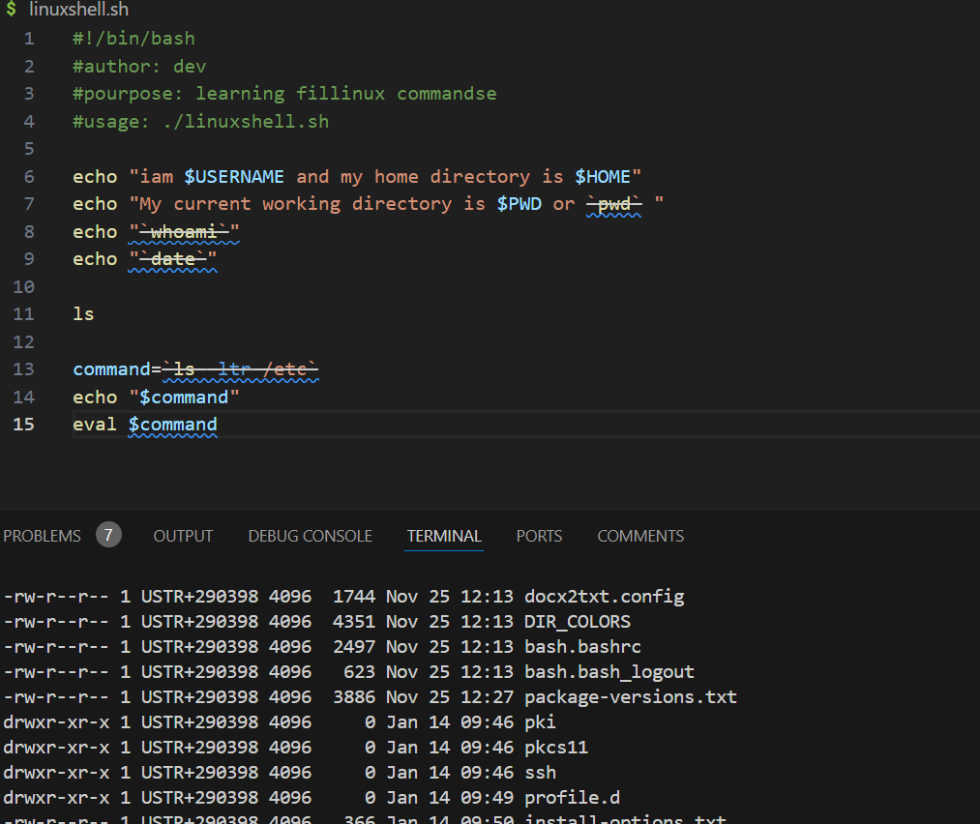

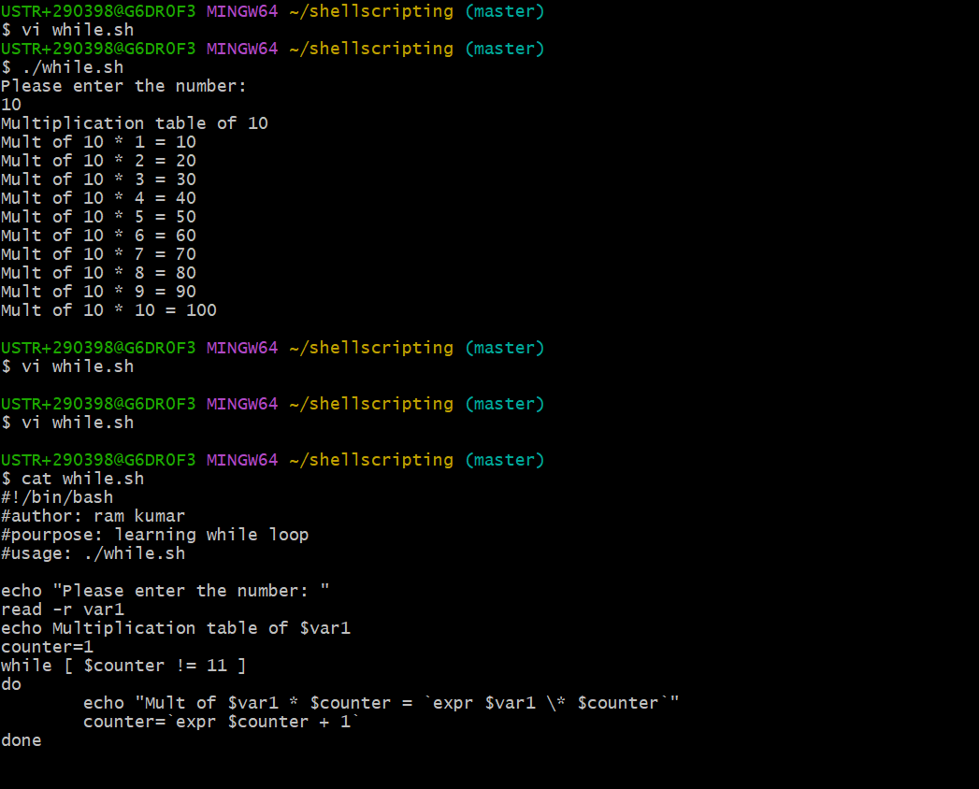

**-r used to read from user**

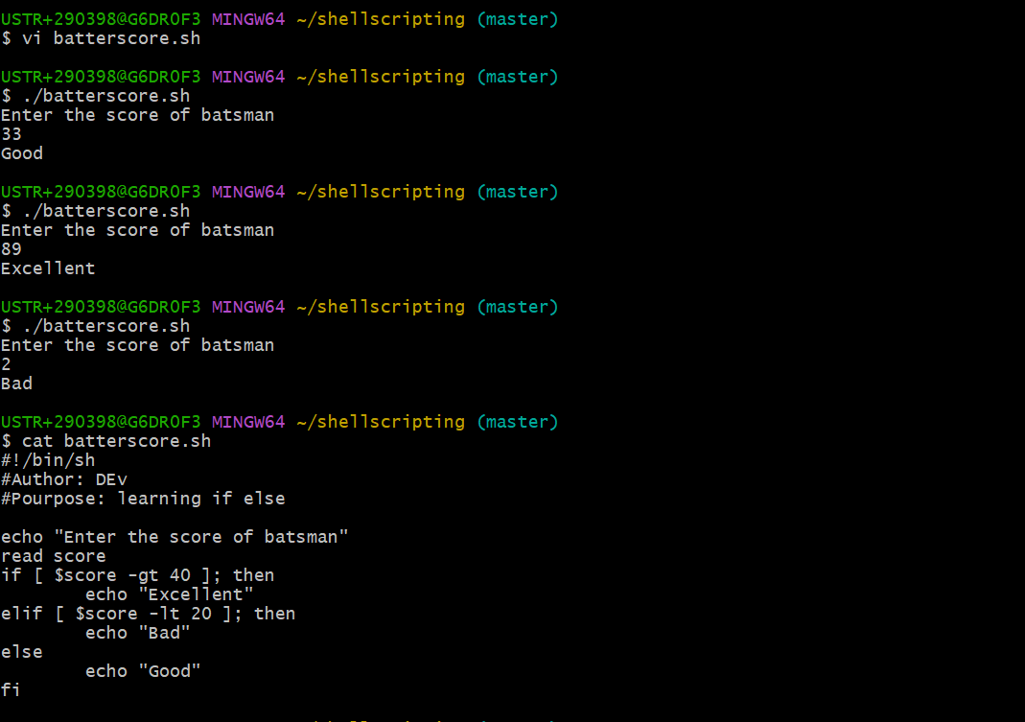

**For loop varieties**

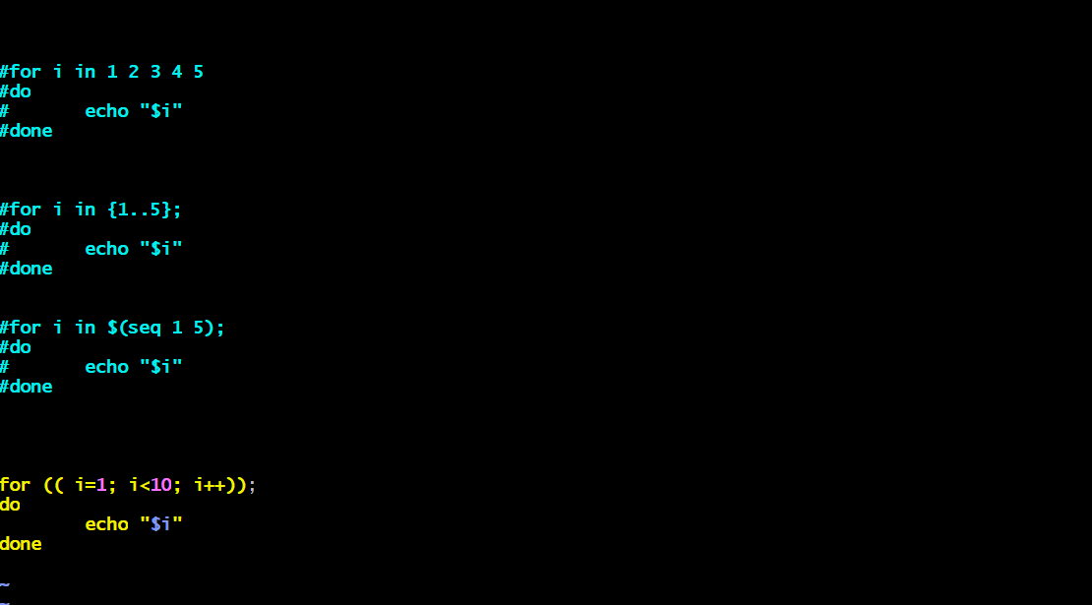

**UNTIL**

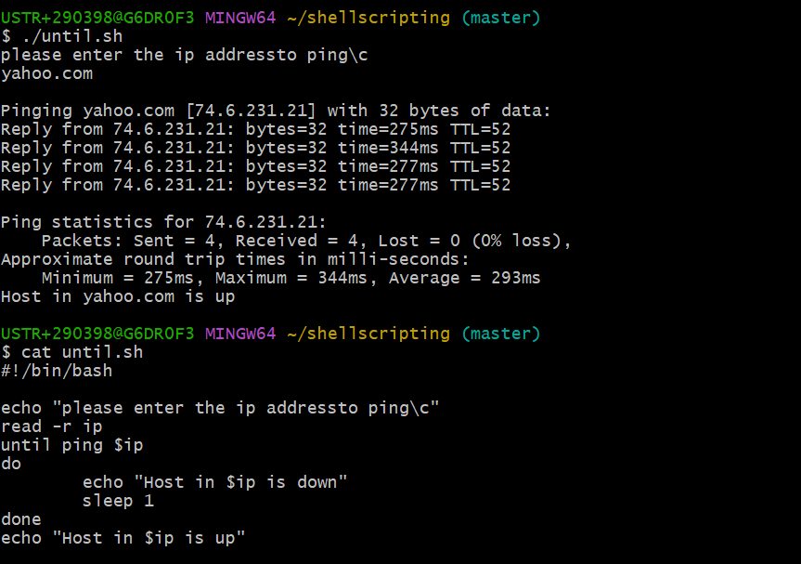

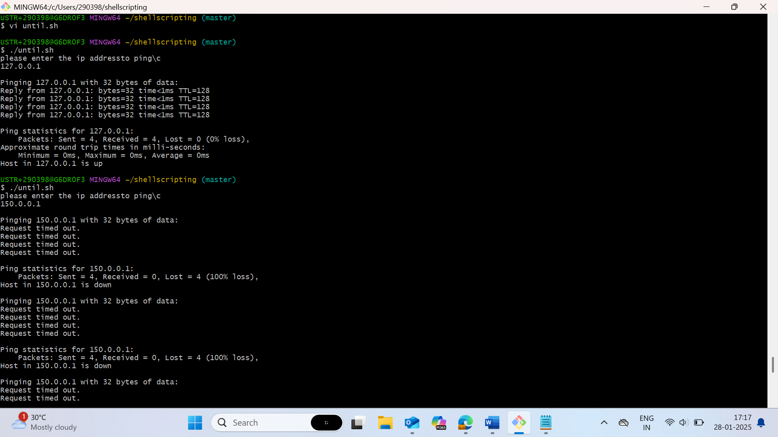

**To take hour from the date then x=`date + %h`**

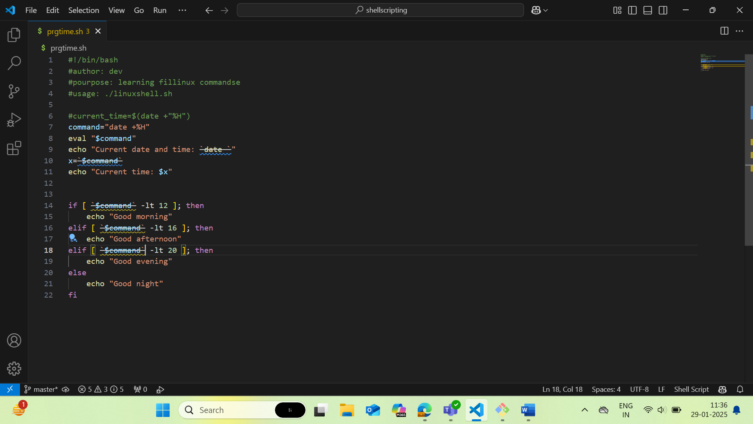

**To get the value of the variable we need to give the `` then only we get the value**

**? has error code is or not**

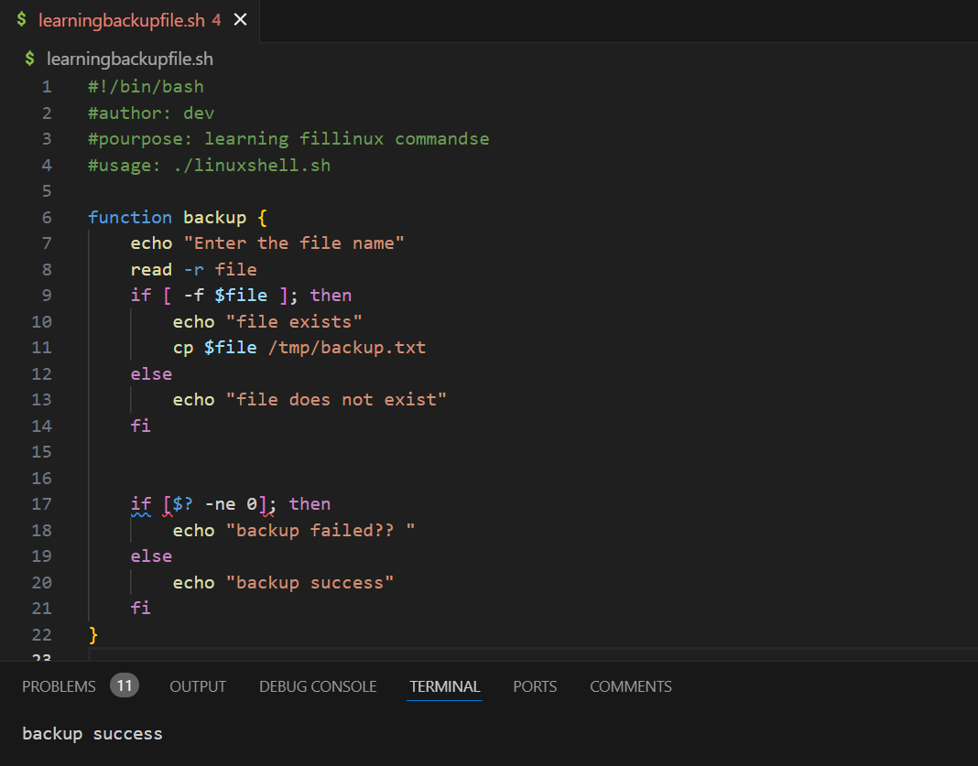

**& execute as backgound process(Daemon)**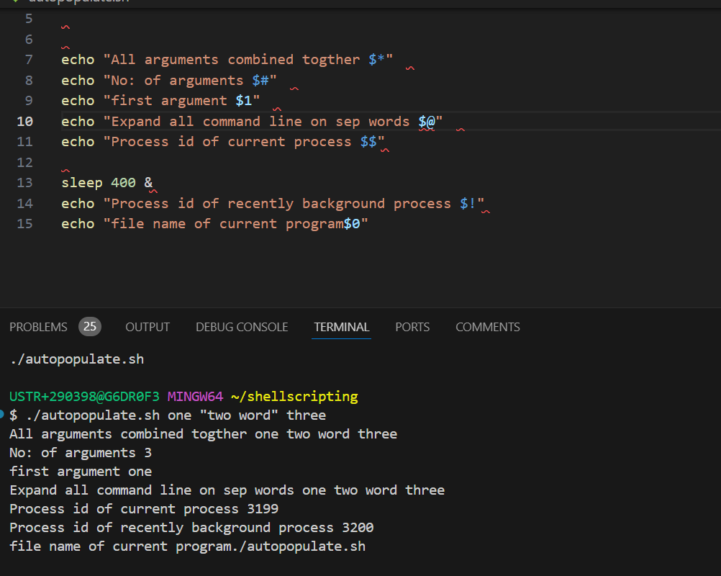

**Date set**

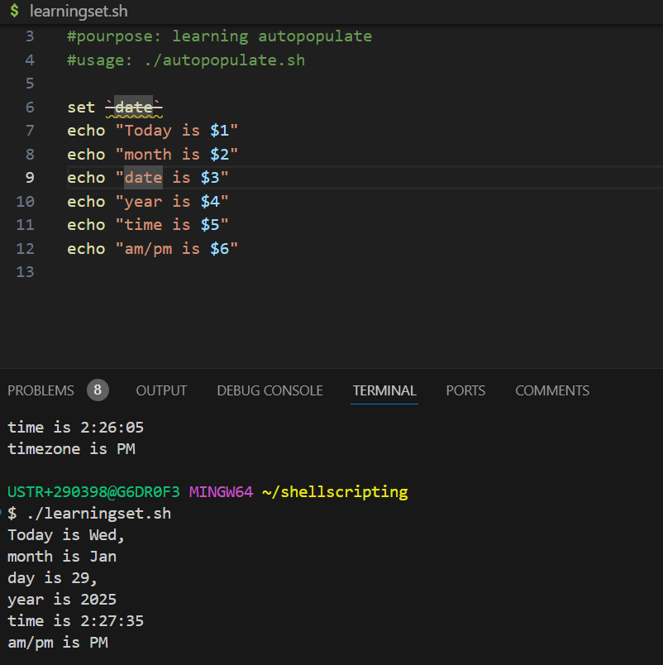

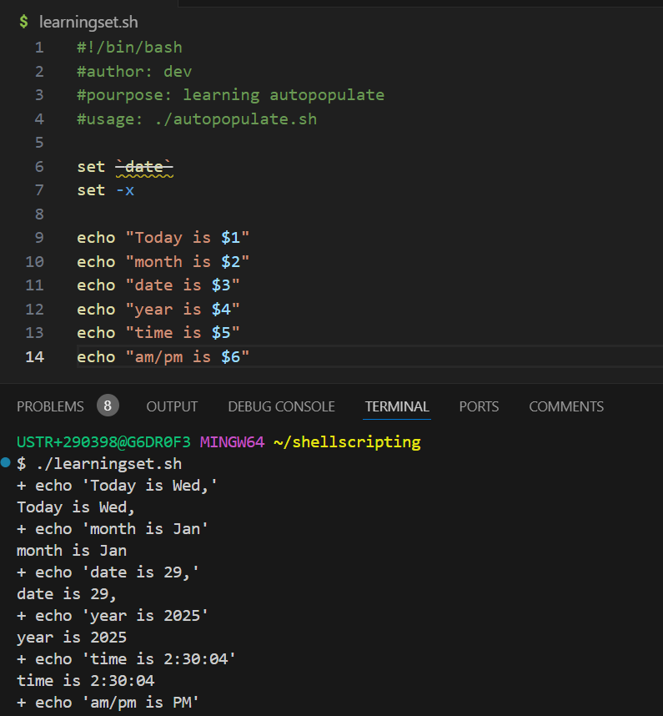

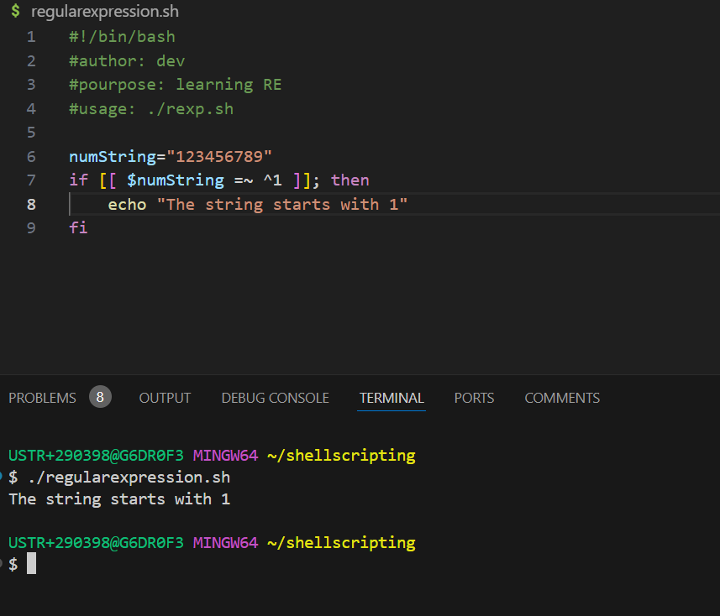

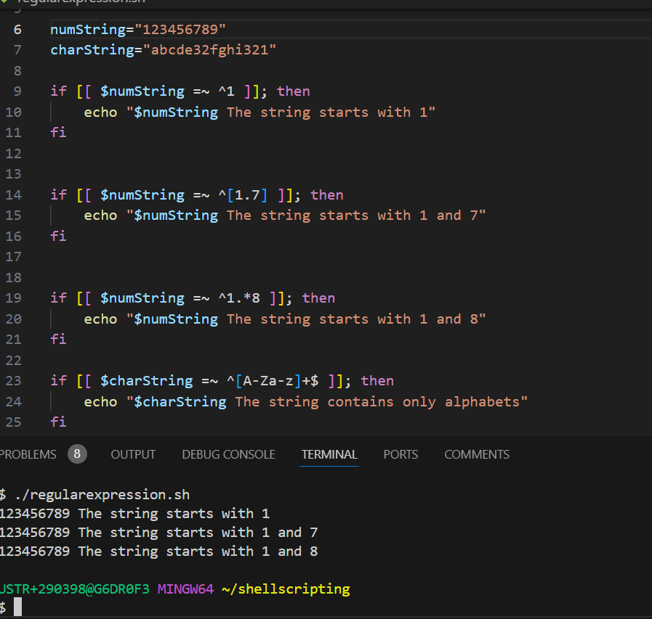

**String upper**

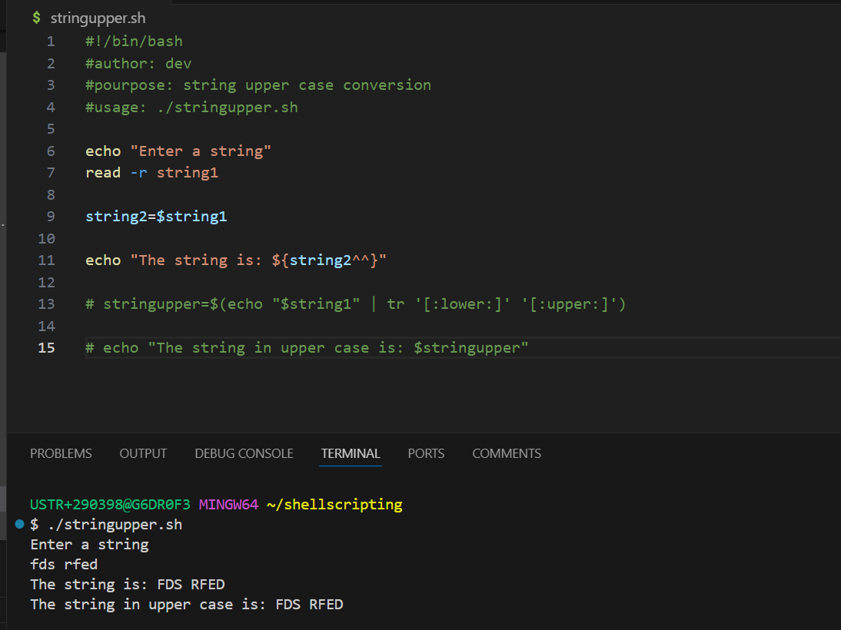

**Pallindrome**

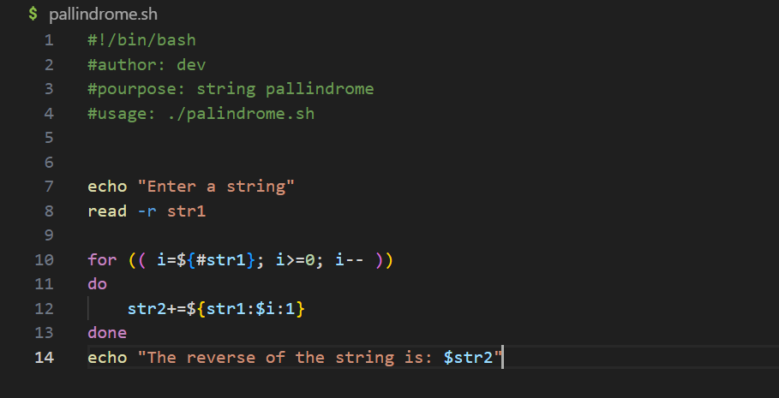

**Count no: of words**

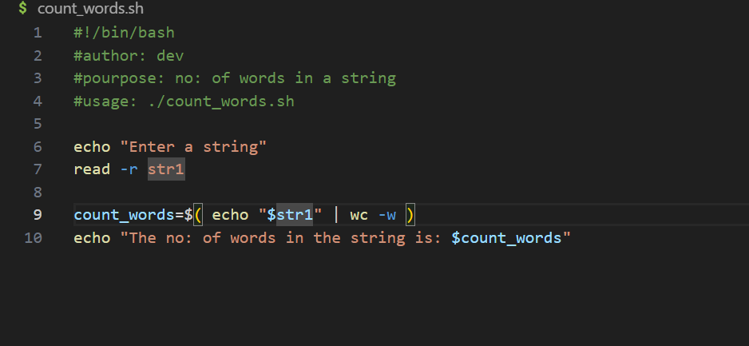

**Replace word**

