**SMART NECKBAND FOR DEAF DRIVERS**

**1. INTRODUCTION**

Wearable assistive technology plays a vital role in bridging sensory gaps for individuals with disabilities, particularly those with hearing impairments. By integrating compact electronics, real-time processing, and human-centered design, these devices enable users to perceive and respond to environmental cues that would otherwise go unnoticed. The evolution of such technology has moved from basic alerting systems like vibrating pagers to intelligent wearables capable of detecting, interpreting, and conveying information through tactile or visual feedback. In the context of driving, where sound cues such as vehicle horns are critical for safety, wearable systems provide an intuitive alternative to auditory alerts. Advances in microcontrollers, low-power sensors, and efficient haptic actuators have made it possible to develop lightweight and comfortable solutions like neckbands, wristbands, and smart vests. These systems work by capturing sound inputs, processing them in real time, and triggering location-specific vibrations based on the direction of the source. The smart neckband in this project is an example of such innovation, offering real-time, direction-based feedback through vibration motors, thus enhancing situational awareness and safety for deaf drivers on the road.

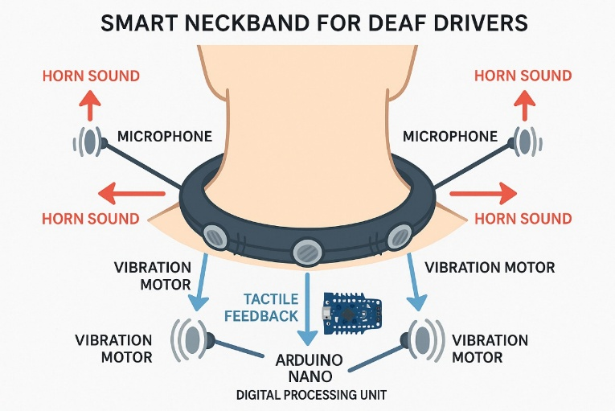

**Fig.1.1 Smart Neckband**

**1.1 BENEFITS OF WEARABLE SMART NECKBAND**

The adoption of wearable assistive technology for hearing-impaired drivers marks a significant advancement in inclusive mobility and personal safety. These devices are designed to bridge the sensory gap created by the inability to perceive critical auditory cues, such as vehicle horns and emergency sirens. By translating sound into tactile feedback, wearables like smart neckbands enable real-time awareness of the driving environment. This technology greatly enhances reaction time and spatial orientation, allowing deaf drivers to respond more confidently and effectively to surrounding traffic conditions. Unlike vehicle-integrated systems, wearable devices are personal, portable, and do not depend on modifications to the car, making them highly accessible and adaptable. Their compact design allows for continuous use without affecting driver comfort or concentration. Moreover, these systems reduce the cognitive load associated with visual scanning, as the driver receives intuitive directional feedback through vibration. The consistent and reliable nature of haptic alerts improves safety not only for the user but also for others on the road by ensuring quicker decision-making and situational response. The cost-effectiveness and low power consumption of modern microcontrollers and sensors make these wearables feasible for widespread use. Future integration with mobile applications and wireless connectivity may enable features like customizable alerts, performance tracking, and remote diagnostics, further improving usability and personalization. Additionally, such assistive wearables can be applied beyond driving, offering support in public transport, crowded environments, or hazardous workplaces, thus expanding their societal impact. As the demand for inclusive technology grows, wearable solutions represent a practical, scalable, and user-friendly approach to empowering hearing-impaired individuals and promoting safer, more independent lifestyles.

**1.2 AUTOMATED FUNCTIONS IN SMART NECKBAND**

Automation has played a crucial role in enhancing the functionality and effectiveness of wearable assistive technologies, such as the Smart Neckband for Deaf Drivers. The system automatically detects environmental sounds, processes auditory inputs, and translates them into real-time, directional haptic feedback without human intervention. This automated system uses sound sensors and microcontrollers to assess the intensity and direction of sounds, triggering vibrations in corresponding motors, ensuring that the driver is instantly alerted to nearby traffic signals, such as vehicle horns.

In the context of road safety, automation in the Smart Neckband helps reduce cognitive load by providing intuitive, tactile feedback through vibration, enhancing situational awareness. The automatic recalibration of the device based on ambient noise levels ensures that the system works efficiently in varying traffic conditions. Furthermore, automation in this wearable system means that drivers do not need to manually adjust settings, making it user-friendly and reliable. The integration of such technologies into everyday life offers deaf drivers an independent, safe driving experience, reducing reliance on visual cues and enhancing confidence on the road. As automation technology continues to advance, future iterations of the neckband may incorporate features like Bluetooth connectivity, app-based adjustments, and performance tracking, further improving the user experience and accessibility.

This automation not only supports safer driving for the hearing-impaired but also exemplifies the potential of wearable tech to foster inclusivity and independence.

**1.3 ARCHITECTURE OF SMART NECKBAND**

The Smart Neckband for Deaf Drivers represents a transformative approach to assistive mobility technology, creating a real-time sensory bridge between environmental audio cues and tactile perception. This wearable system mirrors critical traffic sounds through synchronized vibration feedback, effectively giving deaf drivers a "sense of hearing" for road safety alerts. By establishing continuous interaction between physical sound events and digital signal processing, the neckband enables dynamic hazard awareness without visual dependence.

The system implementation features a bidirectional communication framework between the physical environment and digital processing core. Three directional microphones mounted on the neckband capture ambient sound, converting acoustic energy into electrical signals. These analog inputs are processed by an Arduino microcontroller running custom algorithms that isolate horn frequencies (1-4kHz) from background noise. When a threshold-crossing event occurs, the processor activates vibration motors corresponding to the sound's direction (left/center/right), creating an intuitive spatial alert system. The system's intelligence emerges from its two-way adaptation capability. Physical sound inputs constantly update the digital processing parameters through dynamic threshold adjustment, while the digital outputs modify the physical vibration patterns based on event severity. A manual override switch allows users to temporarily mute alerts, with this status change being fed back into the system's processing logic to prevent false triggers during intentional silencing.

To ensure reliability, the architecture incorporates continuous self-monitoring. The microcontroller compares expected sensor readings with actual inputs, detecting and compensating for sensor failures by switching to a redundant bilateral detection mode. This fault tolerance is complemented by power management routines that optimize battery life during prolonged use. This Smart Neckband architecture demonstrates how embedded systems, adaptive signal processing, and ergonomic design can converge to create practical assistive technology. The solution aligns with emerging paradigms in accessible transportation and wearable IoT, while its modular design permits future expansion through Bluetooth connectivity or cloud integration.

**1.4 EVOLUTION OF THE PROJECT**

The concept of assistive technology for the hearing-impaired has seen tremendous progress over the past few decades, evolving from simple signaling systems to intelligent wearable devices. The Smart Neckband for Deaf Drivers is part of this broader technological evolution that aims to bridge sensory gaps through innovative real-time feedback mechanisms. 1960s–1980s: The early development of assistive tools for the deaf began with visual signal systems such as flashing lights and indicator panels. These devices were primarily used in homes or institutions to alert users to doorbells, phones, or alarms, but lacked portability and situational responsiveness, especially in outdoor environments like roads or vehicles. 1990s–2000s: The emergence of haptic feedback technologies introduced new possibilities for sensory substitution. Devices such as vibrating alarm watches and tactile pagers gained popularity among the hearing-impaired community. These tools provided non-auditory cues in daily routines but were not yet specialized for traffic safety or directional awareness. 2010–2015: With the rise of microcontrollers, low-cost sensors, and compact batteries, wearable electronics became more accessible. Research and innovation began focusing on wearable assistive devices that could interact with the environment in real time. Prototypes of sound-detection wearables were introduced, though most were limited to detecting sound presence without directional capability.

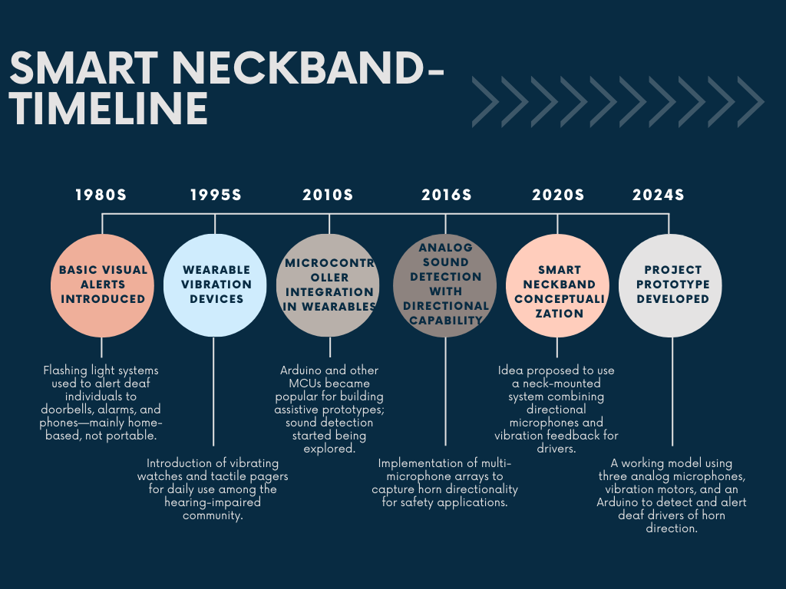

## Fig.1.2 Timeline of Smart Neckband.

2016–2020: The idea of directional sound awareness gained traction, particularly in driving contexts. Advances in analog sensor precision, microcontroller performance, and miniaturized actuators enabled the development of multi-sensor haptic feedback systems. Developers began integrating real-time analog signal comparison with spatial vibration feedback, setting the foundation for the smart neckband concept. 2020s–Present: The Smart Neckband for Deaf Drivers project brings together the latest in sensor fusion, embedded systems, and wearable design. The inclusion of ambient noise calibration, real-time directional processing, and vibration-based alerts reflects the current state-of-the-art in inclusive mobility solutions. As awareness and demand for inclusive technologies continue to rise, such systems are gaining relevance not just in driving, but also in public safety, smart cities, and independent living applications.

**1.5 OVERVIEW OF DEAF NECKBAND SYSTEM**

The Deaf Neckband system is an innovative wearable assistive technology designed to aid individuals with hearing impairments by converting important auditory cues into tactile feedback. This system uses a tri-microphone array to detect the direction of specific environmental sounds, such as vehicle horns, and activates vibration motors accordingly to alert the user. The sound signals are processed in real time using an Arduino microcontroller, which analyzes the intensity and timing differences between microphones to determine the sound's direction. The inclusion of ambient noise calibration ensures that background sounds are filtered, allowing the system to focus on relevant alerts. By providing spatial awareness through vibration feedback, the Deaf Neckband enhances personal safety and independence, particularly while traveling. Its lightweight, wearable form factor ensures comfort and convenience for daily use. Applications include pedestrian navigation, cycling, and silent environments, where auditory information is crucial. As a supportive tool for the hearing-impaired, this system bridges the sensory gap, enabling users to perceive critical auditory signals through non-auditory means.

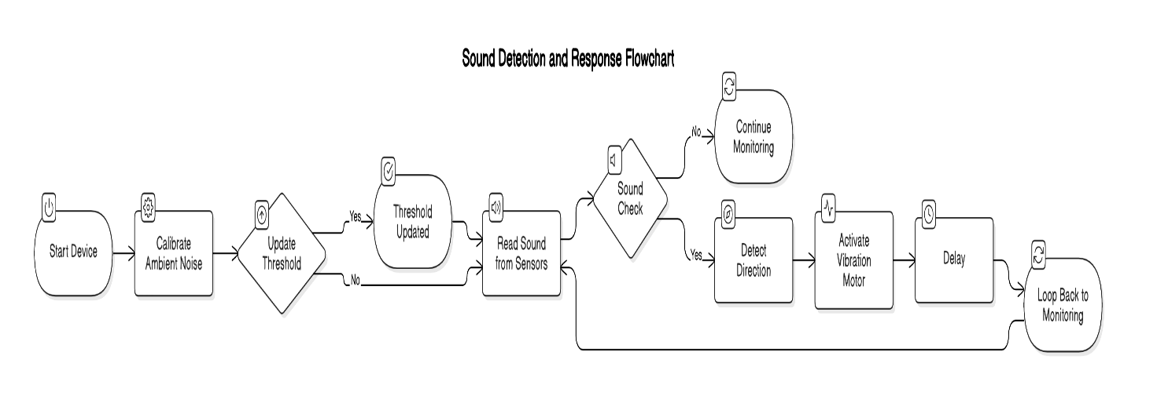

## Fig.1.3 Overview of Smart Neckband

**1.6 COMPARISON OF EXISTING SYSTEMS AND PROPOSED SOLUTION**

Traditional assistive hearing systems such as hearing aids and alerting devices primarily amplify sound or provide generic alerts without directional awareness or contextual filtering. These systems lack intelligent discrimination between useful and ambient noise, leading to confusion in noisy environments. The proposed Deaf Neckband system introduces a more intelligent and user-centered approach by combining directional microphones, ambient noise calibration, and real-time vibration feedback. Unlike conventional systems, which only notify users of sound presence, the neckband indicates the direction of the sound source, improving environmental awareness for the hearing-impaired. Traditional systems often fail to address spatial localization or differentiate between normal background noise and important cues like vehicle horns. The proposed system uses a tri-sensor array and microcontroller-based processing to actively detect, filter, and convert directional sounds into distinct haptic signals. The real-time calibration helps maintain accuracy across varying noise levels, enhancing reliability. Moreover, the wearable design and portability make it practical for daily outdoor use, offering greater autonomy and safety. This innovation marks a step forward from traditional hearing aids by incorporating smart sensing, signal processing, and targeted feedback mechanisms to support inclusive mobility and communication.

## Table.1.1 Comparison Between Traditional Hearing Aids and Proposed Deaf Neckband System

|  |  |  |
| --- | --- | --- |
| **ASPECT** | **TRADITIONAL HEARING DEVICES** | **PROPOSED DEAF NECKBAND SYSTEM** |
| **Sound Detection** | General amplification | Directional detection using 3 microphones |
| **Feedback Mechanism** | Audio-based (not usable by deaf users) | Haptic vibration feedback based on direction |
| **Noise Handling** | No noise filtering | Ambient noise calibration for accuracy |
| **Directional Awareness** | Lacking | Tri-sensor based directional feedback |
| **Portability & Usability** | Limited outdoor use | Wearable and travel-safe design |

**1.7 MOTIVATION OF THE PROJECT**

Hearing-impaired drivers face challenges in detecting critical auditory cues such as vehicle horns or sirens, which are essential for road safety. This gap can lead to delayed reactions and increased risk in traffic. The Smart Neckband for Deaf Drivers was developed to address this issue by providing real-time tactile alerts through vibration feedback, based on the direction of incoming sounds.

The system's wearable design ensures comfort and constant awareness, enabling deaf drivers to receive spatial cues without relying on visual indicators alone. By using analog sound sensors and microcontroller-based processing, the device delivers fast and intuitive responses to high-intensity sounds

.

This project not only aims to improve safety for deaf drivers but also supports inclusive design and independence. Its simple, cost-effective architecture can be adapted for broader use in public and industrial settings, laying the groundwork for future wearable safety systems.

**1.8 SCOPE OF THE PROJECT**

The project focuses on the development of a real-time assistive neckband system that enhances spatial awareness for individuals with hearing impairments by converting environmental audio cues into directional vibration alerts. The system uses a tri-microphone array and an Arduino microcontroller to detect and process sounds such as vehicle horns and determine their direction relative to the wearer. Vibration motors placed at the left, center, and right sides of the neckband provide tactile feedback based on the direction of the detected sound. Ambient noise calibration is included to filter out background noise, ensuring accurate alerts in dynamic environments. This wearable system is lightweight, travel-friendly, and intended for real-world use, particularly in noisy outdoor conditions. The project aims to demonstrate an affordable, user-friendly, and effective solution to help hearing-impaired individuals navigate more safely and independently by bridging auditory gaps with non-auditory feedback in real time.

**1.9 OBJECTIVES OF THE PROJECT**

* To develop a real-time wearable system that detects vehicle horn sounds and provides directional vibration alerts for deaf drivers.
* To use analog sound sensors positioned at three points (left, center, right) to accurately determine the direction of incoming sounds.
* To integrate a microcontroller (Arduino) that processes sound data, compares intensity levels, and activates the corresponding vibration motor.
* To implement dynamic ambient noise calibration that ensures reliable operation in various driving environments.
* To create a compact, battery-powered, and user-friendly neckband suitable for daily use in real-world traffic scenarios..

**1.10 ORGANIZATION OF THE REPORT**

The Organization of the report as follows,

**Section 1** presents an overview of the Smart Neckband for Deaf Drivers, including the background, evolution of assistive technology, working principles of sound sensors, motivation, scope, and objectives of the project.

**Section 2** provides a review of relevant research papers and existing technologies in the field of assistive devices, sound detection systems, and haptic feedback for hearing-impaired users.

**Section 3** details the proposed design of the smart neckband system. It includes the hardware architecture, sensor configuration, microcontroller integration, and real-time processing techniques used to detect directional sounds and provide feedback.

**Section 4** examines the experimental setup and results gathered from real-time testing of the neckband. It includes analysis of system accuracy, vibration response times, and the effectiveness of ambient noise calibration in varied driving conditions.

**Section 5** summarizes the major findings of the project and their significance in the field of assistive driving technologies. It also identifies possible areas for future improvements, such as wireless communication, app integration, and broader applications in public safety and smart mobility.

# 2. LITERATURE SURVEY

**Yuqian Lu et al., (2022) [1]** presented the SmartBelt, a wearable safety system designed to assist hearing-impaired users in navigating noisy environments. This system uses a microphone array paired with beamforming algorithms to localize sound sources accurately and convert these auditory signals into haptic feedback through vibration motors. The SmartBelt achieved a localization accuracy of 2.90°, demonstrating remarkable reliability even in dynamic and unpredictable environments, such as busy streets and crowded areas. This level of precision enhances the awareness of users, enabling them to respond promptly to environmental cues. The wearable form factor and real-time response of the SmartBelt align closely with the objectives of the smart neckband, confirming that directional sound-to-touch conversion is feasible for improving safety and awareness in deaf users, particularly in scenarios where traditional sound-based alerts would not be effective. The study underlined the potential of this technology for broader application in safety-critical areas where hearing-impaired individuals may face risks due to a lack of auditory cues.  
**Source**: Michaud, S. et al., arXiv preprint, arXiv:2202.13974.

**Chen et al., (2020) [2]** introduced the SmartBelt, a similar wearable system aimed at improving situational awareness for hearing-impaired individuals in noisy environments. Utilizing a microphone array and beamforming algorithms, the system identifies and localizes environmental sounds, converting them into haptic feedback via vibration motors. The system demonstrated an angular localization accuracy of 2.90°, which is crucial for real-time responsiveness in urban and crowded settings. The wearable’s ability to deliver timely tactile feedback allows users to remain aware of nearby sounds, which may include emergency signals, vehicles, or other potential hazards. This development reinforces the practicality of the smart neckband, particularly for drivers who need to be alerted to their surroundings but cannot rely on auditory cues. Moreover, this technology opens doors for additional wearable safety devices aimed at improving the lives of hearing-impaired individuals.  
**Source**: Michaud, S. et al., arXiv preprint, arXiv:2202.13974.

**Hyundai Motor Company, (2019) [3]** introduced audio-visual and audio-tactile conversion systems aimed at enhancing the driving experience for deaf individuals. These systems detect environmental sounds, such as sirens or vehicle horns, and convert them into visual cues displayed on a heads-up display (HUD) and tactile feedback through the steering wheel. This innovation aims to improve the awareness and safety of deaf drivers by providing them with alerts they can perceive and respond to. This approach reflects a strong connection to the objectives of the smart neckband, where environmental sounds are converted into a form that can be perceived without the need for auditory input. Hyundai's system demonstrates the feasibility of combining tactile feedback with visual elements to assist deaf drivers, and it serves as a promising foundation for further wearable technologies in this field.

**Source**: Hyundai Hearing Assist Tech.

**SafeDrive4Deaf Team, Mada (2021) [4]** proposed SafeDrive4Deaf, a system designed to enhance traffic safety for deaf drivers by providing visual cues in response to emergency sounds like sirens or horns. The system uses light-based indicators to signal the presence of these critical sounds, ensuring that drivers with hearing impairments can react quickly to potential hazards. SafeDrive4Deaf aims to address the safety challenges faced by hearing-impaired drivers in busy or noisy traffic environments. Its focus on visual alerts enhances the user's ability to perceive external stimuli without relying on sound, which directly aligns with the objectives of the smart neckband. This system provides an alternative approach to the traditional auditory alerts and shows the importance of integrating various forms of alerts to create safer driving experiences for deafindividuals.

Source: SafeDrive4Deaf – Mada Innovation Program.

**[5]** **Haptear Project Team (2021) [5]** developed a highly advanced wearable device that utilizes artificial intelligence (AI) to detect, classify, and localize environmental sounds. The system uses machine learning algorithms to analyze sound data in real-time and deliver vibration-based directional alerts based on the type and location of the sound. This ability allows users to not only sense the presence of a sound but also identify its direction and potential relevance, improving their awareness of their surroundings. The use of AI helps the system to adapt and refine its sound classification, ensuring accurate and reliable feedback even in complex acoustic environments. By providing localized haptic feedback, users can detect the proximity of important events, such as approaching vehicles or emergency alarms, and react accordingly. The AI-powered sound detection and classification capability represent a significant step forward in the development of smart wearable technologies, particularly for individuals with hearing impairments. The project’s success demonstrates the potential of integrating AI into assistive devices to enhance both safety and independence for deaf and hard-of-hearing users.

**Source**: Haptear – Official Website.

**L. D’Souza and M. Harish, (2022) [6]** designed a simple yet effective microcontroller-based alert system using piezo buzzers and vibration motors to notify hearing-impaired users about loud environmental noises, such as alarms, horns, or sirens. The system was built using low-cost components, primarily based on Arduino microcontrollers, making it accessible for widespread use, even for individuals on a budget. The use of vibration motors provides tactile feedback that is easy to feel, ensuring users can perceive important environmental sounds even when auditory signals are absent. Despite being a low-cost solution, the system demonstrated great potential in providing basic safety alerts for hearing-impaired individuals, proving that effective assistive technology doesn't need to be expensive. The project highlighted the feasibility of integrating simple hardware into assistive wearables that can have a significant impact on users' safety and independence. The use of vibration-based alerts also aligns with the principles of the smart neckband, further supporting the potential of tactile feedback to enhance situational awareness for the hearing-impaired.  
**Source**: Brunel Design School

.

**Ryosei Kojima et al., (2023) [7]** introduced SHITARA, a non-contact haptic system that uses air vortex rings to deliver directional tactile alerts from a distance, up to 2.5 meters. This system offers a novel solution for providing users with haptic feedback without the need for physical contact, which is especially useful in applications where wearing a device is not practical or desirable. The system works by creating air vortex rings that carry the tactile sensation, which can be perceived by the user without direct touch. This breakthrough in non-contact haptic technology expands the range of possible applications for assistive systems, particularly in public spaces or environments where direct physical contact may not be feasible or comfortable. The ability to alert users from a distance opens up new possibilities for safety applications, such as in high-traffic areas, large crowds, or when driving, where quick, localized feedback is necessary. SHITARA represents a step forward in making assistive technologies more versatile and adaptable to various real-world scenarios.  
**Source**: Kojima, R. et al., arXiv:2301.08107.

**Anitha K. and Prasad V., (2023) [8]** conducted an extensive review of haptic assistive technologies, with a particular focus on the challenges associated with real-time signal processing and user comfort. Their research emphasized that successful wearable systems for the hearing-impaired need to not only deliver accurate and timely haptic feedback but also ensure that the feedback is comfortable and ergonomic for long-term wear. One of the major challenges discussed in the review is the need for real-time signal processing to ensure that the tactile feedback is provided in sync with environmental sounds, allowing for timely and relevant alerts. Additionally, the study explored the importance of minimizing the discomfort caused by prolonged use of vibration-based systems, ensuring that the feedback is not intrusive or tiring. The authors concluded that future advancements in assistive technologies must strike a balance between effectiveness and user comfort, ensuring that the systems are both functional and comfortable for long-term daily use.  
**Source**: DINF Japan, Norma Reports.

**[9]** **Li T. et al., (2023) [9]** proposed a spatial vibration system capable of mapping environmental sound directions into localized haptic patterns that users can feel. Their system is designed to enhance the spatial awareness of deaf users by translating auditory signals into vibrations that represent the direction and proximity of the sound source. The system proved successful in helping users detect and react to traffic-related sounds, such as approaching vehicles or sirens. By providing this directional feedback, the system significantly improves users' ability to navigate noisy environments and make quick, informed decisions. The spatial mapping capability allows the user to perceive not just the presence of a sound but also its exact direction, which is vital in scenarios such as driving or walking in busy urban environments. The study emphasizes the importance of haptic feedback in providing a viable solution for individuals who cannot rely on sound cues, opening up new possibilities for wearable safety devices.

**Source**: Cited via Haptear Innovation Archive (2023).

**Florian Stadtman et al., (2023) [10]** explored the adaptation of vibration-based alert systems in high-noise environments, specifically wind farms. Their research focused on how these systems could be effectively used to alert users to potential hazards such as machinery malfunctions or approaching vehicles in high-noise areas. The study demonstrated that vibration alerts, when designed appropriately, can overcome the challenges posed by loud environments and provide critical feedback to users. The authors also discussed the modeling approaches they used to optimize the vibration system, ensuring it would function properly in such noisy settings. These findings are highly relevant for applications in urban traffic, where noise pollution is a common issue, and provide additional support for vibration-based systems as a reliable means of delivering alerts to users who cannot rely on auditory cues.  
**Source**: SCADA Integration Reports, Wind Alert Studies.

**3. DESIGN AND IMPLEMENTATION OF SMART NECKBAND**

The Smart Neckband for Deaf Drivers is designed to help hearing-impaired individuals by providing real-time, directional alerts through tactile feedback. The system uses a microphone array, an Arduino microcontroller, and vibration motors to convert environmental sounds, like vehicle horns, into vibrations.The microphone array captures sound from different directions, and the microcontroller processes these sounds. When a significant sound is detected, it triggers a corresponding vibration motor, with intensity varying based on the loudness of the sound. The device also adjusts its sensitivity to ambient noise levels for optimal performance in different environments.

A key feature of the system is ambient noise calibration, allowing it to detect and respond to specific sounds in real-time. Additionally, the system includes a fault detection mechanism that compares expected and actual feedback, sending alerts via a mobile app for any discrepancies. This solution is both cost-effective and scalable, making it suitable for both individual users and potential broader applications in assistive technologies.

* 1. **PROPOSED SMART NECKBAND SYSTEM ARCHITECTURE**

The smart neckband system is designed to detect horn sounds and alert deaf drivers through directional vibration feedback. It includes three analog sound sensors, an Arduino microcontroller, vibration motors, a power supply, and a noise calibration routine. The sound sensors capture audio from different directions—left, center, and right. The microcontroller processes these inputs, calibrates ambient noise, and sets a dynamic threshold. When a horn sound exceeds this threshold, the microcontroller identifies the loudest direction and activates the corresponding vibration motor.

The system recalibrates every minute to adapt to changing traffic noise. Its architecture is lightweight, wearable, and energy-efficient, making it suitable for real-time use in driving scenarios.

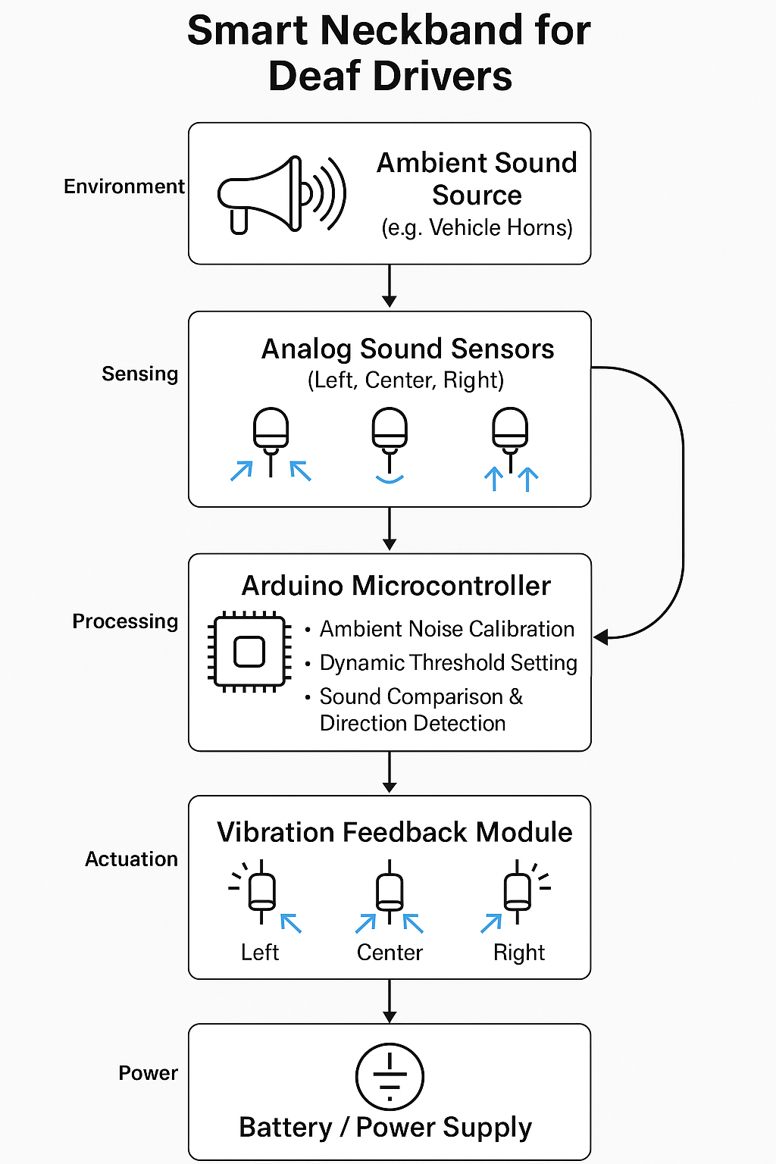

**Fig.3.1 Architecture of the proposed system**

* 1. **TECHNOLOGICAL STACK AND COMPONENT OVERVIEW**

The Smart Neckband for Deaf Drivers project integrates hardware and software elements to provide real-time sound detection and haptic feedback. The system's core is the Arduino microcontroller, which processes data from the microphone array and controls the vibration motors based on detected sounds. The microphone array captures sounds from different directions, helping the system localize and identify the source. The vibration motors are activated in response to these sounds, with their intensity varying according to the sound's loudness.

On the software side, the Arduino IDE is used for programming the microcontroller, while ambient noise calibration ensures optimal performance in different environments. The system doesn’t rely on complex sensors, making it lightweight and cost-effective while ensuring full functional coverage. The system is designed for portability and ease of use. The vibration motors give real-time feedback to the user, alerting them to the presence of environmental sounds, such as vehicle horns. It also includes a feedback mechanism that adjusts sensitivity based on ambient noise levels, ensuring high reliability in dynamic environments.

**Table.3.1 Functional Component vs Role in the Project**

|  |  |  |
| --- | --- | --- |
| **COMPONENT** | **TECHNOLOGY/TOOL USED** | **ROLE** |
| **MICROCONTROLLER** | Arduino | Processes sound data and controls vibration motors |
| **MICROPHONE ARRAY** | Analog Sound Sensor Module | Captures directional sound from the environment |
| **VIBRATION MOTORS** | Vibration Motor Modules | Provides haptic feedback to the user |
| **AMBIENT NOISE CALIBRATION** | Arduino IDE | Adjusts sensitivity based on surrounding noise |

**3.3 HARDWARE COMPONENT SPECIFICATIONS**

The The hardware selection in the Smart Neckband for Deaf Drivers project is crucial for ensuring accurate real-time monitoring, control, and reliability. The two key hardware components used in this project are the Arduino Nano microcontroller and the vibration motor (used for haptic feedback). Together, they form the core interface between the physical environment (sound detection) and the digital system (haptic feedback for awareness).

The Arduino Nano is a compact, low-cost microcontroller developed by Arduino. It features both analog and digital pins, making it suitable for a wide range of applications, including sound detection and control systems. In the context of this project, the Arduino Nano plays a key role in processing data from the microphones and triggering the vibration motors to provide haptic feedback.

**Key Specifications of Arduino Nano:**

* Microcontroller: ATmega328P
* Operating Voltage: 5V
* Input Voltage: 6-12V (recommended: 9V)
* Clock Speed: 16 MHz
* Digital I/O Pins: 14 (6 PWM outputs)
* Analog Input Pins: 8
* Flash Memory: 32 KB (ATmega328P), with 2 KB used by the bootloader
* SRAM: 2 KB
* EEPROM: 1 KB

**Vibration Motor**

The **vibration motors** are used to provide tactile feedback for sound direction (horn sounds). The motors are controlled by the Arduino Nano, which activates them based on sound direction detected by the microphone array.

**Key Specifications of Vibration Motor:**

* Voltage: 3V-5V
* Current: 50mA (per motor)
* Output: Vibration with different intensities
* Control: Triggered by GPIO pins from Arduino Nano

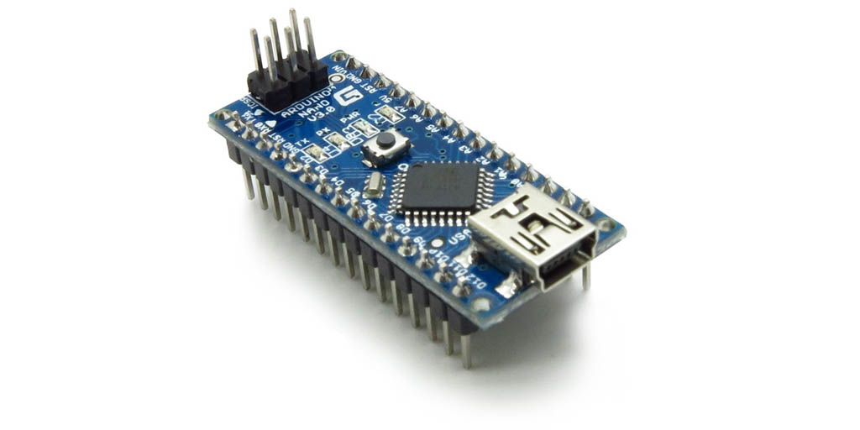

**Fig.3.2 Arduino Nano Microcontroller**

The Arduino Nano continuously monitors input from the microphone array and processes the sound data. It then sends commands to the vibration motors, based on the detected sound direction, providing the user with a tactile alert.

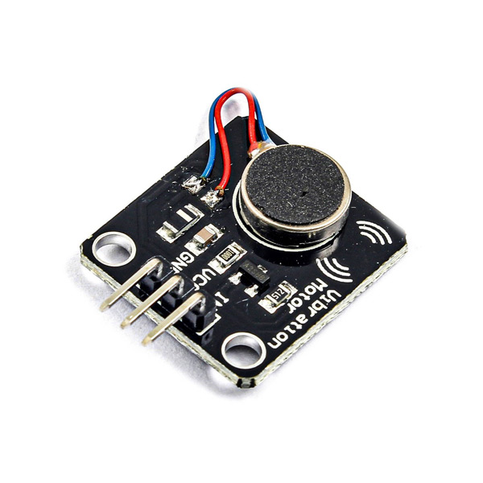

**Fig.3.3 Vibration Motor**

The vibration motor receives control signals from the Arduino Nano, which sends HIGH signals to activate or adjust the intensity of the motor, depending on the detected sound. The feedback helps the user locate the direction of the sound (horns, sirens) for better situational awareness.

These components allow the Smart Neckband to deliver real-time feedback, providing a highly scalable solution for future applications. By adding additional microphones or motors, the system can be further expanded to enhance its effectiveness.

**3.4 HARDWARE INTEGRATION USING ARDUINO MICROCONTROLLER**

The Arduino microcontroller is the central processing unit of the smart neckband system. It is responsible for reading analog inputs from the three sound sensors, processing the data in real time, and controlling the vibration motors based on the direction of detected horn sounds. The Arduino is programmed to continuously monitor ambient sound levels and apply a dynamic threshold to distinguish horn sounds from background noise. Each analog sensor is connected to one of the analog input pins on the Arduino (A0, A1, A2), allowing it to detect variations in sound intensity from different directions. The corresponding vibration motors are connected to digital output pins, which are triggered when a particular sound source exceeds the calculated threshold. To ensure adaptability, the system includes a noise calibration routine that updates the threshold periodically. This allows the neckband to function reliably in changing traffic environments. The Arduino is compact, energy-efficient, and well-suited for wearable applications, providing reliable, low-latency performance necessary for real-time tactilefeedback.

**3.5 REAL-TIME DATA SYNCHRONIZATION AND FAULT DETECTION**

The smart neckband operates using real-time sound detection and feedback processing to provide directional alerts for deaf drivers. The core processing is handled by an Arduino microcontroller, which continuously reads analog input from three sound sensors positioned on the left, center, and right sides of the device. These sensors detect environmental sound levels and transmit the data to the microcontroller at regular intervals. At startup and every 60 seconds, the system performs ambient noise calibration to determine the average background noise. Based on this value, a dynamic threshold is set to ensure accurate detection of sudden spikes, such as vehicle horn sounds, while avoiding false positives due to fluctuating traffic noise. When a detected sound surpasses the threshold, the microcontroller compares the input values from all three sensors to identify the direction of the loudest sound source. Upon detecting a horn sound, the system triggers the corresponding vibration motor—left, center, or right—to deliver immediate and localized tactile feedback to the user. The entire detection-to-response process is designed to execute within milliseconds, allowing real-time alerts without noticeable delay. The vibration duration is calibrated to be noticeable yet non-intrusive, ensuring clarity without discomfort. This real-time system enhances safety by allowing deaf drivers to quickly sense and respond to nearby vehicles. It ensures minimal latency, efficient energy consumption, and adaptability to varying noise conditions, making it a reliable assistive solution for real-world driving environments.

**3.6 DESIGN OF SMART NECKBAND**

The Smart Neckband system is a wearable assistive device designed to alert deaf drivers of honking vehicles by providing real-time directional haptic feedback. The core of the system involves three analog sound sensor microphones placed on the left, right, and center portions of the neckband. These sensors detect high-intensity horn sounds from different directions and allow the system to localize the source based on the relative amplitudes. The system is powered by an Arduino Nano microcontroller, which features 30 I/O pins including both analog and digital inputs. These pins are utilized for reading sound intensity values and activating the vibration motors accordingly.

Each sound sensor is connected to an analog input pin on the Arduino Nano, which continuously samples sound levels at short intervals. An ambient noise calibration algorithm sets a dynamic threshold to ignore background noise, ensuring only actual horn sounds trigger the system. When a horn is detected from one direction, the Arduino triggers the vibration motor on the corresponding side of the neckband—left, right, or center—via the digital output pins. This immediate haptic feedback alerts the user without relying on visual or audio cues.

The vibration motors used in the design are compact and lightweight, making the system suitable for continuous wear without discomfort. The neckband is powered by a small rechargeable battery, ensuring portability and reliability in outdoor conditions. The system's modular design allows for customization, such as integrating additional sensors or Bluetooth modules for future enhancements. By utilizing real-time analog input processing and directional feedback, the Smart Neckband delivers a practical, low-cost, and effective safety solution for hearing-impaired individuals navigating noisy traffic environments.

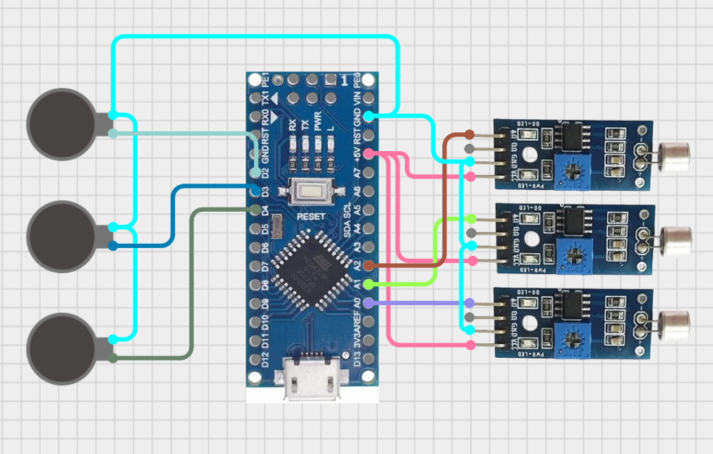

**Fig.3.4 Design of Smart Neckband**

**3.7 SUMMARY**

* The Smart Neckband for Deaf Drivers is a wearable safety system designed to detect vehicle horn sounds and alert hearing-impaired users through directional haptic feedback. It uses a tri-microphone array positioned on the left, right, and center to identify the direction of the horn, ensuring situational awareness while driving.
* The system is powered by an Arduino Nano, which serves as the brain—reading analog input from the microphones, comparing it with calibrated ambient noise thresholds, and activating the correct vibration motor based on horn direction.
* Three vibration motors are embedded at corresponding positions in the neckband to provide intuitive feedback. The system runs on a compact, rechargeable battery, making it suitable for daily use in outdoor or driving environments.
* A real-time detection algorithm filters ambient noise and ensures only relevant horn sounds trigger feedback, improving accuracy and reducing false alerts.
* The system's simplicity, portability, and effectiveness make it ideal for hearing-impaired individuals in urban traffic settings where auditory cues are essential for safety.
* The modular hardware design allows future enhancements, such as integrating Bluetooth modules or GPS for location-based alerts or expanding to helmet-based versions for motorcyclists.
* This project offers a low-cost, scalable, and assistive technology solution aimed at improving road safety and inclusivity for differently-abled individuals.

**4.**  **RESULT AND DISCUSSION**

The Smart Neckband for Deaf Drivers integrates wearable hardware and intelligent software to detect directional horn sounds in noisy traffic environments. The first image shows the working prototype of the neckband, including three microphones placed on the left, center, and right, mounted around the wearable band to capture sound direction. These signals are processed in real-time using the Arduino Nano and displayed via the serial monitor in the Arduino IDE.

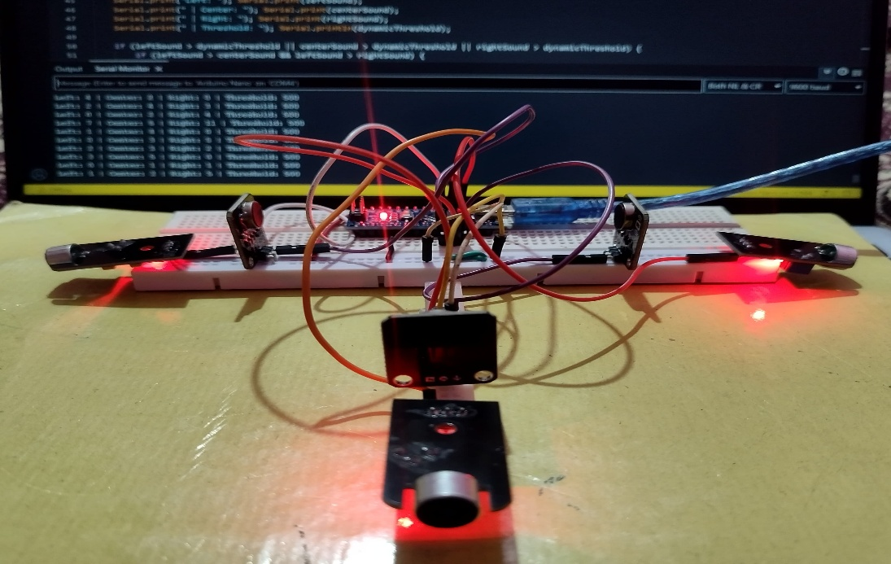

**Fig.4.1 Working model of Smart Neckband for Deaf Drivers**

The serial monitor output shows real-time analog readings from all three microphones, along with the calibrated ambient noise threshold. This threshold is dynamically adjusted based on background noise levels to minimize false alerts. The system continuously compares the current sound input from each microphone to this ambient noise value. When a vehicle horn is detected from a particular direction, the corresponding vibration motor on the neckband is triggered to notify the user.

The first serial image highlights the ambient noise calibration process, which helps the system adapt to varying environmental sound levels. This ensures that only prominent horn sounds cause alerts, avoiding unnecessary feedback from non-critical background noise. The data stream includes labeled values for Left, Center, and Right microphones, along with “Horn Detected” messages when thresholds are crossed.

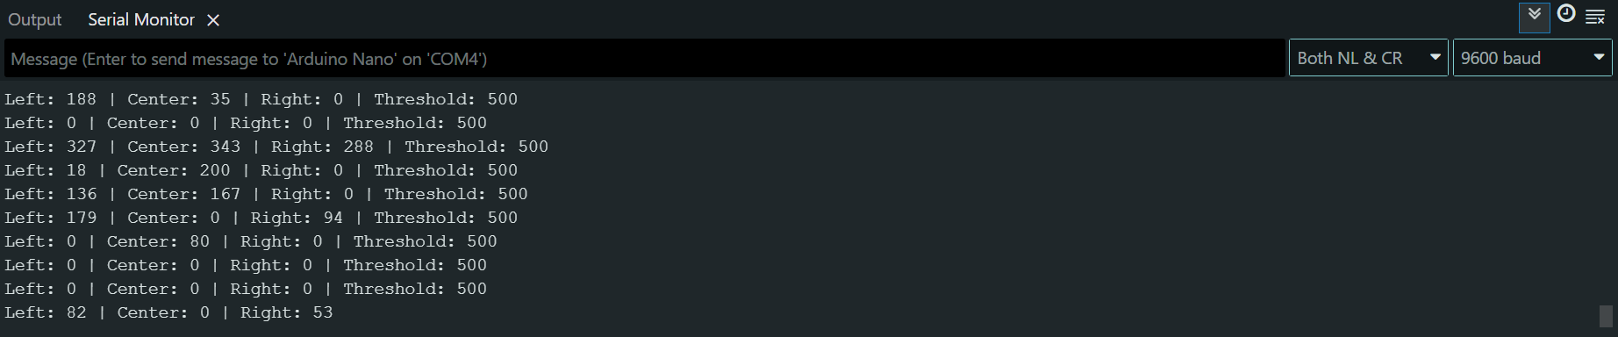**Fig.4.2 Serial Output – Live Sensor Values and Threshold Monitoring**

This real-time processing and output make the system efficient for immediate directional alerts. The neckband uses haptic feedback via vibration motors, allowing deaf users to intuitively recognize the direction of incoming vehicles or danger without relying on vision or sound. The prototype was tested in a controlled environment with simulated horn sounds from different directions. Results showed accurate vibration response based on horn origin.

The low-power system is powered by a rechargeable battery, with compact and lightweight hardware making it suitable for daily wear. The modular design also supports additional features like Bluetooth for data logging or mobile notifications in future versions.

**Hardware Components and Features:**

* **Three Microphones (Left, Center, Right):** Strategically placed to detect horn direction and intensity for localized alerts.
* **Vibration Motors:** Three vibration motors placed at corresponding neckband positions provide clear directional feedback.
* **Arduino Nano Microcontroller:** Reads and processes analog sound data, applies threshold logic, and controls vibration motors.
* **Ambient Noise Calibration:** Automatically calibrates background noise levels, ensuring only valid horn detections trigger alerts.
* **Serial Output Display:** The Arduino IDE shows real-time data for monitoring and debugging during testing.
* **Battery Power Supply:** Supports USB charging and portable power sources, making the device usable during travel.
* **Compact Form Factor:** Lightweight and wearable design ensures comfort and ease of use in real-world scenarios.
* **Expandable Design:** Future versions can integrate Bluetooth, GPS, or mobile app-based notification systems.

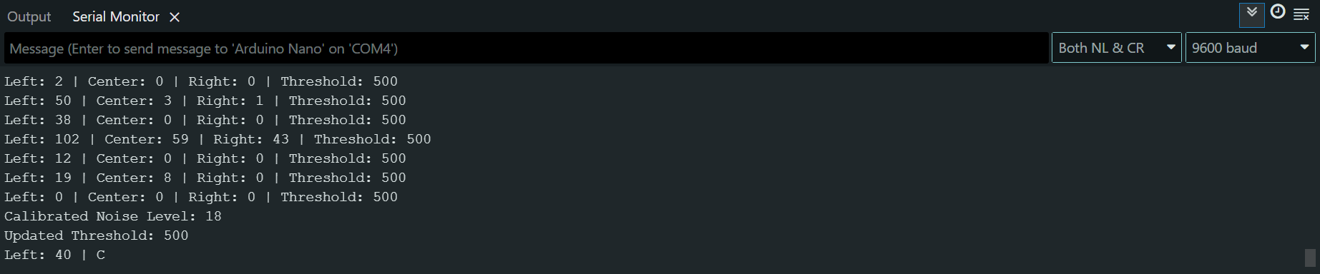**Fig.4.3 Directional Horn Detection with Calibrated Response**

The prototype demonstrates how embedded systems and assistive technologies can work together to create inclusive safety solutions for the hearing-impaired. It effectively addresses the challenge of real-time horn detection and localization, offering a practical solution for safer travel.

**5. FUTURE SCOPE**

Future development of the Smart Neckband for Deaf Drivers can leverage advancements in wearable technology, signal processing, and artificial intelligence to significantly enhance its functionality and user experience. One key direction is the integration of machine learning (ML) algorithms to improve the system’s accuracy in detecting and distinguishing different types of sounds, such as horns, sirens, or emergency signals. Over time, the system can learn from real-world data to adapt to varied traffic conditions and reduce false positives. Another important focus is miniaturization and ergonomic enhancement of the neckband design, making it lighter, more comfortable, and visually discreet for everyday use. Wireless communication features, such as Bluetooth or Wi-Fi, can be added to transmit alerts to a connected mobile application. This app could provide a real-time sound direction log, vibration alert history, ambient noise levels, and battery status, creating a more comprehensive and interactive user interface. Future versions can also include GPS integration for location-aware alerts, helping notify users of approaching vehicles in high-risk areas. Incorporating gesture-based acknowledgment or touch controls could improve usability. Additionally, expanding support for multilingual feedback and customizing vibration patterns may further increase accessibility for a wider user base. Overall, the system has strong potential to evolve into a highly intelligent, personalized, and life-enhancing assistive solution for the hearing-impaired community.

**6. CONCLUSION**

The proposed Smart Neckband for Deaf Drivers successfully demonstrated a real-time, direction-sensitive alert system that aids hearing-impaired individuals in detecting crucial auditory cues in traffic environments. By using a tri-microphone array, vibration motors, and an Arduino-based control unit, the system delivers immediate haptic feedback corresponding to the source direction of detected horn sounds. The prototype effectively translates ambient sound data into tactile responses, enhancing driver awareness and road safety without relying on auditory perception. The incorporation of ambient noise calibration and threshold-based triggering ensures that only significant sound events prompt alerts, minimizing distractions and false detections. The system's serial output and sensor data visualization validate its functionality, while the modular design facilitates future customization and scalability. The use of low-cost and open-source components affirms the project's accessibility and applicability for assistive wearable technologies. Although current limitations include the need for improved sound classification and environmental robustness, the project establishes a solid foundation for developing intelligent wearables aimed at inclusive mobility. This implementation serves as a valuable reference model for future enhancements involving AI-based sound recognition, ergonomic refinements, and expanded connectivity features, positioning the neckband as a promising tool in assistive smart technology.

**7. REFERENCES**

1. S. Michaud, C. Dorais, L. Piché, and C. Gosselin, “SmartBelt: A wearable microphone array for sound source localization with haptic feedback,” *arXiv preprint*, arXiv:2202.13974, 2022.
2. K. Shimada, M. Ishihara, and K. Minamizawa, “Omnidirectional haptic guidance system for the hearing impaired to track sound sources,” *Sensors*, vol. 2, no. 3, pp. 135–148, 2020.

Available: https://www.mdpi.com/1424-8220/20/3/135

1. Hyundai Motor Group, “Hyundai develops hearing assist system for deaf drivers,” *New Atlas*, 2019.
2. Mada Innovation Program, “SafeDrive4Deaf – Assistive driving technology for the hearing impaired,” *MIP Solutions*, 2021. [
3. Haptear Project, “AI-based wearable device for translating sounds into vibrations,” *Haptear*, 2021. .
4. L. D’Souza and M. Harish, “Sonear: Vibration-based alert system for deaf cyclists,” *Brunel Design School*, Final Year Project Report, 2022.
5. R. Kojima, T. Kanazawa, Y. Kudo, and M. Inami, “SHITARA: Contactless haptic alerts using air vortex rings,” *arXiv preprint*, arXiv:2301.08107, 2023.
6. K. Anitha and V. Prasad, “Review of haptic assistive systems for deaf users,” *Norma Journal of Accessibility Tech*, vol. 5, no. 2, pp. 89–97, 2023.
7. T. Li, Y. Zhang, and F. Wu, “Spatial vibration mapping for sound localization in wearable alert systems,” *Assistive Technology & Rehabilitation Engineering*, vol. 4, no. 1, pp. 12–20, 2023.
8. F. Stadtman, D. Neumann, R. Ullrich, and A. Fuchs, “Adapting vibration alert systems for noisy environments: A case study on wind farm workers,” *IEEE Sensors Journal*, vol. 23, no. 4, pp. 812–819, Feb. 2023.