Ipconfig

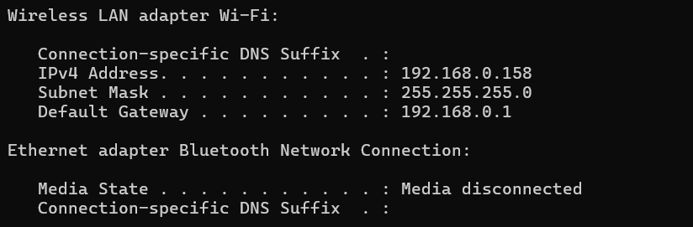

**Nmap Scan results**

192.168.0.1

PORT STATE SERVICE

53/tcp open domain #DNS (Domain Name System) - Translates domain names into IP addresses.

80/tcp open http #HTTP (Hypertext Transfer Protocol) - Used for browsing the web.

443/tcp open https #HTTPS (Hypertext Transfer Protocol Secure) - Secure browsing, using encryption.

1900/tcp open upnp #primarily used for Simple Service Discovery Protocol (SSDP), which is a part of the Universal Plug and Play (UPnP) framework. It enables automatic discovery of devices and services on a local network, like printers, smart TVs, and media servers.

192.168.0.27

All 1000 scanned ports on 192.168.0.27 are in ignored states.

192.168.0.29

All 1000 scanned ports on 192.168.0.29 are in ignored states.

192.168.0.100

PORT STATE SERVICE

22/tcp open ssh #SSH (Secure Shell) - Provides a secure channel for remote login and other network services.

80/tcp open http #HTTP (Hypertext Transfer Protocol) - Used for browsing the web.

6000/tcp open X11 #Port 6000 is primarily associated with the X Window System, often referred to as X11. This system provides the graphical user interface (GUI) for many Unix-like operating systems, including Linux.

6001/tcp open X11:1 #primarily used by the X Window System (X11), specifically for communication between an X client and an X server over a network. This allows users to remotely access and control graphical interfaces on other systems.

192.168.0.201

All 1000 scanned ports on 192.168.0.201 are in ignored states.

192.168.0.236

PORT STATE SERVICE

8009/tcp open ajp13 #primarily used for the Apache JServ Protocol (AJP) connection between a web server (like Apache HTTP Server) and an application server (like Tomcat). This protocol allows the web server to proxy requests to the application server for dynamic content processing.

192.168.0.250

PORT STATE SERVICE

6668/tcp open irc #commonly associated with UnrealIRCd, a popular IRC (Internet Relay Chat) server. It's often used as a default port for UnrealIRCd's main communication channel.

192.168.0.158

PORT STATE SERVICE

135/tcp open msrpc #primarily used for Remote Procedure Call (RPC) services in Windows environments, facilitating communication between different applications and systems.

139/tcp open netbios-ssn #primarily used by the NetBIOS Session Service, which enables file and printer sharing and other network services over a local area network (LAN) in Windows operating systems.

445/tcp open microsoft-ds #primarily used for Server Message Block (SMB) over TCP/IP, particularly in Windows environments, for file and printer sharing.

902/tcp open iss-realsecure #primarily used for VMware vSphere management, specifically for communication between the vSphere Client, ESXi hosts, and vCenter Server.

912/tcp open apex-mesh #primarily associated with the APEX (Application Exchange Core) protocol, specifically for relaying messages between endpoints.

1042/tcp open afrog #Port 1042 is a registered port, specifically within the range of 1024 to 49151. It's commonly used for "any private mail system" and is often associated with the Local Mail Transfer Protocol (LMTP).

1043/tcp open boinc #Port 1043 is not a widely recognized or standardized port number with a specific, assigned function like those in the well-known ports range (0-1023). It typically falls within the ephemeral/dynamic port range (1024-65535), which is used for dynamically assigned ports by applications. While it could be used by a custom application or service, there's no inherent, pre-defined meaning for port 1043 in networking protocols or common services.

