[Publish Date]
Version 1.0
Document Title Here  Prepared for: Company Name Here |  |  |  | 

 |  |  |  |  | 
Content and  Collaboration | Security and  Compliance | Modern  Applications | Data and  Analytics |  | Cloud Infrastructure  and Management


Statement of Confidentiality
This document contains information that is proprietary and confidential to Netwoven, Inc. and Company Name Here which shall not be disclosed, transmitted, or duplicated, used in whole or in part for any purpose other than its intended purpose. Any use or disclosure in whole or in part of this information without the express written permission of Netwoven, Inc. and Company Name Here are prohibited.
Any other company and product names mentioned are used for identification purposes only, and may be trademarks of their respective owners.
©2001 - 2026 Netwoven, Inc. All rights reserved. Any use or distribution of these materials without express authorization of Netwoven, Inc. and Company Name Here are strictly prohibited.

Document Revision History

This document was prepared by:

Author Name
Job Position
Netwoven Inc.

Date | Version | Revision Description | Author
 | 0.1 | Initial document draft
 | 0.2 | Revisions after internal review
 | 0.3 | Updates from internal review
 | 1.0 | Final report

Table of Contents
1 Heading 1 1
1.1 Heading 2 1
1.1.1 Heading 3 1
2 How to use this template 2
2.1 Updating the cover page 2
2.1.1 Customer Information 2
2.1.2 Document Title 3
2.1.3 Version and Publishing Date 3
2.1.4 Cover Page Image 3
2.2 Confidentiality, doc history, and TOC pages 4
2.2.1 Confidentiality Statement Page 4
2.2.2 Document Revision History Page 4
2.2.3 Table of Contents Pages 4
2.3 Using Headers and Font Styles 5
2.4 Using tables 6
2.5 Using figures 7

List of Figures
Figure 1 Company Info 2
Figure 2 Document Title 3
Figure 3 Update Field 5
Figure 4 Update Entire Table 5
Figure 5 Headers and Styles 5
Figure 6 Table Styles 6
Figure 7 Sample Image 7
Figure 8 Sample Image with Border 7

List of Tables
Table 1 Netwoven Table 1 6
Table 2 Netwoven Table 2 6
Table 3 Netwoven Table 3 6

Heading 1
Sample Normal Text

Heading 2
Sample Normal Text

Heading 3
Sample Normal Text

Heading 4
Sample Normal Text

How to use this template
This section explains how to properly use this template for customer delivery. Please follow the instructions defined here for your development of customer deliverables.
When you are ready to use this document as a starting point, delete everything within Section 2 of the document and start with the header placeholders found in Section 1.

Updating the cover page
The cover page design has been created to showcase Netwoven’s competencies and expertise while providing a professional look and feel. Certain parts of the cover page should or can be updated before final delivery.

Customer Information
Two areas related to customer info should be updated on the cover page. The Customer Name and Customer Logo.
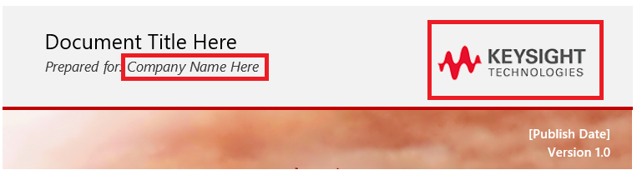
Figure 1 Company Info
The Company Name can be updated by replacing the placeholder text provided. This update will be reflected both in the Confidentiality Statement and the footer on all pages in the document.
The company logo can be replaced by following the steps outlined below.
- Click on the placeholder logo image to select it.
- From the Ribbon, select the Picture Tools Format tab that appears.
- Click the Change Picture dropdown, and replace the image using one of the available options.
- Once replaced, ensure the sizing of the logo fits in the available space on the page.
If you need to make an image transparent to hide a background color, follow the steps outlined below.
- Click on the logo image to select it.
- From the Ribbon, select the Picture Tools Format tab that appears.
- Click the Colors dropdown, and then click Set Transparent Color
- Once the mouse icon has changed, click on the logo image background color you want to make transparent.

Document Title
The Document Title field is provided directly below the Customer Name.

Figure 2 Document Title
The Title needs to be updated to accurately describe the topic being covered within the document. Ensure the Title is not too long, and fits within the provided space on the Cover Page. Once updated, the Title will automatically be reflected in the header of all pages in the document.

Version and Publishing Date
The Version and Publishing date are two items on the cover page that require manual updating. Once updated, the publishing date will be reflected in the footer of all pages in the document. The version number should reflect what is provided in the Document Revision History page.

Cover Page Image
The image on the cover page has been designed to be easily replaced with another image. If you prefer, feel free to use a different stock photo that may resonate better with the customer the document is being deliver to.
The one thing to keep in mind is to ensure you use images that are free or have already been paid for business use. Some great FREE stock photos can be found at the following link.
https://www.pexels.com/
To replace the cover page image, follow the steps described below.
- Click on the cover page image to select it.
- From the Ribbon, select the Picture Tools Format tab that appears.
- Click the Change Picture dropdown, and replace the image using one of the available options.
- Once replaced, ensure the sizing of the image fits in the available space on the page.
- Use the crop feature found under the same ribbon tab if necessary.

Confidentiality, doc history, and TOC pages

Confidentiality Statement Page
The Confidentiality Statement information will automatically update based on the Company Name used on the Cover Page, so no additional changes are necessary. This page can be removed if it is not needed for your deliverable.

Document Revision History Page
The Document Revision History page is designed to provide information on who prepared the document, as well as when any revision and changes were made. For deliverables, these can be useful to ensure the customer knows when the document was last updated and what was updated. This page is not needed for documents like SOW or other sales proposals. It can be removed by the discretion of the author as needed.

Table of Contents Pages
The Table of Contents (TOC) pages should be provided for all documents that are greater than 2 to 4 pages. These are designed to allow for simplified and quick navigation of the document by the customer. If using this template properly, the following steps can be completed for each TOC section to update them.
- Right-click the body of the Table of Content section you wish to update.
- From the right-click menu, select Update Field.
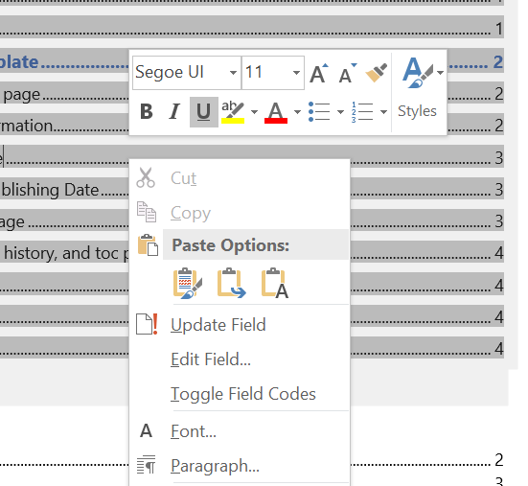
Figure 3 Update Field
- From the dialog box that pops up, select the Update entire table radio button and then click OK.
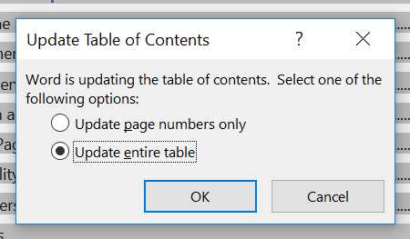
Figure 4 Update Entire Table
These steps should be repeated for each Table of Contents list provided on the page as needed.

Using Headers and Font Styles
Four header styles have been created for use within this document template. They are listed below.
- NW Header 1
- NW Header 2
- NW Header 3
- NW Header 4
These header styles can be found within the Home tab on the ribbon.
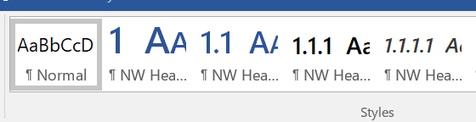
Figure 5 Headers and Styles
The default font used throughout this document is Segoe UI, with headers being created with Segoe UI Semibold. These fonts should be utilized throughout the entirety of the document for a consistent look and feel. To help simplify this, the Normal style has been updated to use the Segoe UI font as well.

Using tables
Below are examples of the available table styles to be used within documentation.
 | Jan | Feb | Total
East | 100 | 200 | 300
West | 100 | 200 | 300
Total | 200 | 400 | 600
Table 1 Netwoven Table 1
 | Jan | Feb | Total
East | 100 | 200 | 300
West | 100 | 200 | 300
Total | 200 | 400 | 600
Table 2 Netwoven Table 2
 | Jan | Feb | Total
East | 100 | 200 | 300
West | 100 | 200 | 300
Total | 200 | 400 | 600
Table 3 Netwoven Table 3
These table styles have been saved to the document and can be accessible under the Table Design tab within the ribbon.
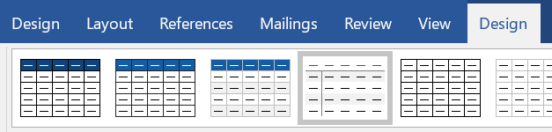
Figure 6 Table Styles

Using figures
Below are examples of how figures should be captioned within documentation.
When using an image / figure in documentation, ensure the image is centered on the page, and provide a figure caption.
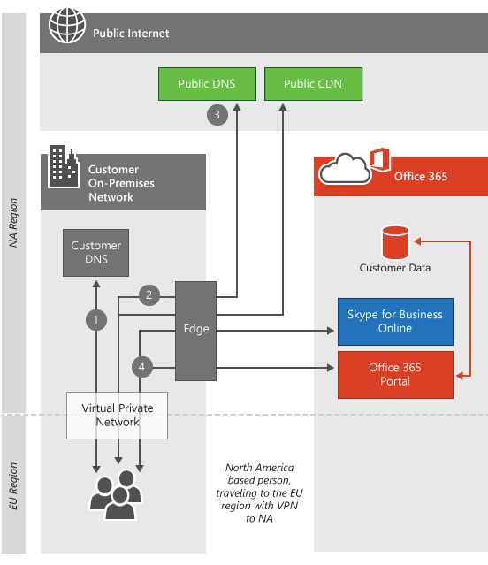
Figure 7 Sample Image
Utilizing a simple frame, white border with an image is optional. However, if a border is used on an image, then all images within the document should also have borders to ensure a consistent look and feel is provided.
Figure 8 Sample Image with Border

