15BCE025

OSL

Perl Project – File Combination and Mailing

**Abstract**

Automation is the use of machines, control systems and information technologies to optimize productivity in the production of goods and delivery of services. The correct incentive for applying automation is to increase productivity, and/or quality beyond that possible with current human labour levels so as to realize economies of scale, and/or realize predictable quality levels. In the scope of industrialisation, automation is a step beyond mechanization. Whereas mechanization provides human operators with machinery to assist them with the muscular requirements of work, automation greatly decreases the need for human sensory and mental requirements while increasing load capacity, speed, and repeatability. Automation plays an increasingly important role in the world economy and in daily experience. Automation has had a notable impact in a wide range of industries beyond manufacturing (where it began). Here, we have used automation to simplify human task for copy file data from multiple file just like combining any transaction data and automatic mailing to the given id.

**Project flow diagram**

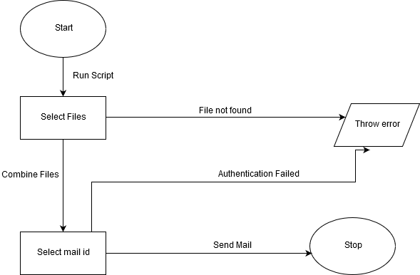

**Code**

The project script is run which does all the processing task and calls the mail script at the end which loads code from the mail script and that run is run subsequently.

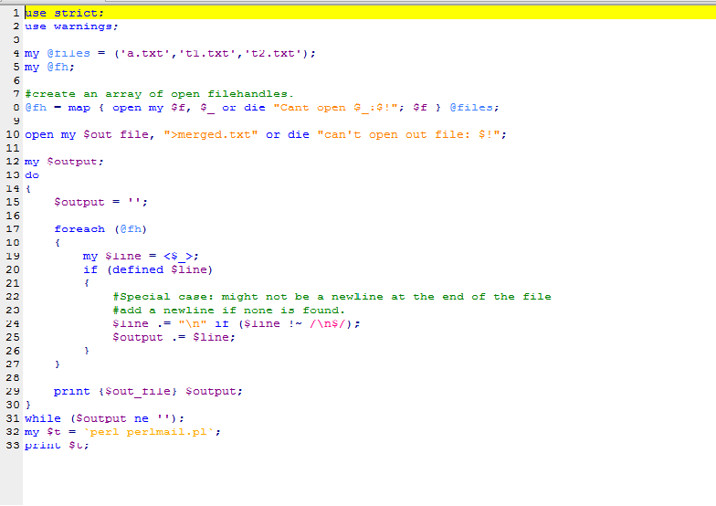

**Conclusion**

Hence, by undergoing this project, perl, a scripting language and its features are learnt, and the importance of automating our daily tasks to save time and resources is realized.