

March 19, 2014

Dr. Inder M. Verna

Editor-in-Chief

*Proceedings of the National Academy of Science of the United States of America*

Dear Dr. Verma:

Enclosed is an original manuscript by Dennis Evangelista, Sharlene Cam, Tony Huynh, Austin Kwong, Homayun Mehrabani, Kyle Tse, and Robert Dudley entitled “Shifts in stability and control effectiveness during evolution of the Paraves support aerial maneuvering hypotheses for flight origins”, which is being submitted for publication as an article in *PNAS*.

This manuscript is new, is not being considered elsewhere, and reports the results of a comparative aerodynamic study of stability and flight control in the line of dinosaurs leading to birds. The focus on evolution of control is unique; we provide data (drawn from an extensive series of wind tunnel tests but analyzed in a phylogenetic context) indicating that some traits traditionally thought of as related to force production may have been much more relevant to aerial stability and also maneuverability. Given broad interest in the evolution of flight in vertebrates, *PNAS* is a particularly appropriate venue to publish this interdisciplinary work that bridges aerodynamics, engineering, biomechanics, palaeontology, and evolution.

In general terms, the dinosaurs that ultimately became birds possessed long, feathered tails and feathers on their legs along with feathers on their forelimbs. As birds evolved, their tails shortened, feathers on the legs were reduced, in size, and wings became larger and more powerful. Both fore- and hindlimbs along with the tail could serve to control the animal in the air (like the tails on airplanes, except potentially at steep flight angles), and by tracing out how aerodynamic control changed through time, we infer that aerial maneuvering was a major factor in avian evolution.

We suggest Zhonghe Zhou, David Hillis, or Neil Shubin as a appropriate subject-matter editors; appropriate reviewers include Xing Xu (IVPP), David Alexander (Kansas), Tom Daniel (UW), Mark Denny (Stanford), John Hutchinson (RVC), Alan Turner (Stony Brook), Richard Bomphrey (Oxford), and Andy Biewener (Harvard). We formally oppose Colin Palmer and Gareth Dyke (both University of Southampton) and Michael Habib (USC) because of unfair reviews despite clear conflicts of interest on our past work on this topic, including suppression of this work. Other persons who may have a conflict of interest include R. de Kat, J. van der Kindere, D. Naish, and B. Ganapathisubramani (Southampton pterosaur group, due to their association with Drs Dyke and Palmer); J Hall, D Hone, and L Chiappe (USC/NHM pterosaur group, due to their association with Dr. Habib); Mimi Koehl (UC Berkeley); and Kevin Padian (UC Berkeley), and Ken Dial (Montana), who have stated categorical opposition to model tests.

The submission body text is 3,062 words and 22,824 characters. We anticipate that this article will be approximately six pages in length after final formatting. Correspondence regarding this manuscript may be sent to Dennis Evangelista at the address given above or via email: [devangel77b@gmail.com](mailto:devangel77b@gmail.com); alternate [devangel@live.unc.edu](mailto:devangel@calmail.berkeley.edu).

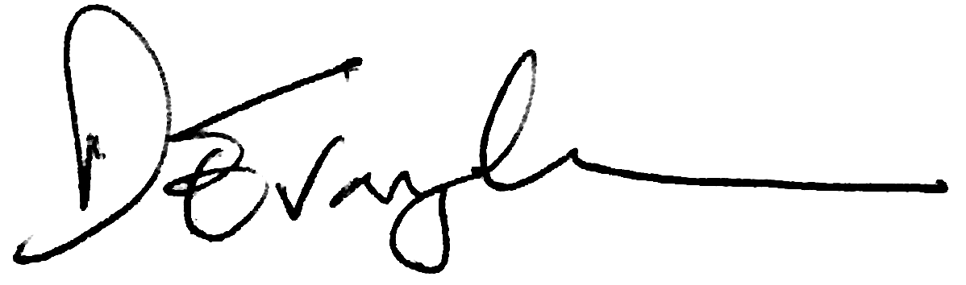

Dennis J Evangelista

Department of Biology

University of North Carolina at Chapel Hill