EW402 Final Report

Shape Formation Control for Autonomous Aircraft

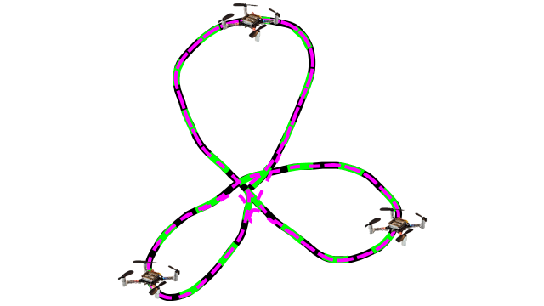

Author: MIDN 1/C B. Canlas
Date: Apr. 30th, 2019

Adviser: Prof. L. D. DeVries

__________________ ___________
(signature) (date)

Department Chair: Prof. B. E. Bishop

__________________ ___________
(signature) (date)

Shape Formation Control for an Autonomous Aircraft

Student: MIDN 1/C B. Canlas Adviser: Asst. Prof. L. DeVries

Abstract — As the capabilities of unmanned aerial vehicles (UAVs) increase, their use is becoming more common. The capability and efficiency of these systems are greatly increased when multiple UAVs work together to accomplish a task. Many tasks involve adhering to a formation. To control formations, schemes that involve leader following, target tracking, and waypoint following have been previously employed. However, these methods alone do not focus on the design of specific formation shapes or complex patterns. This project investigates a group of quadcopters to be controlled about a user defined formation. User defined shapes are mathematically modeled using discrete Fourier transforms to calculate Fourier descriptors. An algorithm that calculates trajectories for a controller was developed to control the quadcopters about these shapes. The performance of this algorithm is demonstrated though mathematical analysis, simulation, and a proof-of-concept demonstration. The simulation is constructed in MATLAB using vehicle dynamics and a trajectory algorithm that determines control inputs to the vehicle controller. In simulation, the algorithm was able to order each vehicle to within 5 cm or less of the desired path. The proof-of-concept experiment was carried out using quadcopters and a motion capture system to measure the vehicles’ states of position, velocity, and acceleration. Each aircraft was able to maintain a trajectory within 5-10 cm of the desired path. The work in this research has successfully generated an algorithm that has the capability to generate formations and develop controls for most user defined shapes, both in simulation and experimentally.

Background and Motivation
Unmanned aerial vehicles (UAVs) are being used for applications such as delivery services [1], surveillance, search and rescue, agriculture [2], and airshow entertainment [3]. As the capabilities of these systems increases, their use becomes more prevalent. They have the capability of providing persistent surveillance and data gathering solutions that can be useful for both civilian and military applications. A single vehicle can only take in a limited amount of data during a single mission. The amount of data that can be obtained is greatly increased by using several vehicles that work collectively to complete a task [2]. This motivates the need for new algorithms to control the cooperation and movement between vehicles working in unison. For example a user may wish to collect surveillance information along a specified route. This task can be accomplished through the use of many unmanned aerial vehicles collecting data simultaneously at different points spaced along the path. A common method for prescribing vehicle paths is waypoint following. However, entering waypoints manually is time consuming and can be difficult if trying to generate a complex, self-crossing path. Similarly, for the application of aerial entertainment, the controller must move the formation into many different shapes and orientations, Figure 1. This project seeks to develop a method for simplifying user input and develop a potential decentralized control method.

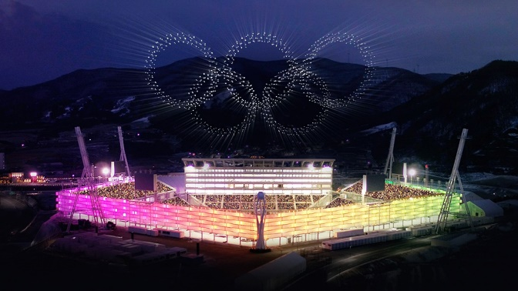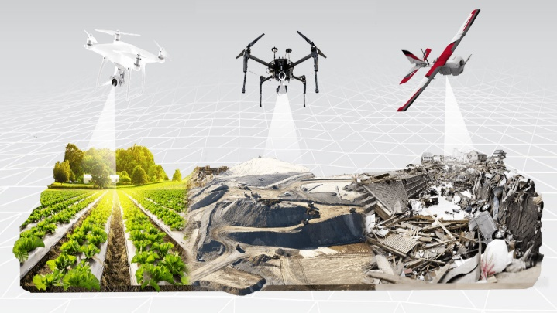
Figure 1: Over 1200 Intel Shooting Star drones create a light show at the 2018 Olympics (left) [3] and an image of drones performing survey operations in various domains [4].
The term collective implies that the vehicles are cooperating together to achieve a common task. To actuate the individual vehicles in the collective, a distributed multi-vehicle control algorithm must be developed to drive them at a specific trajectory and velocity.
Successful development of this control algorithm would provide a means for a user to easily command a formation into any shape desired. As highlighted by the Naval Aviation Vision [5], unmanned aerial systems will play a key role in future missions. Future advancement of this technology would provide even more capabilities to drone survey and surveillance missions that would help facilitate future mission success in both military and civilian applications.

Problem Statement
Consider a group of N vehicles controlled from a centralized control architecture [6]. The dynamics of the vehicles have been previously determined and a user has defined the desired shape of the formation such as that in Figure 2.
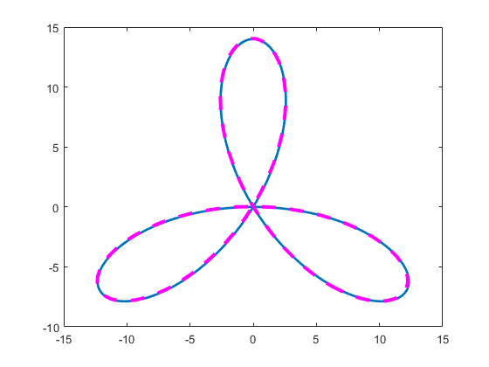
Figure 2: This figure shows and example of a user defined formation generated in MATLAB. The blue is the original image and the magenta dashes represent the Fourier approximation limited to 4 terms.
The goal of this project is to design and experimentally implement a novel algorithm that performs the following steps.
- Given a user defined shape, decompose the shape using a discrete Fourier transform
- Reconstruct the shape using Fourier Descriptors (FDs).
- Calculate desired trajectories
- Provide spacing control such that each vehicle is space evenly about the formation.
- Determine vehicle control inputs

Literature Review
With the increased proliferation of unmanned aerial vehicles, formation control is becoming more of a particular interest. Earlier work in formation control for multi-agent systems involved created virtual placeholder structures [7] that vehicles were ordered to follow. In [7] this method was only demonstrated on a simple formation and unfortunately does not take into consideration more complex cases. More recent work has accomplished formation control without the need for GPS or external motion capture technology by using Visual Inertial Odometry [8]. This allows the vehicles to determine position without the need for a centralized controller.

A common approach to formation control is leader following. This is accomplished by declaring one vehicle the leader and all other vehicle trajectories are planned with respect to it. This strategy was used in [9] and [10] for the control of quad-copters. This is similar to the approach used in [7], but different because this method uses a physical vehicle as the entity to follow. This approach can be useful for achieving certain formations, such as the “figure 8” demonstrated in [10]. However, the results of this approach can be affected based on the initial positions of the vehicles. For the experiments carried out in [10], initial limits in the angular displacement between the leader and the followers had to be set in order to avoid complications.

A few works have considered the control of formations about a curve. Work in [11] demonstrates a solution to control about an arc in a continuous wind. Here a control law was implemented that allowed for the control of two UAVs performing a sampling application. Previous work accomplished in [12] shows a method for control about specific shapes such as circles, ellipses, and rounded parallelograms. Both of these works focus only on the control about a convex curve and do not consider a non-convex case. Developing a means of control about non-convex curves would allow for formations to achieve many more shapes and configurations.

In [13] the use of all-to-all communication, that is, every entity has the ability communicate with one another, is used to achieve collective motion. This method, allows for a means of spacing control and synchronization of orientation in space, for both parallel and circular formations. In [13] it is shown how a formation can be ordered into a stable circular orbit about a reference frame, translate in parallel motion through space, and then converge into a stable circular orbit again. For this application, the use of all-to-all communication forces the path planner controller for all the vehicles to be centralized. This centralized structure will be used in later research for work proposed in this paper.

Several works consider the case of a formation tracking a target. Both [14] and [6] demonstrate this by representing the target as a reference frame that is translating about a global frame of reference. The UAV’s are ordered to move with respect to the target frame. Work in [6] provides an algorithm that generates control inputs based on the UAV’s position and velocity relative to the target frame and the target frame’s velocity and acceleration with respect to the global reference frame.

The approach proposed in this paper will be closely related to the work found in [13] and [6]. Unlike most of the literature mentioned in this section, the method proposed in this paper will be focused on the generation of user defined shapes. While the leader following method seen in [9] is useful for achieving certain shapes, the vehicles motion is constrained in such a way that may limit its usefulness. I believe an algorithm that can be used to control formations into complex user defined formation is a novel approach to the problem of autonomous tracking and surveillance.

Results
The capability of the control algorithm was demonstrated by implementing it with a group of vehicles in a controlled, experimental environment. Prior to implementing the algorithm on a physical system, a simulation was developed using predetermined vehicle dynamics to test the algorithm’s ability to recreate user defined shapes as well as observe performance of the controller.

Mathematical Development
The algorithm for development is used to provide trajectories about a user defined shape to a controller. The input to the algorithm is the shape and the states of the vehicles (position, velocity and acceleration) in the inertial frame. It then designs controls that drive the individual vehicles at the desired trajectory in the inertial frame.

The shape is mathematically modeled using Fourier Descriptors (FDs). In the first phase of the process, we map the user-drawn coordinates to the complex plane using Equation (1), where z[m] is the complex position of the m^{th} user-drawn point. Equation (2) performs a discrete Fourier transform modeling the shape in the frequency domain. N is the number of user drawn coordinates, M is the number of terms to use in the deconstruction of the path constrained such that M<N, and k is the number of frequencies mapped.

 | $$z\left[m\right]=x\left[m\right]+jy\left[m\right]$$ | (1)

 | $$Z\left[k\right]=DFT\left[z\left[m\right]\right]=\frac{1}{N}\sum_{k=-M/2}^{M/2}{z\left[m\right]e^{-j2πmk/N}}$$ | (2)
Z[k] will now be referred to as matrix C which is a k x 2 matrix that contains the Fourier Descriptors for the user defined path. The algorithm will then reconstruct the desired shape using this matrix. This is accomplished by taking the inverse of (2) as seen in (3). A path variable, ϴ is defined that describes the position of an individual point along the path such that $θ∈[0,2π]$.

 | $$\hat{z}\left[θ\right]=\sum_{k=1}^{M}{C_{k,1}e^{ikθ}-C_{k,2}e^{ikθ}}$$ | (3)

By taking the derivate of (3) the desired velocity can be written with respect to $\dot{θ}$ , as shown in (4). For the vehicles to maintain equal spacing about the path (5) must be true, where the desired velocity,$v_{o}$ is constant. (6) can then be found by rearranging (4) to solve for $\dot{θ}$. This allows the information gained from $\left|\dot{z}\right|$ to be used later to develop trajectory controls.

 | $$v_{o}[θ]=\dot{θ}\left|\sum_{k=1}^{M}{C_{k,1}e^{ikθ}-C_{k,2}e^{ikθ}}\right|$$ | (4)
 | $$\left|\dot{z}\right|=v_{o}(t)$$ | (5)
 | $$\dot{θ}[θ]=\sum_{k=1}^{M}{\frac{v_{o}}{\left|C_{k,1}e^{ikθ}-C_{k,2}e^{ikθ}\right|}}$$ | (6)
The algorithm requires a closed path to successfully decompose and reconstruct the path. It is extremely difficult for a user to form a closed shape on the MATLAB interface by hand. It is then necessary to provide a software means by which the path can be closed. This is accomplished by defining unit vectors r₁ and r₂ that align with the direction of the end of the user’s drawing and a unit vector and the beginning of the drawing, respectively. This is shown in Figure 3.

Figure 3: Vectors r₁ and r₂ on user drawn path
Next a function can be found that can be used to close the gap. Define the end of the path such that $r_{o}=\left[\begin{matrix}x_{o} \\ y_{o}\end{matrix}\right]$ and the beginning of the path such that$r_{b}=\left[\begin{matrix}x_{b} \\ y_{b}\end{matrix}\right]$. To derive a function to fill the gap the following conditions must be true:
1. | $$r\left(0\right)=r_{o}$$
2. | $$r\left(1\right)=r_{b}$$
3. | $$r^{'}\left(0\right)=r_{o}^{'}$$
4. | $$r^{'}\left(1\right)=r_{b}^{'}$$
Now define equation (7), (8), and (9) to meet these criterion.
 | $\overset{⃑}{r}\left(s\right)=\left[\begin{matrix}x(s) \\ y(s)\end{matrix}\right]$ where $s∈[0,1]$ | (7)
 | $$x\left(s\right)=a_{1}s^{3}+a_{2}s^{2}+a_{3}s+a_{4}$$ | (8)
 | $$y\left(s\right)=b_{1}s^{3}+b_{2}s^{2}+b_{3}s+b_{4}$$ | (9)
If these conditions are true then equations (10)-(14) can be defined as follows:
 | $$x^{'}\left(s\right)={3a}_{1}s^{2}+2a_{2}s+a_{3}$$ | (10)
 | $$x^{'}\left(0\right)=a_{3}=x_{o}^{'}$$ | (11)
 | $$x^{'}\left(1\right)={3a}_{1}+2a_{2}+a_{3}=x_{1}^{'}$$ | (12)
 | $$x\left(0\right)=a_{4}=x_{o}$$ | (13)
 | $$x\left(1\right)=a_{1}+a_{2}+a_{3}+a_{4}=x_{1}$$ | (14)
With $\overset{⃑}{r}\left(s\right)$ defined, a patch can be implemented to fill gap left by the user. This can be observed in Figure 4. S is subdivided according to the number of points in the full path. This is done so that the length of the patch has the same density of points as the rest of the shape.

Figure 4: Patch implemented on a user drawn shape

Simulation
The algorithm is implemented in a simulation using MATLAB. It utilizes the algorithm developed to reconstruct the user defined paths, and the controller and dynamics for a CrazyFlie quadrotor found in [15], to simulate the movement of a swarm. This simulation is used to test various parameters such as the number of Fourier descriptors used in the reconstruction, controllable speed, and various complex shapes. Figure 5 displays a block diagram of the simulation and shows where the trajectory algorithm fits into the overall system.

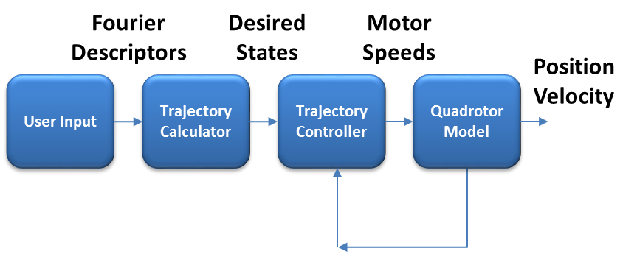
Figure 5: Simulation block diagram

- User Input: A user input in the form of a closed shape drawn in MATLAB. This shape will be reconstructed using Fourier descriptors.
- Trajectory Calculator: Receives a vector of Fourier Descriptors, C, from the decomposition software, as well as the desired to velocity and number of Fourier descriptors to generate the desired trajectories. This is accomplished using equations (3)-(6).
- Vehicle Controller: A proportional derivative controller which takes inputs from the trajectory algorithm and generate commands to produce desired motor speeds for the quadcopters using calculations found in [15].
- Quadrotor Model: Models each quadcopter as a rigid body using model from [15].

Analysis of Fourier Descriptors
By varying the number of Fourier Descriptors used, it is possible to increase the fidelity of the reconstructed paths. Figure 6 illustrates reconstruction of a user-drawn shape using varying numbers of Fourier Descriptors. The original user-drawn shape is shown as a solid cyan line, whereas the shape reconstructed from the descriptors is shown as a dashed red line. The figure shows four reconstructions with increasing number of descriptors, (2, 6, 10, and 24) shown from top left to bottom right. Note as the number of descriptors increases, the reconstructed path matches the user-drawn path.

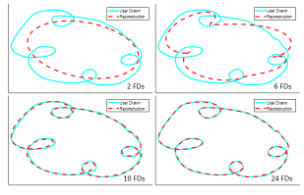
Figure 6: Example of increasing number of FDs in reconstruction.
While increasing the quality of the reconstruction can be beneficial, it also makes it more likely that a user can create a shape that the system cannot reproduce. For example a shape that is drawn with extreme curvature, or jagged edges that require instantaneous trajectory changes to recreate are problematic for control. These edges may get smoothed out by the reconstruction process. Figure 7 demonstrates the smoothing effect. The figure shows a user-drawn shape with multiple prominent spikes. Using 27 descriptors nearly recreates the path to the user’s exact specification. However, by using only 7, the shape is naturally smoothed, decreasing the likelihood of control issues at the sharp corners on the spikes.
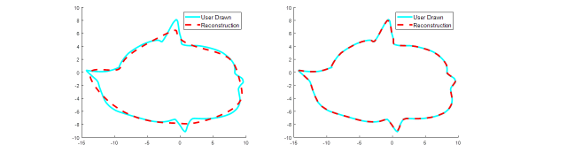
Figure 7: Spikes deliberately placed on curve to demonstrate smoothing. 7 FDs used (left) 27 FDs used (right)

Simulation Performance

For most experiments the software is successfully able to drive the vehicles about the user defined shapes. For the simulation shown in Figure 8, spacing controls are set so that each vehicles initial position along the arc, θ, is set to conform with (15), where N is the total number of vehicles.
 |  | $$θ=\frac{2π}{N}$$ | (15)

Figure 8: Quatrefoil simulation with 4 vehicles
Figure 9 demonstrates the use of the algorithm with a variety of self-crossing paths. The user’s original drawing is shown with bold black line, the Fourier reconstruction is shown in green, and the simulated trajectories are shown in a dashed, magenta line. Each of these simulations used 25 FDs in the reconstruction and 6 vehicles to fly about the path. During these experiments, the vehicles all started at rest from a central location, then fanned outward toward their respective positions about the curves given a desired magnitude of velocity of 1.1 m/s. After the initial transient, every vehicle settled along the path to within less than 5 cm.

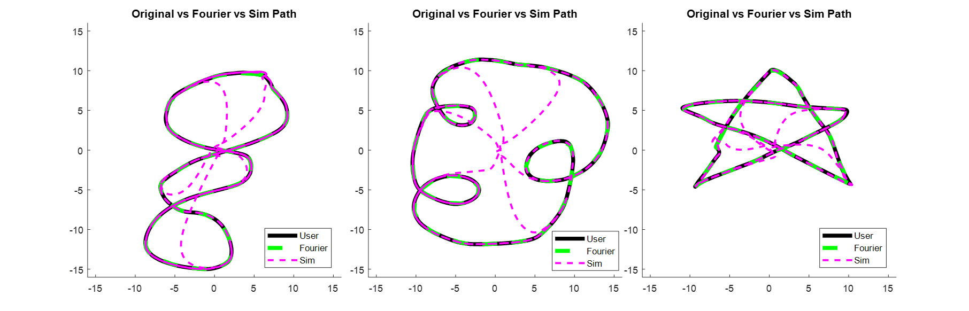
Figure 9: 25 FDs used to generate paths for 6 vehicles for multiple user inputs across three separate simulations.
:
Figure 10 shows an experiment that demonstrates velocity control of the quadcopters. A single quadcopter is ordered from rest to follow a ‘figure 8’ path at 1 m/s for the duration of the path’s length. After the initial transient, the vehicle maintains a speed within 5% of the desired value.
Figure 10: ‘figure 8’ path (left), velocity profile (right)

Spacing Control

Spacing for each vehicle is set such that each vehicle is equally interspersed along the path. This condition is set by (16), where $κ$ is the distance along the path between each vehicle, L is the total arc length of the path, and N is the number of vehicles. Given (5) is true, $κ$ will remain constant. This means that equal spacing can be achieved so long as spacing is set equally at the beginning of the path. Initial positions, $χ(n)$ are set by (17), where n is the vehicle number.

 | $$κ=\frac{L}{N}$$ | (16)
 | $$χ\left(n\right)=κ(n-1)$$ | (17)

Position along the reconstructed path, $\hat{z}$, from (3), is a function of θ. Therefore, the initial value of θ can be selected such that (16) and (17) are true. Each vehicles initial theta parameter is set to match (17).

Experimental Results

Proof of Concept Experiment
To prove the viability of this algorithm, it was implemented onto a small group of CrazyFlie nanocopter quadrotors. The experiments were carried out in the United States Naval Academy’s Autonomous Systems Motion Capture Laboratory using an Optitrack motion capture system to measure the quadrotors positions, velocities, and accelerations. The system architecture used followed a scheme similar to [6]. The trajectory algorithm was implemented using MATLAB. Calculated trajectories were transmitted to each individual vehicle via a Linux based Robot Operating System (ROS) interface. The vehicle controllers were run on the Linux computer in C++. An Odroid processor acted as the ROS master node and was used to manage communication between each software node. Commands from the controllers were sent to each vehicle using 2.4 GHz wireless radios at 100Hz. The CrazyFlie Server coordinated communications with all CrazyFlies and the radios. Data received from the Optitrack system was fed back to the vehicle algorithm to determine trajectories, to the controllers to determine additional control inputs, and saved for later analysis. A functional block diagram for the experiment is shown in Figure 11.

The vehicles were ordered into various formation and their states and performance were assessed. Since this research does not focus on collision avoidance, each individual vehicle was prescribed to a different altitude to avoid conflict.

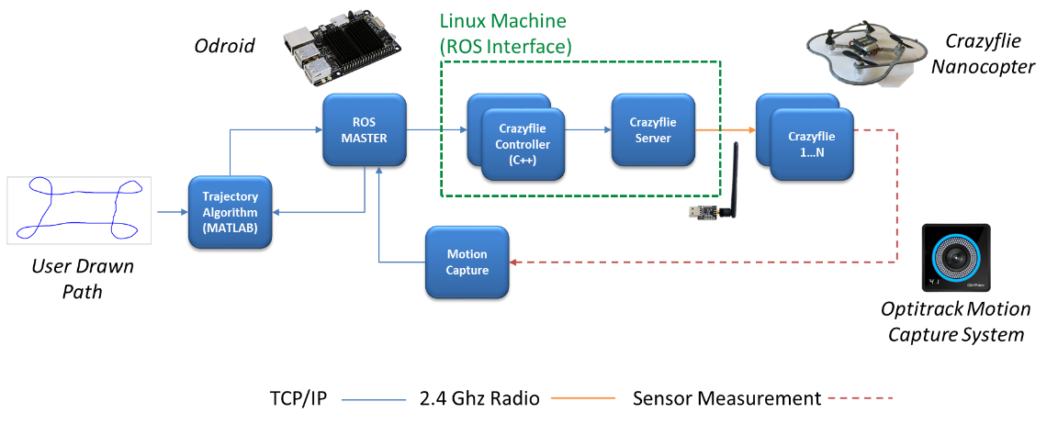
Figure 11: Experimental Block Diagram

Experimental Analysis
To assess the initial performance of the algorithm, one aircraft was used to follow the user drawn path. $v_{o}$ in equation (6) was set to 0.3 m/s. This parameter was selected to ensure the safety and stability of the aircraft. The aircraft initially started on the ground in the experimental space. To initiate each experiment, a user would first establish which aircraft were to be launched using both the MATLAB and Linux interfaces. They would then draw the desired path using a drawing tool in MATLAB function. This drawing would then be processed by the algorithm and trajectories would be developed. This information would then be streamed to each aircraft and they would execute a flight along the prescribed path for two full periods, then land. During multiple trials, the aircraft were able to successfully follow the desired trajectory. After the initial transient, the aircraft maintained its position within 5-10 centimeters of the desired path. Figure 12 shows the results of these experiments. The user’s original drawing is shown in blue, the simulated trajectory is shown in a dotted, red line, and the path during the experiment is shown in a dashed, green line. Each of these shapes was selected to demonstrate the ability of the algorithm to develop controls about a complex, self-crossing path. A top down view is shown to show the recreation of the shape.

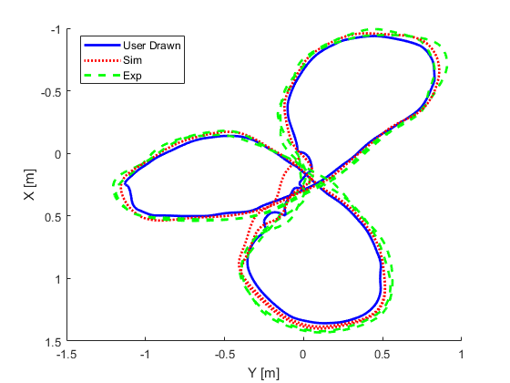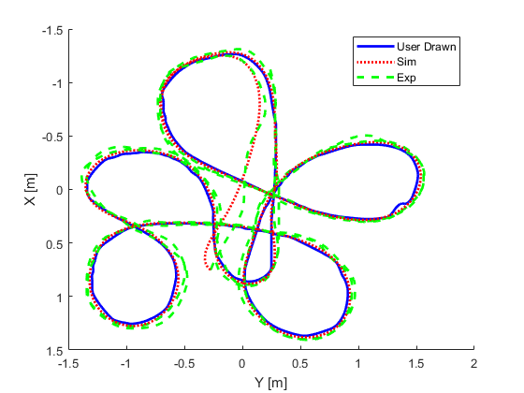

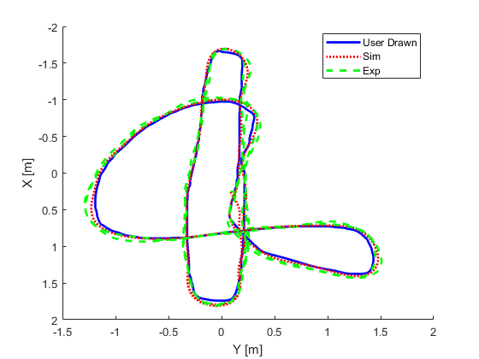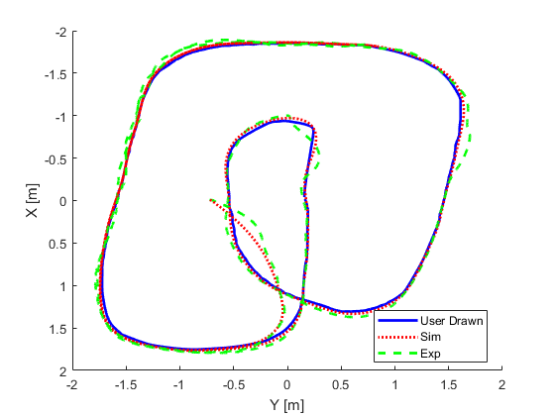
Figure 12: Multiple experiments exhibiting the algorithm’s ability to control one aircraft about a user-drawn, self-crossing path.
The ability of the algorithm to control trajectories for multiple quadrotors was then assessed. This was done using the same experimental setup as with one aircraft. Each quadrotor was placed at least 0.5 meters away from each other and prescribed altitudes one foot apart to deconflict paths. Experiments were conducted with both two and three quadrotors simultaneously. As with experiments utilizing only one quadcopter, average position error after the initial transient was within a maximum of 5-10 centimeters or less. Initial movement to the steady state trajectories did exhibit slightly greater overshoot. This was likely caused by the slight delay in communication caused by the server distributing signals to multiple agents. Figure 13 shows the results of these experiments. The user’s original input is shown as a solid blue line, the simulated path is shown a dotted, red line, and each vehicles path, is shown with dashed lines. Each experiment shown utilized three aircraft.
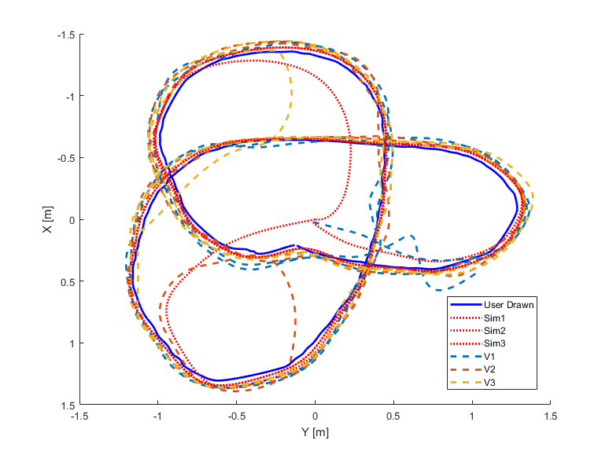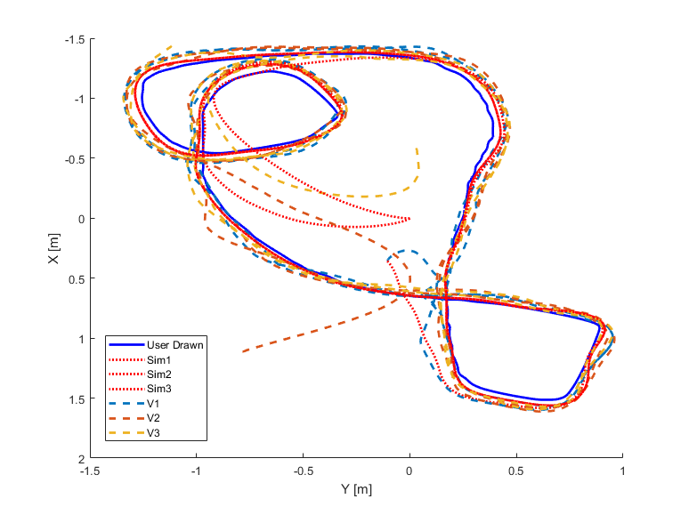
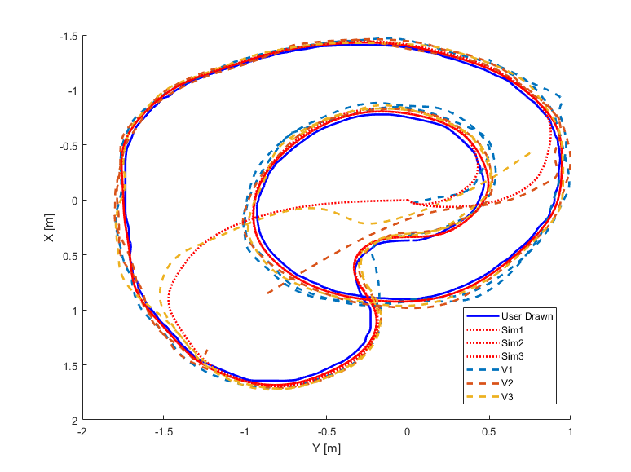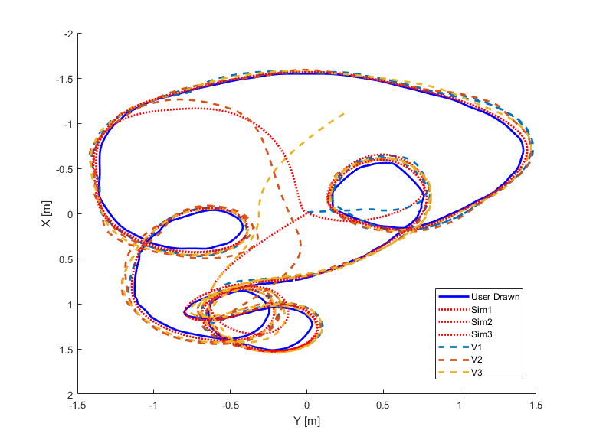
Figure 13: Multiple experiments exhibiting the algorithm’s ability to control multiple aircraft about a complex, user-drawn, self-crossing paths.

Future Work
A future application of this software is to take the existing infrastructure and create a tablet application that can be used to command groups of autonomous aircraft about various paths. A concept image is shown in Figure 14. This would increase the accessibility and portability of the system. The reconstruction equation could be programmed into the controller of more capable quadcopters. This would allow each aircraft to receive only the Fourier descriptors to recreate the desired path. After initial transmission of the FDs, the aircraft would be able to generate their own trajectories, thus eliminating the need for a centralized controller. A distributed control structure would allow multiple aircraft to complete their mission without intervention. Using navigational instruments such as GPS could potentially allow this system be used outdoors over large areas. An application like this would be able to provide a flexible solution for surveillance and data gathering missions.

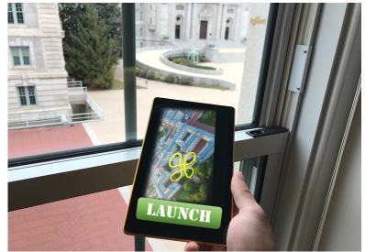
Figure 14: Future tablet application concept

Conclusion
The goal of this project was to develop an algorithm that can generate controls for a small group of quadcopters such that they form a desired formation about a user defined shape. The novelty of this research lies in the use of Fourier descriptors to design the controls. This method allowed for the creation of complex, self-crossing formations [6]. In simulation this algorithm was successful in most applications. It performed consistently with one to dozens of quadcopters. Experimentally it was able to control multiple aircraft, with only a few centimeters of positional error. The next step in this research would be to use the developed software on a more capable, robust aircraft and perform experiments in an outdoor environment.

References

[1] | D. Carrington and J. Soffel, "CNN," CNN, 18 November 2013. [Online]. Available: https://www.cnn.com/2013/11/03/business/meet-your-friendly-neighborhood-drones/index.html. [Accessed 6 March 2018].
[2] | M. Gotzy, D. Hetenyi and L. Blazovics, "Aerial Surveillance System with Cognitive Swarm Drones," Proceedings of the 28th International Conference 2016 Cybernetics & Informatics, pp. 1-6, 2016.
[3] | B. Brian, "Inside the Olympic Opening Ceremony World-Record Drone Show," Wired , 9 February 2018. [Online]. Available: https://www.wired.com/story/olympics-opening-ceremony-drone-show/. [Accessed 6 3 2018].
[4] | A. Buczkowski, "How accurate is your drone survey? Everything you need to know.," Geo Awesomeness, 4 July 2017. [Online]. Available: http://geoawesomeness.com/accurate-drone-survey-everything-need-know/. [Accessed 3 May 2018].
[5] | Naval Aviation Enterprise, "Naval Aviation Vision: 2016-2025," United States Navy, Washington DC, 2016.
[6] | L. DeVries and J. Dawkins, "Multi-Vehicle Target Tracking and Formation Control in Non-Inertial Reference Frames," American Controls Conference.
[7] | B. Young, R. Beard and K. Jed, "A Control Scheme For Improving Mulit-Vehicle Formation Maneuvers," IEEE Proceedings of the American Control Conference, pp. 704-709, 2001.
[8] | A. Weinstein, A. Cho and V. Kumar, "VIO Swarm: An Autonomous Swarm of Vision Based Quadcopters," IEEE Robotics and Automation Letters. Preprint Version, pp. 1-7, 2018.
[9] | H. Tanner, G. Pappas and V. Kumar, "Leader-to-Formation Stability," IEEE Transactions on Robotics and Automation, vol. 20, no. 3, pp. 443-455, 2004.
[10] | V. Roldão, R. Cunha, D. Cabecinhas, C. Silvestre and P. Oliveira, "A Novel Leader-Following Strategy Applied to Formations of Quadcopter," European Control Conference, pp. 1817-1822, 2013.
[11] | L. Techy, D. Paley and C. Woolsey, "UAV Coordination on Convex Curves in Wind: An Evironmentla Sampling Application," Proceedings of the European Control Conference, Budapest, Hungary, pp. 4967-4972, 2009.
[12] | D. Paley, N. Leonard and R. Sepulchre, "Stabilization of Smmetric Formations to Motion Around Convex Loops," Systems and Control Letters, no. 57, pp. 209-215, 2007.
[13] | R. Sepulchre, D. Paley and N. Leonard, "Stabilization of Planar Collective Motion: All to All Communication," IEEE TRANSACTIONS ON AUTOMATIC CONTROL, vol. 52, no. 5, pp. 811-824, 2007.
[14] | E. Frew, D. Lawrence and S. Morris, "Coordinated Standoff Tracking of Moving Targets Using Lyapunov Vector Fields," Journal of Guidance, Control, and Dynamics, vol. 21, no. 2, pp. 290-306, 2008.
[15] | D. Mellinger, "Trajectory Generation and Control for Quadrotors," Penn Libraries, Philadelphia, 2012.
[16] | R. Molla, "recode," The Verge, 10 February 2018. [Online]. Available: https://www.recode.net/2018/2/10/16998652/drones-guinness-world-record-pyeongchang-2018-winter-olympics. [Accessed 3 March 2018].

