

April 23, 2014

Professor Brian Charlesworth

Editor-in-Chief

*Biology Letters*

Dear Prof Charlesworth:

Enclosed is an original manuscript by Dennis Evangelista, Sharlene Cam, Tony Huynh, Igor Krivitskiy, and Robert Dudley entitled “Aerial righting in juvenile birds”, which is being submitted for publication in *Biology Letters*.

This manuscript is new, is not being considered elsewhere, and reports the first results of a study of aerial behavior and incipient wing use during ontogeny in Chukar Partridge, as a counterpoint to the large amount of attention on wing assisted incline running (WAIR). We observed asymmetric movements of the wings tied to righting and inertial and aerial force production for maneuvers, that precede WAIR in development and are not linked to gross force production for traction on inclines. Given broad interest in the evolution of flight in vertebrates, *Biology Letters* is a particularly appropriate venue to publish this work that connects aerodynamics, engineering, biomechanics, and evolution.

We suggest Sanjay Sane or Alan Wilson as appropriate subject-matter editors; appropriate reviewers include Brandon Jackson (Skidmore College), Chris Clark (UC Riverside), Jakob Vinther (Bristol), John Hutchinson (RVC), and Andy Biewener (Harvard). We oppose Mimi Koehl (UC Berkeley) who obstructed this work; and Kevin Padian (UC Berkeley), and Ken Dial (Montana), who have previously stated categorical opposition to our findings.

The manuscript has 2493 words; we anticipate that it will be approximately 3 pages in length after final formatting. Correspondence regarding this manuscript may be sent to Dennis Evangelista at the address given above or via email: [devangel77b@gmail.com](mailto:devangel77b@gmail.com); alternate [devangel@live.unc.edu](mailto:devangel@calmail.berkeley.edu).

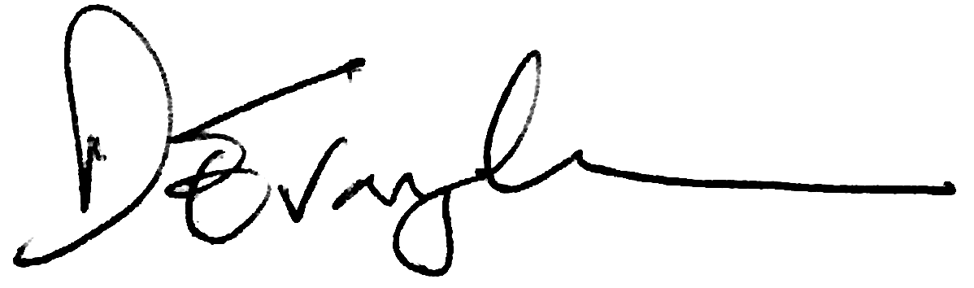

Dennis J Evangelista

Department of Biology

University of North Carolina at Chapel Hill