**A Project Case Study On**

***DMS***

**Technology – Python-Django & ML**

**Submitted in the partial fulfillment for the Semester-V Mini-Project** in

**MASTER OF COMPUTER APPLICATIONS**

**(M.C.A.)**

**[Batch 2019-2021]**

**Submitted by**

**Group-2**

**Team Members**

**Aghera Kevin Bipinbhai | Garach Devang Bharatbhai | Changela Savan Prasudbhai  
 (191823002) (191823011) (191823008)**

**Under the guidance of  
Prof. Shrey Shah**

**M.C.A. Head of Department**

**Dr. Parag Shukla**

**Submitted To:**



**ACKNOWLEDEGEMENT**

The success and final outcome of this project required a lot of guidance and assistance from many people and we extremely privileged to have got this all along the completion of our project. All that we have done is only due to such supervision and assistance and we would not forget to thank them.

We learn lots of thing like Analysis, Designing, Deal with Large amount of Datasets, Test-cases, Debugging and lot many.

It is our gratefulness to acknowledge the sincere help and guidance from all our teachers and peers. I would firstly like to thank and gratify to Mini-Project Guide Prof. Shrey Shah and Prof. Ankit Faldu for their all-time support and sincere guidance, without which project could have never reached to its completion. Their all-time readiness for understanding the problem faced by the students and their ability to solve them with ease is truly appreciable and unforgettable.

Special thanks to head of the department Dr. Parag Shukla for their guidance and constant supervision as well as for providing necessary information regarding the Ethics and Technical Concepts, who always inspired us in semester-V Mini-Project.

We would like to thank from core of our heart to Department of MCA for giving the awesome opportunity for doing the Mini-Project, support and guidance from all Teaching staffs of MCA Department which helped us in successfully completing our project work.

Table of Content

1. PROJECT PROFILE 1

1.1. Project Description 1

1.2. Core Components 1

1.2.1. Login Module 1

1.2.2. Stock Management Module 1

1.2.3. Billing Module 1

1.2.4. Print Module 1

1.2.5. Report & Analysis Module 1

1.2.6. Stock Notify Module 2

1.2.7. Sales Return Module 2

1.3. System Requirements 2

1.3.1. Minimal Hardware Requirements 2

1.3.2. Software Requirements 2

1.3.3. Network Requirements 2

2. ABOUT THE TOOLS & TECHNOLOGIES 3

3. SYSTEM ANALYSIS 5

3.1. About Existing System 5

3.2. Feasibility Study 5

3.2.1. Economical 5

3.2.2. Technical 5

3.2.3. Operational 5

3.3. Limitation of Existing System 6

3.4. Scope of Proposed System 6

3.5. Limitation of Proposed System 6

3.6. Targeted Users 6

3.7. Project Module 6

4. SYSTEM DESIGN 8

4.1. Use Case Diagram 8

4.2. Activity Diagram 9

4.3. Class Diagram 14

4.4. Sequence Diagram 15

5. CONCLUSION 18

5.1 Future Extension 18

5.2 Timeline Chart 18

BIBLIOGRAPHY 19

WEB REFERENCES: 19

List of Tables

Table 1 Minimal Hardware Requirements 2

Table 2 Software Requirements 2

Table 3 Network Requirements 2

List of Images

Figure 1 UseCase Diagram 8

Figure 2 Activity Diagram of Login 9

Figure 3 Activity Diagram of add Products 10

Figure 4 Activity Diagram of Print QR Code PDF 11

Figure 5 Activity Diagram of Billing 12

Figure 6 Activity Diagram of Sales Return 13

Figure 7 Class Diagram 14

Figure 8 Sequence Diagram of Login 15

Figure 9 Sequence Diagram of Add Products 16

Figure 10 Sequence Diagram of Print QR Codes 16

Figure 11 Sequence Diagram of Billing 17

Figure 12 Sequence Diagram of Sales Return 17

Figure 35 Timeline Chart 18

# PROJECT PROFILE

## Project Description

DMS is online stock management application, invoicing by scan QR Code, statistical data and some other features which will help to grow their business, on web-based application responsive design mobile-tablet-desktop supportive, for any small or large scale business/organization, which covers all sports store, supermart, gift and home-decor shop, book store, stationery, hardware, auto-parts store.

## Core Components

In this application/system there are **seven modules** which are describes below

### Login Module

Registration of any organization, Registration of any organization, while registration we will take basics details about organization which will take be like business name, username, password, address, city, state, contact details and business logo, GSTIN Number. Once registration completes, authenticate user of organization has to login via their username and password.

### Stock Management Module

Stock Management Module is divided into 2 sub-modules, Add Products, Add/Modify Stock Details. While adding products or modifying stock details we will get some details like, product name, quantity, HSNCode, Cost Price, Selling Price, expire date, packing date. User can add product manually or they can insert directly stocks, if there is any new product it will automatically first add product and then it add stocks.

### Billing Module

User will scan the products QR Code and each items will be added to list of billing desk, billing was done with some basic calculation related to GST and discount based on product. Qty*SellingPrice=Amount,AmountDiscount=TaxableAmount, TaxableAmount+GST=TotalAmount information we get while billing are Customers Mobile / email, Selling Price(With GST). Quantity, Payment Mode

### Print Module

Based on the product inserted into the stock user can also print out the QR code, they can select the product and system will ask how many QR Code must be printed for per product.

### Report & Analysis Module

All kind of statistical data will be displayed here which will help owner to boost their business/ entier organization. Report & Analysis details like..

* Maximum Selling Product in the Day
* Maximum Selling Product in the Month
* Unique Customers
* Total Products in their Shop
* Which Products not sale in Day or Month
* Product wise selling count Report of the Day, Month and Year
* Profit of the Day, Month and Year
* Current Stock Report
* Sales Return Products
* And Many More Reports with PDF and Excel files.

### Stock Notify Module

If any stock is less than given limit or product is expired then it will notify instantly to owner, to remove that stock from their shop.

### Sales Return Module

Whenever any customer return any product, due to any reason like damaged product, Defective Product, Product not as per expected, etc... We will get some details at the time of sales return like, Customer Mobile, Product ID, Quantity, Note (Reason for Return)

**Future enhancement modules**

* + **Transaction Module**

Currently we are billing and taking Cash. But if we have time then we have to accept online transaction via POS Machine or UPI with any gateway

* + **Bot Module**

Bot will gives some basics answer related to transactional entries or statistical output based on the questions asked by user

## System Requirements

### Minimal Hardware Requirements

|  |  |
| --- | --- |
| Operating System | Microsoft Windows 7, 8 or 10, Ubuntu, Mac |
| CPU Processor | Dual Core 3rd Gen. or above |
| RAM | 2GB |
| Hard Disk | 250GB |
| Camera | 2.0 MP TrueVision |

Table Minimal Hardware Requirements

### Software Requirements

|  |  |
| --- | --- |
| Python 2.7+ | Support some libraries, (if requires) |
| Adobe Reader or any pdf reader | Used for Label printing and billing |
| MS Excel | Checking Excel sheet files |
| Chrome Browser 30+ or any browser | For Running application |

Table Software Requirements

### Network Requirements

|  |  |
| --- | --- |
| Mobile Data Plan | 3G or Above |

Table Network Requirements

# ABOUT THE TOOLS & TECHNOLOGIES

1. HTML

* HTML stands for HyperText Markup Language.
* It is the standard markup language used for creating the web pages.
* It describes the structure of a web page.
* It consists of a series of elements.
* HTML elements tell the browser how to display the content.

1. CSS

* CSS stands for Cascading Style Sheets.
* CSS describes how HTML elements are to be displayed on screen, paper, or in other media.
* CSS saves a lot of work. It can control the layout of multiple web pages all at once.
* External stylesheets are stored in CSS files.
* CSS is easy to learn and understood but it provides powerful control over the presentation of an HTML document.

1. JavaScript

* JavaScript enables interactive web pages and is an essential part of web applications.
* The vast majority of websites use it for client-side page behaviour, and all major web browsers have a dedicated JavaScript engine to execute it.
* As a multi-paradigm language, JavaScript supports event-driven, functional, and imperative programming styles. It has application programming interfaces (APIs) for working with text, dates, regular expressions, standard data structures, and the Document Object Model (DOM).
* However, the language itself does not include any input/output (I/O), such as networking, storage, or graphics facilities, as the host environment (usually a web browser) provides those APIs.

1. JQuery

* jQuery is a JavaScript library.
* jQuery greatly simplifies JavaScript programming.
* jQuery is easy to learn.
* Purpose of jQuery is to make it much easier to use JavaScript on mobiles.
* The jQuery team knows all about cross-browser issues, and they have written this knowledge into the jQuery library. jQuery will run exactly the same in all major browsers.

1. PostgreSQL

* PostgreSQL, also known as Postgres, is a free and open-source relational database management system emphasizing extensibility and SQL compliance.
* It was originally named POSTGRES, referring to its origins as a successor to the Ingres database.
* PostgreSQL features transactions with Atomicity, Consistency, Isolation, Durability (ACID) properties, automatically updatable views, materialized views, triggers, foreign keys, and stored procedures.
* It is designed to handle a range of workloads, from single machines to data warehouses or Web services with many concurrent users.
* It is the default database for macOS Server, and is also available for Linux, FreeBSD, OpenBSD, and Windows.

1. Django

* Django is a Python-based free and open-source web framework that follows the model-template-views (MTV) architectural pattern.
* It is maintained by the Django Software Foundation (DSF), an American independent organization established as a non-profit.
* Django's primary goal is to ease the creation of complex, database-driven websites.
* The framework emphasizes reusability and "pluggability" of components, less code, low coupling, rapid development, and the principle of don't repeat yourself.
* Python is used throughout, even for settings, files, and data models. Django also provides an optional administrative create, read, update and delete interface that is generated dynamically through introspection and configured via admin models.

1. Machine Learning

* The live feed of a camera can be used to identify objects in the physical world.
* Using the “streaming” mode of ML Object Detection, a camera feed can detect objects and use them as input to perform a visual search with our app’s own image classification model and databases.

1. Bootstrap

* Bootstrap is a free and open-source CSS framework directed at responsive, mobile-first front-end web development.
* It contains CSS- and (optionally) JavaScript-based design templates for typography, forms, buttons, navigation, and other interface components.

1. Visual Studio Code

* Visual Studio Code is a free source-code editor made by Microsoft for Windows, Linux and macOS. Features include support for debugging, syntax highlighting, intelligent code completion, snippets, code refactoring, and embedded Git.

1. Edraw Max

* Edraw Max is a 2D business technical diagramming software which help create flowcharts, organizational charts, mind map, network diagrams, floor plans, workflow diagrams, business charts, and engineering diagrams.

1. Microsoft Project

* Microsoft Project is a project management software product, developed and sold by Microsoft. It is designed to assist a project manager in developing a schedule, assigning resources to tasks, tracking progress, managing the budget, and analyzing workloads.

1. Microsoft Visio

* Microsoft Visio is software for drawing a variety of diagrams. These include flowcharts, org charts, building plans, floor plans, data flow diagrams, process flow diagrams, business process modeling, swimlane diagrams, 3D maps, and many more. It's a Microsoft product, sold as an addition to MS Office.

# SYSTEM ANALYSIS

## About Existing System

There are many billing system like zoho, vyaparapp, justbilling, retailcore, Anapurna Supermarket, etc. Some of applications works Online or Offline standalone applications. Many system are just for specific purpose, supports only stock management and billings, While some of system also gives statistical information and analysis of stock with profit/loss, and to track customers buying analysis, and many more.

## Feasibility Study

### Economical

Economic analysis is the most frequently used method for evaluating the effectiveness of the candidate system. More commonly known as cost/benefit analysis, the procedure is to be determining the benefits and savings that are expected from a candidate and compare them with costs. If benefits outweigh costs, then the decision is made to design and implement the system.

A systems financial benefit must exceed the cost of developing that system. I.e. a new system being developed should be a good investment for the organization. Economic feasibility considers the following

* The cost to conduct a full system investigation.
* The cost of hardware and software for the class of application.
* The benefits in the form of reduced cost or fewer costly errors.
* The cost if nothing changes (i.e. the proposed system is not developed).

The proposed “DMS” is economically feasible because

The system requires very less time factors.

* The system will provide fast and efficient automated environment instead of slow and error prone manual system, thus reducing both time and man power spent in running the system.
* The system will have GUI interface and very less user-training is required to learn it.
* The system will provide service to view various information for proper managerial decision making.

### Technical

Technical feasibility centers around the existing computer system (Hardware and Software etc) and to what extend it support the proposed addition. For example, if the current computer is operating at 80 percent capacity - an arbitrary ceiling - then running another application could overload the system or require additional Hardware. This involves financial considerations to accommodate technical enhancements. If the budgets is a serious constraint, then the project is judged not feasible. In this project, all the necessary cautions have been taken care to make it technically feasible. Using a key the display of text/object is very fast. Also, the tools, operating system and programming language used in this localization process is compatible with the existing one.

### Operational

People are inherently resistant to change, and computers have been known to facilitate change. An estimate should be made of how strong a reaction the user staff is likely to have toward the development of a computerized system. Therefore it is understandable that the introduction of a candidate system requires special efforts to educate and train the staff. The software that is being developed is user friendly and easy to learn. In this way, the developed software is truly efficient and can work on any circumstances, tradition, locales.

## Limitation of Existing System

There are many billing system like zoho, vyaparapp, justbilling, retailcore, Anapurna Supermarket, etc. Some of applications works Online or Offline standalone applications.

Many system are just for specific purpose, supports only stock management and billings, while some of system also gives statistical information and analysis of stock with profit/loss, and to track customers buying analysis, and many more.

## Scope of Proposed System

Online stock management, invoicing by scan QR Code, statistical data and some other features which will help to grow their business, on the base of statistical data analysis on web-based application, which will be responsive design mobile-tablet-desktop supportive, for any small or large scale business/organization, which covers all sports store, supermart, gift and home-decor shop, book store, stationery, hardware, auto-parts store. Targeted to Small Shops. This system works only in Smart Cities, requires Internet.

## Limitation of Proposed System

This system requires Internet, mobile or laptop and It may works only in smart cities.

Currently it was proposed with one user authentication for organization.

## Targeted Users

Targeted users are any small or large scale business/organization, which covers all sports store, supermart, gift and home-decor shop, book store, stationery, hardware, auto-parts store.

Targeted to Small Shops First.

## Project Module

Login Module

Registration of any organization, Registration of any organization, while registration we will take basics details about organization which will take be like business name, username, password, address, city, state, contact details and business logo, GSTIN Number. Once registration completes, authenticate user of organization has to login via their username and password.

Stock Management Module

Stock Management Module is divided into 2 sub-modules, Add Products, Add/Modify Stock Details. While adding products or modifying stock details we will get some details like, product name, quantity, HSNCode, Cost Price, Selling Price, expire date, packing date. User can add product manually or they can insert directly stocks, if there is any new product it will automatically first add product and then it add stocks.

Billing Module

User will scan the products QR Code and each items will be added to list of billing desk, billing was done with some basic calculation related to GST and discount based on product. Qty*SellingPrice=Amount,AmountDiscount=TaxableAmount, TaxableAmount+GST=TotalAmount information we get while billing are Customers Mobile / email, Selling Price(With GST). Quantity, Payment Mode

Print Module

Based on the product inserted into the stock user can also print out the QR code, they can select the product and system will ask how many QR Code must be printed for per product.

Report & Analysis Module

All kind of statistical data will be displayed here which will help owner to boost their business/ entier organization. Report & Analysis details like..

* Maximum Selling Product in the Day
* Maximum Selling Product in the Month
* Unique Customers
* Total Products in their Shop
* Which Products not sale in Day or Month
* Product wise selling count Report of the Day, Month and Year
* Profit of the Day, Month and Year
* Current Stock Report
* Sales Return Products
* And Many More Reports with PDF and Excel files.

Stock Notify Module

If any stock is less than given limit or product is expired then it will notify instantly to owner, to remove that stock from their shop.

Sales Return Module

Whenever any customer return any product, due to any reason like damaged product, Defective Product, Product not as per expected, etc... We will get some details at the time of sales return like, Customer Mobile, Product ID, Quantity, Note (Reason for Return)

**Future enhancement modules**

**Transaction Module**

Currently we are billing and taking Cash. But if we have time then we have to accept online transaction via POS Machine or UPI with any gateway

**Bot Module**

Bot will gives some basics answer related to transactional entries or statistical output based on the questions asked by user

# SYSTEM DESIGN

## Use Case Diagram

Figure UseCase Diagram

## Activity Diagram

* 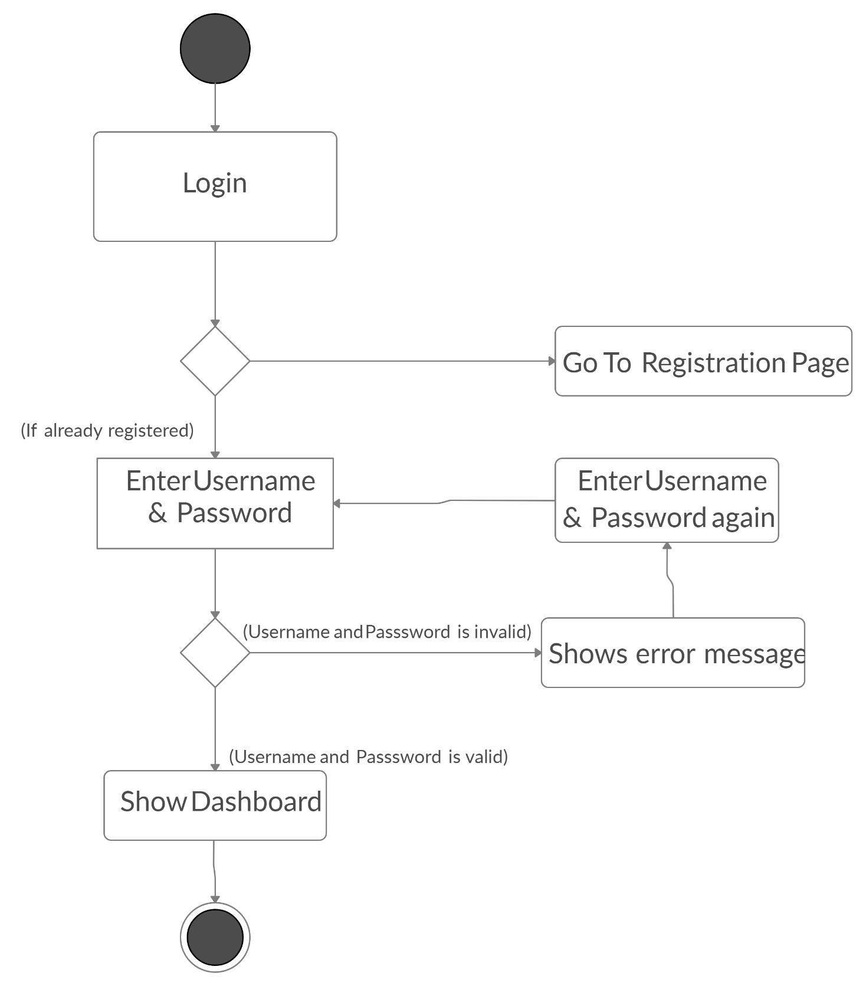An Activity Diagram for **Login Page**

Figure Activity Diagram of Login

* An Activity Diagram for **Add Product**

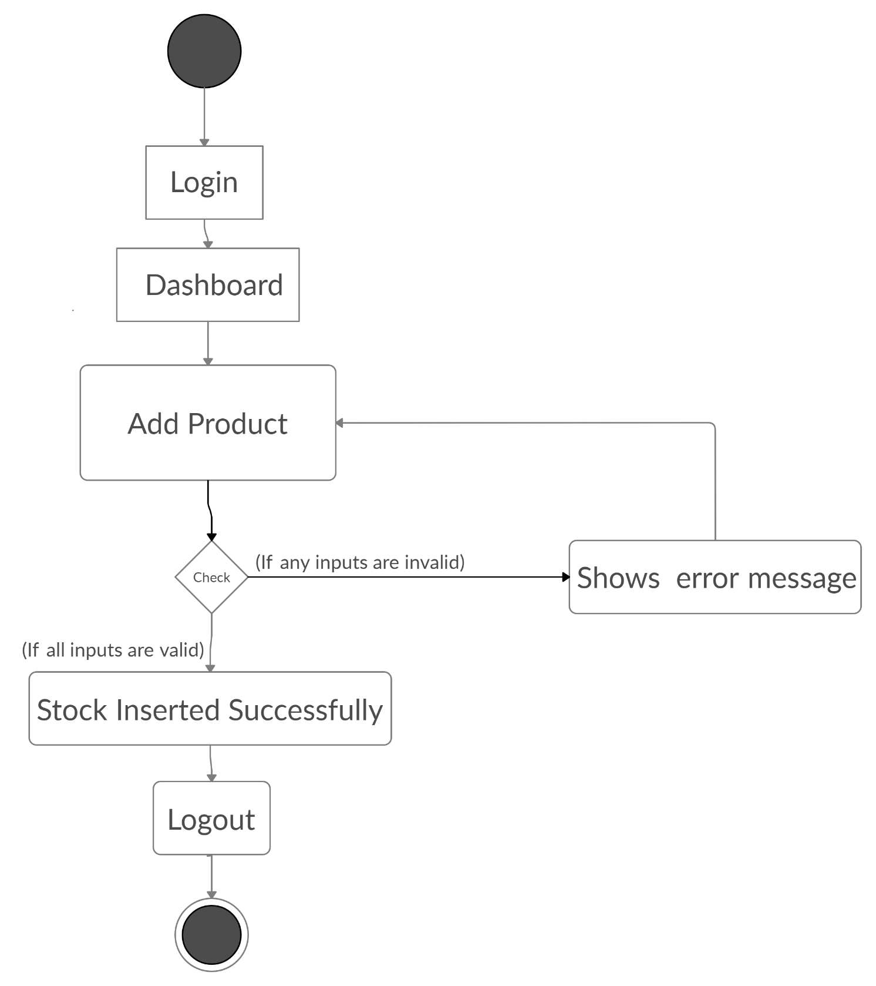

Figure Activity Diagram of add Products

* An Activity Diagram for **Print QR Code PDF**

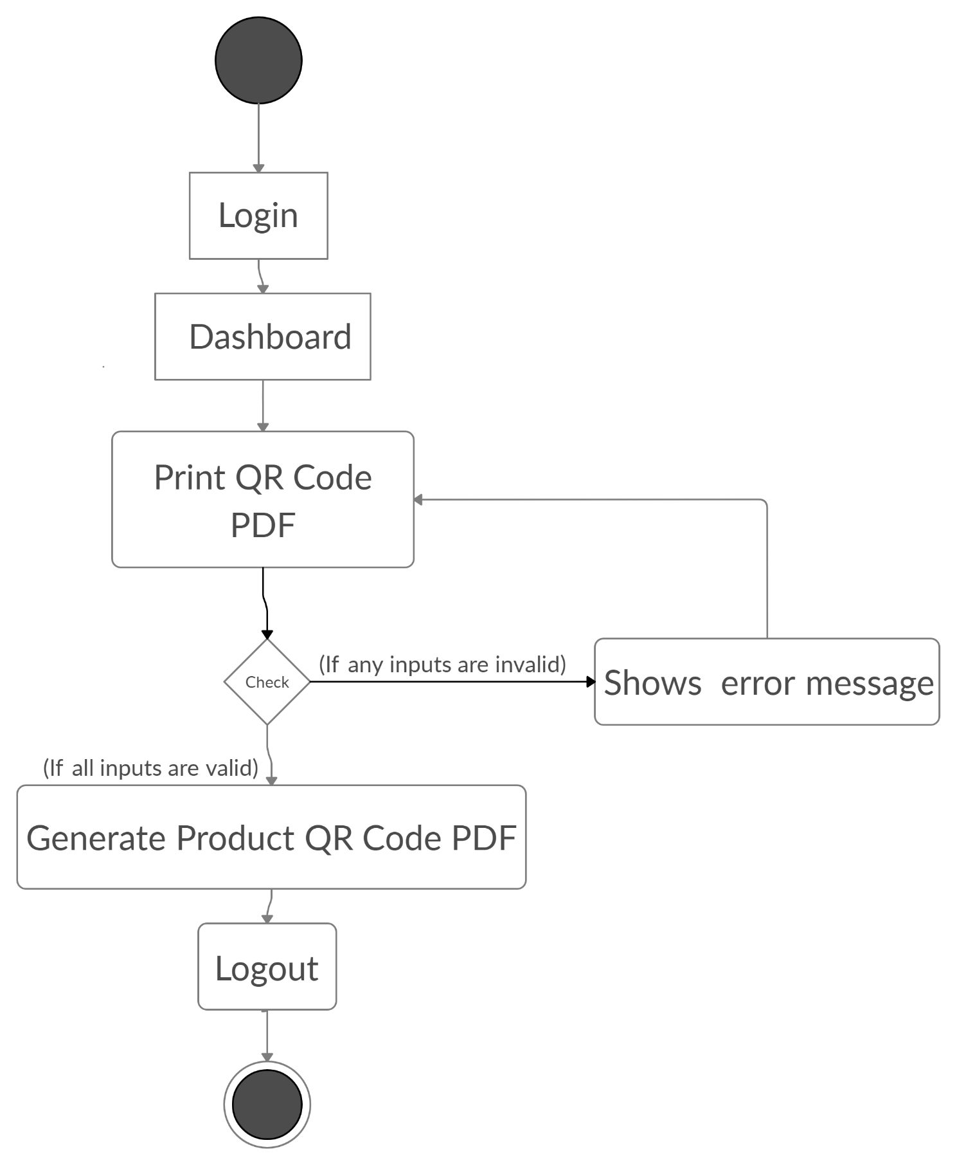

Figure Activity Diagram of Print QR Code PDF

* An Activity Diagram for **Billing**

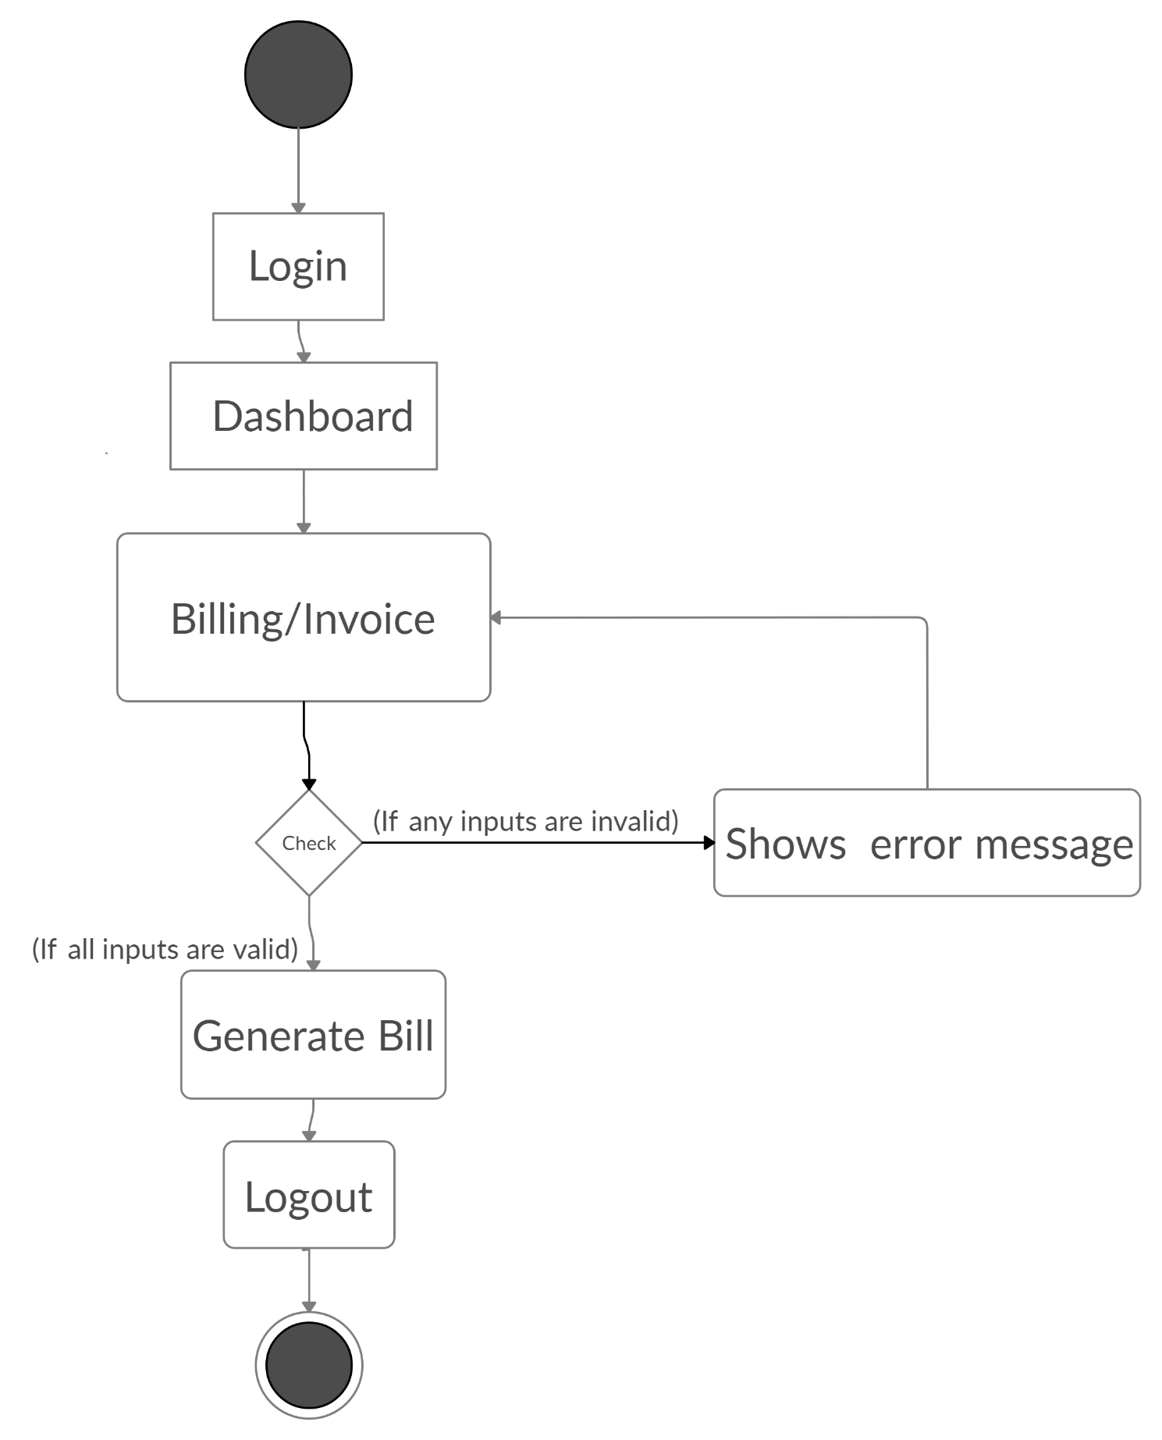

Figure Activity Diagram of Billing

* An Activity Diagram for **Sales Return**

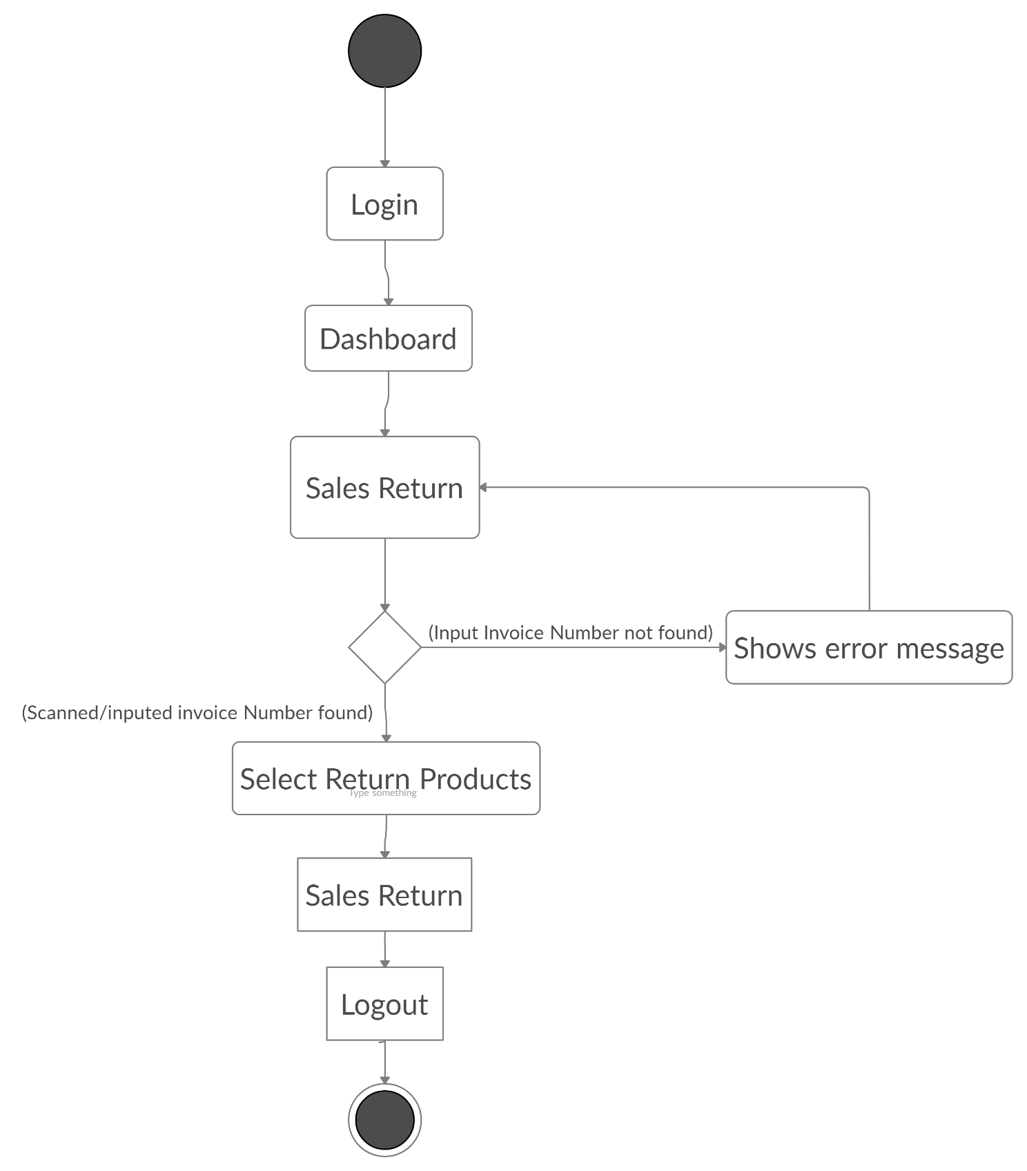

Figure Activity Diagram of Sales Return

## Class Diagram

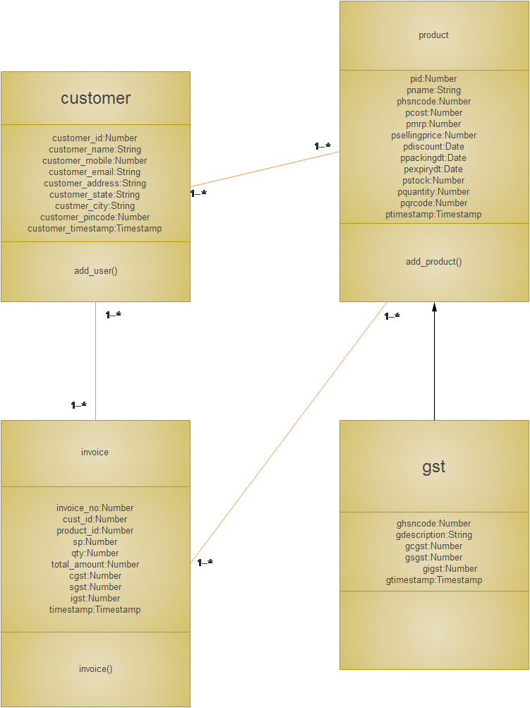

Figure Class Diagram

## Sequence Diagram

* 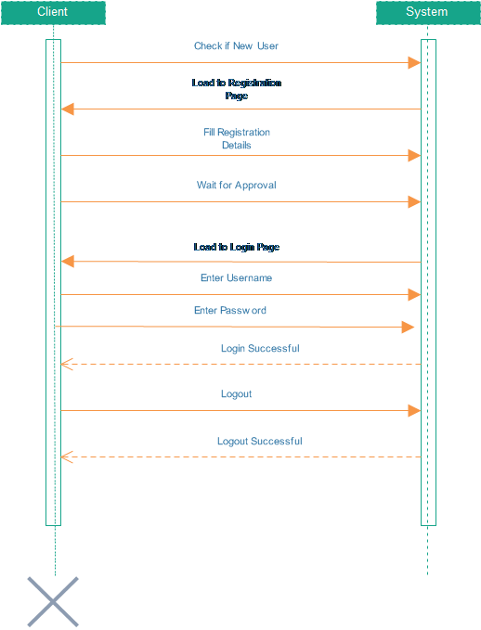Sequence Diagram for **Login**

Figure Sequence Diagram of Login

* 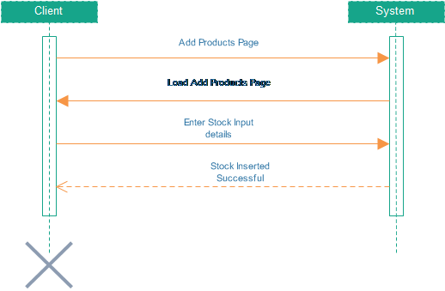Sequence Diagram for **Add Product**

Figure Sequence Diagram of Add Products

* 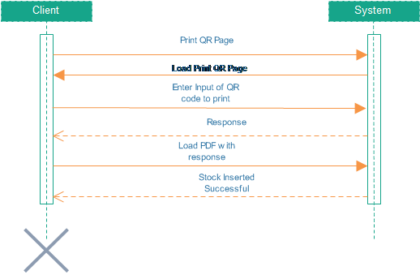Sequence Diagram for **Print QR codes**

Figure Sequence Diagram of Print QR Codes

* 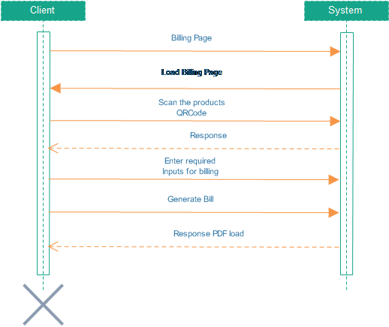Sequence Diagram for **Billing**

Figure Sequence Diagram of Billing

* 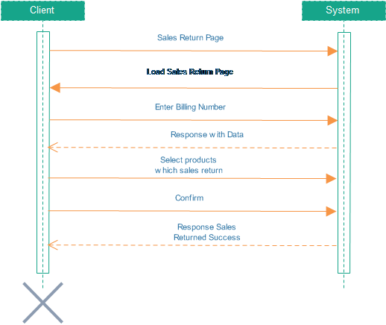Sequence Diagram for **Sales Return**

Figure Sequence Diagram of Sales Return

# CONCLUSION

## Future Extension

* + - **Transaction Module**

Currently we are billing and taking Cash. But if we have time then we have to accept online transaction via POS Machine or UPI with any gateway

* + - **Bot Module**

Bot will gives some basics answer related to transactional entries or statistical output based on the questions asked by user

## Timeline Chart

Figure Timeline Chart

# BIBLIOGRAPHY

## WEB REFERENCES:

For making QRCode

<https://pypi.org/project/qrcode/>

<https://pypi.org/project/PyQRCode/>

<https://github.com/devanggarach/python-qrcode>

Decode QRCode into Text

<https://github.com/Edinburgh-Genome-Foundry/blabel>

Printing QRCode into PDF

<https://pypi.org/project/blabel/>

<https://github.com/Edinburgh-Genome-Foundry/blabel>

Making PDF

<https://docs.djangoproject.com/en/3.1/howto/outputting-pdf/>

<https://stackoverflow.com/questions/17940669/django-python-how-to-convert-text-to-pdf>

Generate Excel sheet

<https://pypi.org/project/django-excel/>

<http://django.pyexcel.org/en/latest/>

Django specific errors and understanding

<https://docs.djangoproject.com/en/3.1/ref/models/constraints/>

<https://docs.djangoproject.com/en/3.1/topics/forms/>

<https://stackoverflow.com/questions/50538244/django-how-to-add-constraints-on-the-foreign-key-dashboard>

<https://docs.djangoproject.com/en/3.1/ref/contrib/postgres/constraints/>

<https://docs.djangoproject.com/en/3.1/ref/exceptions/>

Django Bot integration

<https://chatterbot.readthedocs.io/en/stable/django/>

<https://chatbotslife.com/implementing-a-chatbot-in-django-b2fd3c1bcd2a>