1. Cat command

To Create a file

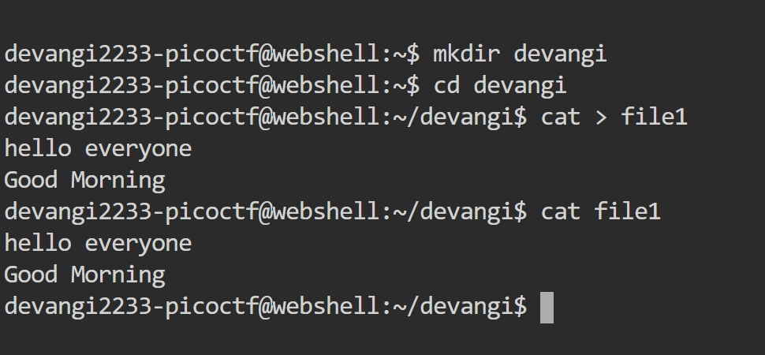

To Append

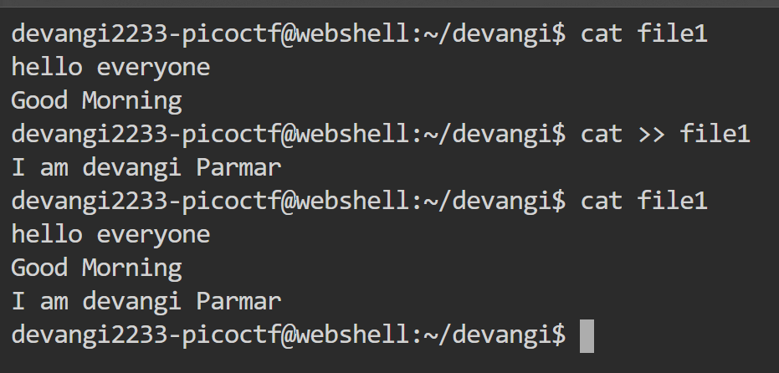

To concatenate

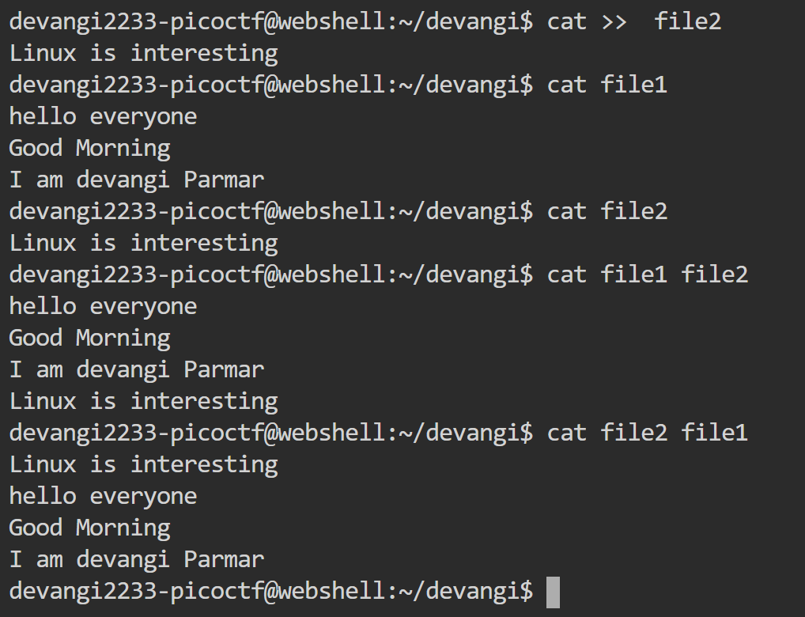

To concatenate several files and to transfer the output to anotherfile.

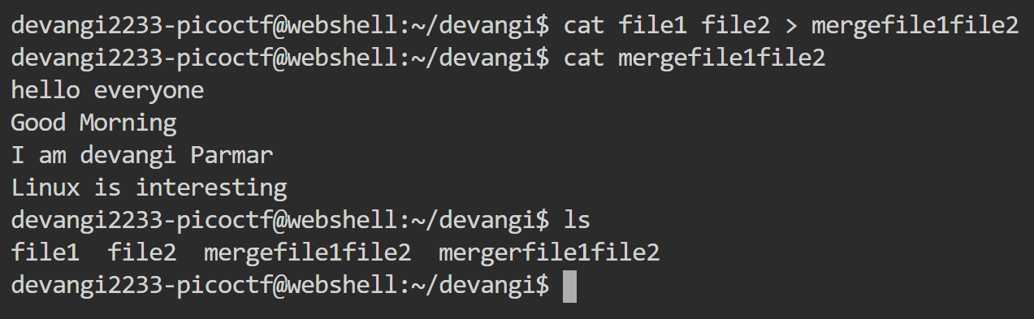

1. Rm command

To Remove / Delete a file:

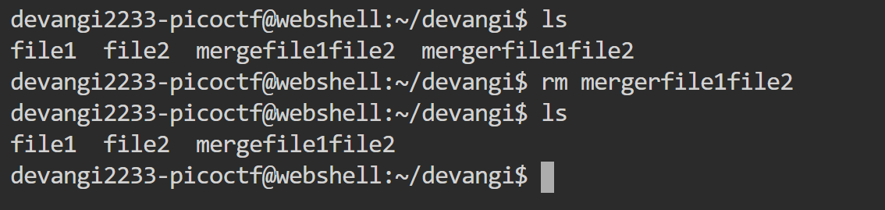

To delete a directory tree:

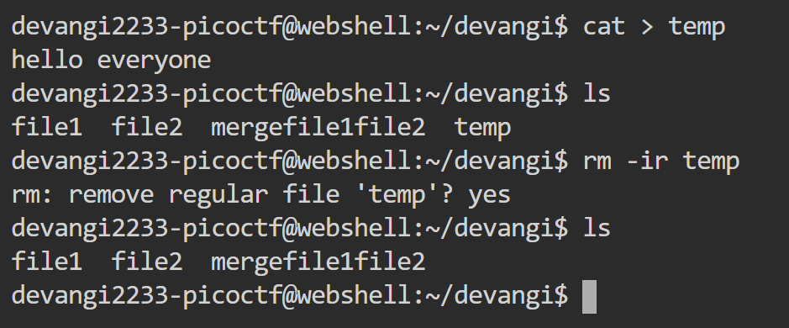

To remove more files at once

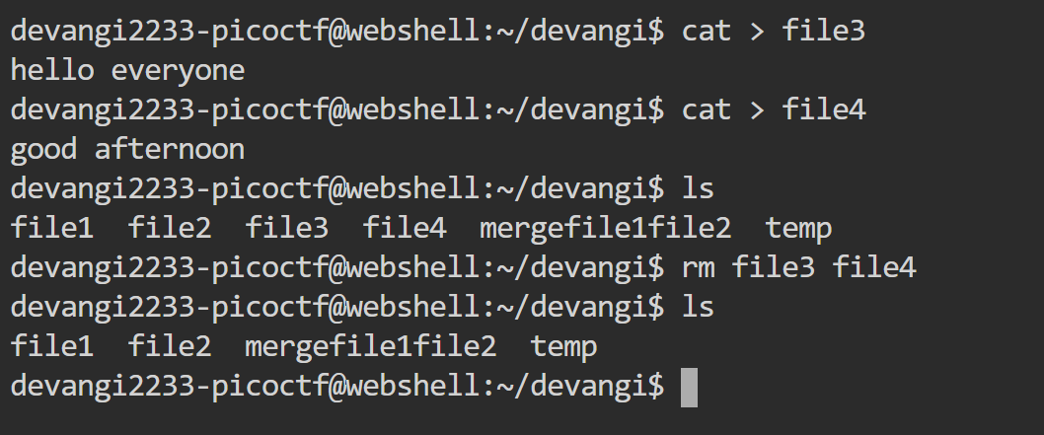

This rm command recursively removes the contents of all subdirectories of the tmp directory, prompting you regarding the removal of each file, and then removes the tmp directory itself.

1. Cd command

Cd

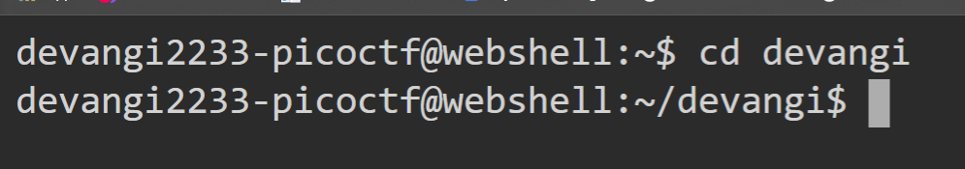

Cd ..

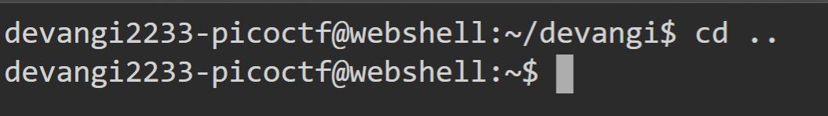

1. Cp command

Copy two files

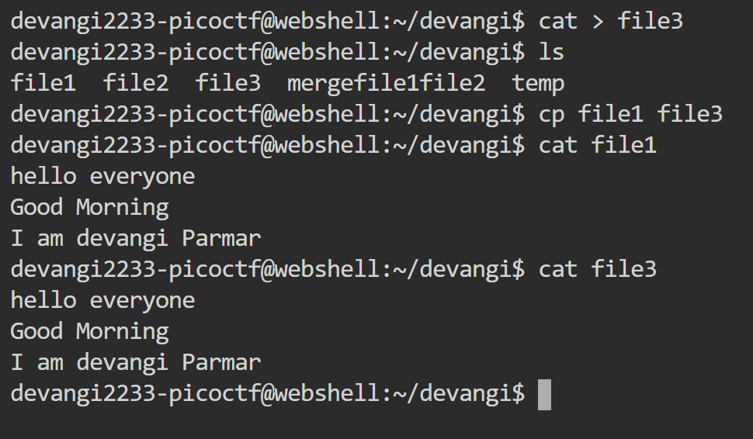

To backup the copied

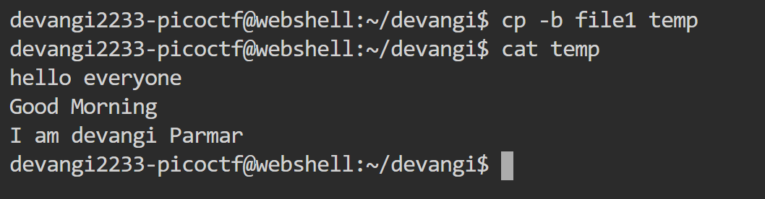

To copy folder

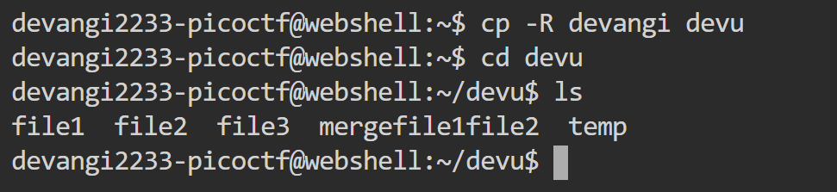

1. Ls command

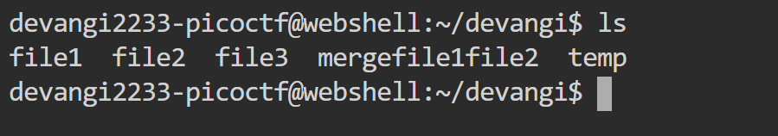

Ls – t : Lists in order of last modification time

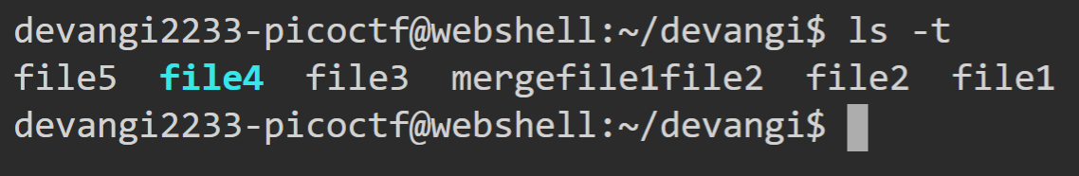

Ls – a : Lists all entries including hidden files.

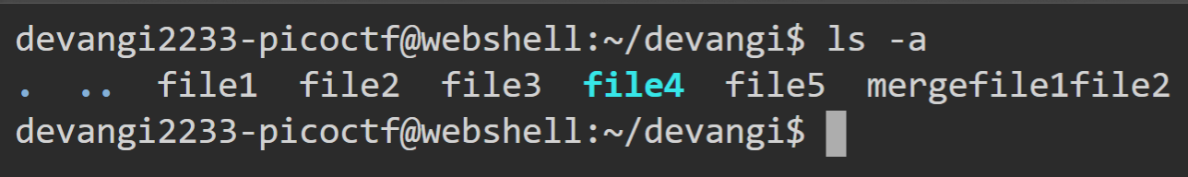

Ls –l : Lists all the files, directories and their mode, Number of links, owner of the file, file size, Modified date and time and filename.

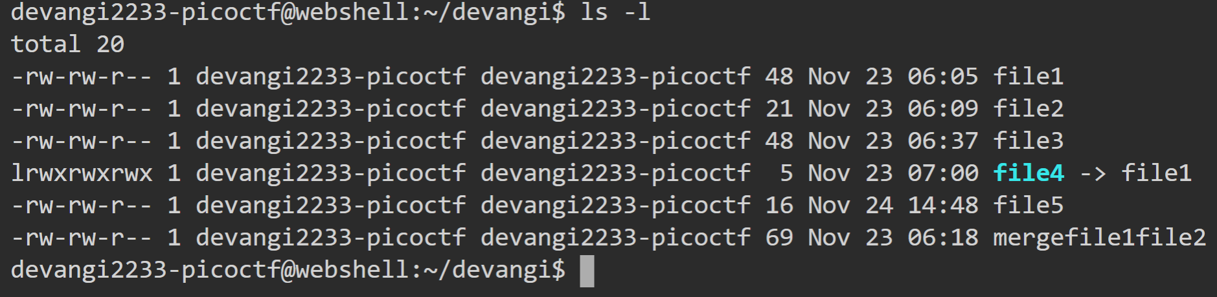

Ls –d : Lists directory files instead of contents

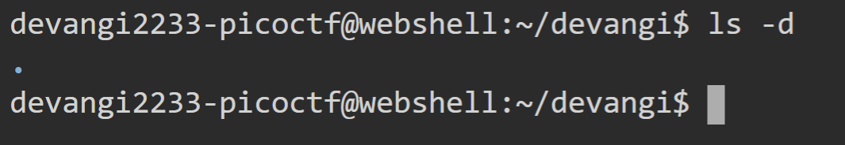

Ls –p : Puts slash at the end of each directories.

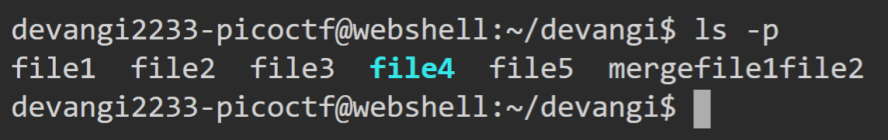

Ls –u : List in order of last access time

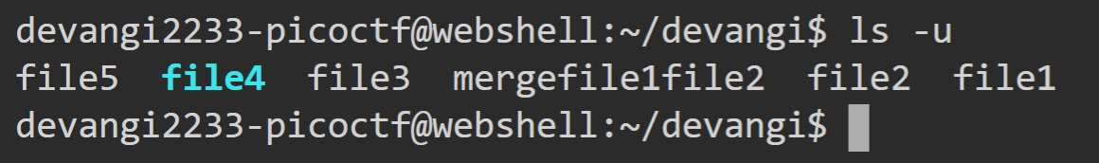

Ls –i : Display inode information.

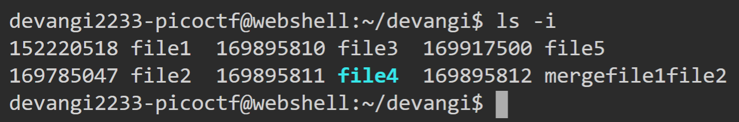

1. Ln command : ln command is used to create link to a file (or) directory. It helps to provide soft link for desired files. Inode will be different for source and destination.

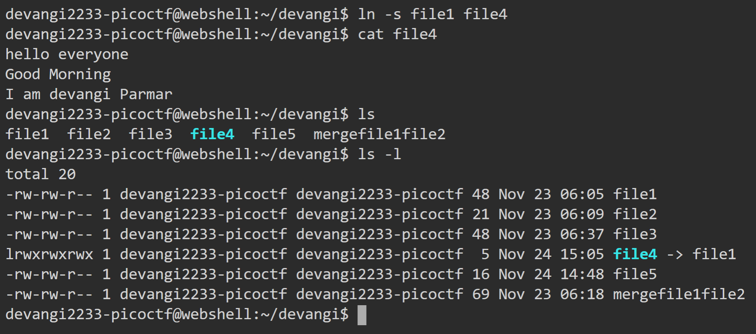

1. chown command : chown command is used to change the owner / user of the file or directory. This is an admin command, root user only can change the owner of a file or directory
2. Permissions chmod command : chmod command allows you to alter / Change access rights to files and directories. File Permission is given for users, group and others as, Read, Write, Execute.

File Permission

# File Permission

0 none

1 execute only

2 write only

3 write and execute

4 read only

5 read and execute

6 read and write

7 set all permissions

Permission numbers are:

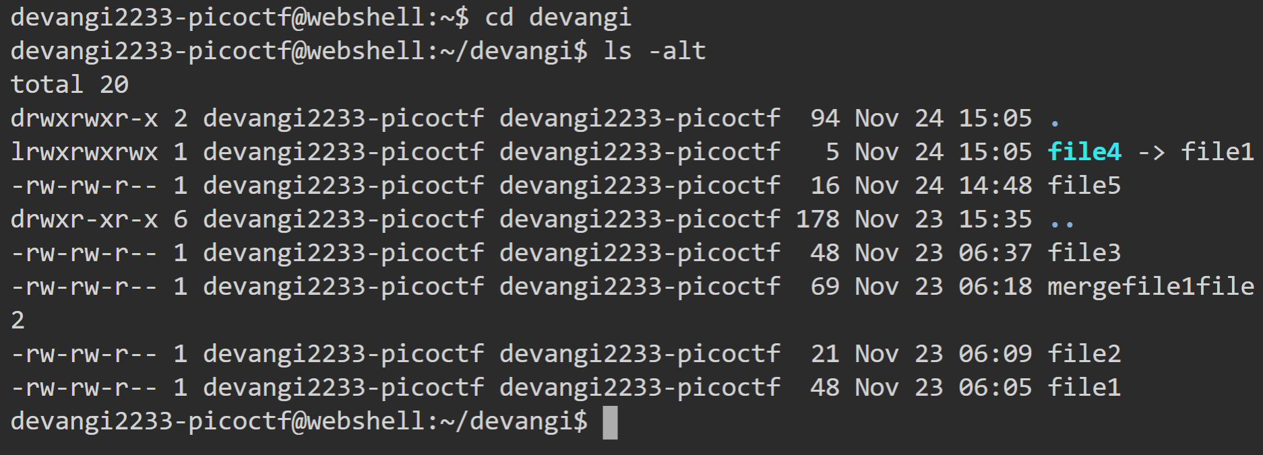

This command is used to view your files with what permission they are.

To make a file readable and writable by the group and others.



To allow everyone to read, write, and execute the file

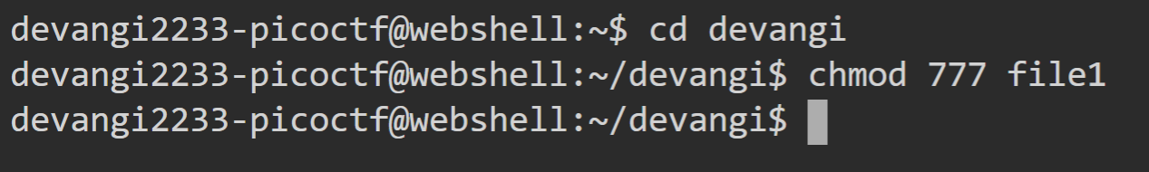

1. Mkdir command : mkdir command is used to create one or more directories.

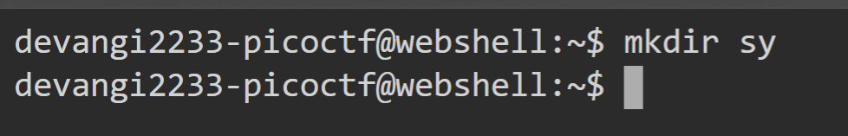

1. Rmdir : rmdir command is used to delete/remove a directory and its subdirectories

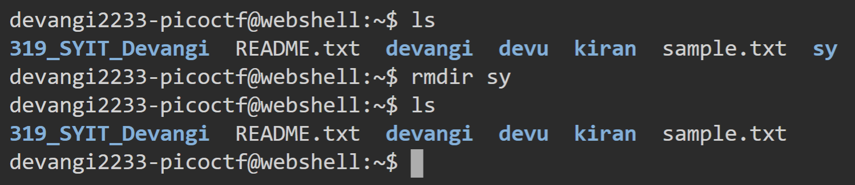

1. Mv command:

To Rename / Move a file:

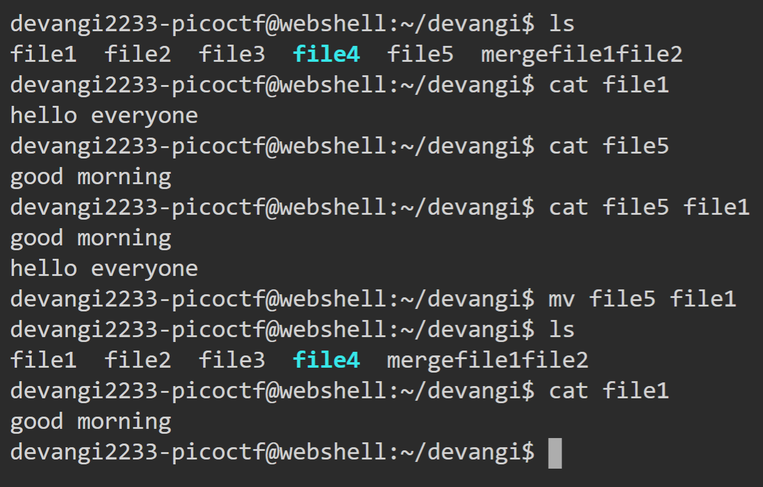

To move a directory

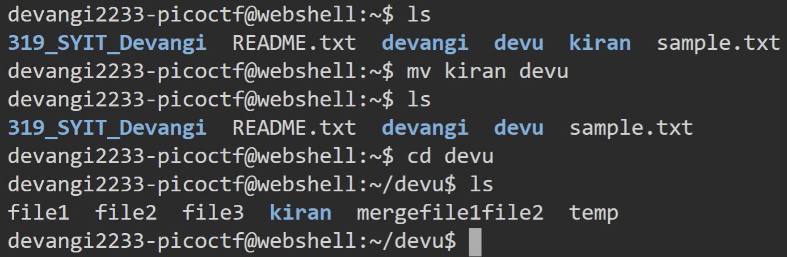

To Move multiple files/More files into another directory

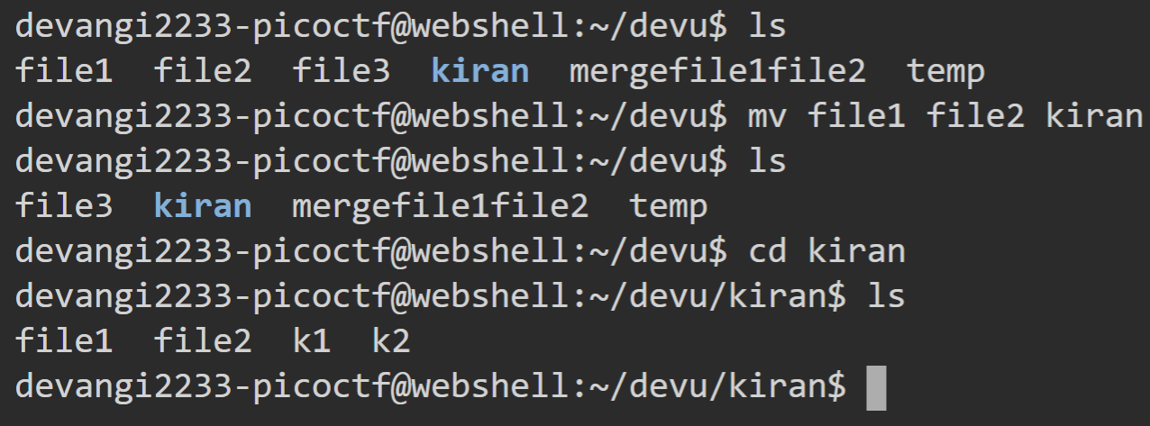

1. Diff command

Diff –a : Treat all files as text and compare them line-by-line

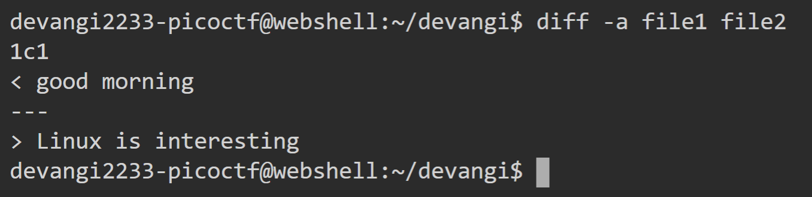

Diff –b : Ignore changes in amount of white space.

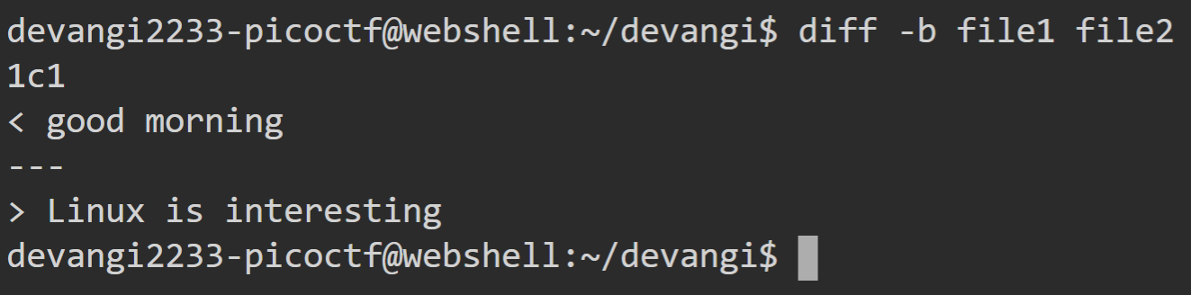

Diff –c :

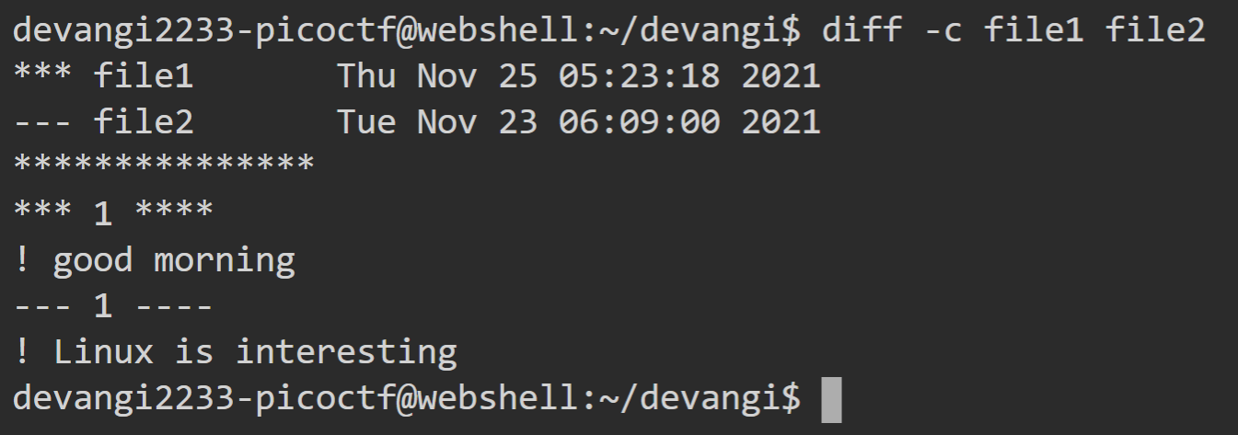

Diff – e : Make output that is a valid ed script

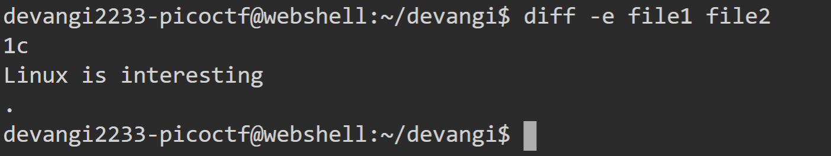

Diff –w : Ignore white space when comparing lines

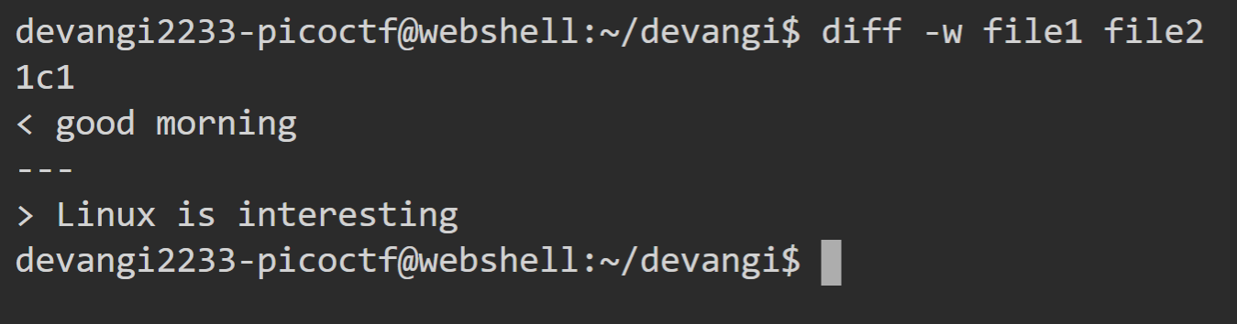

Compare the files side by side, ignoring white space



1. chgrp command : chgrp command is used to change the group of the file or directory. This is an admin command. Root user only can change the group of the file or directory.
2. Wc command : Short for word count, wc displays a count of lines, words, and characters in a file.

Wc –c : Count bytes.

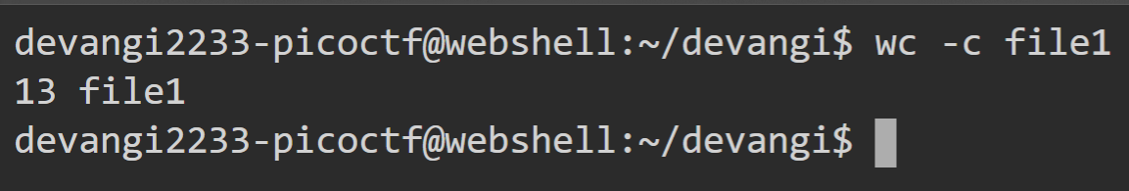

Wc – m : count characters

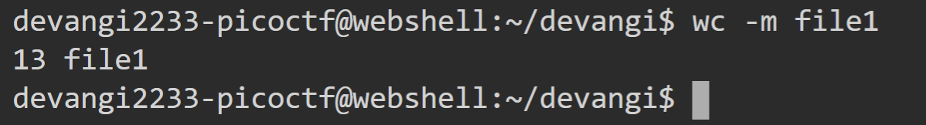

Wc –l : count lines

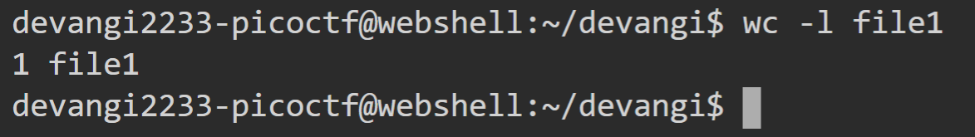

Wc –w : Count words delimited by white space characters or new line characters. Delimiting characters are Extended Unix Code (EUC) characters from any code set defined by iswspace()

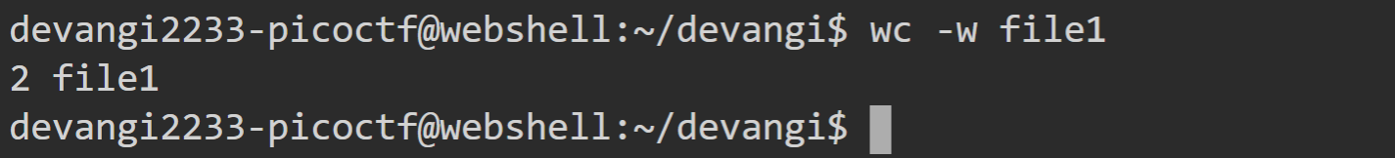

Wc :

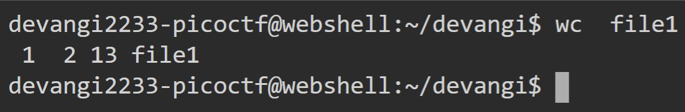

1= Lines

2 = Words

13 = Characters

To Rename / Move a file:

