Practical 2

Name: Devangi Parmar

Class: SYIT

Division: A

Roll no.: 319

Date of submission: 14th August 2021

Bird’s Nest

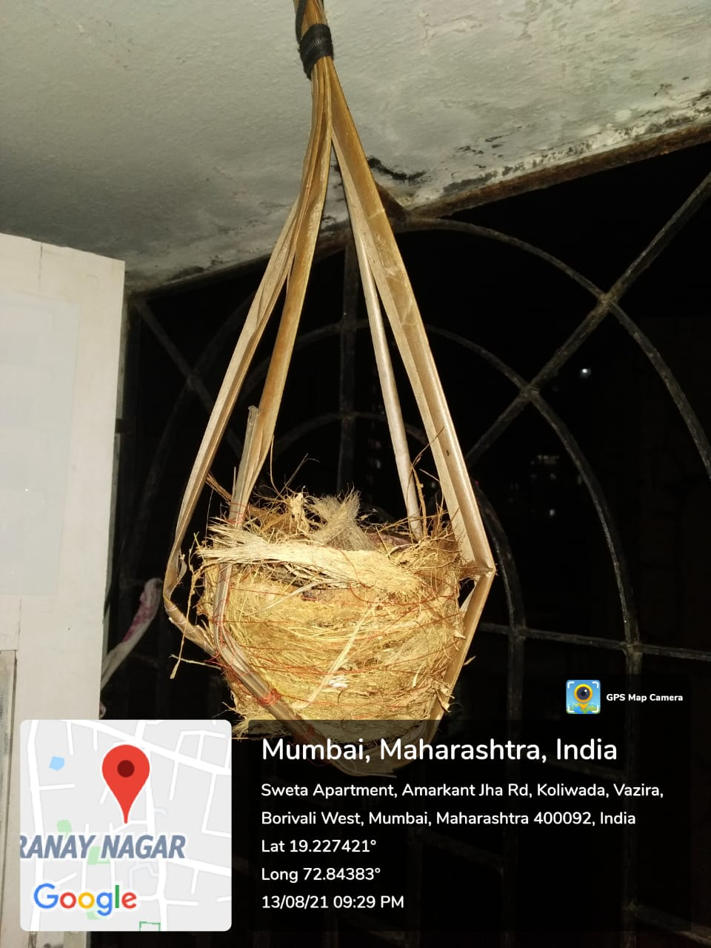

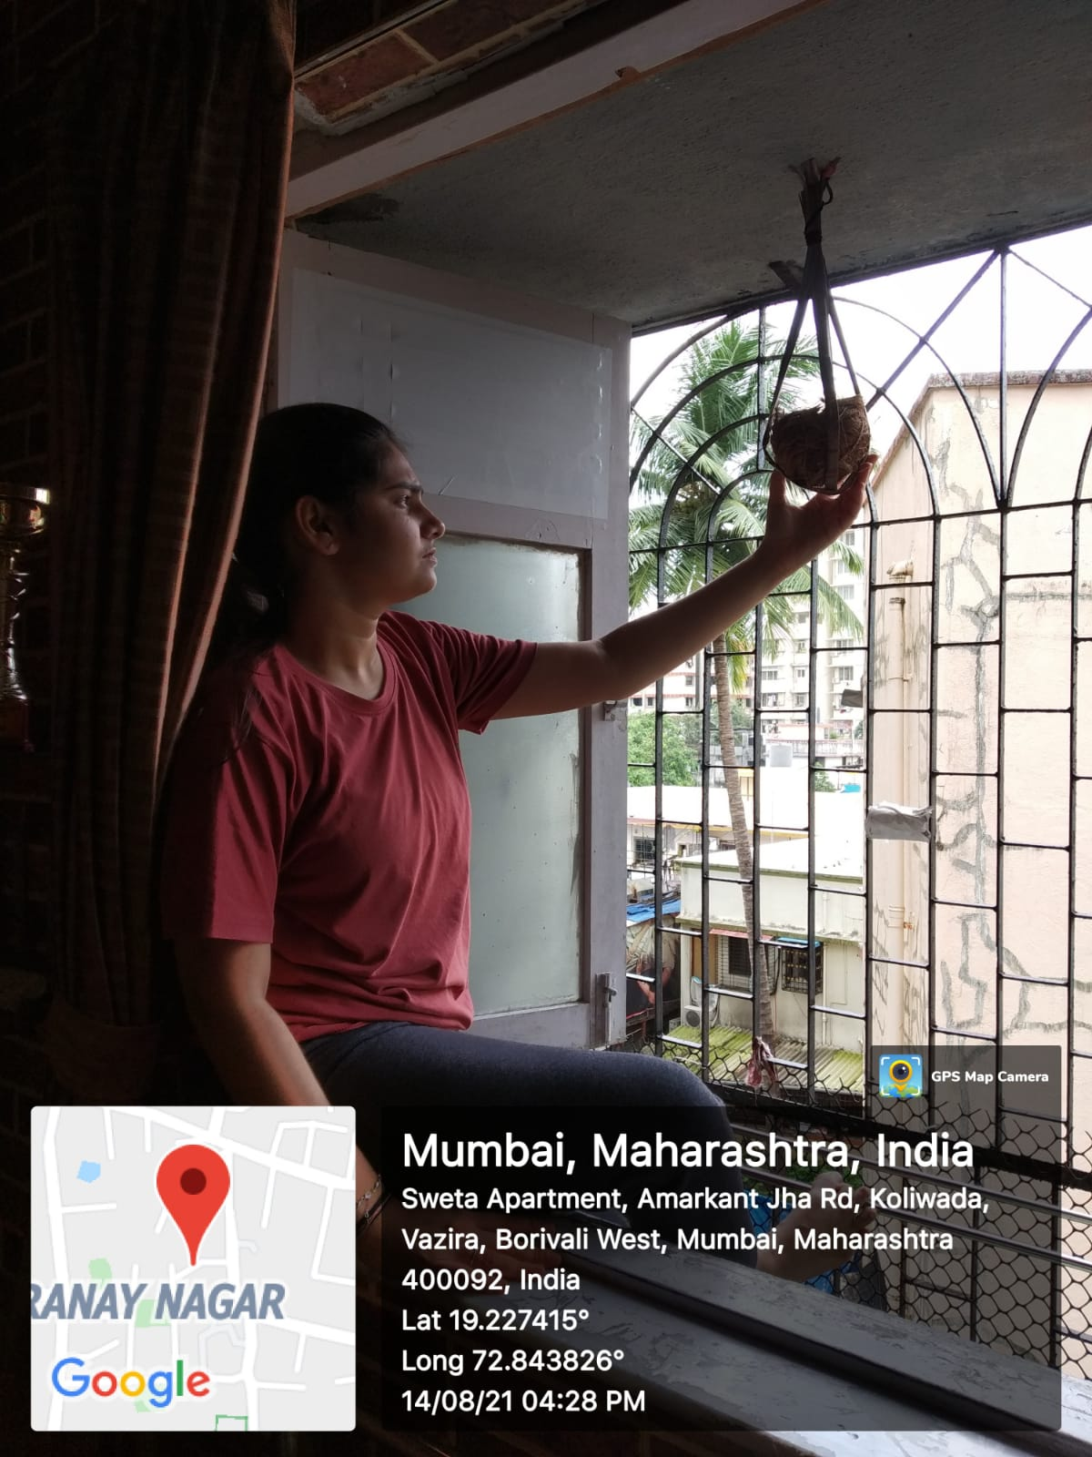

**Description**

Bird nest is the spot where bird lays and hatch their eggs. Mainly bird make their own nest from broken branches of trees and make structure like deep cup. I have also made a nest using coconut shell and coconut coil.

**Material (coconut shell, coco coir, fevicol, coconut leaves)**

Step 1 : Take a half coconut shell.

Step 2 : cover outer layer of the coconut shell with the coco coir help of fevicol

Step 3 : Also put coco coir in the inner layer of coconut shell.

Step 3 : make a rope with the help of coconut leaves so that we can put it in the balcony

**What I feel after doing this activity**

It was an unique and creative feeling I have had will making the bird’s house, I was making something for bird, they will get a nest, a house to lay eggs from which small-small chick will make noise they grew and one day they will fly away. It will be safe for birds to lay eggs. It was my contribution towards saving the environment.