MACHINE LEARNING
AND
ITS APPLICATIONS

By

DEVANGINI V. PATEL
07BCE201



DEPARTMENT OF COMPUTER SCIENCE & ENGINEERING
Ahmedabad 382481

Machine Learning and its applications

Seminar

Submitted in fulfilment of the requirements

For the degree of

Bachelor of Technology in Computer Engineering

By

DEVANGINI V. PATEL
07BCE201

Guided By
POOJA SHAH
DEPARTMENT OF COMPUTER SCIENCE & ENGINEERING

DEPARTMENT OF COMPUTER SCIENCE & ENGINEERING
Ahmedabad 382481

CERTIFICATE

This is to certify that the Seminar entitled “Machine Learning and its applications” submitted by Devangini V. Patel (07BCE201), towards the partial fulfilment of the requirements for the degree of Bachelor of Technology in Computer Engineering of Nirma University is the record of work carried out by her under my supervision and guidance. In my opinion, the submitted work has reached a level required for being accepted for examination.

Date of submission: 21/04/2010

Vijay Ukani Prof.D.J.Patel
Assistant Professor Dept. of Computer Science & Engg.,
Department of Computer Science & Engg., Institute of Technology,
Institute of Technology, Nirma University,
Nirma University, Ahmedabad
Ahmedabad

ACKNOWLEDGEMENT

This project will always remain special because this is my first java project in which I have made my own algorithms.

My guide never said “no” and always cooperated. Her response always pushed me to work harder.

When I told my friends about my seminar project, most of them got shocked that I was going to code for seminar but their interest in my project boosted my own interest in it and made me work even harder so that I could complete it.

Priyanka Sharma Ma’am even helped me to solve one exception, due to lack of data server name, which was bugging me for one week.

ABSTRACT

Machine learning is related to the design and development of algorithms that allow computers to change behaviour based on data such as from sensor data or databases using example data or past experience.

Machine learning is closely related to probability, statistics, artificial intelligence and calculus.

The need for such a subject has risen basically because humans can not explain the basic algorithms behind the simple things that they do easily e.g. speech recognition, walking without bumping into objects and other decision making tasks. It aims at making machines experts by training them and making them understand how to make predictions and conclusions depending on the regularity of the inputs.

Already, there are many successful applications of machine learning applications in various domains. There are commercially available systems for recognizing speech and handwriting. Retail companies analyze their data to learn their past customers’ behaviour to improve customer relationship management. Financial institutions analyze past transactions to predict customers’ credit risks. In bioinformatics, the huge amount of data can only is analyzed and knowledge be extracted by computers. Robots learn to optimize their behaviour to complete a task using minimum resources.

CONTENTS

Certificate III
Acknowledgement IV
Abstract V
Table of Contents VI
List of figures VII

Chapter 1 Introduction 1
1.1 General 1
1.2 Objective of study 1
1.3 Scope of Work 1

Chapter 2 Literature survey 2
  - General 2
  - Literature review 2

Chapter 3 Types of machine learning 2
  - Associations 2
  - Classifications 3
  - Pattern recognition 3
    - Optical pattern recognition 3
    - Language recognition 4
    - Face recognition 4
    - Speech recognition 4
  - Regression 4
  - Supervised learning 5
  - Unsupervised learning 5
  - Reinforcement 5

Chapter 4 Tic-Tac-Toe implementation 6
  - Decision tree 6
  - Representation of decision tree 8
  - Creation of decision tree 10
    - Making a database containing suitable 10
cases and their results
    - Making a tree representation from 23
the database
4.4 Testing the Tic-Tac-Toe game 37

Chapter 5 Conclusion 46
5.1 Summary 46
5.2 Conclusions 46

References 47
Appendix – A List of Useful Websites 47

List of Figures

Figure no Details
1.1 Relationship between AI and ML
3.1 Relationship between savings and income and division of these
data sets into two classes high risk class and low risk class.
3.2 Conversion of image to people
3.3 Diagram showing flow of information in reinforcement learning
3.4 Relationship between price and mileage
3.5 Conversion of acoustic signals into words
4.1 Snapshot of tictactoe.java in execution
4.2 Snapshot of makedt.java program in execution
4.3 Decision tree for Tic-Tac-Toe game

Chapter 1 Introduction
  - General
Machine learning is a part of Artificial Intelligence which deals with the design and development of algorithms that change behaviour based on the inputs from sensors and databases. The algorithms analyze the input and find the regularities by which predictions can be made.
Learning is that attribute of an algorithm that not only gives it dynamism but also the capacity to judge how to react.
Machine learning has come about because human expertise doesn’t exist, if they do then they can not explain the working, the problem is dynamic or the problem depends on environment. Examples include: learning routing program, which the best path is learnt by monitoring traffic and speech recognition.

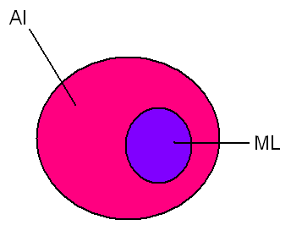
Figure 1.1- relationship between AI and ML

  - Objective of study
This study aims at understanding how machines can learn or how they acquire the human ability to learn simple things and perform complicated and difficult tasks. It covers the types of machine learning and various examples that help to understand the variety of learning that is possible.

  - Scope of work
This project work discusses the types of machine learning and details of supervised machine learning. It also includes an implementation of tic-tac-toe and how machine learning actually takes place in this application.

Chapter 2 Literature survey

  - General
Many documents and books can be found on machine learning but the book that I referred to initially was quite interesting and easy to understand. Many subtopics are included under machine learning; each with their own distinct characteristics. It is not possible to go through all the different areas under machine learning because all are very different and vast.

  - Literature review
The book that I initially referred to was “Introduction to Machine Learning” by Ethem Alpaydin. The topics presented in the book are easy to follow. Enough examples have been given to make the concepts clear. The book also takes a practical approach towards each section by including the possible application of the concepts.

Chapter 3 Types of machine learning

The various types of machine learning techniques are as follows:

  - Associations
In this case, certain classes are associated with other classes. Consider the following example which is known as basket analysis (finding associations between products and customers):

 | Product x | Product y
Group A | √ | √
Group B | √ | X
Table 3.1 – table showing relationship between group of customers and products

It is clear from this example that people of group A are the potential buyers of product y. So, in order to boost the sales of product y, one way would be to lure the customers of product x who belong to group A and promote its sales.
Association rule is the conditional probability of the form P (y|x). In this case, P (Y|X) is the probability that the customer would purchase product y when product x has already been purchased.
Another way would be to consider, P (y|x, D) where D is the set of customer parameters such as gender, age, occupation.
An application of this form of machine learning would be to lessen the time to access a web page in a web portal by surveying the potential links the user would select taking factors such as age, interests and occupation into consideration.

  - Classification
The input set is applied to a classifier function which maps the input set to one of the two classes [1]. A discriminant is a function that separates the examples of different classes.
Consider a bank that gives loans. The information that is considered while giving loans is income, savings, profession, age and financial history. In this case, the system should check the past records and should be able to decide whether to give the loan or not.
In this example, two classes can be considered: low risk customers and high risk customers. Let the parameters that would be deciding the classes be income and saving. The following training set is considered:
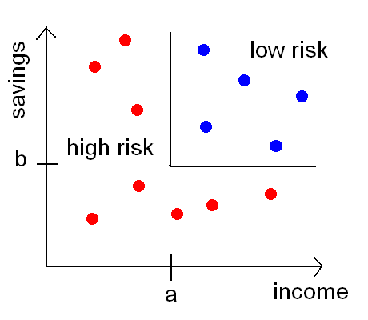
Figure 3.1-Relationship between savings and income and division of these
data sets into two classes high risk class and low risk class.

The applications of this type of machine learning include: pattern recognition (optical character recognition, face recognition, speech recognition), compression, knowledge extraction, outlier detection.

    - Pattern Recognition

      - Optical pattern recognition
There are various possibilities in pattern due to style, size, slanted, pen, and pencil. But the common things are the strokes. So the regularity has to be captured and learned.

      - Language
A word consists of characters; a sentence consists of words and a language sentences. Using the syntax and semantics of a language the sequences have to be learned and dependencies modeled.

      - Face recognition
The difference in different photographs of the same person may be due to size, pose, light, glasses, beard, etc. The common thing is the structure of the face that can never be changed.

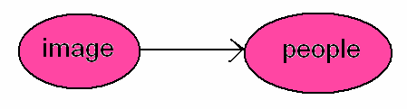
Figure 3.2- conversion of image to people

      - Speech recognition
The difference in speech of different people may be due to age, gender, temporal differences. Here, the lip movements are recorded by camera and by using sensor fusion (acoustic + visual), the words can be interpreted.
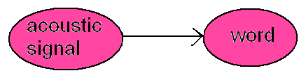
Figure 3.3- conversion of acoustic signals into words

  - Regression
Regression is the type of machine learning algorithms in which the output is a number.
Consider a problem in which the price of a car has to be determined. Let x be the car attributes (mileage, in this case) and y be the price of the car. A linear relation may exist between the two, of the following form:
y=wx+wo

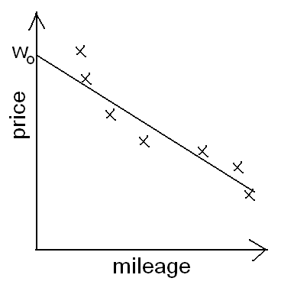
Figure 3.4– Relationship between price and mileage

The linear model being restrictive, the relation may be expressed in higher polynomial forms.
Regression is generally used when a function has to be optimized because here the numerical values need to be taken not for differentiation of the examples but for their exact values in terms of output.

  - Supervised learning
Two examples of supervised learning are: classification and regression. Here, data sets are provided and the algorithm has to learn the mapping and the correct values are provided by supervisor.

  - Unsupervised learning
As the name implies, there is no supervision and only the input is given. The aim is to find regularities in input data and find out what generally what happens and what does not. The statistics obtained is known as density estimation. One type of this is clustering (finding groups) to employ strategies. An example of this is image compression in which groups of pixels are collected and their code is replaced by a code to represent the group. Here, there is a decrease in memory storage at the cost of loss in details.

  - Reinforcement learning
The output is a sequence of actions. Here, the agent learns from past experience. In this case, there is no good action but an action is good if it is a part of a good policy. An example of this is game playing. It is easy to describe but difficult to play. There are a small number of moves in the rules in the game but a large number of possible moves in the game. An agent can move in any direction. It has to learn the path and increase its speed and not hit. In the game of robots playing soccer, there are multiple agents which must interact and cooperate.
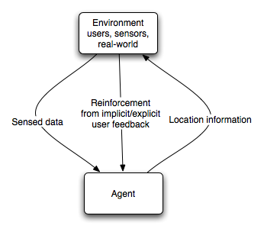
Figure 3.5– Diagram showing flow of information in reinforcement learning

- Tic-Tac-Toe Implementation

  - Decision Tree

The following figure 4.1 shows a restricted decision tree without any probability attached to the nodes. Here, a red node represents an action taken by the computer and the green coloured node represents an action taken by the user. Initially in this game, the middle box will be marked indicating the action taken by the computer (marked by O). Now, the user has eight possibilities: 1, 2, 3, 4, 6, 7, 8 and 9. Only, the possibilities for 3, and 8 have been shown because the possibilities or 1, 3, 7 and 9 are equivalent and the possibilities for 2, 4, 6, 8 are equivalent.
Some nodes’ children have not been shown and considered in this project to reduce complexity.
The word “WIN” and “DRAW” mean that the corresponding player has won and the game has stopped.
Here, X means the value of the node is any other value other than the other possibility from its parent node.

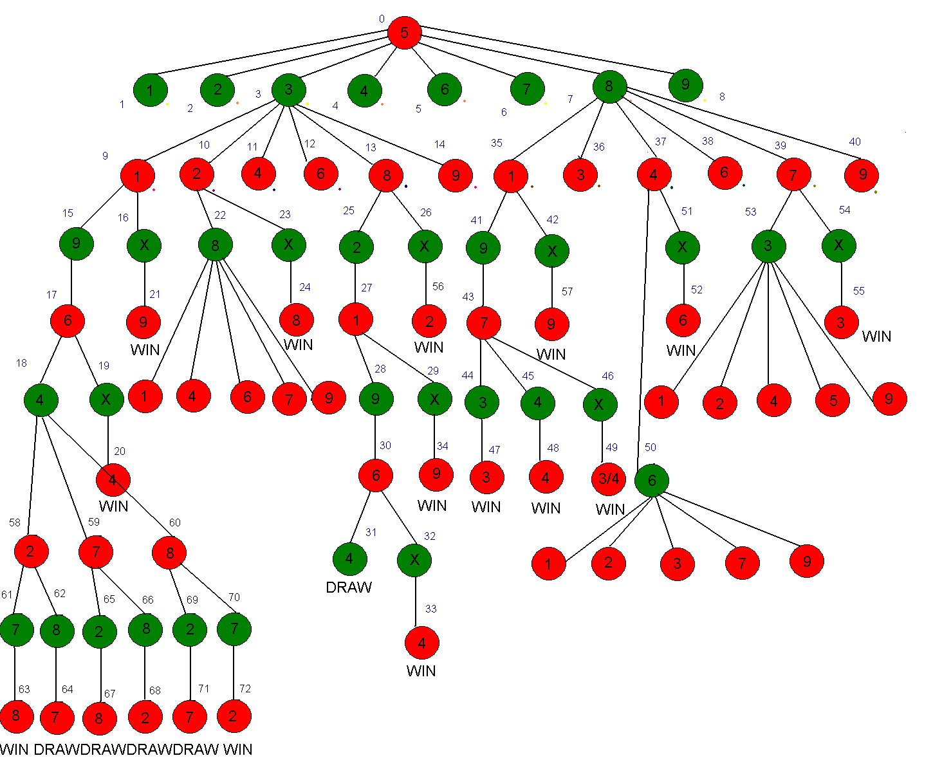

Figure 4.1- Decision tree for Tic-Tac-Toe game

  - Representation of decision tree

int tree[][]={
{5,1,8}, //0
{1,0,0}, //1
{2,0,0}, //2
{3,9,14}, //3
{4,0,0}, //4
{6,0,0}, //5
{7,0,0}, //6
{8,35,40}, //7
{9,0,0}, //8
{1,15,16}, //9
{2,22,23}, //10
{4,0,0}, // 11
{6,0,0}, //12
{8,25,26}, //13
{9,0,0}, //14
{9,16,16}, //15
{90,21,21}, //16
{6,18,19}, //17
{4,-1,-1}, //18
{40,20,20}, //19
{4,-2,-2}, //20
{9,-2,-2}, //21
{8,0,0}, //22
{80,24,24}, //23
{8,-2,-2}, //24
{2,27,27}, //25
{20,56,56}, //26
{1,28,29}, //27
{9,30,30}, //28
{90,34,34}, //29
{6,31,32}, //30
{4,-1,-1}, //31
{40,33,33}, //32
{4,-2,-2}, //33
{9,-2,-2}, //34
{1,41,42}, //35
{3,0,0}, //36
{4,50,51}, //37
{6,0,0}, //38
{7,0,0}, //39
{9,0,0}, //40
{9,43,43}, //41
{10,57,57}, //42
{7,44,44}, //43
{3,47,47}, //44
{4,48,48}, //45
{340,49,49}, //46
{3,-2,-2}, //47
{4,-2,-2}, //48
{3,-2,-2}, //49 3/4
{6,0,0}, //50
{60,52,52}, //51
{6,-2,-2}, //52
{3,0,0}, //53
{30,55,55}, //54
{3,-2,-2}, //55
{2,-2,-2}, //56
{9,-2,-2} //57
{2,61,62} //58
{7,65,66} //59
{8,69,70} //60
{7,63,63} //61
{8,64,64} //62
{8,-2,-2} //63
{7,-1,-1} //64
{2,67,67} //65
{8,68,68} //66
{8,-1,-1} //67
{2,-1,-1} //68
{2,71,71} //69
{7,72,72} //70
{7,-1,-1} //71
{2,-2,-2} //72
};

Here, tree is the 3D array which will be holding the decision tree. The first element in each row specifies the value of the node; the second value is the start index of its children and the third value is the stop index of its children. Here, the children of a node are stored in sequential order; so that the pointer to its children need not be a collection of indices. If a node does not have children then it means that the game has stopped; so the result associated with that node should be stored in that tree. Instead creating another field for the result, it is actually expressed through the second field as a negative index. If the value of the start index is -1 then it is a draw or if it is -2 then the corresponding player wins. A 0 value in that position means that the children of that node have not been specified.
Here, the X node is actually represented as the 10’s multiple of the other node e.g. for node 19, the value would be 40 and for node 46, the value would be 340 or 430.

  - Creation of decision tree

    - Make a database containing suitable test cases and their results

makedt.java

import java.awt.*;
import javax.swing.*;
import java.awt.event.*;
import javax.swing.event.*;
import java.sql.*;

public class makedt extends JFrame
{
JFrame frame;
JButton b1;
JButton b2;
JButton b3;
JButton b4;
JButton b5;
JButton b6;
JButton b7;
JButton b8;
JButton b9;
JButton bnext;
JButton bstep;
JButton bend;
JButton bstop;
JRadioButton r1;
JRadioButton r2;
JRadioButton r3;
ButtonGroup g;
JButton bresult;

int mat[][][]=new int[3][3][3];
static ResultSet rs;
static Statement s;
static PreparedStatement ps;
static PreparedStatement ps1;
static Connection con;

int level;
int stop; //1=first person,2=second person,0=no person
int result; //0=draw 1=win
int val; //get from db
int turn;
int current; //present row
int col; //present column

makedt()
{
frame=new JFrame("Tic-Tac-Toe");
frame.setDefaultCloseOperation(JFrame.EXIT_ON_CLOSE);

JPanel panel=new JPanel();

frame.getContentPane().add(panel);
panel.setLayout(new BorderLayout());

JPanel grid=new JPanel();
grid.setLayout(new GridLayout(3,3));

JPanel options=new JPanel();
panel.setLayout(new GridLayout(4,2,10,10));

b1=new JButton("1");
b1.setSize(20,20);
b2=new JButton("2");
b2.setSize(20,20);
b3=new JButton("3");
b3.setSize(20,20);
b4=new JButton("4");
b4.setSize(20,20);
b5=new JButton("o");
b5.setSize(20,20);
b6=new JButton("6");
b6.setSize(20,20);
b7=new JButton("7");
b7.setSize(20,20);
b8=new JButton("8");
b8.setSize(20,20);
b9=new JButton("9");
b9.setSize(20,20);

grid.add(b1);
grid.add(b2);
grid.add(b3);
grid.add(b4);
grid.add(b5);
grid.add(b6);
grid.add(b7);
grid.add(b8);
grid.add(b9);
panel.add(grid,BorderLayout.CENTER);

ActionListener logic=new logic();

bnext=new JButton("next");
bstep=new JButton("step");
bstop=new JButton("stop");
bnext.addActionListener(logic);
bend=new JButton("end");
bend.addActionListener(logic);
bresult=new JButton("result");
bresult.addActionListener(logic);

r1=new JRadioButton("draw");
r2=new JRadioButton("X wins");
r3=new JRadioButton("0 wins");

g=new ButtonGroup();
g.add(r1);
g.add(r2);
g.add(r3);

options.add(bnext);
options.add(bstep);
options.add(bend);
options.add(bstop);
options.add(r1);
options.add(r2);
options.add(r3);
options.add(bresult);

panel.add(options,BorderLayout.SOUTH);

KeyListener enter=new enter();
bstep.addKeyListener(enter);

frame.setSize(500,500);
frame.setVisible(true);
frame.setLocationRelativeTo(null);

turn=0;
current=0; //0
col=0;

}

private void reset()
{
b1.setText("1");
b2.setText("2");
b3.setText("3");
b4.setText("4");
b5.setText("O");
b6.setText("6");
b7.setText("7");
b8.setText("8");
b9.setText("9");
turn=0;
col=0;
for(int i=0;i<3;i++)
for(int j=0;j<3;j++)
{
mat[i][j][0]=0;
mat[i][j][1]=0;
}
}

private void settext(int c)
{
String s;

//translate col val into its corresponding val stored in mat[][][]

int m=mat[c/3][c-3*(c/3)][2];
mat[(m-1)/3][(m-1)-3*((m-1)/3)][turn]=1;
System.out.println("turn"+turn);

if(turn==0)
s="O";
else
s="X";
if(m==1)
{
b1.setText(s);
}
else if(m==2)
{
b2.setText(s);
}
else if(m==3)
{
b3.setText(s);
}
else if(m==4)
{
b4.setText(s);
}
else if(m==5)
{
b5.setText(s);
}
else if(m==6)
{
b6.setText(s);
}
else if(m==7)
{
b7.setText(s);
}
else if(m==8)
{
b8.setText(s);
}
else if(m==9)
{
b9.setText(s);
}
}

private int check()
{
int i,j,k,sum=0;

for(k=0;k<3;k++)
{
for(i=0;i<3;i++)
{
for(j=0;j<3;j++)
System.out.print(mat[i][j][k]+" ");
}
System.out.println();
}

//check for 3 marks in a row
for(k=0;k<2;k++)
{
for(i=0;i<3;i++)
{
for(j=0;j<3;j++)
sum=sum+mat[i][j][k];
if(sum==3)
{
System.out.println("s"+i);
return(0);
}
sum=0;
}
}

//check for 3 marks in a col
for(k=0;k<2;k++)
{
for(i=0;i<3;i++)
{
for(j=0;j<3;j++)
sum=sum+mat[j][i][k];
if(sum==3)
{System.out.println("t"+i);
return(0);
}
sum=0;
}
}

//check for 3 marks in principal diagonal
for(k=0;k<2;k++)
{
sum=mat[0][0][k]+mat[1][1][k]+mat[2][2][k];
if(sum==3)
{System.out.println("u"+k);
return(0);
}
}
//check for 3 marks in other diagonal
for(k=0;k<2;k++)
{
sum=mat[0][2][k]+mat[1][1][k]+mat[2][0][k];
if(sum==3)
{System.out.println("v"+k);
return(0);
}
}
return(1);

}

class enter implements KeyListener
{
public void keyReleased(KeyEvent e)
{
}
public void keyPressed(KeyEvent e)
{
System.out.println("c");
int i;

try
{
if(col<9)
{

i=check();
System.out.println(i);
if(i==0)
{
col++;

System.out.println("win"+col);
//show final status through radio buttons
if(turn==1)
r2.setSelected(true);
else
r3.setSelected(true);

ps1.setInt(1,col);

ps1.setInt(2,turn);
ps1.setInt(3,current);
ps1.executeUpdate();
}
else if(i!=0 && col<8)
{
col++;
//update buttons
turn=1-turn;
settext(col);
}
else
col++;
}
else
{
System.out.println("draw");
r1.setSelected(true);
//draw
ps1.setInt(1,9);
ps1.setInt(2,2);
ps1.setInt(3,current);
ps1.executeUpdate();

}
}
catch(Exception err)
{
System.out.println("ERROR: " + err);
err.printStackTrace();
}
}
public void keyTyped(KeyEvent e)
{
}
}

class logic implements ActionListener
{
public void actionPerformed(ActionEvent e)
{
String s=e.getActionCommand();
if(s.equals("next"))
{
try
{
reset();
turn=0;
col=0;
current++;

System.out.println("current"+current);
ps.setInt(1,current);
ps.execute();
rs=ps.getResultSet();
if (rs!=null) // if rs == null, then no ResultSet
while ( rs.next() ) // step through data row-by-row
{
for(int i=0;i<3;i++)
{
for(int j=0;j<3;j++)
{
mat[i][j][2]=rs.getInt(3*i+j+1+1); //1=sr
System.out.println(current+"row ="+mat[i][j][2]);
}
}
}
mat[1][1][0]=1; //5 is already marked
}
catch(Exception err)
{
System.out.println("ERROR: " + err);
err.printStackTrace();
}
}
else if(s.equals("result"))
{
try
{
//add result to db
ps1.setInt(1,col);
ps1.setInt(2,result);
ps1.setInt(3,current);
}
catch(Exception err)
{
System.out.println("ERROR: " + err);
err.printStackTrace();
}
}
else if(s.equals("end"))
{
try
{
con.commit();

// close prep-Statement
ps.close();

//close connection
con.close();
}
catch(Exception err)
{
System.out.println("ERROR: " + err);
err.printStackTrace();
}
}
else if(s.equals("stop"))
{
//user has found out that a draw is there
try
{
ps1.setInt(1,col);
ps1.setInt(2,2);
ps1.setInt(3,current);
ps1.executeUpdate();
}
catch(Exception err)
{
System.out.println("ERROR: " + err);
err.printStackTrace();
}
}
}
}

private static void train()
{
int i=0;
try
{
//load driver
Class.forName("sun.jdbc.odbc.JdbcOdbcDriver");

con = DriverManager.getConnection("jdbc:odbc:db1Table1","","");

ps=con.prepareStatement("select * from Table1 where sr=?");
ps1=con.prepareStatement("update Table1 set stop=?,res=? where sr=?");

}
catch (Exception err)
{
System.out.println("ERROR: " + err);
err.printStackTrace();
}
}

public static void main(String []args)
{
JFrame f=new makedt();
train();
}
}

This program connect to a database which contains the following fields: srno., a1, a2,a3, a4, a5, a6, a7, a8, a8, a9, stop (column at which the game finishes) and the result (0=computer wins, 1=user wins and 2=draw).It retrieve a row from the database shows the trace of the actions of the players and determines the result and stop column by constantly calling the check() function at each action of the players.
The screen shot of this program is shown in figure 4.2.

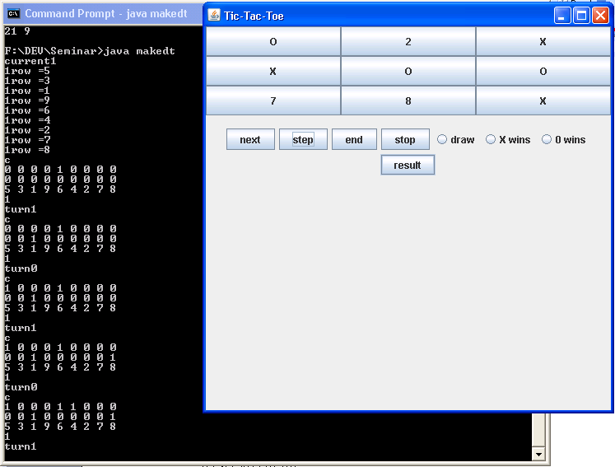

Figure 4.2 – Snapshot of makedt.java program in execution

    - Making a tree representation from that database

dectree.java

import java.sql.*;
import java.io.*;

public class dectree
{
static ResultSet rs;
static Statement s;
static PreparedStatement ps;
static Connection con;

static int tree[][]=new int[150][3]; //0=val,1=start of children,2=end,3=stop
static int last; //last free position in tree
static int level;
static int stack[][]=new int[9][2]; //top=level 0=start 1=end
static int remove[]=new int[20];

private static void removenegcases()
{
try
{
s.execute("delete * from Table1 where res=1"); //user wins
}
catch(Exception r)
{
System.out.println("ERROR: " + r);
r.printStackTrace();
}
}

private static int maketree(int lev) //start at that particular level
{
int i,limit,end;
System.out.println("\nmaketree level="+lev+" node="+tree[stack[lev-1][0]][0]);

if(lev<9)//9
{

//get nodes in that level
try
{
if(lev==1)
{
ps=con.prepareStatement("select distinct a2 from Table1 where a1=? and stop>=2");
ps.setInt(1,tree[stack[lev-1][0]][0]);
}
else if(lev==2)
{
ps=con.prepareStatement("select distinct a3 from Table1 where a2=? and a1=? and stop>=3");
ps.setInt(1,tree[stack[lev-1][0]][0]); //parent
ps.setInt(2,tree[stack[lev-2][0]][0]);
}
else if(lev==3)
{
ps=con.prepareStatement("select distinct a4 from Table1 where a3=? and a2=? and a1=? and stop>=4");
ps.setInt(1,tree[stack[lev-1][0]][0]); //parent
ps.setInt(2,tree[stack[lev-2][0]][0]);
ps.setInt(3,tree[stack[lev-3][0]][0]);
}
else if(lev==4)
{
ps=con.prepareStatement("select distinct a5 from Table1 where a4=? and a3=? and a2=? and a1=? and stop>=5");
ps.setInt(1,tree[stack[lev-1][0]][0]); //parent
ps.setInt(2,tree[stack[lev-2][0]][0]);
ps.setInt(3,tree[stack[lev-3][0]][0]);
ps.setInt(4,tree[stack[lev-4][0]][0]);

}
else if(lev==5)
{
ps=con.prepareStatement("select distinct a6 from Table1 where a5=? and a4=? and a3=? and a2=? and a1=? and stop>=6");
ps.setInt(1,tree[stack[lev-1][0]][0]); //parent
ps.setInt(2,tree[stack[lev-2][0]][0]);
ps.setInt(3,tree[stack[lev-3][0]][0]);
ps.setInt(4,tree[stack[lev-4][0]][0]);
ps.setInt(5,tree[stack[lev-5][0]][0]);
}
else if(lev==6)
{
ps=con.prepareStatement("select distinct a7 from Table1 where a6=? and a5=? and a4=? and a3=? and a2=? and a1=? and stop>=7");
ps.setInt(1,tree[stack[lev-1][0]][0]); //parent
ps.setInt(2,tree[stack[lev-2][0]][0]);
ps.setInt(3,tree[stack[lev-3][0]][0]);
ps.setInt(4,tree[stack[lev-4][0]][0]);
ps.setInt(5,tree[stack[lev-5][0]][0]);
ps.setInt(6,tree[stack[lev-6][0]][0]);
}
else if(lev==7)
{
ps=con.prepareStatement("select distinct a8 from Table1 where a7=? and a6=? and a5=? and a4=? and a3=? and a2=? and a1=? and stop>=8");
ps.setInt(1,tree[stack[lev-1][0]][0]); //parent
ps.setInt(2,tree[stack[lev-2][0]][0]);
ps.setInt(3,tree[stack[lev-3][0]][0]);
ps.setInt(4,tree[stack[lev-4][0]][0]);
ps.setInt(5,tree[stack[lev-5][0]][0]);
ps.setInt(6,tree[stack[lev-6][0]][0]);
ps.setInt(7,tree[stack[lev-7][0]][0]);
}
else if(lev==8)
{
ps=con.prepareStatement("select distinct a9 from Table1 where a8=? and a7=? and a6=? and a5=? and a4=? and a3=? and a2=? and a1=? and stop>=9");
ps.setInt(1,tree[stack[lev-1][0]][0]); //parent
ps.setInt(2,tree[stack[lev-2][0]][0]);
ps.setInt(3,tree[stack[lev-3][0]][0]);
ps.setInt(4,tree[stack[lev-4][0]][0]);
ps.setInt(5,tree[stack[lev-5][0]][0]);
ps.setInt(6,tree[stack[lev-6][0]][0]);
ps.setInt(7,tree[stack[lev-7][0]][0]);
ps.setInt(8,tree[stack[lev-8][0]][0]);
}

ps.execute();
rs=ps.getResultSet();

//store the level nodes in tree

limit=0;
i=0;
while ( rs.next() ) // step through data row-by-row
{
limit=rs.getRow();
tree[last+i][0]=rs.getInt(1);
System.out.println(tree[last+i][0]);
i++;
}

if(limit!=0)
{
//store the next level in stack
stack[lev][0]=last;
stack[lev][1]=last+limit-1;

//store the tree indices in parent
tree[stack[lev-1][0]][1]=last;
tree[stack[lev-1][0]][2]=last+limit-1; //even works when there is no child under it

//update limit
last=last+limit;
maketree(lev+1); //get children if not stopped
}

else //store result in that
{
//change the info stored by store tree indices in parent(even works when no chdr)
if(lev==1)
{
ps=con.prepareStatement("select distinct res from Table1 where a1=?");
ps.setInt(1,tree[stack[lev-1][0]][0]);
}
else if(lev==2)
{
ps=con.prepareStatement("select distinct res from Table1 where a1=? and a2=?");
ps.setInt(1,tree[stack[lev-2][0]][0]);
ps.setInt(2,tree[stack[lev-1][0]][0]);
}
else if(lev==3)
{
ps=con.prepareStatement("select distinct res from Table1 where a1=? and a2=? and a3=?");
ps.setInt(1,tree[stack[lev-3][0]][0]);
ps.setInt(2,tree[stack[lev-2][0]][0]);
ps.setInt(3,tree[stack[lev-1][0]][0]);
}
else if(lev==4)
{
ps=con.prepareStatement("select distinct res from Table1 where a1=? and a2=? and a3=? and a4=?");
ps.setInt(1,tree[stack[lev-4][0]][0]);
ps.setInt(2,tree[stack[lev-3][0]][0]);
ps.setInt(3,tree[stack[lev-2][0]][0]);
ps.setInt(4,tree[stack[lev-1][0]][0]);
}
else if(lev==5)
{
ps=con.prepareStatement("select res from Table1 where a1=? and a2=? and a3=? and a4=? and a5=?");
ps.setInt(1,tree[stack[lev-5][0]][0]);
ps.setInt(2,tree[stack[lev-4][0]][0]);
ps.setInt(3,tree[stack[lev-3][0]][0]);
ps.setInt(4,tree[stack[lev-2][0]][0]);
ps.setInt(5,tree[stack[lev-1][0]][0]);
}
else if(lev==6)
{
ps=con.prepareStatement("select distinct res from Table1 where a1=? and a2=? and a3=? and a4=? and a5=? and a6=?");
ps.setInt(1,tree[stack[lev-6][0]][0]);
ps.setInt(2,tree[stack[lev-5][0]][0]);
ps.setInt(3,tree[stack[lev-4][0]][0]);
ps.setInt(4,tree[stack[lev-3][0]][0]);
ps.setInt(5,tree[stack[lev-2][0]][0]);
ps.setInt(6,tree[stack[lev-1][0]][0]);
}
else if(lev==7)
{
ps=con.prepareStatement("select distinct res from Table1 where a1=? and a2=? and a3=? and a4=? and a5=? and a6=? and a7=?");
ps.setInt(1,tree[stack[lev-7][0]][0]);
ps.setInt(2,tree[stack[lev-6][0]][0]);
ps.setInt(3,tree[stack[lev-5][0]][0]);
ps.setInt(4,tree[stack[lev-4][0]][0]);
ps.setInt(5,tree[stack[lev-3][0]][0]);
ps.setInt(6,tree[stack[lev-2][0]][0]);
ps.setInt(7,tree[stack[lev-1][0]][0]);
}
else if(lev==8)
{
ps=con.prepareStatement("select distinct res from Table1 where a1=? and a2=? and a3=? and a4=? and a5=? and a6=? and a7=? and a8=?");
ps.setInt(1,tree[stack[lev-8][0]][0]);
ps.setInt(2,tree[stack[lev-7][0]][0]);
ps.setInt(3,tree[stack[lev-6][0]][0]);
ps.setInt(4,tree[stack[lev-5][0]][0]);
ps.setInt(5,tree[stack[lev-4][0]][0]);
ps.setInt(6,tree[stack[lev-3][0]][0]);
ps.setInt(7,tree[stack[lev-2][0]][0]);
ps.setInt(8,tree[stack[lev-1][0]][0]);
}

ps.execute();
rs=ps.getResultSet();
rs.next();

//doubt
tree[stack[lev-1][0]][1]=rs.getInt(1);
if(tree[stack[lev-1][0]][1]==0)//result -1=draw,-2=win,-3=lose
{ //db 0=win 2=draw
tree[stack[lev-1][0]][1]=-2;
}
else if(tree[stack[lev-1][0]][1]==2)
{
tree[stack[lev-1][0]][1]=-1;
}
}

//go to next child

while(stack[lev][0]<stack[lev][1])
{
stack[lev][0]++;
System.out.println("child"+tree[stack[lev][0]][0]);
maketree(lev+1); //+1 extra
}

//when limit==0||1
//no more children
System.out.println("no more children");
return(0);
}
catch(Exception x)
{
System.out.println("ERROR: " + x);
x.printStackTrace();
}
}
else
{
try
{

ps=con.prepareStatement("select distinct res from Table1 where a1=? and a2=? and a3=? and a4=? and a5=? and a6=? and a7=? and a8=? and a9=?");
ps.setInt(1,tree[stack[lev-9][0]][0]);
ps.setInt(2,tree[stack[lev-8][0]][0]);
ps.setInt(3,tree[stack[lev-7][0]][0]);
ps.setInt(4,tree[stack[lev-6][0]][0]);
ps.setInt(5,tree[stack[lev-5][0]][0]);
ps.setInt(6,tree[stack[lev-4][0]][0]);
ps.setInt(7,tree[stack[lev-3][0]][0]);
ps.setInt(8,tree[stack[lev-2][0]][0]);
ps.setInt(9,tree[stack[lev-1][0]][0]);
ps.execute();
rs=ps.getResultSet();

rs.next();
tree[stack[lev-1][0]][1]=rs.getInt(1);
if(tree[stack[lev-1][0]][1]==0)//result -1=draw,-2=win,-3=lose
{ //db 0=win 2=draw
tree[stack[lev-1][0]][1]=-2;
}
else if(tree[stack[lev-1][0]][1]==2)
{
tree[stack[lev-1][0]][1]=-1;
}
return(0);
}
catch(Exception f)
{
System.out.println("ERROR: " + f);
f.printStackTrace();
}
}
return(0);
}

private static void compact()
{
int sum,i,j,k,gres,gval,first;

for(i=0;tree[i][0]!=0;i++) //valid nodes
{
if(tree[i][0]>9) //X nodes
{
continue;
}
//not end node
if(tree[i][1]<0)//terminator node
{
continue;
}
//check if the node has atleast two children
if(tree[i][2]-tree[i][1]<1)
{
continue;
}

//check if all children have children by checking that children
//don't have negative numbers in their second field

sum=0;

for(j=tree[i][1];j<=tree[i][2];j++)
{
if(tree[j][1]>0)
sum++;
}
if(sum!=(tree[i][2]-tree[i][1]+1))
{
continue;
}

//observation:all grangchildren node exept one are termainator nodes
sum=0;
for(j=tree[i][1];j<=tree[i][2];j++)
{
if(tree[tree[j][1]][1]<0)
sum++;
}

if(sum!=tree[i][2]-tree[i][1])
continue;

else
{
System.out.println(i+" "+tree[i][0]);

//check for each child if others have common grandchildren
for(j=tree[i][1];j<=tree[i][2];j++)
{
if(tree[tree[j][1]][1]<0)//because X is followed by result
continue;

sum=0;
first=0;
gres=3; //init so that error does not occur during compilation
gval=-1;
for(k=tree[i][1];k<=tree[i][2];k++) //others have same grandchild value and result
{
if(j==k)
continue;
if(first==0)
{
gres=tree[tree[k][1]][1];
gval=tree[tree[k][1]][0];
first=k;
sum++;
}
else
{
if(gres==tree[tree[k][1]][1] && gval==tree[tree[k][1]][0])
sum++;
}
}
//check if the children and grandchildren can be combined
if(sum==tree[i][2]-tree[i][1]) //don't consider j==k case
{
System.out.println("can be combined");
//put X
//change range

//last child then put X just beore it
if(j==tree[i][2])
{
tree[i][1]=j-1;
tree[j-1][1]=first; //point to any terminator node
tree[j-1][0]=tree[j][0]*10; //X=10*value of j
System.out.println("new "+tree[j-1][0]+" "+tree[j-1][1]);
}
else //put X after it
{
tree[i][1]=j;
tree[i][2]=j+1;
tree[j+1][1]=first;//point to any terminator node
tree[j+1][0]=tree[j][0]*10;
System.out.println("new "+tree[j+1][0]+" "+tree[j+1][1]);
}
break;
}
}
}
}
}

private static void writetofile(String file)
{
try
{
int i=0;
String v="";
FileWriter fstream=new FileWriter(file);
BufferedWriter out=new BufferedWriter(fstream);
while(tree[i][0]!=0)
{
v=tree[i][0]+" "+tree[i][1]+" "+tree[i][2];
if(!v.equals(""))
out.write(v+"\n");
i++;
}
out.close();
}
catch(Exception n)
{
System.out.println("ERROR: " + n);
n.printStackTrace();
}
}

public static void main(String []args)
{

//init
tree[0][0]=5;
stack[0][0]=0;
stack[0][1]=0;
last=1; //position at which new entry can be made
level=1;

try
{
//load driver
Class.forName("sun.jdbc.odbc.JdbcOdbcDriver");

con = DriverManager.getConnection("jdbc:odbc:db1Table1","","");
s=con.createStatement();

removenegcases();

maketree(level);

writetofile("dtree.txt");

compact();

writetofile("tempdtree.txt");

con.commit();
s.close();
con.close();

}
catch(Exception e)
{
System.out.println("ERROR: " + e);
e.printStackTrace();
}
}
}

First this program removes all negative results from the database so that all the negative cases are not considered while making the decision tree.
A stack would need to be used to store the information regarding the current and previous levels while traversing the tree.
Function maketree() is used to create the decision tree. The select distinct statements will select all distinct children of a particular node to remove redundancies. The value and position of the particular node in the tree can be found out using the stack. This is a recursive function and it will call itself to expand the tree for its children
The compact() function will put all X in the tree and remove all unwanted nodes corresponding to the X.

4.4 Testing the Tic-Tac-Toe game

Tictactoe.java

import java.awt.*;
import javax.swing.*;
import java.awt.event.*;
import javax.swing.event.*;

public class tictactoe extends JFrame
{
JFrame frame;
JButton b1;
JButton b2;
JButton b3;
JButton b4;
JButton b5;
JButton b6;
JButton b7;
JButton b8;
JButton b9;
int turn;
//int mat[][]={{0,0,0},{0,0,0},{0,0,0}}; //1=X,2=O
int current; //node,minlimit,maxlimit
int tree[][]={ //-1=draw,-2=win,-3=loss 0-NOT DEFINED SO FAR
{5,1,8}, //0
{1,0,0}, //1
{2,0,0}, //2
{3,9,14}, //3 implemented
{4,0,0}, //4
{6,0,0}, //5
{7,0,0}, //6
{8,35,40}, //7 implemented
{9,0,0}, //8
{1,15,16}, //9
{2,22,23}, //10
{4,0,0}, // 11
{6,0,0}, //12
{8,25,26}, //13
{9,0,0}, //14
{9,16,16}, //15 10=X=REMAINING
{90,21,21}, //16
{6,18,19}, //17
{4,58,60}, //18
{40,20,20}, //19
{4,-2,-2}, //20
{9,-2,-2}, //21
{8,0,0}, //22
{80,24,24}, //23
{8,-2,-2}, //24
{2,27,27}, //25
{20,56,56}, //26
{1,28,29}, //27
{9,30,30}, //28
{90,34,34}, //29
{6,31,32}, //30
{4,-1,-1}, //31
{40,33,33}, //32
{4,-2,-2}, //33
{9,-2,-2}, //34
{1,41,42}, //35
{3,0,0}, //36
{4,50,51}, //37
{6,0,0}, //38
{7,0,0}, //39
{9,0,0}, //40
{9,43,43}, //41
{10,57,57}, //42
{7,44,44}, //43
{3,47,47}, //44
{4,48,48}, //45
{340,49,49}, //46
{3,-2,-2}, //47
{4,-2,-2}, //48
{3,-2,-2}, //49 3/4
{6,0,0}, //50
{60,52,52}, //51
{6,-2,-2}, //52
{3,0,0}, //53
{30,55,55}, //54
{3,-2,-2}, //55
{2,-2,-2}, //56
{9,-2,-2}, //57
{2,61,62}, //58
{7,65,66}, //59
{8,69,70}, //60
{7,63,63}, //61
{8,64,64}, //62
{8,-2,-2}, //63
{7,-1,-1}, //64
{2,67,67}, //65
{8,68,68}, //66
{8,-1,-1}, //67
{2,-1,-1}, //68
{2,71,71}, //69
{7,72,72}, //70
{7,-1,-1}, //71
{2,-2,-2}, //72
};

tictactoe()
{
frame=new JFrame("Tic-Tac-Toe");
frame.setDefaultCloseOperation(JFrame.EXIT_ON_CLOSE);

JPanel panel=new JPanel();
frame.getContentPane().add(panel);
panel.setLayout(new BorderLayout());

JPanel grid=new JPanel();
grid.setLayout(new GridLayout(3,3));

ActionListener logic=new logic();

b1=new JButton("1");
b1.setSize(20,20);
b1.addActionListener(logic);
b2=new JButton("2");
b2.setSize(20,20);
b2.addActionListener(logic);
b3=new JButton("3");
b3.setSize(20,20);
b3.addActionListener(logic);
b4=new JButton("4");
b4.setSize(20,20);
b4.addActionListener(logic);
b5=new JButton("O");
b5.setSize(20,20);
b5.addActionListener(logic);
b6=new JButton("6");
b6.setSize(20,20);
b6.addActionListener(logic);
b7=new JButton("7");
b7.setSize(20,20);
b7.addActionListener(logic);
b8=new JButton("8");
b8.setSize(20,20);
b8.addActionListener(logic);
b9=new JButton("9");
b9.setSize(20,20);
b9.addActionListener(logic);

JButton start=new JButton("Start");
//start.addActionListener(logic);
//panel.add(start,BorderLayout.SOUTH);

grid.add(b1);
grid.add(b2);
grid.add(b3);
grid.add(b4);
grid.add(b5);
grid.add(b6);
grid.add(b7);
grid.add(b8);
grid.add(b9);

panel.add(grid,BorderLayout.CENTER);

frame.setSize(500,500);
frame.setVisible(true);
frame.setLocationRelativeTo(null);

current=0;
turn=1;
}

private void reset()
{
b1.setText("1");
b2.setText("2");
b3.setText("3");
b4.setText("4");
b5.setText("o");
b6.setText("6");
b7.setText("7");
b8.setText("8");
b9.setText("9");
current=0;
turn=0;
}

private int settext(String k,int t)
{
String s;
int m=Integer.parseInt(k);
//mat[m/3][m-3*(m/3)]=2-t;
if(t==0)
s="O";
else
s="X";
if(m==1)
{
b1.setText(s);
}
else if(m==2)
{
b2.setText(s);
}
else if(m==3)
{
b3.setText(s);
}
else if(m==4)
{
b4.setText(s);
}
else if(m==5)
{
b5.setText(s);
}
else if(m==6)
{
b6.setText(s);
}
else if(m==7)
{
b7.setText(s);
}
else if(m==8)
{
b8.setText(s);
}
else if(m==9)
{
b9.setText(s);
}
else
return(1);
return(0);
}

private void play()
{
int next;
do
{
next=(int)(tree[current][1]+(Math.random()*(tree[current][2]-tree[current][1])));
}while(tree[next][1]==0);
System.out.println(next+" "+tree[next][0]);
current=next;
settext(Integer.toString(tree[current][0]),0);
turn=1-turn;
check();
}

private void check()
{
if(tree[current][1]==-2)
{
JOptionPane.showMessageDialog(frame,"The computer has won");
reset();
}
else if(tree[current][1]==-1)
{
JOptionPane.showMessageDialog(frame,"Draw");
reset();
}
else if(tree[current][1]==-3)
{
JOptionPane.showMessageDialog(frame,"You win");
reset();
}
}

class logic implements ActionListener
{
public void actionPerformed(ActionEvent e)
{
int n,i,no;
String key=e.getActionCommand();
//if(key.equals("Start"))
{
//reset();
}
//else
{
no=Integer.parseInt(key);
if(turn==1)
{
n=settext(key,1);
if(n==0)
{
//change current

//if X
for(i=tree[current][1];i<=tree[current][2];i++)
{
if(tree[i][0]/10!=0) //check for presence of X
{ //check if user has gone for any other key
if(no!=tree[i][0]/10 ||((tree[i][0]>=100)&&(no!=tree[i][0]/100 ||no!=(tree[i][0]-tree[i][0]/100*100)/10)))
{
current=i;
System.out.println(current+" "+tree[current][0]);
}
}
}

for(i=tree[current][1];i<=tree[current][2];i++)
{
if(tree[i][0]==no && tree[i][1]!=0)
{
current=i;
System.out.println(current+" "+tree[current][0]);
break;
}
}
turn=1-turn;
check();
play();

}
}
}
}
}

public static void main(String []args)
{
JFrame f=new tictactoe();
}
}

This game takes the decision tree created by the two programs and is used to help the program decide what good possibilities are there and the result.
A snapshot of this program is shown in figure 4.3.

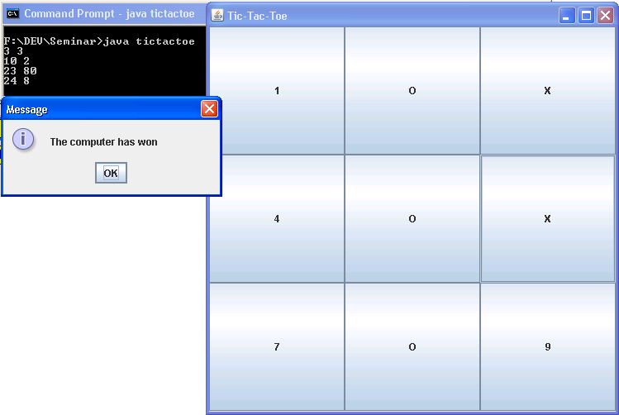
Figure 4.3- snapshot of tictactoe.java in execution

- Conclusion

  - Summary
This project deals with the implementation of Tic-Tac-Toe game. By this example, the steps of machine learning are demonstrated. The use of data mining, algorithms, data structures is shown through this example.

  - Conclusions
Even though the implementation is quite restricted and constrained, I have learnt the meaning of machine learning and how it can be done practically. Machine learning depends not on the problem definition or the algorithm but on the data and scenario. The algorithm changes as the data complexity and range increase because more condition checking has to be done.

References

1. Ethem Alpaydın (2004) Introduction to Machine Learning (Adaptive Computation
and Machine Learning), MIT Press
2. Learning DNF by decision trees by Giulia Pagalio

Appendix – A List of Useful Websites

- http://en.wikipedia.org/wiki/Machine_learning
- http://www.clsp.jhu.edu/people/rahulr/FAM/RAJAT/robocup/proposal.html
- http://ercim-news.ercim.eu/autonomous-systems-safety-critical-embedded-systems-and-intelligence.html
- http://www.scholarpedia.org/article/Reinforcement_learning
- http://en.wikipedia.org/wiki/Decision_tree

