|  |
| --- |
| Development and Transformation of Social Consciousness |
| H-104 Education and Self, Term Paper Due date: 7/11/2015 |
|  |

Introduction

Ishank Arora Roll No: 14074009

**Social consciousness** is [consciousness](https://en.wikipedia.org/wiki/Consciousness) shared by individuals within a [society](https://en.wikipedia.org/wiki/Society). According to [Karl Marx](https://en.wikipedia.org/wiki/Karl_Marx), human beings enter into certain productive, or economic, relations and these relations lead to a form of social consciousness. Increasing understanding and explicit awareness of social consciousness can develop through transformations in worldview. As a person’s worldview transforms, awareness can expand to include each of these levels, leading to enhanced pro-social experiences and behaviours. Increased social consciousness can in turn stimulate further transformations in worldview. Each person has his or her own personal story about the nature of reality. Genetic tendencies, religion, culture, and geographic region, together with all the experiences people have both internally and in relationship to their environments, give rise to their worldview, or their general way of viewing themselves and the world around them.

Worldview is one aspect of consciousness. Psychological, social and neurophysiological theories of development indicate that as we grow and interact with the world we learn to categorize, discriminate, and generalize about what we see and feel (Flavell, Miller and Miller, 2002; Siegler and Alabali, 2005). A worldview combines beliefs, assumptions, attitudes, values, and ideas to form a comprehensive model of reality. Worldviews also encompass formulations and interpretations of past, present, and future. Human perceptions are filtered by the ways people view the world. People’s worldviews therefore influence every aspect of how they understand and interact with the world around them. Worldviews profoundly impact individual and shared goals and desires, shaping perceptions, motivations and values both consciously and unconsciously. Worldviews inform human behaviour in relationships and choreograph individual and social reactions and actions every moment of the day.

Some aspects of worldviews are dynamic and some are stable over time. Responses based on apparently solid belief structures (such as the belief in free-will vs. destiny, for example) can be manipulated with subtle unconscious priming. At the same time, worldviews can become quite rigid over time and resistant to change, even when new contrasting information is presented. Yet there are times when an experience is so profound, or shifts people’s steady state in such a fundamental way, that they are forced to change the way they view the world. When worldviews change, new possibilities can emerge, even within the same set of circumstances. Worldview transformation, then, is a fundamental shift in perspective that results in long-lasting changes in people’s sense of self, perception of relationship to the world around them, and way of being.

Levels of Social Consciousness

What does it mean to be part of a greater whole? How does our worldview, or model of reality, impact what we understand about who we are and how we relate to others? And how can we become more aware of all the ways we are part of an interrelated, global community?

The complex dynamics of our social identity unfold through five nested levels of social consciousness. These in turn relate to transformations in worldview. We use the term social consciousness to denote conscious awareness of being part of an interrelated community of others. When used this way, social consciousness refers to the level of explicit awareness a person has of being part of a larger whole. It includes the level at which one is aware of how he or she is influenced by others, as well as how his or her actions may affect others. It also includes an understanding that there are many factors shaping experience that lie below the threshold of conscious awareness.

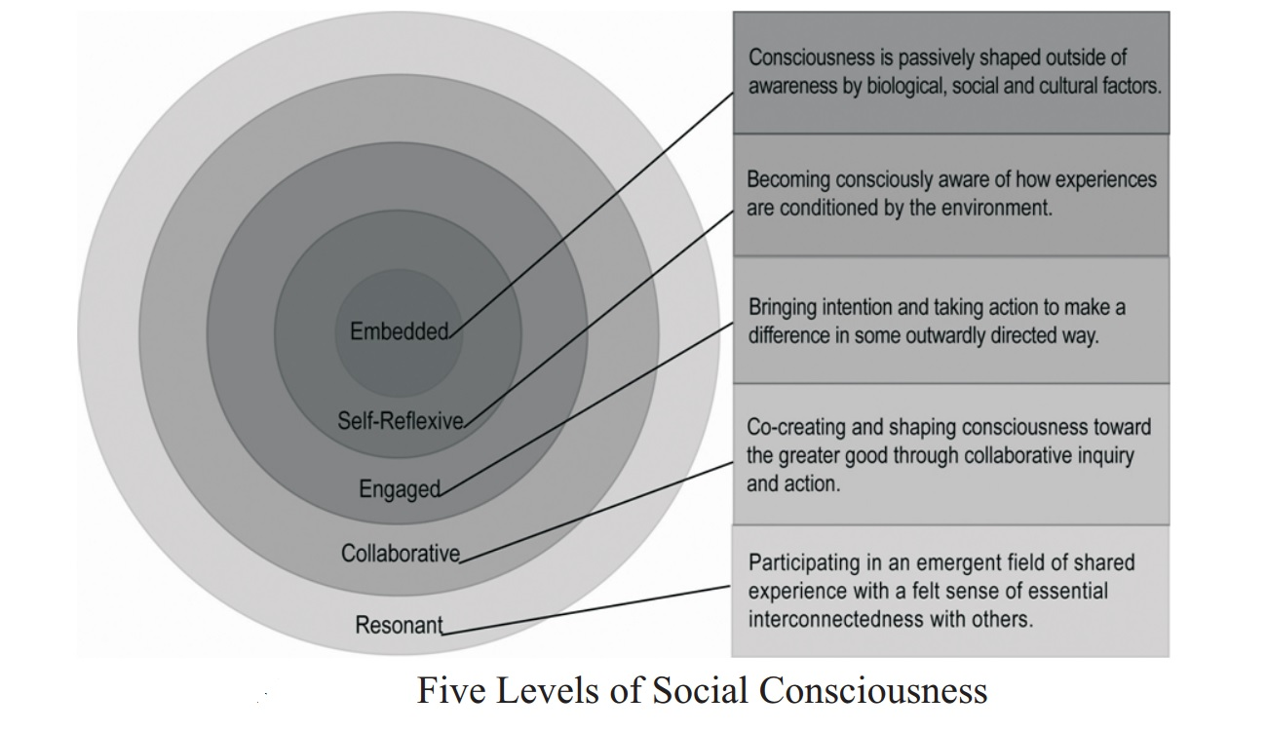

Embedded Social Consciousness

There is a vast literature exploring the impact of psychological, social and cultural factors in the shaping of human experience. Sociologists, anthropologists, psychologists, and historians alike have found that people’s worldviews shape their experience of reality. In large part, worldviews are influenced by factors that lie outside of conscious awareness, including shared beliefs, values, and social attitudes. At the embedded level of social consciousness, a person’s understanding of his or her relationship to the larger social system, and of how individuals are influenced by and influence their environment, is implicit, primarily residing outside of conscious awareness. It is seen here as a baseline for the development of social consciousness as defined above.

Within critical theory, the ideological and hegemonic nature of power relations is shown to shape lived experience and subjectivity. Through this theoretical lens, individual worldviews are socially embedded and controlled by large-scale social and economic forces (Macpherson, 1962). The construction of personal and social identity is deeply influenced by economic factors involving the rise of materialism, capitalism, and the objectification of nature. From this perspective, society has a determining effect and human agency is downplayed. At the same time, the relationship of self to society is a complex and ongoing dialectic. Human choice and creativity play a liberating role, allowing the ongoing unfolding of human expression as history demonstrates the power, ingenuity, and resilience of the human spirit.

Self-reflexive Social Consciousness

Scientists, scholars, and contemplative teachers are beginning to work together to study processes by which it is possible for people to gain greater awareness of how they are conditioned by the biological, social and physical world in which they are embedded, and, in so doing, to recognize a broader picture of human potential. Here the emphasis is on developing ‘metacognitive’ awareness. From the confessional in the Catholic tradition, to insight meditation in the Buddhist tradition, to taking inventory of one’s behaviour in steps four and ten of twelve-step programmes, transformative traditions often include practices to cultivate the capacity for self-reflexivity. Developmental models have historically placed less focus on skills of self-reflection, metacognition, and cognitive flexibility in favour of developing ego strength, a strong sense of self, or a cohesive belief structure. However, one of the most significant impacts of self-reflexivity is increased cognitive flexibility.

Learning to hold beliefs as the best working hypothesis one has at the moment, and being consciously willing to change belief systems, increases the likelihood of developing the ability to hold and consider multiple points of view, to engage with difference, and to find comfort in unfamiliarity. Self-reflection is a process and a practice that requires support as it may trigger cognitive and affective ‘roadblocks’ that require people to look at their own biases. Learning to understand that our view of self and the world is only ever partial can ease the discomfort that may arise and invite the development of capacities that allow people to adapt successfully to ever-changing conditions.

Engaged Social Consciousness

With increased self-reflexivity comes a shifting awareness not only of the individual self, but also of the relationship to others and to the world. This alone represents an increase in social consciousness. But as individuals develop further, this passive awareness can develop into a desire to engage actively in improving the wellbeing of others and the world. When people experience being situated in a social world, and connected explicitly and implicitly to local and global communities, they may be drawn to civic responsibility for the common good (Ammentorp, 2007; Spinosa et al., 1997). Seeing the plight of those who are suffering, for example, can lead to passive sympathy, but when a person has the sense that their participation in their social environment has an impact, they often awake to a desire and intention to relieve that suffering, either directly or through the choices they make and the way they direct their energy and other resources.

In addition to anecdotes and qualitative data collected by educators and social psychologists, science is increasingly demonstrating that humans are predisposed to connect. Data from interpersonal neurobiology, for example, suggests that the human brain develops through close attachments to other people; beginning with their mothers, fathers, and extended family, and then moving out to the broader community. Additionally, a growing body of evidence suggests that people’s brains respond and grow through pathways of meaning, born with a built-in capacity and drive to search for purpose and to reflect on their role in relationship to others and to their environment. The field of neuroscience is just beginning to understand how brains themselves exist in relationship to other brains.

Resonant Consciousness

In addition to exploring the phenomenon and development of shared discourse and action, there is a growing literature that informs the theory of social consciousness as a field of shared experience and emergence that is felt and expressed in social groups. At this level, descriptions of social consciousness involve experiences that reportedly transcend the physical properties of the group. In our studies of transformational teachers, for example, informants commonly reported a sense of essential interdependence and interconnectedness with others as a stage in the worldview transformative process. It is this level that we refer to as resonant consciousness.

Additional research suggests interconnections between people that support transpersonal experiences of unity. In a series of controlled experiments, participants were isolated from one another while their physiology was being monitored. At random times through the session, one participant sent intentions to the distant person. Often the study used a closed circuit video system to project the image of the ‘receiver’ to the ‘sender’ in the distant room.

Collaborative Consciousness

As people gain greater awareness of themselves in relation to social issues and challenges, they also may experience a growing desire not only to take individual action, but also to participate in co-creating solutions with others. Rather than learning abstractly about global situations, a growing number of organizations and institutions are recognizing the importance of engaged social consciousness. Within education, there is an increasing focus on participatory learning, service learning, and project-based learning, all of which emphasize collaborative action.

When people begin to engage actively with the world around them and with others, initially it can be viewed as an endeavour to ‘help’, or a mission to save others. Like charity, this type of action can be seen as a one-way street — ‘I will give to you’. But with increasing awareness, the limitations of this mindset can be seen and it can be recognized that engagement with the world and others must be collaborative rather than prescriptive. There are ways in which a shared cognition can take form in social engagement. A key mechanism for the activation of this cognition is empowering conversation. Through the sharing of stories, experiences, and ideas, people begin to recognize that solutions must be co-created with all involved, especially those who are being ‘helped’.

Given the human ability to learn by example, the presence of positive role models also helps bring individuals into relationship with others in a mutually life-enhancing way. Offering role models can help people find their way to prosocial behaviours, rather than actions that work only in the interest of the individual, or even in opposition to the greater good. In the process, there is the possibility of a worldview shift that includes a shared identity around collaboration and shared purpose (Spinosa et al., 1997), while acknowledging healthy individuality.

Conclusion

Scientists, scholars, and contemplative teachers are finally beginning to work together to explore the ways in which people are conditioned by the biological, social, and physical world in which they are embedded, and in so doing to recognize a broader picture of our collective human potential.

Today, we see a rapid rate of change that is calling on people to consider their worldview and to develop different identities and ways of engaging with the world. It is clear that navigating life in the twenty-first century will require not simply the acquisition of new skills, but also the intentional cultivation of novel states of mind (Kegan, 1994; Gardner, 2004). Among those skills most essential for success in this new era of global connectivity will be greater cognitive flexibility, comfort with unfamiliarity, appreciation of diverse perspectives, agility in the face of rapidly changing circumstances, ability to hold multiple perspectives simultaneously, and a capacity for discernment that relies equally on intellect and intuition. These skills don’t spring as much from what we know but instead from how we know it, and how we view the world. As worldviews transform, they adapt to include increasing levels of awareness of how people are interrelated to the world around them. It is in individual and shared mind-sets where psychological, physiological, and cultural forces may engage one another to promote social consciousness and to develop prosocial perceptions and actions.

References

* Ammentorp, L. (2007) Imagining social change: Developing social consciousness in an arts-based pedagogy, Critical Social Studies.
* Flavell, J.H., Miller, P.H. & Miller, S.A. (2002) Cognitive Development (4th ed.), Upper Saddle River, NJ: Prentice Hall.
* Gardner, H. (2006) Five Minds for the Future, Boston, MA: Harvard Business School Press.
* Kegan, R. (1994) In Over Our Heads: The Mental Demands of Modern Life, Boston, MA: Harvard University Press.
* Macpherson, C.B. (1962) The Political Theory of Possessive Individualism: Hobbes to Locke, New York: Oxford University Press.
* Siegler, R.S. & Alibali, M.W. (2005) Children’s Thinking (4th ed.), Upper Saddle River, NJ: Prentice Hall.
* Spinosa, C., Flores, F. & Dreyfus, H. (1997) Disclosing New Worlds: Entrepreneurship, Democratic Action, and the Cultivation of Solidarity, Cambridge, MA: MIT Press.

_______________