Name: Devang Kishor Wani  Roll No: 66  Division: B  Group No: 3 | DOP:  DOS: 10/08/26  Score:  Batch No: B3
---------------------------------------------------------------------------------------------------------------------
Experiment No 2: Select the social media platforms of your choice (Twitter, Facebook, LinkedIn, YouTube, Web blogs etc) and collect social media data for business.

Different ways of collecting data:
There are several ways in which social media data can be collected for business analysis. Some of the common methods include using official APIs provided by platforms (like the Twitter API, Facebook Graph API, YouTube Data API), manual data collection through surveys and forms, third-party analytics tools, and web scraping. Each platform has its own set of rules and access levels, so the method chosen usually depends on how much data is needed, how frequently it needs to be updated, and what the platform allows.
For this experiment, web scraping was used to collect data, since it allows large volumes of publicly visible data to be extracted directly from web pages without needing manual copy-pasting.

Web Scraping:
Web scraping is the process of automatically extracting data from websites using a program or tool instead of manually copying it. It works by sending a request to a webpage, loading its HTML content, and then pulling out the specific pieces of information that are needed, such as text, images, prices, ratings, comments, etc. The extracted data is usually saved in a structured format like CSV, JSON, or Excel so that it can be analysed later.
In this experiment, web scraping was performed using Apify, which is a cloud-based web scraping and automation platform. Apify provides pre-built "Actors" (ready-made scrapers) for popular websites, so instead of writing scraping code from scratch, an existing Actor can be configured with the required input (like a search keyword or product URL) and run directly from the browser.

Use of Web Scraping:
Web scraping is widely used by businesses for the following purposes:
• Market Research - tracking competitor prices, product listings, and customer reviews.
• Social Media Monitoring - collecting posts, captions, hashtags, and comments to understand audience engagement and sentiment.
• Lead Generation - gathering publicly available contact or business information.
• Sentiment Analysis - analysing customer opinions and reviews about a product or brand.
• Trend Analysis - identifying what content, products, or topics are currently popular.

Different Categories Of Web Scraper:
Web scrapers can be broadly categorised as follows:
1. Self-built vs Pre-built Scrapers - Self-built scrapers are custom-coded (usually in Python using libraries like BeautifulSoup or Scrapy), while pre-built scrapers are ready-made tools (like the Apify Actors used in this experiment) that just need configuration.
2. Browser Extension Scrapers - Lightweight tools that run directly inside the browser for small-scale scraping.
3. Cloud-based Scrapers - Run on remote servers (like Apify), allowing large-scale scraping without using the local system's resources.
4. Software/Desktop Scrapers - Installed applications that run scraping tasks locally on a computer.

Web Scraping Tools And Features:
For this experiment, Apify was used as the web scraping tool. Apify offers a marketplace of ready-made scrapers called "Actors" for different websites and platforms. Three Actors were used for this experiment:
1. Amazon Product Scraper - used to extract detailed product data from Amazon, including product title, price, brand, ratings, number of reviews, product description, images, and customer reviews.
2. Instagram Scraper - used to extract post-level data from Instagram, including captions, hashtags, mentions, likes, comment count, and the comments themselves along with the commenter's details.
3. YouTube Scraper - used to extract video-level data from a brand's YouTube channel, including video title, view count, likes, comments count, duration, hashtags, and channel-level statistics like subscriber count and total views.

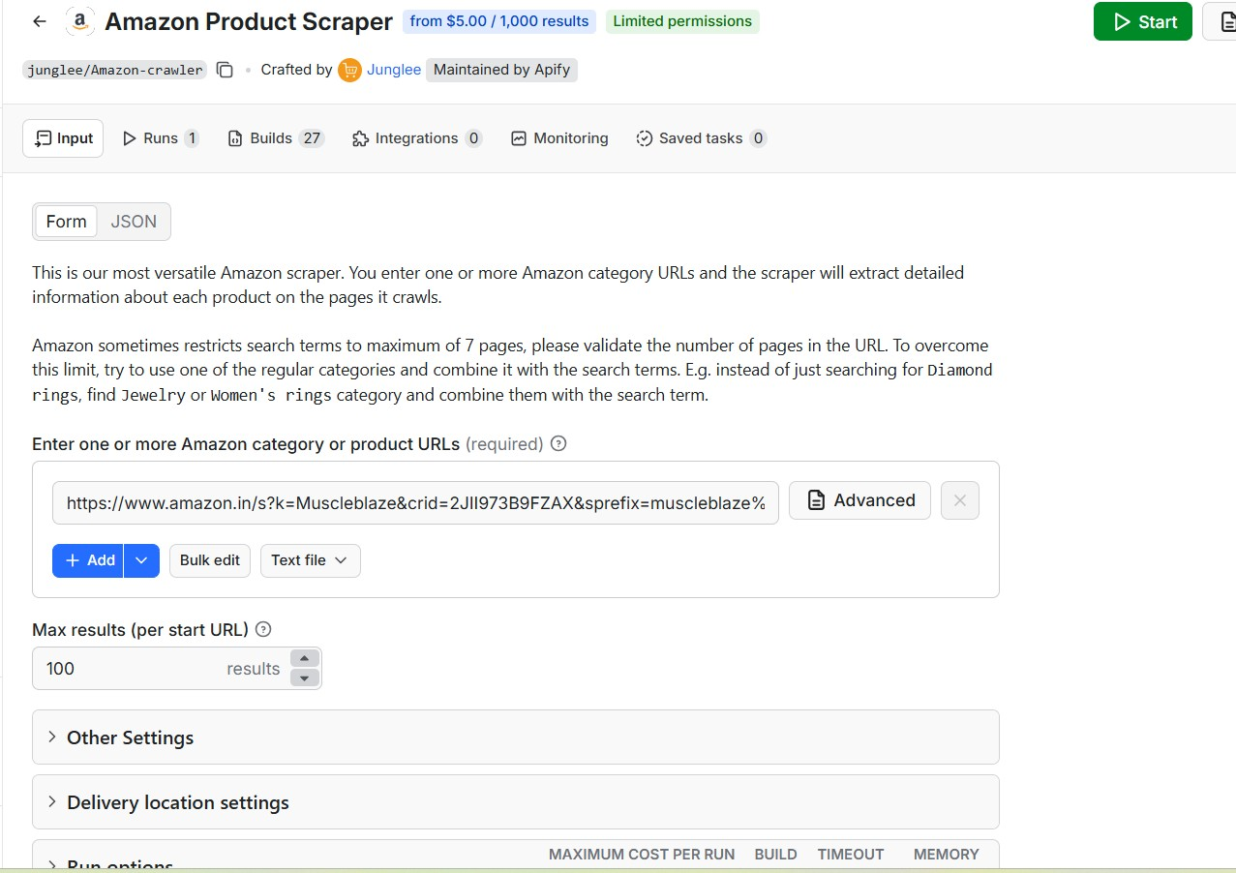

Legal and Ethical Considerations In Web Scraping:
While web scraping is a powerful tool for data collection, it also comes with certain legal and ethical responsibilities:
• Terms of Service - Many websites restrict or prohibit automated scraping in their Terms of Service, so this should be checked before scraping.
• Data Privacy - Personal data (like usernames or profile pictures) should be handled responsibly and not misused, especially data belonging to private individuals.
• Server Load - Sending too many requests too quickly can overload a website's server, so scraping should be done at a reasonable rate.
• Copyright - Scraped content (like images or descriptions) may be copyrighted, so it should generally be used only for analysis and not republished commercially.
• Public Data Only - Ideally, scraping should be limited to data that is publicly visible and does not require bypassing login screens or security measures.

Data Sources For Your Problem Statement:
Problem Statement: To understand how businesses can use social media and e-commerce data to analyse customer engagement, sentiment, and purchasing behaviour, data was collected from three different sources - Instagram, Amazon, and YouTube.
1. Instagram - Posts from a business/brand account were scraped to study audience engagement in the form of likes, comments, and hashtags used.
2. Amazon - Product listings (in the health and fitness supplements category) were scraped to study pricing, ratings, and customer reviews, which can help a business understand customer sentiment and competitor positioning.
3. YouTube - Videos from the same brand's YouTube channel (MuscleBlaze) were scraped to study video performance in terms of views, likes, and comments, along with overall channel growth metrics like subscriber count.

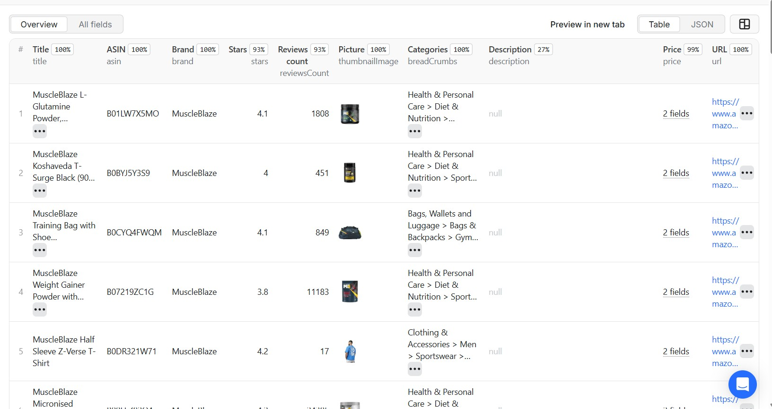

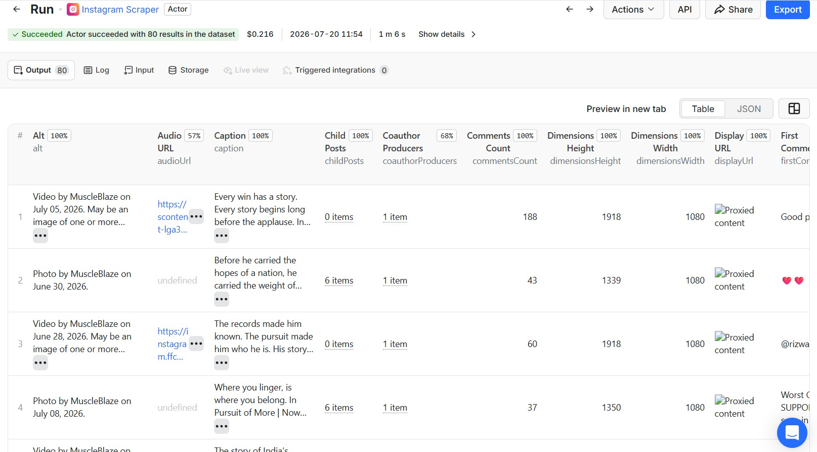

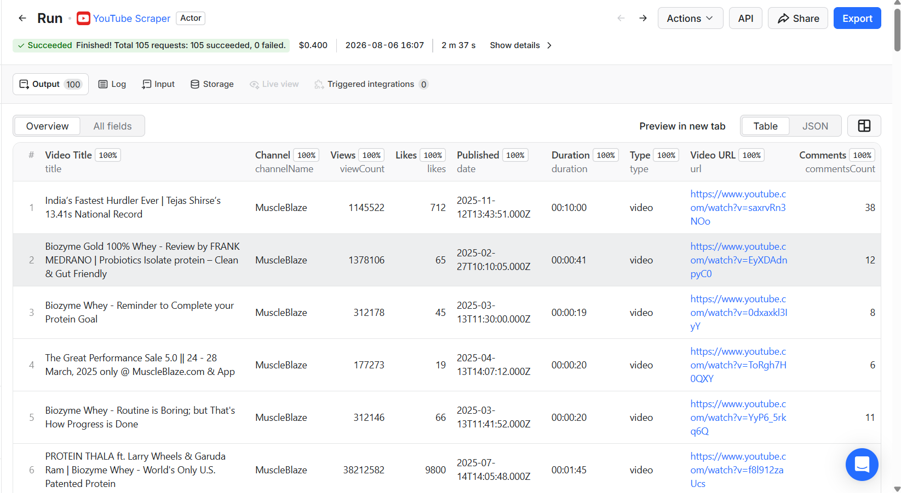

Data Description:
Instagram Dataset (80 rows X 42 columns): The Instagram dataset contains 80 posts, with fields such as post ID, type (photo/video), caption, hashtags, mentions, URL, comments count, likes count, timestamp, owner username, and a nested field of the latest comments on each post (each comment further includes the commenter's username, comment text, timestamp, and like count).

Amazon Dataset (100 rows X 1271 columns): The Amazon dataset contains 100 product listings, with fields such as product title, ASIN, price, list price, brand, star rating, rating breakdown, number of reviews, product description, key features, product attributes, and individual customer reviews (each with reviewer name, rating, review title, review text, and date). The large number of columns is because Apify returns every nested detail of a product (images, variants, A+ content, review-level fields, etc.) as separate flattened columns.

YouTube Dataset (100 rows X 45 columns): The YouTube dataset contains 100 videos scraped from the MuscleBlaze YouTube channel, with fields such as video title, URL, view count, like count, comment count, upload date, video duration, hashtags, and channel-level details like subscriber count, total channel views, and total number of videos on the channel.
All three datasets were exported from Apify in JSON/CSV format and were converted and cleaned so that nested fields (like comments, reviews, and channel details) could be represented properly in tabular form for analysis.

Sample Collected Data:
A sample of the collected data is shown below:

Amazon Data:
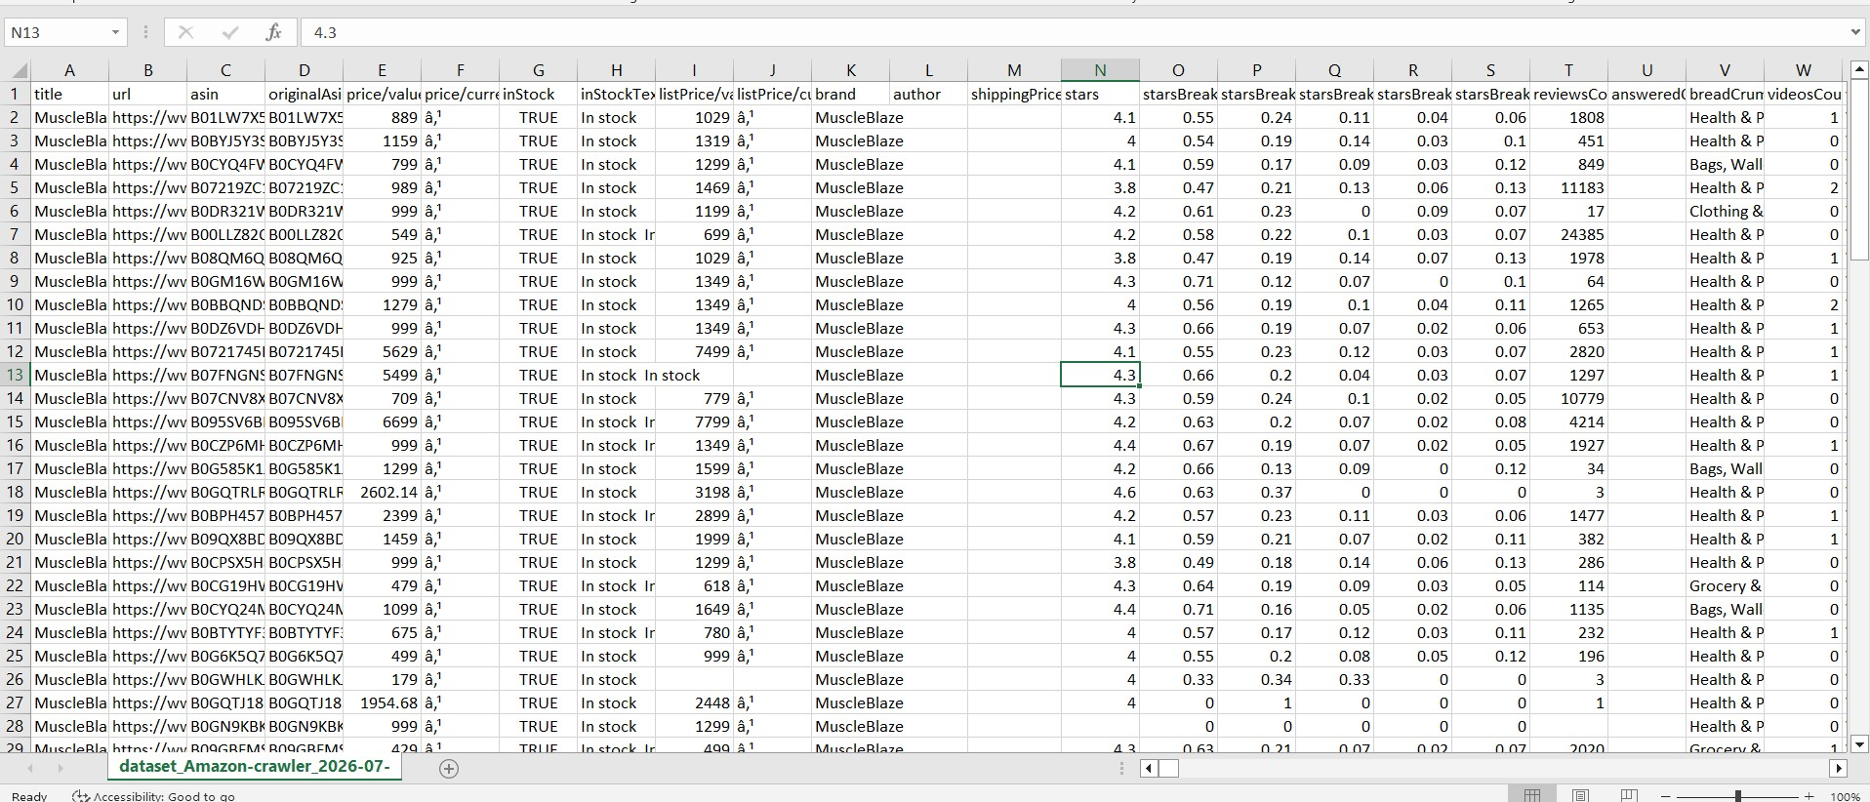

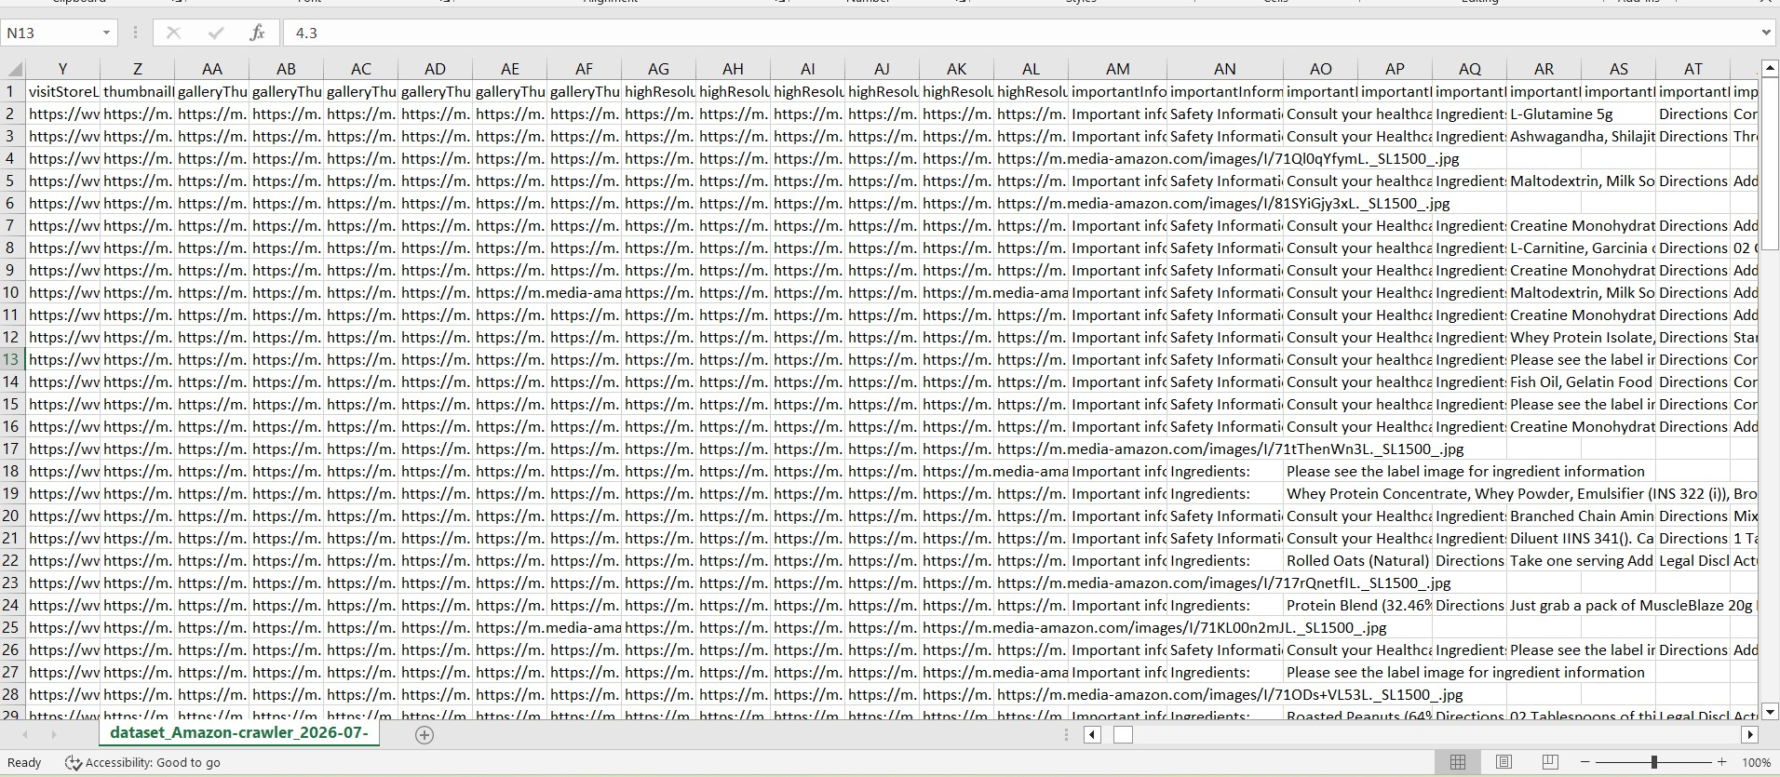

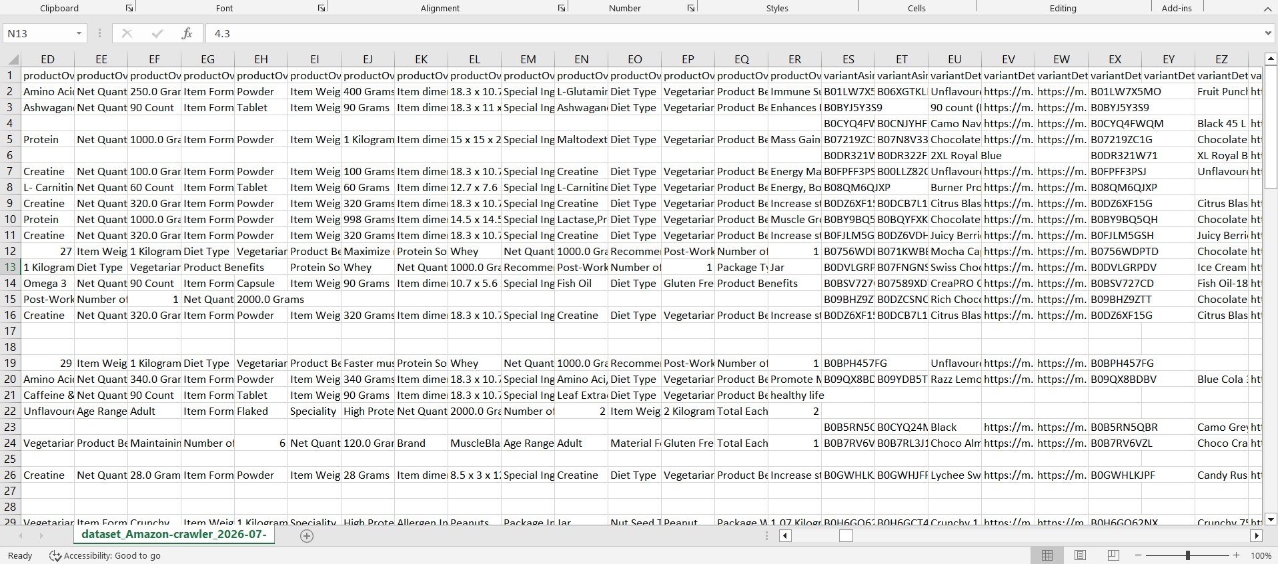

Instagram Data:

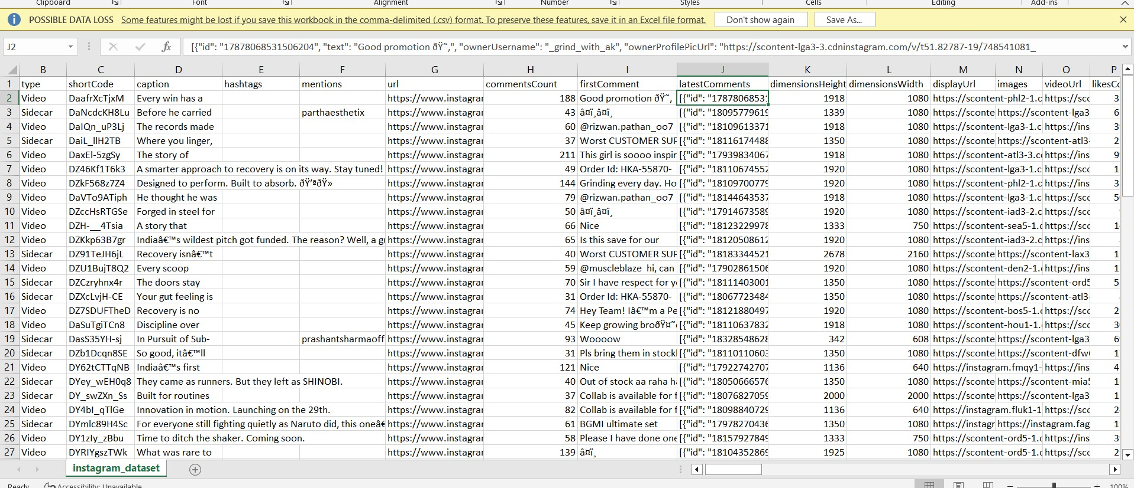

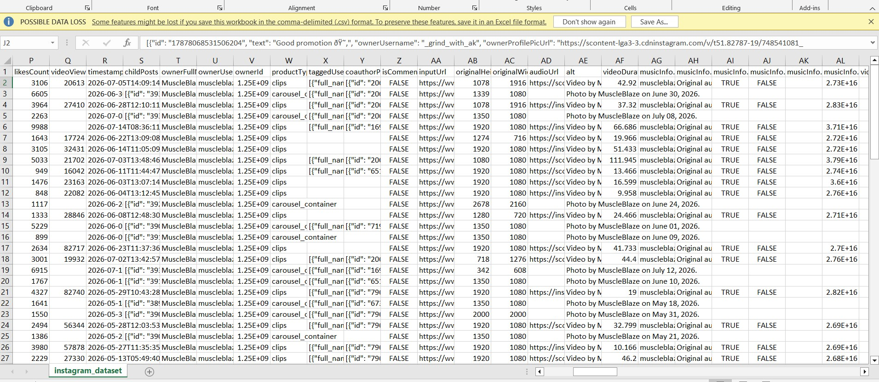

Youtube Dataset:

