
User Documentation

Salalah Methanol Company

Inventory Management System

July 12, 2018

Devan K S

Introduction

The SMC inventory management system allows the user to create and manage records of information related to users and the devices they have been assigned to by the IT team. The system features various validation features to remove errors in the information. It contains graphs to show information in a clearer manner. This is a system documentation to help out any future developers of the project. Many steps followed has alternate methods too. Any pethood can be used according to the users wish. A user needs to have minimum knowledge in Python and Django framework.

Screens
There are multiple screens to this application. They allow access to the data according to the permissions given to the user. Screen accessible:

- Login
- Home screen
  - Authentication and Authorization
    - Groups
    - Users
  - Inventory Management
    - Departments Grouped Graph
    - List Of Devices
    - Records Of Inventory
      - Add record
      - Import Records
      - History of each record

These screens will be elaborated by using screenshots.
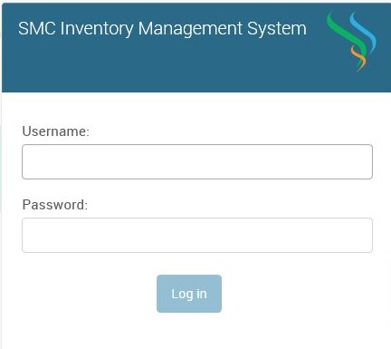
Login: The only way to access the console is by getting a valid username and password from the admin who already has access to the system.

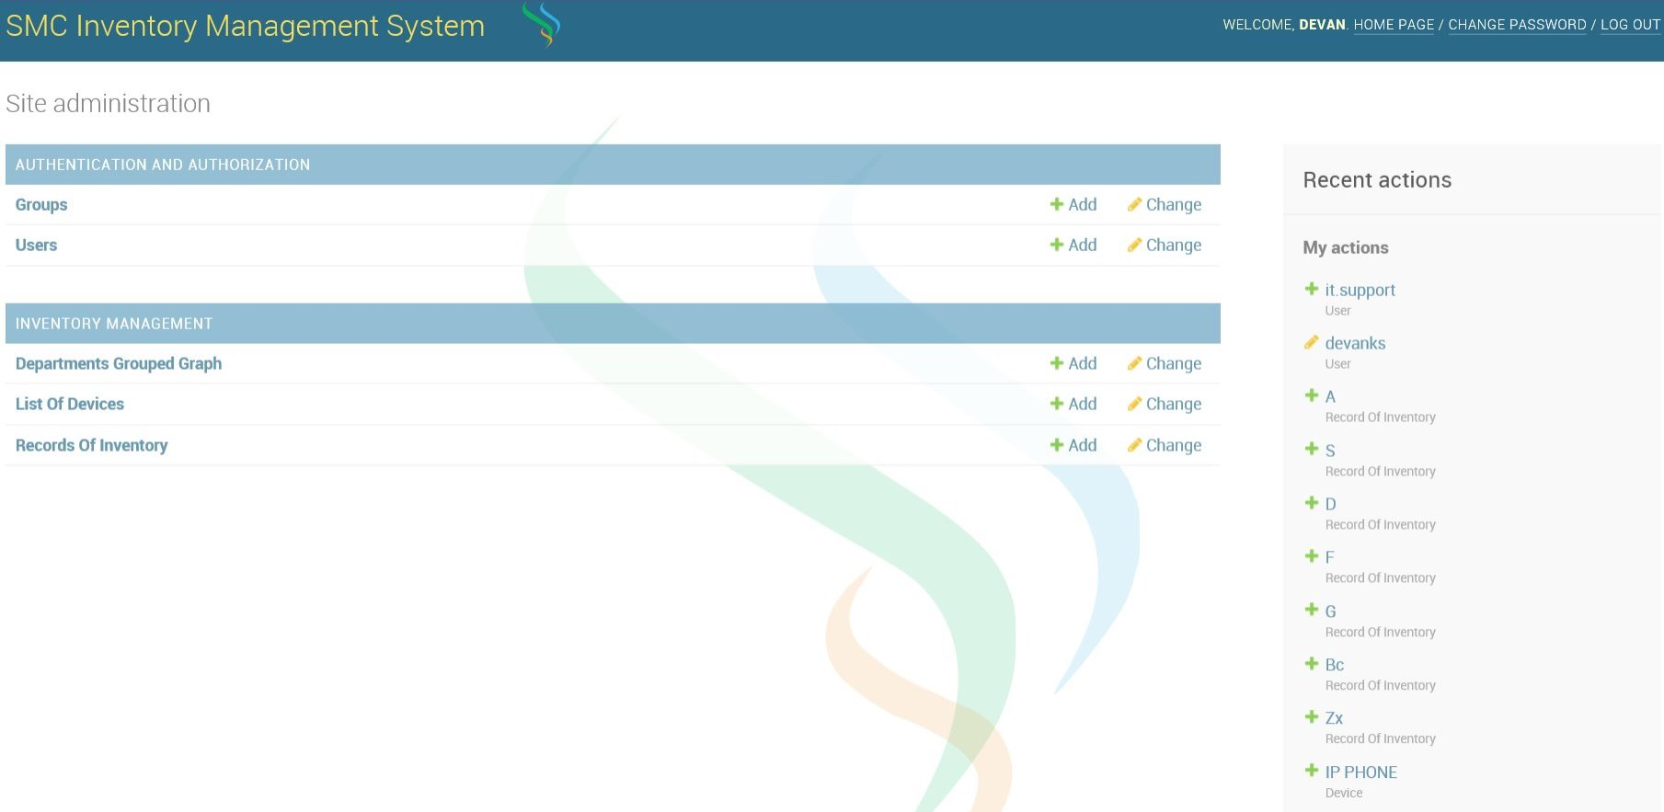
Home: This page contains links to the sub sections of other screens directly. The subsections and their parent sections will be hidden if you don’t have the permissions for it.

“Inventory Management” and “Authentication and Authorization”:
Both of the above pages contain links to their sub sections in the original Home page. This was done so that “Breadcrumbs” feature works as expected. You can directly go to any of the subsections from the home page or go to either of these sections to select the sub section.

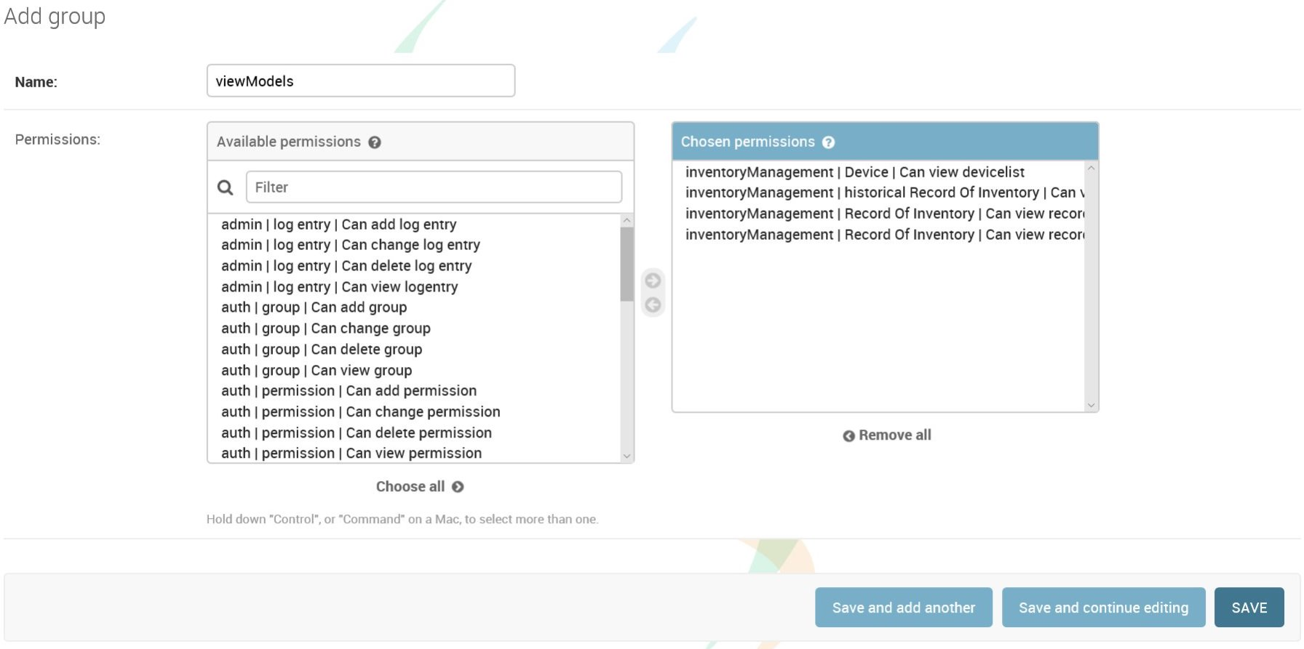
Groups: This page is for creating and deleting permission groups for the ease of giving and removing permission of users much more easily. You can set permissions for each user without groups, but the process will be tedious as there are a lot of permissions available.

User: You can create, delete or add extra details to users using the application from this portal. Changing passwords of the present user can be done anytime from the top right corner.
When Adding users please note, “Active” is just a replacement to deleting the account. It is more efficient than deleting. “Staff Status” MUST BE GIVEN TO ALL USER WHO HAVE ACCESS TO THE SITE. “Superuser Status” is an easy way of giving all permissions to the user.
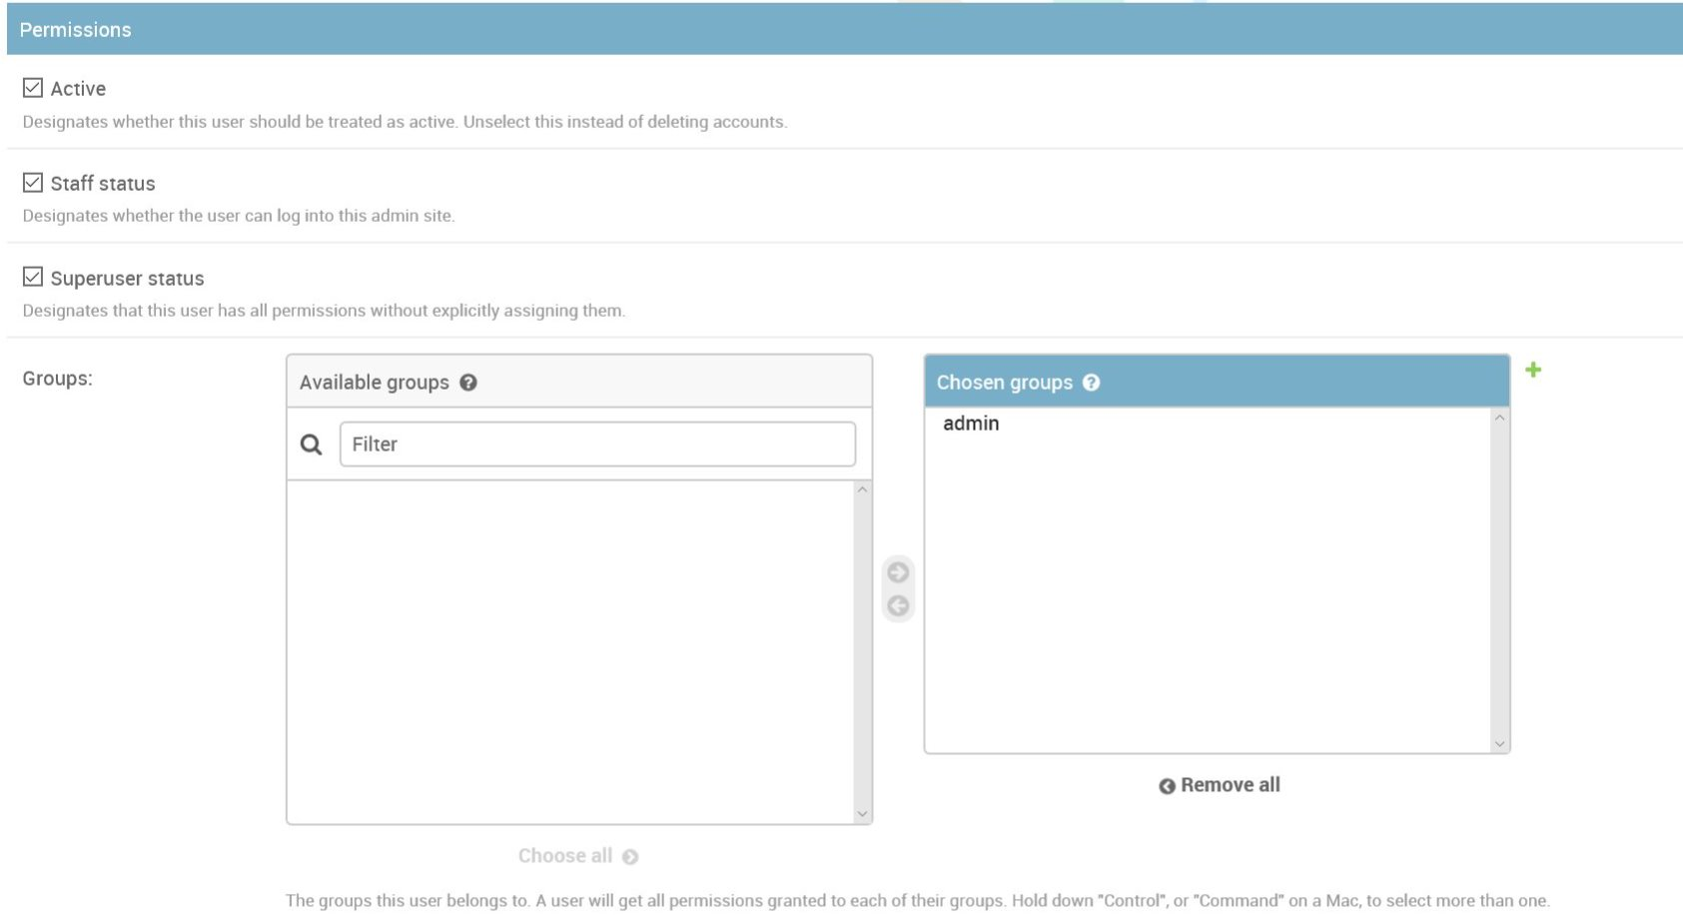
List of Devices: The purpose of this page is to add device names beforehand so that input to the records list isn’t corrupted. The admin can remove permissions to this module and add all devices to further drive the point. Any input give while adding will be made into capital case. And the input start and end with alphanumeric characters and must not have any consecutive spaces.

Departments Grouped Graph: This site requires JavaScript execution to be on for it work. It has all its major components like graphs and table creation done on JavaScript. The graph changes according to the filter applied.

Records Of Inventory: This page allows the user to search any of the fields from the search box, filter using the options given in the sidebar, import data using the button next to add record, or export data using the action option. The headers of the table also sort table below. Click again for descending order.
If all the information of the record isn’t in the table, it will be available if you click the record name to access the full details. There is also a “History” button which takes the user to a view with all revisions made to that particular record. The changes can be reverted too.
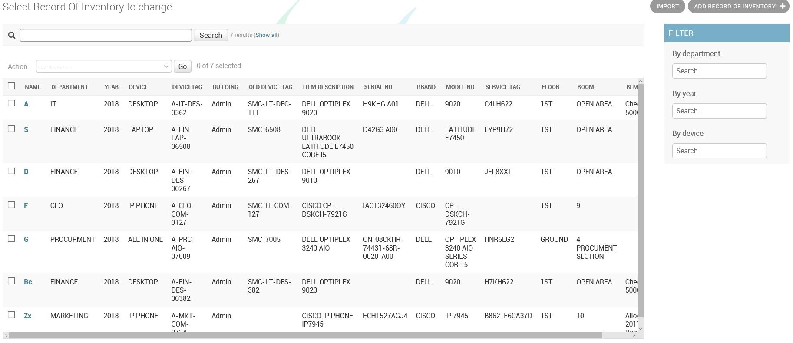
When adding records, please make sure the device name already exists in the device List. If the user is using the built in importer, the error will be similar to “deviceName not appearing in DeviceList”. The error message can change. If you are using the “Add record” page and the user has permissions to add devices, you can directly add a device from the page using the “+” on the right of the attribute. This will open a new window for input the new device name. The field will automatically get filled with the new device name.

Django can be learned by doing a sample project available online in docs.django.org

