Article

Perceptions of Prescribed Fire Among Ranchers Near Northern US National Grasslands

Kaylee Boland 1, Devan Allen McGranahan 2,*, Benjamin Geaumont 1, Carissa L. Wonkka 3, and Jaqueline Ott 4

|  |
| --- |
| **Citation:** To be added by editorial staff during production.  Academic Editor: Firstname Lastname  Received: date  Revised: date  Accepted: date  Published: date    **Copyright:** © 2024 by the authors. Submitted for possible open access publication under the terms and conditions of the Creative Commons Attribution (CC BY) license (https://creativecommons.org/licenses/by/4.0/). |

1 Hettinger Research Extension Center, North Dakota State University, Hettinger, ND 58639, USA; [kaylee.boland@ndsu.edu](mailto:kaylee.boland@ndsu.edu); [benjamin.geaumont@ndsu.edu](mailto:benjamin.geaumont@ndsu.edu)

2 USDA Agricultural Research Service, Livestock & Range Research Laboratory, Miles City, MT USA; [Devan.McGranahan@usda.gov](mailto:Devan.McGranahan@usda.gov)

3 University of Florida Western Florida Research Education Center, Milton, FL USA

4 US Forest Service Rocky Mountain Research Station, Rapid City, SD USA

**\*** Correspondence: Devan.McGranahan@usda.gov

**Abstract:** A single paragraph of about 200 words maximum. For research articles, abstracts should give a pertinent overview of the work. We strongly encourage authors to use the following style of structured abstracts, but without headings: (1) Background: Place the question addressed in a broad context and highlight the purpose of the study; (2) Methods: briefly describe the main methods or treatments applied; (3) Results: summarize the article’s main findings; (4) Conclusions: indicate the main conclusions or interpretations. The abstract should be an objective representation of the article and it must not contain results that are not presented and substantiated in the main text and should not exaggerate the main conclusions.

**Keywords:** keyword 1; keyword 2; keyword 3

1. Introduction

Fire has long played a crucial role in shaping rangeland ecosystems, yet its use in land management today is debated, especially in the northern Great Plains. The northern Great Plains historically experienced a frequent, low-intensity regime [1], but currently operates on an infrequent, variable regime [2–4]. Prior to Euro-American settlement, Indigenous peoples used fire to remove old vegetation, promote grass growth, manage game, and other cultural reasons [5–7]. Fire promotes landscape heterogeneity, controls invasive plants, and woody plant species, and increases rangeland forage quality [8,9]. Despite these benefits, wildfire suppression and aversion to prescribed fire use leaves the northern Great Plains largely unburned [4]. Reintroducing fire through prescribed burning has proven difficult, as social perceptions often weigh heavily on prescribed fire use [10].

Social barriers include societal norms and attitudes; liability; and education, knowledge and training, whereas physical barriers include labor, equipment, cost, and government restrictions [10,11]. Social norms tend to highlight the attitude many community members display [12], as they often have “feelings or moral obligation to perform or refrain from specific action”[13]. Social science can help managers identify and evaluate management plans based on social and ecological tradeoffs [14] and make decisions that are better for humans and the environment alike. Human perceptions of landscapes are often shaped by our cognitive mind [15]. Introducing the concept that humans tend to value different aspects of the land in their mind more so than of reason.

Considering social and ecological components together could help shift management decisions [15]. But in the northern Great Plains, social norms often play an outsized role in the decision making process of tight-knit ranching communities [16,17]. Social pressures often weigh on government and private agencies as well, limiting how often they use or support fire for management of federal, state, and private lands [18–21]. Ranching communities in the southern Great Plains--having recognized a lack of disturbance caused a decline in biodiversity and livestock forage production—formed prescribed burning associations to bring fire back to the landscape [22]. This realization has been slow to be adopted in the northern Great Plains.

The transtheoretical model of behavior changes outlines and conceptualizes intentional behavioral change. The five stages of change include pre-contemplation, contemplation, preparation, action, and maintenance. The beginning stages include no intention of behavioral change, or unaware that a problem exists and aware of a problem but no commitment to an action for change [23]. Navigating this process requires both knowledge and social support. The individual must comprehend the change and be committed to implementing it.

One of the largest drivers of decision making for landowners and ranchers is being a good steward. People develop stewardship for landscapes, as these are a basic component of our natural and cultural heritage; they contribute to the formation of local cultures and provide ecosystem services both for the benefit of individual and societal wellbeing [24]. In North America, working landscape partnerships foster effective stewardship and conservation of land through active human presence and management [25]. Landscape stewardship comprises all ‘efforts to create, nurture and enable responsibility in landowners and resource users to manage and protect land and its natural and cultural heritage’ [26]. ‘Stewardship’ is not only a management approach but perhaps even more, an ethic that emphasizes responsibility, collaboration, participation, and communication in the planning and management of land resources [27]. Stewards often manage environmental features, especially those important for wildlife and sustain these for future generations [28]. Social perceptions of fire can foster negative attitudes, which in turn, contribute to the barriers that restrict the use of prescribed fire. Comunity members believe that fire poses risk to nearby property, human safety, loss of forage, soil erosion, and negative impacts on wildlife. Ranchers and other community members agreed that there was potential for negative effects when a prescribed fire was on their neighbor's property [23]. However, a review of 23,050 prescribed burns had only 1% of fires result in an escape—although there is a risk of an escaped fire, the likelihood is not enough to call for concern [29]. Human safety is another perception that is often misconstrued. Prescribed burns have fewer accidents than crop and animal production: between 1963 and 2013 only six deaths were reported from prescribed burns, as well as having one minor injury in the 23,050 prescribed burns studied [30]. Potential practioners do not just worry about the safety of those conducting the burn, but also community members in the area that may have to deal with harmful smoke, particulary vulnerable populations, leading to another barrier [31]. Ranching communities also look at fire as the potential to destroy livestock forage [19], and as a cause of increased soil erosion allowing for more surface runoff until vegetation regrows [32].

Liability appears to have the greatest barrier to prescribed fire use. Numerous studies have found that liability is the largest barrier stated by landowners, including risk of an escaped fire, harm to neighbors, community and personal safety [18,19,23,31,33]. Weir et al. [29] infers that people often fear the perception of liability “Inaccurate perception of the danger and severity of liability is a greater barrier to prescribed fire than that of the actual danger and liability”, suggesting that the actual risks of fire are not the same as the perceived risks. States vary in approach from having strict liability to having more precautions in place [34]. North Dakota itself has a strict burn liability, indication that the burner is always responsible for damages [35].

Perceptions can also turn into personal beliefs about fire. Clark et al. [10] found that respondents did not find prescribed fire to be beneficial and a legitimate land management practice, 2/44 studies noted that over 50% of their respondents found it beneficial, equaling to only 5% of the studies. Others found that burning should only be used in limited circumstances, only be used by professionals, and should have adequate training.

As recent studies have shown that most research and papers have been from the southern Great Plains, as the northern Great Plains do not have a pro-fire culture, with roughly 79% of papers and information coming from the southern Great Plains [10]. The northern Great Plains encompass 7 National Grasslands; Buffalo Gap (SD), Cedar River (ND), Fort Pierre (SD), Grand River (SD), Little Missouri (ND), and Sheyenne (ND). These grasslands range in size from 6,700 acres to over 1 million acres. With a misson for sustaining health, diveristy, and productivity of the nations grasslands for current and future generations. The US Forest Services manages these landscapes at a multi-use management scale for the wellbeing of livestock, wildlife, plants and humans alike. Given that the northern Great Plains contains some of the largest grassland areas, it is essential to address managemnet techniques, including the use of prescribed fire. A hestinancy to burn based off social perceptions can harm the land, limiting production, quality, and overall wellbeing.

This study aims to outline why landowners are hesitant to burn on their land and their overall feelings of fire, to begin working with landowners and community members to introduce prescribed fire as a management tool back on to the grasslands. By understanding the concerns and misconceptions surrounding fire as a management tool on the northern Great Plains. We are able to develop targeted outreach and educational programs to address these specific issues. The goal is to adopt a more widespread use of prescribed fire as a sustainable management practice.

2. Materials and Methods

The study was designed to assess the perceptions of Northern Great Plains ranchers who are likely to graze livestock on public grazlingland towards prescribed fire as an aspect of rangeland management. To this end, we followed the two-phase Exploration and Confirmation approach employed to study rangeland landowner perceptions of energy development elsewhere in western North Dakota [36] and in South Africa [37].

2.1. Survey design

Our Exploratory Phase consisted of unstructured interviews with rangeland management stakeholders to familiarize ourselves with prominent issues and prefered nomenclature. We initially reached out to Grazing Associations, who distributed contact information for the research team to their membership; members subsequently reached out to the researchers on their own volition. From those initial contacts we conducted snowball sampling [38]—we requested additional contacts from their peer group who might not have received information from a Grazing Association. We also included agency and non-governmental organizations (NGOs) by contacting individuals on organizational websites, also pursuing additional individuals through snowball sampling.

Conducted over the telephone or Internet video calls, audio from the interviews were recorded using Microsoft Windows voice recorder, transcribed to text, and coded to identify emergent themes with the RQDA qualitative data management package [39] for the R statistical environment [40]. Using the emergent themes to focus on key dimensions of known human dimensions of prescribed fire management in the Great Plains in general [10,41], we developed a survey specific to the Northern Great Plains for distribution to agricultural landowners in counties including or adjacent to USFS National Grasslands in North and South Dakota. Survey administration followed the basic Dillman protocol [42] consisting of introductory postcards, the survey instrument, a reminder postcard for unreturned surveys, and a final abbreviated survey designed to assess potential nonresponse bias.

2.1.1. Study area & participants

The survey was distributed to landowners in 18 counties—13 in North Dakota and 5 in South Dakota—that include or are adjacent to management units of the USFS Dakota Prairies National Grasslands. Focal counties, by nearest Grassland, included: *Little Missouri National Grassland*—Billings, Golden Valley, McKenzie, Slope, and Hettinger Counties, North Dakota; *Grand River National Grassland*—Adams County, North Dakota; Butte, Corson, Harding, Perkins, and Ziebach Counties, South Dakota; *Cedar River National Grassland*—Grant, Morton, and Sioux Counties, North Dakota; and *Sheyenne National Grassland*—Cass, Ransom, Richland, and Sargent Counties, North Dakota.

Participants were primarily identified—and addresses obtained—through a Freedom of Information Act request to the USDA Farm Service Administration based on records of pasture and rangeland ownership within each county. Additional information was provided on a case-by-case basis by individual county FSA offices. Approximately 75 surveys were mailed to randomly drawn addresses from each of the 18 counties, for a total of 1350 mailed surveys and a response rate of 18% following 247 surveys returned as undeliverable.

2.1.2. The survey instrument

Questions in the survey consisted principally of a five-point Likert scale format in which respondents were asked to indicate the degree to which they agreed or disagreed with a series of statements. The instrument also included several questions designed to better understand the demographic and geographic distribution of respondents.

Questions were organized around the following themes:

*Agency relationships*.—The survey asked participants to assess their use of, and trust in, resources provided by a number of institutions known to interact with landowners and managers in North Dakota. *Federal agencies* included the United States Department of Agriculture (USDA) Agricultural Research Service (ARS), Forest Service, and Natural Resource Conservation Service (NRCS); United States Department of Interior Bureau of Land Management (BLM) and Fish and Wildlife Service (USFWS). One s*tate agency* consisted of North Dakota State Game and Fish Department (ND G&F). Non-governmental organizations included the Audubon Society, Pheasants Forever, and The Nature Conservancy (TNC). Respondents were questioned about each source in general terms of natural resource management, and with respect to prescribed fire, specifically.

*Management decisionmaking*.—Respondents were asked to identify which environmental concerns were important to them, and what drives their decisionmaking with respect to rangeland management. Potential environmental concerns included plant diversity, control of encroaching or invading woody plants, grassland/prairie restoration, wildlife habitat protection, invasive plant species control, and wildfire risk reduction. Considerations for management decisionmaking included being a good steward, the teachings of previous generations in their family/community, professional advice, scientific research and/or University publications, and management decisions/attitudes of neighbors.

*Attitudes towards public grazinglands*.—As the target community for the survey was ranchers likely to lease public grazingland on the Grasslands as part of their livestock operation, we asked respondents about their attitudes regarding management of public grazinglands, and their own additional uses of these Federal lands managed specifically for multiple use, including recreation. Respondents were asked to identify the degree to which they felt public grazingland administrators do a good job in management, whether administrators should use the best available science, whether administrators should manage to meet user expectations, whether there is an appropriate amount of prescribed fire on public grazingland, and whether there should be more prescribed fire in public grazingland management. Participants were also asked to describe whether they or their families also use National Grasslands for walking/hiking, hunting, bird watching, horseback riding, mountain biking, or camping.

*Attitudes towards prescribed fire*.—Respondents were asked to focus on their perceptions of prescribed fire, firstly in terms of how they perceive prescribed fire to be understood by their communities, and secondly in terms of how they personally perceive prescribed fire. With respect to community perceptions, respondents were asked to identify the degree to which members of their community felt fire poses a risk to nearby property and human safety, produces harmful smoke, results in lost forage or soil erosion, or has negative impacts to wildlife. With respect to their personal perceptions, respondents were asked to identify the degree to which they agreed that burning is a poor management practice that shouldn’t be used or whether it can be used in a limited set of circumstances; whether it should be only used by professionals or whether it is a good option for anyone with training, and whether people should be able to use fire as frequently as they want; whether their management plan includes prescribed fire use, and whether they are prepared to use prescribed fire if they choose to.

2.2. Survey analysis

As all survey questions outside of demographic inquiries were based on five-point Likert scales, all data were analyzed using the agreement index employed in prior analyses of rangeland landowner perceptions [36,37,43]. The agreement index combines into a single measure (a) the magnitude of the mean response, by calculating an effect size on the difference between the distribution of the responses and a null, uniform distribution across response categories [44]; and (b) whether the observed positive (agreement) or negative (disagreement) trend is significantly different than zero (ambivalence), by multiplying the above-derived effect size by the mean response [45] in 1000 simulations that allow the estimation of 95% confidence intervals using R script available in McGranahan et al. [36]. As preliminary analysis indicated no discernable patterns in responses among demographic and geographic categories, responses are combined here to maximize statistical power.

3. Results and Discussion

3.1. Agency relationships

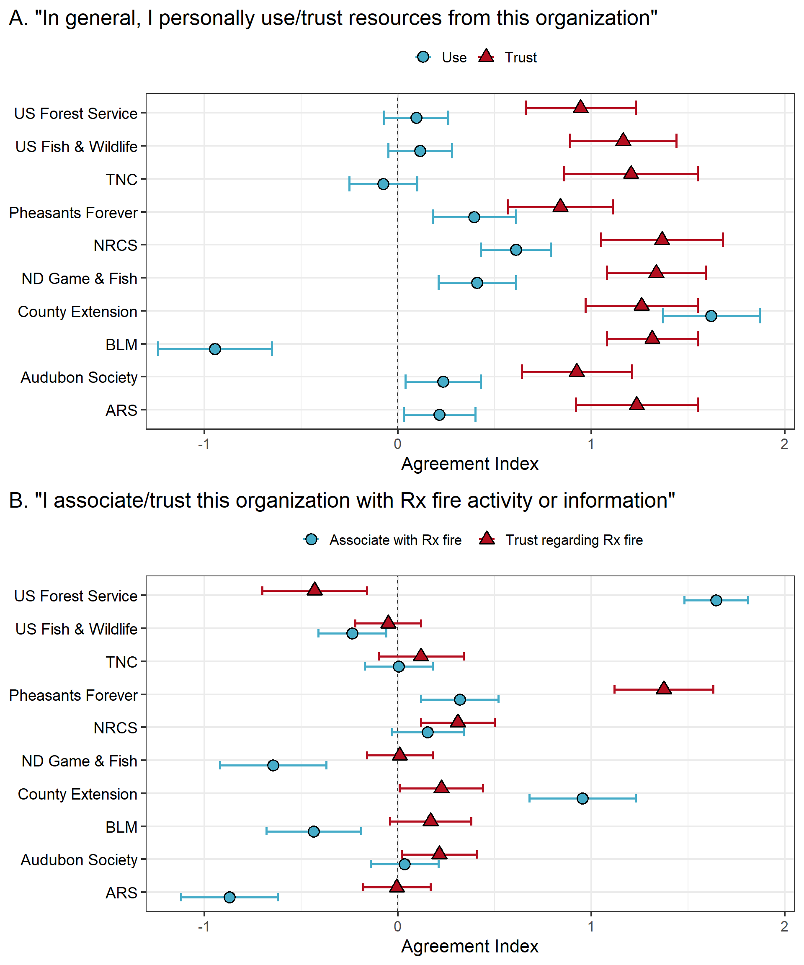

**Figure 1.** Degree to which survey participants agreed with statements about several governmental agencies and non-governmental organizations and (A) respondents’ personal use and trust of resources in general, and (B) respondents’ association and trust regarding prescribed fire, specifically. Agreement index quantifies median effect size of response and 95% confidence intervals based on five-point Likert scales. Organization abbreviations on vertical axis include TNC = The Nature Conservancy, NRCS = US Dept. Agriculture Natural Resource Conservation Service; BLM = US Dept. Interior Bureau of Land Management; ARS = US Dept. Agriculture Agricultural Research Service; US = United States, indicating US Government agencies; ND = North Dakota, indicating state agency.

We found that although respondents generally have a high degree of trust in information from the queried sources, county extension offices stood out as particularly often-used by respondents. This high reliance on information from county extension is consistent with other studies, including studies based on asking for an overall consensus of trust and information, like cattle, forage production, wildlife and more [46,47]. We found that the Bureau of Land Management (BLM) was used the least, likely because there are small amounts of BLM land in the study area. County extension offices are the most trusted resource and these offices could be the ones to connect ranchers/ landowners and scientists together to allow information to be spread [48].

Overall, respondents indicated a high degree of trust in Pheasants Forever. These results support previous work suggesting that environmental groups and organizations are often trusted more than government agencies [46,47], the exception being county extension. Although North Dakota does not have a sanctioned Prescribed Burn Association, other studies found that these groups use NRCS or Pheasants Forever significantly more than they use state or federal wildlife agencies [29]. Confirming that groups including Pheasants Forever are the most trusted sources with environmental knowledge and actions.

We also asked respondents which organizations and agencies they associated and trust with prescribed fire, because trust in an agency doing prescribed fire is a key variable that shapes public acceptance [46,49]. Respondents associated the US Forest Service the most with prescribed fire but rated them least trusted, whereas Pheasants Forever is the most trusted with prescribed fire. Going along with the notion that the public gives greater trust to environmental groups than government entities [49]. There was a decrease in public trust with the US Forest Service, Shindler et al. [46] had 50% of respondents trust the US Forest Service, with just 4 years later that number had decreased, the study found that the US Forest Service was not building trust with landowners. It has been reported that trust can be perceived different ways, and oftentimes is not assigned to one person but an organization as a whole, allowing one bad interaction to dissuade trust in the future [50]. Trust has been found to be a strong predictor of approval and acceptance of government agencies to make the proper decisions about management methods, including prescribed burning [51,52].

3.2. Perceptions of management and decision-making

3.2.1. Perceptions of public grazingland management

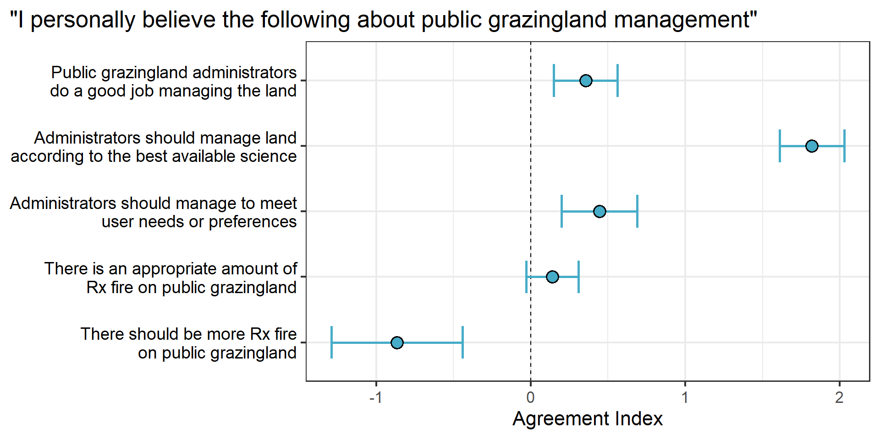

**Figure 2.** Degree to which survey participants agreed with statements regarding their perceptions about how public grazingland is managed by agencies like the US Forest Service, who administers grazing leases on the National Grasslands. Agreement index quantifies median effect size of response and 95% confidence intervals based on five-point Likert scales.

Respondents generally expressed a positive view of management practices on National Grasslands, believing that the best science should take precedence over user needs or preferences. At the same time, there was general disagreement that prescribed fire use should be increased. Our study was focused around 4 National Grasslands in North Dakota/ South Dakota, with many of the respondents residing within or adjacent to these grasslands. This leads to how lack of trust with the Forest Service can cause disagreements regarding management plans. Even if respondents believe that the best science should prevail, with a lack of trust they disagree that the management plan should be fire. Without the trust, cooperation, and coordination among landowners, it is hard for the US Forest Service to conduct prescribed burns and other management methods on grasslands due to landscape fragmentation [53]. Vaske et al. [54] found that perceived similarity often initiates public trust: when someone believes that they share similar values as a management agency, they tend to trust that agency more.

3.2.2. Contributions to individual management decision-making

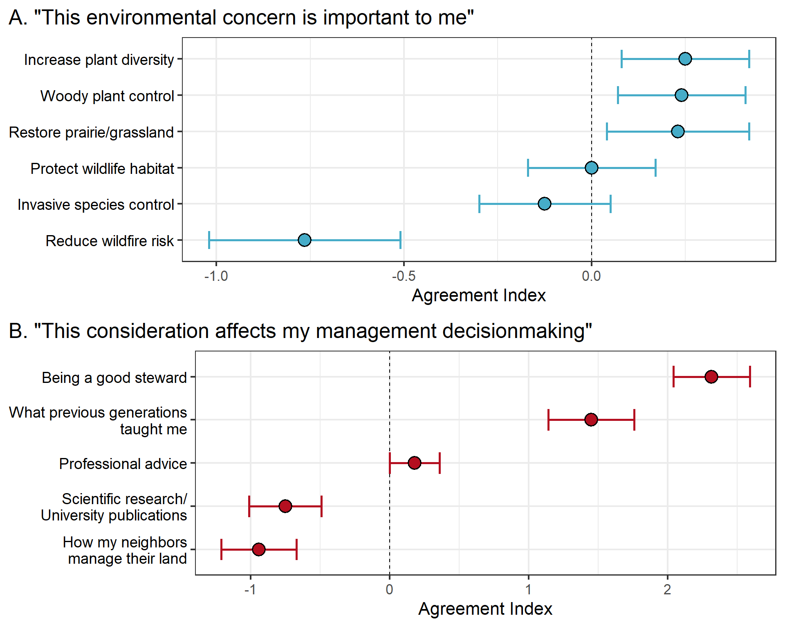

**Figure 3.** Degree to which survey participants agreed with statements regarding motivation for management decision-making. (A) Respondents’ personal concern about potential environmental co-benefits to prescribed fire. (B) Respondents’ regard for potential influences on management. Agreement index quantifies median effect size of response and 95% confidence intervals based on five-point Likert scales.

We asked respondents what environmental concern is important to them to understand what could be driving motivators and co-benefits to introducing or increasing prescribed fire use. In response, landowners reported that they value open rangelands, increasing plant diversity, controlling woody plants, and restoring prairie/ grassland, but they do not seem to care about reducing wildfire risk. Other studies have shown that ranchers value open rangeland, noting that open space and wildlife habitat were as important factors as food and fiber production in protecting agricultural land [55]. Landowners worry about prescribed fire on their land due to the possibility of limited forage production in years to follow because of drought [56].

These results suggest respondents are not familiar with existing research that demonstrates the value of prescribed fire for rangeland forage and cattle production. Elsewhere in the Great Plains, when portions of pastures have recently been burned, cattle can spend as much as 75% of their grazing time in the most-recently burned patches [57]. Recently burned areas also have fewer ticks and horn and face flies [58,59]. In North Dakota, recently-burned patches offer higher forage nutritional value and greater mineral content; as a result, grazing systems that incorporate prescribed fire produce better cattle performance than continuous or rotational systems [60].

The strongest motivators were the desire to be a responsible land stewards and the lessons passed down by generation, with these influences often intertwining. Scientific research and what other neighbors do to their land provided the least motivation, contrary to the belief that best science should prevail on National Grasslands., having a strong stewardship aspect is noted in many studies throughout the Great Plains, where respondents value “conserving natural resources” over economic gain [47]. Having this feeling of stewardship includes having a feeling of responsibility for environmental concerns [61]. The concept of stewardship is often passed down from generation to generation [28], so the notion of being a good steward and following what previous generations have taught, goes hand in hand.

3.3. Attitudes about prescribed fire

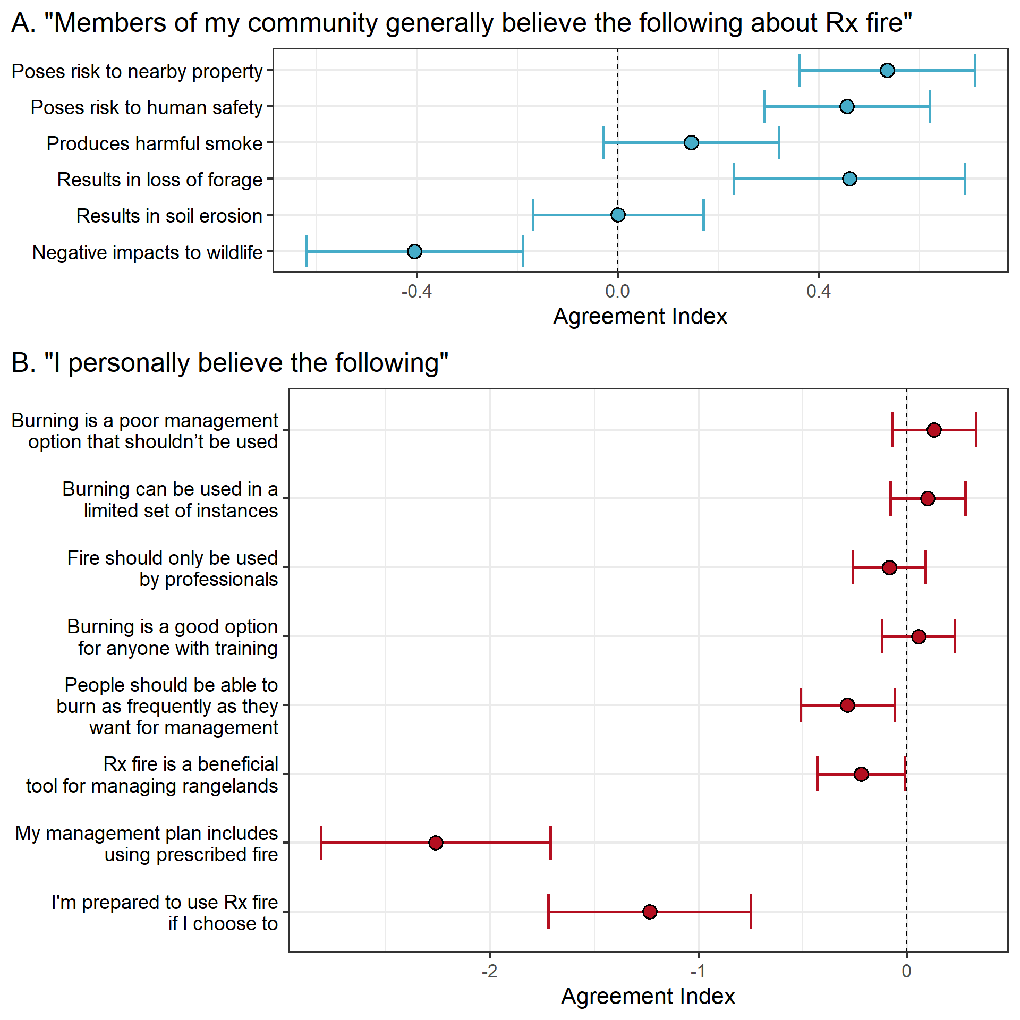

**Figure 4.** Degree to which survey participants agreed with statements regarding their beliefs about prescribed fire. (A) Respondents’ perceptions about how members of their community regard prescribed fire. (B) Respondents’ personal attitudes regarding when, and for whom, prescribed fire use is appropriate. Agreement index quantifies median effect size of response and 95% confidence intervals based on five-point Likert scales.

Overall, respondents to our survey felt that fire is risky to people, property, and forage (Fig. 4). At the same time, respondents felt that fire was beneficial for wildlife, and had neutral attitudes towards smoke. McCaffrey [49] also found a lower barrier imposed by smoke limiting people’s attitude towards fire, as they felt smoke was going to be there regardless from wildfire or prescribed fires alike. Our findings are consistent with other studies in which respondents reported fire to be risky towards property, people and forage, where landowners believed there were negative effects of fire when on a neighboring property. The belief of fire being harmful to neighbors creates a barrier, as landowners have a feeling of moral obligation to their neighbors [61]. Participants in Harr et al. [19] study outlined that fire did not directly benefit ranching operations as it benefited wildlife and oftentimes destroyed food for their cattle.

We found strong evidence that respondents are neither prepared nor willing to burn on their own land. Clark et al. [10] compiled many studies together in the Great Plains to determine attitudes of fire and found that respondents of these studies don't see fire as a beneficial tool, similar to our findings of respondent's slight disagreement that fire was beneficial, in the Northern Great Plains.

Respondents showed unpreparedness or willingness to introduce prescribed fire back on to the landscape, suggesting they are at the precontemplation/ contemplation stage of the Transtheoretical model of behavior [23]. These early levels are characterized by having little to no intention of changing, being either unaware of a problem or being aware of a problem but having not yet committed to action, respectively. Our results suggest respondents were split between whether fire was beneficial on the landscape or not, split between both levels of realizing a problem in the Transtheoretical Model of Behavior. Although respondents did lean more towards the disagreement side, allowing us to put more emphasis on the precontemplation level. An increase in information from sources that the respondents trust can help move people through the five levels of the Transtheoretical model of behavior including preparation, where there is intent or action on addressing a problem [62–64]. Action where measures have taken place to address the problem, and following with maintenance, where change has occurred and been sustained for a period. Through adequate information, action and maintenance levels are feasible.

3.4. Addressing barriers

Although a lot of attention is given to the barriers landowners face in accepting or adopting new practices, social science research often describes remedies that can help overcome each barrier. Clark et al. [10] matches *barrier builders* with *barrier busters* to help articulate how specific approaches can reduce perceived barriers to prescribed fire use.

*Barrier builder* indicates situations, social or physical, that limit or restrict the use of an activity, including prescribed fire. *Barrier busters* are resources or information that counteract the *barrier builders,* to encourage the use of prescribed fire [10]. These topics can involve categories that have social, knowledge, practical, and regulation in mind. Social impacts negative attitudes towards prescribed fire, that are busted by positive attitudes formed through information and resources. Which correlates with the knowledge aspect, when people lack knowledge, they do not understand the benefits and safety of prescribed fire. Practical barriers are often the most known barrier due to having a lack of time, finances, equipment and labor, all of which are able to be overcome when working in a group of likeminded individuals [10]. These groups are able to share resources to conduct prescribed burns. Regulation or liability is the hardest to overcome, as it is based on the state or local government, due to burn restrictions and legal repercussions [10].

Using *barrier busters,* to provide tools and resources to encourage the use of prescribed fire. *Barrier busters* include fostering a positive social attitude towards fire, providing access to knowledge, information, equipment, and reducing liability concerns [10]. Access to this information is essential to overcoming the *barrier builders* that prevent landowners from introducing prescribed fire back on to the landscape. Through this study it was reiterated that landowners in the northern Great Plains, adjacent to National Grasslands, are not equipped to introduce prescribed fire on to the landscape. Due to negative social attitudes and barriers limiting their involvement. Using the *barrier busters’* concept could change this direction and bring new knowledge and management plans to the area.

4. Conclusions

This section is not mandatory but can be added to the manuscript if the discussion is unusually long or complex.

**Supplementary Materials:** The following supporting information can be downloaded at: www.mdpi.com/xxx/s1, Figure S1: title; Table S1: title; Video S1: title.

**Author Contributions:** Conceptualization, D.A.M.; writing—original draft preparation, K.B. & D.A.M.; writing—review and editing, B.G., C.L.W, J.O.; visualization, D.A.M..; supervision, B.G. & D.A.M.; project administration, D.A.M. & B.G.; funding acquisition, D.A.M. All authors have read and agreed to the published version of the manuscript.

**Funding:** This research was funded by a Joint Venture Agreement between North Dakota State University and the US Forest Service Rocky Mountain Research Station.

**Institutional Review Board Statement:** This study granted an exemption by the Institutional Review Board of North Dakota State University, protocol #AG20167, 23 November 2020.

**Informed Consent Statement:** Informed consent was obtained from all subjects involved in the study.

**Data Availability Statement:** Summarized data are available as Supplementary Information to the article.

**Acknowledgments:** A.S. Clark provided technical assistance with survey administration.

**Conflicts of Interest:** The authors declare no conflicts of interest.

References

1. McGranahan, D.A.; Wonkka, C.L. *Ecology of Fire-Dependent Ecosystems: Wildland Fire Science, Policy, and Management*; CRC Press: Boca Raton, 2020; ISBN 978-0-429-48709-5.

2. Fuhlendorf, S.D.; Smeins, F.E.; Grant, W.E. Simulation of a Fire-Sensitive Ecological Threshold: A Case Study of Ashe Juniper on the Edwards Plateau of Texas, USA. *Ecological Modelling* **1996**, *90*, 245–255, doi:10.1016/0304-3800(95)00151-4.

3. Margolis, E.Q. Fire Regime Shift Linked to Increased Forest Density in a Piñon–Juniper Savanna Landscape. *Int. J. Wildland Fire* **2014**, *23*, 234–245, doi:10.1071/WF13053.

4. Umbanhowar, C.E. Recent Fire History of the Northern Great Plains. *American Midland Naturalist* **1996**, *135*, 115, doi:10.2307/2426877.

5. Courtwright, J. ”When We First Come Here It All Looked Like Prairie Land Almost”: Prairie Fire and Plains Settlement1. *Western Historical Quarterly* **2007**, *38*, 157–179, doi:10.1093/whq/38.2.157.

6. Anderson, R.C. Evolution and Origin of the Central Grassland of North America: Climate, Fire, and Mammalian Grazers1. *tbot* **2006**, *133*, 626–647, doi:10.3159/1095-5674(2006)133[626:EAOOTC]2.0.CO;2.

7. Pyne, S.J. *The Great Plains: A Fire Survey*; University of Arizona Press, 2017; ISBN 978-0-8165-3616-0.

8. Toledo, D.; Kreuter, U.P.; Sorice, M.G.; Taylor, C.A. The Role of Prescribed Burn Associations in the Application of Prescribed Fires in Rangeland Ecosystems. *Journal of Environmental Management* **2014**, *132*, 323–328, doi:10.1016/j.jenvman.2013.11.014.

9. Fuhlendorf, S.D.; Fynn, R.W.S.; McGranahan, D.A.; Twidwell, D. Heterogeneity as the Basis for Rangeland Management. In *Rangeland Systems*; Briske, D.D., Ed.; Springer Series on Environmental Management; Springer International Publishing: Cham, 2017; pp. 169–196 ISBN 978-3-319-46707-8.

10. Clark, A.S.; McGranahan, D.A.; Geaumont, B.A.; Wonkka, C.L.; Ott, J.P.; Kreuter, U.P. Barriers to Prescribed Fire in the US Great Plains, Part I: Systematic Review of Socio-Ecological Research. *Land* **2022**, *11*, 1521, doi:10.3390/land11091521.

11. Clark, A.S.; McGranahan, D.A.; Geaumont, B.A.; Wonkka, C.L.; Ott, J.P.; Kreuter, U.P. Barriers to Prescribed Fire in the US Great Plains, Part II: Critical Review of Presently Used and Potentially Expandable Solutions. *Land* **2022**, *11*, 1524, doi:10.3390/land11091524.

12. Hechter, M.; Opp, K.-D. *Social Norms*; Russell Sage Foundation, 2001; ISBN 978-1-61044-280-0.

13. Schwartz: A Normative Decision-Making Model of Altruism - Google Scholar Available online: https://scholar.google.com/scholar_lookup?&title=A%20normative%20decision-making%20model%20of%20altruism&pages=189-211&publication_year=1981&author=Schwartz%2CSH&author=Howard%2CJA#d=gs_cit&t=1722021650185&u=%2Fscholar%3Fq%3Dinfo%3AJgSvJktujf8J%3Ascholar.google.com%2F%26output%3Dcite%26scirp%3D0%26hl%3Den (accessed on 26 July 2024).

14. Charnley, S.; Carothers, C.; Satterfield, T.; Levine, A.; Poe, M.R.; Norman, K.; Donatuto, J.; Breslow, S.J.; Mascia, M.B.; Levin, P.S.; et al. Evaluating the Best Available *Social* Science for Natural Resource Management Decision-Making. *Environmental Science & Policy* **2017**, *73*, 80–88, doi:10.1016/j.envsci.2017.04.002.

15. Brunson, M.W. The Elusive Promise of Social-Ecological Approaches to Rangeland Management. *Rangeland Ecology & Management* **2012**, *65*, 632–637, doi:10.2111/REM-D-11-00117.1.

16. Sliwinski, M.; Burbach, M.; Powell, L.; Schacht, W. Ranchers’ Perceptions of Vegetation Heterogeneity in the Northern Great Plains. *Great Plains Research* **2018**, *28*, 185–197.

17. Yung, L.; Belsky, J.M. Private Property Rights and Community Goods: Negotiating Landowner Cooperation Amid Changing Ownership on the Rocky Mountain Front. *Society & Natural Resources* **2007**, *20*, 689–703, doi:10.1080/08941920701216586.

18. Schohr, T.K.; Gornish, E.S.; Woodmansee, G.; Shaw, J.; Tate, K.W.; Roche, L.M. Practitioner Insights into Weed Management on California’s Rangelands and Natural Areas. *Environmental Management* **2020**, *65*, 212–219, doi:10.1007/s00267-019-01238-8.

19. Harr, R.; Wright Morton, L.; Rusk, S.; Engle, D.; Miller, J.; Debinski, D. Landowners’ Perceptions of Risk in Grassland Management: Woody Plant Encroachment and Prescribed Fire. *Ecology and Society* **2014**, *19*, doi:10.5751/ES-06404-190241.

20. Haines, T.K.; Busby, R.L.; Cleaves, D.A. Prescribed Burning in the South: Trends, Purpose, and Barriers. *Southern Journal of Applied Forestry* **2001**, *25*, 149–153, doi:10.1093/sjaf/25.4.149.

21. Quinn-Davidson, L.N.; Varner, J.M. Impediments to Prescribed Fire across Agency, Landscape and Manager: An Example from Northern California. *Int. J. Wildland Fire* **2011**, *21*, 210–218, doi:10.1071/WF11017.

22. Twidwell, D.; Rogers, W.E.; Fuhlendorf, S.D.; Wonkka, C.L.; Engle, D.M.; Weir, J.R.; Kreuter, U.P.; Taylor, C.A. The Rising Great Plains Fire Campaign: Citizens’ Response to Woody Plant Encroachment. *Frontiers in Ecology and the Environment* **2013**, *11*, e64–e71, doi:10.1890/130015.

23. Bendel, C.; Toledo, D.; Hovick, T.; McGranahan, D. Using Behavioral Change Models to Understand Private Landowner Perceptions of Prescribed Fire in North Dakota. *Rangeland Ecology & Management* **2020**, *73*, 194–200, doi:10.1016/j.rama.2019.08.014.

24. Bieling, C.; Plieninger, T.; Pirker, H.; Vogl, C.R. Linkages between Landscapes and Human Well-Being: An Empirical Exploration with Short Interviews. *Ecological Economics* **2014**, *105*, 19–30, doi:10.1016/j.ecolecon.2014.05.013.

25. Abrams, J.; Bliss, J.C. Amenity Landownership, Land Use Change, and the Re-Creation of “Working Landscapes.” *Society & Natural Resources* **2013**, *26*, 845–859, doi:10.1080/08941920.2012.719587.

26. Brown, J.; Mitchell, N.; Sarmiento, J. Landscape Stewardship: New Directions in Conservation of Nature and Culture. *The George White Forum* **2000**, *17*.

27. Gundersen, V.; Mäkinen, K. Aldo Leopold and Stewardship: Lessons for Forest Planning and Management in the Nordic Countries? *Norsk Geografisk Tidsskrift - Norwegian Journal of Geography* **2009**, *63*, 225–232, doi:10.1080/00291950903368334.

28. Huntsinger, L.; Sayre, N.F. 14 Landscape Stewardship for Rangelands. *The Science and Practoces of Landscape Stewardship* **2017**, 284.

29. Weir, J.R.; Kreuter, U.P.; Wonkka, C.L.; Twidwell, D.; Stroman, D.A.; Russell, M.; Taylor, C.A. Liability and Prescribed Fire: Perception and Reality. *Rangeland Ecology & Management* **2019**, *72*, 533–538, doi:10.1016/j.rama.2018.11.010.

30. Twidwell, D.; Wonkka, C.L.; Sindelar, M.; Weir, J.R. First Approximations of Prescribed Fire Risks Relative to Other Management Techniques Used on Private Lands | PLOS ONE Available online: https://journals.plos.org/plosone/article?id=10.1371/journal.pone.0140410 (accessed on 26 August 2024).

31. Morton, L.W.; Regen, E.; Engle, D.M.; Miller, J.R.; Harr, R.N. Perceptions of Landowners Concerning Conservation, Grazing, Fire, and Eastern Redcedar Management in Tallgrass Prairie. *Rangeland Ecology & Management* **2010**, *63*, 645–654, doi:10.2111/REM-D-09-00041.1.

32. Wade, D.; Lunsford, J. A Guide for Prescribed Fire in Southern Forests | Fire Research and Management Exchange System Available online: https://www.frames.gov/catalog/12713 (accessed on 26 August 2024).

33. Polo, J.A.; Tanner, E.P.; Scholtz, R.; Fuhlendorf, S.D.; Ripberger, J.T.; Silva, C.L.; Jenkins-Smith, H.C.; Carlson, N. Mismatches in Prescribed Fire Awareness and Implementation in Oklahoma, USA. *Rangelands* **2020**, *42*, 196–202, doi:10.1016/j.rala.2020.09.002.

34. Wonkka, C.L.; Rogers, W.E.; Kreuter, U.P. Legal Barriers to Effective Ecosystem Management: Exploring Linkages between Liability, Regulations, and Prescribed Fire. *Ecological Applications* **2015**, *25*, 2382–2393, doi:10.1890/14-1791.1.

35. Yoder, J.; Engle, D.; Fuhlendorf, S. Liability, Incentives, and Prescribed Fire for Ecosystem Management. *Frontiers in Ecology and the Environment* **2004**, *2*, 361–366, doi:10.1890/1540-9295(2004)002[0361:LIAPFF]2.0.CO;2.

36. McGranahan, D.A.; Fernando, F.N.; Kirkwood, M.L.E. Reflections on a Boom: Perceptions of Energy Development Impacts in the Bakken Oil Patch Inform Environmental Science & Policy Priorities. *Science of The Total Environment* **2017**, *599–600*, 1993–2018, doi:10.1016/j.scitotenv.2017.05.122.

37. McGranahan, D.A.; Kirkman, K.P. Local Perceptions of Hydraulic Fracturing Ahead of Exploratory Drilling in Eastern South Africa. *Environmental Management* **2019**, *63*, 338–351, doi:10.1007/s00267-019-01138-x.

38. Goodman, L.A. Snowball Sampling. *The annals of mathematical statistics* **1961**, 148–170.

39. Huang, R. Package “RQDA”: R-Based Qualitative Data Analysis. *R package version* **2014**, *0.2-3*.

40. R Core Team *R: A Language and Environment for Statistical Computing*; R Foundation for Statistical Computing: Vienna, Austria, 2020;

41. Clark, A.S.; McGranahan, D.A.; Geaumont, B.A.; Wonkka, C.L.; Ott, J.P.; Kreuter, U.P. Barriers to Prescribed Fire in the US Great Plains, Part II: Critical Review of Presently Used and Potentially Expandable Solutions. *Land* **2022**, *11*, 1524, doi:10.3390/land11091524.

42. Dillman, D.A. *Mail and Internet Surveys: The Tailored Design Method--2007 Update with New Internet, Visual, and Mixed-Mode Guide*; John Wiley & Sons, 2011; ISBN 1-118-04463-0.

43. Larson, S.; Timm, R.M.; McGranahan, D.A. The Marin County Livestock Protection Program: 15 Years in Review. *Human–Wildlife Interactions* **2019**, *13*, 63–78, doi:10.5070/V427110695.

44. Menzel, U. Package “EMT”: Exact Multinomial Test: Goodness-of-Fit Test for Discrete Multivariate Data. *R package version* **2013**, *1*.

45. Bryer, J.; Speerschneider, K. Package “Likert”: Analysis and Visualization Likert Items. *R package version* **2015**, *1.3.3*.

46. Shindler, B.; Toman, E. Fuel Reduction Strategies in Forest Communities: A Longitudinal Analysis of Public Support. *Journal of Forestry* **2003**, *101*, 8–15, doi:10.1093/jof/101.6.8.

47. Roche, L.M.; Schohr, T.K.; Derner, J.D.; Lubell, M.N.; Cutts, B.B.; Kachergis, E.; Eviner, V.T.; Tate, K.W. Sustaining Working Rangelands: Insights from Rancher Decision Making. *Rangeland Ecology & Management* **2015**, *68*, 383–389, doi:10.1016/j.rama.2015.07.006.

48. Robin H. Liffmann; Lynn Huntsinger; Larry C. Forero To Ranch or Not to Ranch: Home on the Urban Range? *J. Range. Manage.* **200AD**, *53:362-370*.

49. McCaffrey Understanding Public Perspectives of Wildfire Risk.

50. Emborg, J.; Daniels, S.E.; Walker, G.B. A Framework for Exploring Trust and Distrust in Natural Resource Management. *Front. Commun.* **2020**, *5*, doi:10.3389/fcomm.2020.00013.

51. Examining Social Trust in Fuels Management Strategies | Journal of Forestry | Oxford Academic Available online: https://academic.oup.com/jof/article/102/6/8/4613171 (accessed on 15 November 2024).

52. Winter, G.; Vogt, C.A.; McCaffrey, S. Examining Social Trust in Fuels Management Strategies. *Journal of Forestry* **2004**, *102*, 8–15, doi:10.1093/jof/102.6.8.

53. Augustine, D.; Davidson, A.; Dickinson, K.; Van Pelt, B. Thinking Like a Grassland: Challenges and Opportunities for Biodiversity Conservation in the Great Plains of North America. *Rangeland Ecology & Management* **2019**, S1550742419300697, doi:10.1016/j.rama.2019.09.001.

54. Salient Value Similarity, Social Trust and Attitudes toward Wildland Fire Management Strategies on JSTOR Available online: https://www.jstor.org/stable/24707708 (accessed on 15 November 2024).

55. Brunson, M.W.; Huntsinger, L. Ranching as a Conservation Strategy: Can Old Ranchers Save the New West? *Rangeland Ecology & Management* **2008**, *61*, 137–147, doi:10.2111/07-063.1.

56. Holechek, J.L.; Geli, H.M.E.; Cibils, A.F.; Sawalhah, M.N. Climate Change, Rangelands, and Sustainability of Ranching in the Western United States. *Sustainability* **2020**, *12*, 4942, doi:10.3390/su12124942.

57. Fuhlendorf, S.D.; Engle, D.M. Application of the Fire–Grazing Interaction to Restore a Shifting Mosaic on Tallgrass Prairie. *Journal of Applied Ecology* **2004**, *41*, 604–614, doi:10.1111/j.0021-8901.2004.00937.x.

58. Polito, V.J.; Baum, K.A.; Payton, M.E.; Little, S.E.; Fuhlendorf, S.D.; Reichard, M.V. Tick Abundance and Levels of Infestation on Cattle in Response to Patch Burning. *Rangeland Ecology & Management* **2013**, *66*, 545–552, doi:10.2111/REM-D-12-00172.1.

59. Scasta, J.D. Fire and Parasites: An Under-Recognized Form of Anthropogenic Land Use Change and Mechanism of Disease Exposure. *EcoHealth* **2015**, *12*, 398–403, doi:10.1007/s10393-015-1024-5.

60. Wanchuk, M.R.; McGranahan, D.A.; Sedivec, K.K.; Swanson, K.C.; Hovick, T.J. Prescribed Fire Increases Forage Mineral Content in Grazed Rangeland. *International Journal of Wildland Fire* **2024**, *33*, WF24009, doi:10.1071/WF24009.

61. Coon, J.J.; van Riper, C.J.; Morton, L.W.; Miller, J.R. What Drives Private Landowner Decisions? Exploring Non-Native Grass Management in the Eastern Great Plains. *Journal of Environmental Management* **2020**, *276*, 111355, doi:10.1016/j.jenvman.2020.111355.

62. Doran, E.MB.; Doidge, M.; Aytur, S.; Wilson, R.S. Understanding Farmers’ Conservation Behavior over Time: A Longitudinal Application of the Transtheoretical Model of Behavior Change. *Journal of Environmental Management* **2022**, *323*, 116136, doi:10.1016/j.jenvman.2022.116136.

63. Abrash Walton, A.; Nageotte, N.L.; Heimlich, J.E.; Threadgill, A.V. Facilitating Behavior Change: Introducing the Transtheoretical Model of Behavior Change as a Conservation Psychology Framework and Tool for Practitioners. *Zoo Biology* **2022**, *41*, 386–397, doi:10.1002/zoo.21704.

64. Briccetti, L.H.; Doran, E.M.B.; Coleman, K.J. Using the Transtheoretical Model of Behavior Change to Explore Forest Landowner Perspectives on Water Quality. *Small-scale Forestry* **2024**, *23*, 275–294, doi:10.1007/s11842-024-09565-3.

**Disclaimer/Publisher’s Note:** The statements, opinions and data contained in all publications are solely those of the individual author(s) and contributor(s) and not of MDPI and/or the editor(s). MDPI and/or the editor(s) disclaim responsibility for any injury to people or property resulting from any ideas, methods, instructions or products referred to in the content.