Soil Heating effects of prescribed fire in US Great Plains

Devan Allen McGranahan

Soil is a natural system comprised of minerals, organic matter, air, and water. Soil development begins with the weathering of local geologic parent material and is continually influenced by climate and organisms. Soil is not just the natural medium for plant growth—it is the habitat for organisms that regulate the delivery of multiple ecosystem services, and a substantial repository for elements and minerals important to global processes, such as carbon and nitrogen.

Many soil properties can be affected by wildland fire, either directly or indirectly. Variability in these affects comes largely from the intensity and duration of heat exposure as well as the environmental conditions before and after fire (Pereira et al. 2019; McGranahan and Wonkka 2021). Direct effects are those produced by exposure to heat generated by combustion—e.g., chemical conversion of organic nitrogen to mineral ammonium, protein denaturation. Indirect effects are responses that follow environmental alterations attributable to fire—e.g., biomass removal, increased insolation, and second-order vegetation dynamics.

## General patterns of soil heating

There is little evidence that prescribed fire has substantial impact on biotic or abiotic soil properties in the Great Plains. The overall lack of effect is primarily due to the fact that soil heating in grassland ecosystems is relatively benign, due to the low residence time of flame fronts in fuelbeds dominated by fine fuels, especially under the moderate fire weather conditions typical of prescribed fire in the region. Soil itself resists heating—the majority of heat released from surface combustion rises, and organic matter and air effectively insulate against energy from moving downward. Research from Europe indicates that only under conditions of very high soil moisture and prolonged heat input will substantial heating penetrate more than 3-5 cm into the soil profile and subsequently affect soil properties (Valette et al. 1994; Giovannini and Lucchesi 1997; Barreiro et al. 2020). The limited data on soil heating during prescribed fire in the Great Plains provides evidence of this drastic attenuation (Table 1).

Table 1: Selection of studies reporting soil surface and/or sub-surface temperatures from prescribed fire in Great Plains grassland communities. All reported data collected from thermocouples connected to digital dataloggers. Sensor placement refers to where the hot end of thermocouple was placed; negative values indicate depth below soil surface. * Values derived via soil heating model.

| **Study** | **Prairie type (Location)** | **Sensor placement** | **Temperature ($​^{∘}$ C)** |
| --- | --- | --- | --- |
| Archibold et al. (2003) | Fescue prairie (Saskatchewan) | −1 cm | 22 |
| Archibold et al. (1998) | Mixed grass (Saskatchewan) | Soil surface | 252 |
|  |  | −5 cm | 12 |
| Zopfi (2020) | Mixed grass (central North Dakota) | Soil surface | 150 |
| Zopfi (2020) | Mixed grass (sw North Dakota) | Soil surface | 120 |
| McGranahan et al. (2022) | Mixed grass (sw North Dakota) | Soil surface | 275 |
|  |  | −2 cm | 100 * |
|  |  | −5 cm | 50 * |
| Ohrtman et al. (2015) | Tallgrass (South Dakota) | Soil surface | 384 |
| Anderson (2016) | Tallgrass (Texas) | −5 cm | 28 |

Many fire effects on soils are modulated by the fire regime, particularly the frequency and intensity of fire. While infrequent fire can increase nitrogen availability and increase nutrient cycling rates, annual burning increased soil respiration in tallgrass prairie (Johnson and Matchett 2001). Indeed, annual burning might generally elevate the net export of necessary nutrients above what deposition and mineralization can replace (Brye 2006). Conversely, low-intensity fires in *Poa pratensis*-dominated mixed grass prairie in North Dakota had no appreciable effect on soil properties (Gerhard et al. 2022). The conclusion here was that soil properties are resilient to heating, but given that soil surface temperatures in the studied burned units averaged just 150 $​^{∘}$ C (Zopfi 2020), it is just as likely that the soil strata measured received very little heating.

## Specific belowground responses to soil heating

Prescribed fire tends to increase soil surface temperature and decrease soil moisture, but the magnitude of reported effects are generally small. In western Oklahoma, soil temperatures were 1-3 $​^{∘}$ C higher after burns, but soil moisture on these sandy soils did not vary among treatments (Vermeire et al. 2005). In eastern Montana, burned plots were 0.5 $​^{∘}$ C warmer and 1% drier than unburned plots (Vermeire et al. 2011). In southern Saskatchewan, soil moisture did not vary signficantly between burned and unburned sites while in only one instance was a 5 $​^{∘}$ C increase in soil temperature significantly greater than in unburned controls (Yang et al. 2013). But drier soil might not be a universal response to fire, especially in grazed areas: Spiess (2021) reported *higher* soil moisture in burned patches in which grazers maintained low-stature vegetation, suggesting reducing the amount of leaf tissue capable of moving soil moisture into the atmosphere might conserve water in the soil. This hypothesis, however, has yet to be formally tested at the plant level, although altered water flux has been documented in burned prairie (Fischer et al. 2012).

Plant-available, or *mineralized*, nitrogen (N) has been widely reported to increase in response to fire. Although much of this research has been conducted beyond the Great Plains (McGranahan and Wonkka 2021), work from our region corroborates these trends. In one of few studies to directly measure mineral N and soil heating, McGranahan et al. (2022) found that ammonium levels increased immediately after fall fire in North Dakota, and nitrate levels were elevated 7 mo after fire, into the next growing season (Fig. 1). This same pattern was reported in Colorado shortgrass steppe (Augustine et al. 2014). Similarly, Reinhart and Vermeire (2016) also reported increases in soil N following fire in eastern Montana.

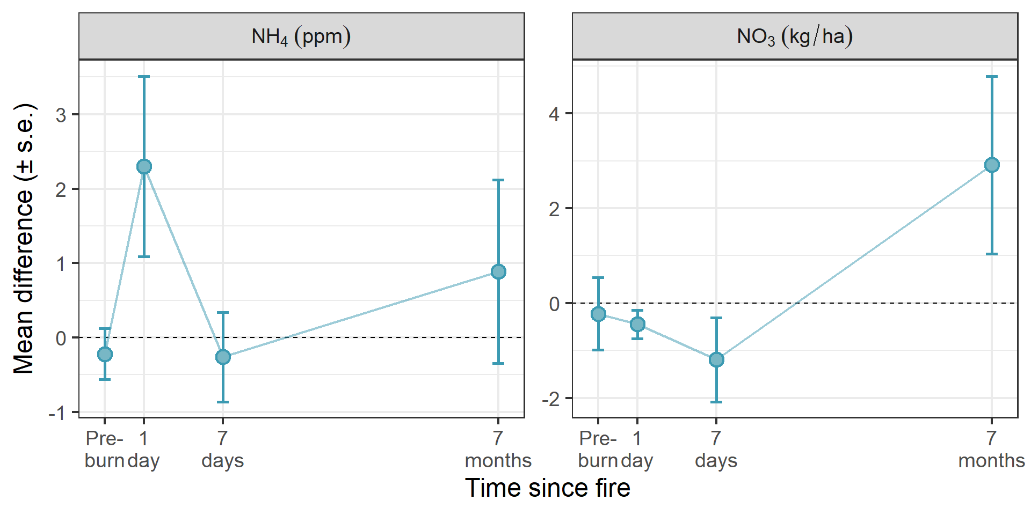

Figure 1: Response of two mineral N species to prescribed fire in southwestern North Dakota. NH4 = ammonium; NO3 = nitrate. From McGranahan et al. (2022).

Soil microbes have generally been described as resilient to fire—in the event that limited reductions in microbial biomass occur immediately after fire, abundance typically recovers within weeks or months (McGranahan et al. 2022). But fire-driven reductions are not universally observed (Reinhart and Vermeire 2016) and microbial community composition is typically unaffected by fire (Dangi et al. 2010; Spiess 2021; McGranahan et al. 2022).

Most reported fire effects on soil properties are limited to upper soil layers. For example, in mesquite-prairie rangeland in Texas, Dai et al. (2006) found fire regimes that included summer fires increased soil organic C and total N in the top 20 cm, but had no effect on either variable lower in the profile. Thus, the role of fire in long-term, ecosystem-level soil nutrient dynamics, such as carbon sequestration, in the Great Plains likely lies mostly in indirect effects related to plant community composition—e.g., herbaceous vs. woody vegetation—than direct effects of fire. In some systems, *pyrogenic* charcoal byproducts of wildland fire known as *PyC* or *PyOM* have been shown to decompose more slowly than similar amounts of carbon or organic matter unaltered by heating, suggesting a recalcitrance that might contribute to carbon sequestration (Quilliam et al. 2013). However, experimental work on grass tissue, specifically, reports similar rates of microbial activity (Hilscher et al. 2009; Hilscher and Knicker 2011), suggesting carbonization does little to enhance the carbon storage capacity of the dominant vegetation type in the Great Plains.

# References

Anderson ER (2016) Quantifying physical changes in near-surface soil during prescribed fire. Master’s thesis, Texas Christian University

Archibold O, Nelson L, Ripley E, Delanoy L (1998) Fire temperatures in plant communities of the northern mixed prairie. Canadian Field-Naturalist 112:234–240

Archibold O, Ripley E, Delanoy L (2003) Effects of season of burning on the microenvironment of fescue prairie in central Saskatchewan. The Canadian Field-Naturalist 117:257–266

Augustine DJ, Derner JD, Smith DP (2014) Characteristics of burns conducted under modified prescriptions to mitigate limited fuels in a semi-arid grassland. Fire Ecology 10:36–47. https://doi.org/[10.4996/fireecology.1002036](https://doi.org/10.4996/fireecology.1002036)

Barreiro A, Lombao A, Martı́n A, Cancelo-González J, Carballas T, Dı́az-Raviña M (2020) Soil heating at high temperatures and different water content: Effects on the soil microorganisms. Geosciences 10:355

Brye KR (2006) Soil physiochemical changes following 12 years of annual burning in a humid–subtropical tallgrass prairie: A hypothesis. Acta Oecologica 30:407–413

Dai X, Boutton T, Hailemichael M, Ansley R, Jessup K (2006) Soil carbon and nitrogen storage in response to fire in a temperate mixed-grass savanna. Journal of Environmental Quality 35:1620–1628

Dangi SR, Stahl PD, Pendall E, Cleary MB, Buyer JS (2010) Recovery of soil microbial community structure after fire in a sagebrush-grassland ecosystem. Land Degradation & Development 21:423–432

Fischer ML, Torn MS, Billesbach DP, Doyle G, Northup B, Biraud SC (2012) Carbon, water, and heat flux responses to experimental burning and drought in a tallgrass prairie. Agricultural and Forest Meteorology 166:169–174

Gerhard L, Gasch CK, Sedivec K (2022) Soil properties are resilient despite grass invasion, fire, and grazing. Agrosystems, Geosciences & Environment 5:e20257

Giovannini G, Lucchesi S (1997) [Modifications induced in soil physico-chemical parameters by experimental fires at different intensities](https://journals.lww.com/soilsci/Fulltext/1997/07000/MODIFICATIONS__INDUCED_IN_SOIL_PHYSICO_CHEMICAL.3.aspx?casa_token=8YY84_yhD2oAAAAA:LvrUkr6QRF06A-djuc7rXOzycqR03fwaKvwXOfHRUZvuQIFRA9DesfuyFG9mFTffd5J8Pnas80mT-BW9_W-9B3z0fA). Soil Sci 162:479

Hilscher A, Heister K, Siewert C, Knicker H (2009) Mineralisation and structural changes during the initial phase of microbial degradation of pyrogenic plant residues in soil. Organic Geochemistry 40:332–342

Hilscher A, Knicker H (2011) Degradation of grass-derived pyrogenic organic material, transport of the residues within a soil column and distribution in soil organic matter fractions during a 28 month microcosm experiment. Organic Geochemistry 42:42–54

Johnson LC, Matchett JR (2001) Fire and grazing regulate belowground processes in tallgrass prairie. Ecology 82:3377–3389

McGranahan DA, Wonkka CL (2021) Ecology of Fire-Dependent Ecosystems: Wildland Fire Science, Policy, and Management. CRC Press, Boca Raton, FL

McGranahan DA, Wonkka CL, Dangi S, Spiess JW, Geaumont B (2022) Mineral nitrogen and microbial responses to soil heating in burned grassland. Geoderma 424:116023

Ohrtman MK, Clay SA, Smart AJ (2015) Surface temperatures and durations associated with spring prescribed fires in eastern South Dakota tallgrass prairies. The American Midland Naturalist 173:88–98

Pereira JMC, Mataix-Solera J, Úbeda X, Rein G, Cerdà A (2019) [Fire Effects on Soil Properties](https://www.publish.csiro.au/book/7743). CRC Press

Quilliam RS, Glanville HC, Wade SC, Jones DL (2013) Life in the “charosphere” – Does biochar in agricultural soil provide a significant habitat for microorganisms? Soil Biology and Biochemistry 65:287–293. https://doi.org/[10.1016/j.soilbio.2013.06.004](https://doi.org/10.1016/j.soilbio.2013.06.004)

Reinhart KO, Vermeire LT (2016) Soil aggregate stability and grassland productivity associations in a northern mixed-grass prairie. PloS one 11:e0160262

Spiess JW (2021) Patch-burn grazing in southwestern north dakota: Assessing above-and belowground rangeland ecosystem responses. PhD thesis, North Dakota State University

Valette J-C, Gomendy V, Maréchal J, Houssard C, Gillon D (1994) Heat-transfer in the soil during very low-intensity experimental fires-the role of duff and soil-moisture content. International Journal of Wildland Fire 4:225–237

Vermeire LT, Crowder JL, Wester DB (2011) Plant community and soil environment response to summer fire in the northern great plains. Rangeland Ecology & Management 64:37–46

Vermeire LT, Wester DB, Mitchell RB, Fuhlendorf SD (2005) Fire and grazing effects on wind erosion, soil water content, and soil temperature. Journal of Environmental Quality 34:1559–1565

Yang X, Kovach E, Guo X (2013) Biophysical and spectral responses to various burn treatments in the northern mixed-grass prairie. Canadian Journal of Remote Sensing 39:175–184

Zopfi ME (2020) Characteristics and spatial heterogeneity of prescribed fire behavior in north dakota grasslands. Master’s thesis, The University of North Dakota