Evaluating an attempt to restore summer fire in the Northern Great Plains

### Running head: Summer burning in the Northern Plains

Devan Allen McGranahan* and Jay P. Angerer

Livestock and Range Research Laboratory, USDA Agricultural Research Service, Miles City, Montana, USA

*Correspondence: [Devan.McGranahan@usda.gov](mailto:Devan.McGranahan@usda.gov)

**Author contributions:** Conception, analysis, writing: DAM; Programming and editing: JPA

# Abstract

There is growing interest in diversifying human-managed fire regimes. In many North American grasslands, late growing season burns re-introduce fire to periods most prone to lightning-driven fire prior to wildfire suppression policies. We report here on restoring summer fire in central North Dakota, USA, from a research project in which summer fire was only successfully achieved in two out of four years. We use remotely-sensed imagery and local weather data to assess whether fuel or weather conditions limited burning in the summer, and to compare fire environmental conditions and subsequent burn severity across prescribed burns conducted in the spring and summer. Finally, we review historical data to determine if conditions have changed in either the spring or summer burn seasons over 42 years. We found that burn severity declined with fuelbed greenness but was independent of burn season—summer burns could effect as high of severity as spring burns despite having greener fuelbeds. What little phenological change seems to have occurred at the study location—slightly greener fuelbeds and slightly lower relative humidity in spring—likely offset each other to some degree. Overall, we found little evidence that successful summer burns were anomalies, and conclude that it is reasonable for managers to incorporate late growing season fire into prescribed fire programs with the caveat that some summers will simply be too wet and/or too green to burn.

**Keywords:** Burn severity; Phenology; Seasonality of fire; Pyrodiversity

# Implications for practice

* Successful Rx fire in the summer is likely the norm, not the exception.
* At least at this specific research station, there is little evidence that fuel and weather conditions have changed over 42 years except for slightly greener spring fuels and lower relative humidity, which might cancel each other out.

# Introduction

Fire is essential to the maintenance of grasslands and other open ecosystems, and has been described as a key component of restoring pre-colonial ecological conditions (Bond 2021; Fuhlendorf et al. 2017). The nature of fire in a given ecosystem is described as a regime. While determining the vegetation layer(s) that carry fire and the typical frequency and intensity of burning are relatively straightforward, seasonality and ignition source are much more difficult to reconstruct (McGranahan & Wonkka 2021). As such, the appropriate season(s) in which to burn is among the most debated aspects of fire restoration projects.

Burning in different seasons can produce different effects. While combustion in the wildland fire environment is theoretically possible whenever a competent ignition source is introduced to a sufficient amount of dry vegetation, climate often determines whether these conditions occur simultaneously. Lightning is the primary source of natural ignitions responsible for most fire starts prior to the emergence of hominids several hundred thousand years ago (Pyne 1994). As humans evolved and their technological capacity increased, so too did the influence of their ignitions. In regions with extant cultural fire use, the seasonality of fire is often dictated by localized and traditional land-use goals (McGranahan et al. 2022). In most Western countries, however, cultural burning has been replaced by systematic, command-and-control fire management in which most unplanned ignitions are suppressed and intentional burning occurs under strict prescriptions (e.g., Steen-Adams et al. 2017).

Restoring summer fire is of particular interest among managers in the North American Great Plains, where the influence of Indigenous ignitions was extensive and interacted with climate (Boyd 2002; Roos et al. 2018). Prescribed fire in the Great Plains has conventionally occurred while vegetation is dormant, although Engle & Bidwell (2001) argued prairie was resilient to fire in any season and challenged managers to consider summer burns. Although subsequent research has shown benefits of summer fire for diversity and productivity (Ansley & Castellano 2007; Decker & Harmon-Threatt 2019), a survey of grassland managers found that summer remains the least frequent season for prescribed fire (Harmon-Threatt & Chin 2016). Meanwhile, wide variability in responses to seasonal fire have been reported within and across plant functional groups, often driven by disproportionately large responses by few species (Steuter 1987; Mndela et al. 2023; Biondini et al. 1989; Sparks et al. 1998). Considerable variability in responses to summer fire has been attributed to the fact that higher humidity and fuel moisture during the growing season often reduce fire intensity and effect lower severity (Steuter 1987; Tangney et al. 2022).

The Northern Great Plains might have had one of the most pronounced differentials in fire seasonality between lightning-caused and anthropogenic ignitions. Fire was frequent in the region for at least 400 years prior to European colonization (Umbanhowar 1996). Contemporary accounts of fires set by Native Americans and early Europeans beginning in 1673 identified a bimodal pattern of human-set fires in the spring and fall (Higgins 1986). But for the last 80 years, at least, lightning-caused fires occurred predominately in late July and August (Higgins 1984; McGranahan & Wonkka 2024).

In this paper we report on mixed success in conducting summer prescribed fire in the Northern Great Plains. As researchers attempted to restore spatially-patchy prescribed fire to grazed mixed-grass prairie, two patterns of fire were introduced: one in which an entire one-quarter patch was burned each spring, and another in which half of the patch—one-eighth of the pasture—was burned in the spring, followed by the second half-patch scheduled for a late summer burn, in an attempt to provide a late-season flush of high-quality forage (e.g., Allred et al. 2011; Nichols et al. 2021) and determine whether a greater number of patches would increase spatial heterogeneity (e.g., McGranahan et al. 2018). While all spring burns were completed as planned, summer fires were only successful in two out of four years. Here we present seasonal and long-term remotely-sensed burn severity and fuel data alongside weather information in considering whether successful summer burns are likely to be the exception or the norm based on historical patterns.

# Methods

## Study location

The prescribed fire restoration project was established at the North Dakota State University Central Grasslands Research Extension Center, near Streeter, in south-central North Dakota, USA (99°25′W, 42°42′N). Vegetation at the Center is typical northern mixed-grass prairie with substantial abundance of the non-native C3 grasses *Poa pratensis* and *Bromus inermis*. In 2017, a research project began in which 12, 65-ha pastures were assigned to one of each of three management strategies (N = 4), none of which involved internal fences: continuous grazing, in which livestock had unhindered access to pastures with no additional disturbance; spring-only patch burning, in which a 16-ha patch was burned each spring and livestock allowed unhindered access; and spring-summer patch burning, in which half of a 16-ha patch was burned in the spring, and the second half scheduled to be burned in the summer. All pastures were stocked with approximately 22 Angus *Bos taurus* cow-calf pairs from May-October; see Duquette et al. (2022) for a complete description of the study location and experimental design.

Forty prescribed fires were conducted over four years, 2017–2020. All 32 planned spring burns were completed, between 25 April and 25 May. Only eight of 16 planned summer burns were completed: 4 in 2017, and 4 in 2020, between 13-25 August. Burn units were surrounded with plowed mineral firebreaks and ignitions varied between backing and head fires, and interior strip ignitions, with handheld drip torches.

## Data

Two types of data are presented here: remotely-sensed imagery from earth observation satellites, and weather data logged by the Center’s mesonet weather station. We used remotely-sensed data from two separate sources. For the study period alone, 2017–2020, we used the European Space Agency’s Sentinel-2 mission, multispectral imagery at 10 10 m resolution in the visible and near-infrared region and 20 20 m in the red-edge and shortwave infrared regions. Data are collected and produced at 5-10 day intervals. For historical context, 1990–2022, we used Landsat resources from the US Geological Survey (Landsat 5, 7, and 8 Level 2, Collection 2, Tier 1 Surface Reflectance), which provide multispectral imagery at 30 30 m resolution at 7-14 day intervals; Sentinel-2 only began in 2016, while the first Landsat 5 mission launched in the mid 1980s.

Remotely-sensed data consisted of two indices: the Normalized Burn Ratio (NBR; Key & Benson (2006)), which is used to estimate burn severity, and Normalized Difference Vegetation Index (NDVI; Rouse Jr et al. (1974)), used to estimate greenness of vegetation. Sentinel-2 imagery was retrieved from the online Copernicus Browser using a custom EvalScript to return values for each index as a separate band in a geo-referenced raster file; each scene was inspected to ensure cloud-free imagery over pasture locations beginning with the first snow-free scene through to the final snow-free scene each year. To calculate burn severity, we subtracted the first post-fire image from the most-recent pre-fire image for each burn unit, generating a burn severity index known as differenced Normalized Burn Ratio (dNBR; Key & Benson (2006)). Estimates of fuel greenness were made with the NDVI from the same most-recent pre-burn image.

Landsat imagery was processed with Google Earth Engine (Gorelick et al. 2017) using a custom script to merge missions over time, mask clouds, and calculate NDVI for the burn seasons defined above, 1990–2022. See Supplemental Information for scripts used for both Copernicus and Google Earth Engine.

Remotely-sensed values were extracted from raster images at sample points using the *terra* package for the **R** statistical environment (Hijmans et al. 2022; R Core Team 2024). Data from the patch-burned pastures were retrieved from gridded points assigned with 30 m spacing never less than 10 m from the edges of burn units, with ponds and ephemeral water bodies within burn units excluded. Data from unburned control pastures were retrieved from points used in forage quality assessments by Wanchuk et al. (2024).

Weather data—which included air temperature, relative humidity, dew point, windspeed, and vapor pressure deficit—were retrieved from the North Dakota Agricultural Weather Network’s Streeter station (NDAWN 2023). To characterize day-of fire weather for successful burn days, we calculated mean values for operational burn periods (1000–1700) from hourly data for days recorded as having at least one completed fire. To characterize seasonal fire weather, we used daily precipitation totals to eliminate days with more than 25 mm precipitation—days no fire would be conducted under any other circumstance—and calculated mean values for the operational period for each spring (25 April–25 May) and summer (7–27 August) burn season. Seasonal values were determined for both the study period (spring and summer burn seasons, 2017–2020) and the historical range (1 April–31 October, 1990–2023).

To examine potential changes in conditions over time, all data related to the fire environment—NDVI, cumulative rainfall, and average hourly fire weather data for the operational period—were summarized for each burn season in the first and final decades of the dataset, 1990–1999 and 2012–2022, respectively.

# Results

Grassland fuelbeds were less green during each of the spring fire seasons (Sentinel-2 NDVI 0.3-0.4) than in the summer (NDVI > 0.5), with the two seasons in which summer burns could not be completed being the most green (NDVI > 0.6; Fig. 1A). Burn severity ranged widely within and across seasons and years (Fig. 1B). Among the 32 spring burns, there was a general decline in burn severity with increasing fuelbed greenness. The low number of successful summer burns precluded a linear assessment, but despite having categorically higher greenness, summer burning effected the same range of variability in burn severity as in the spring (Fig. 1B).

Fuelbed greenness during successful burn seasons was close to the typical range over the 42-year historical period (Fig. 2A), while cumulative rainfall was at or below the typical historical range (Fig. 2B). Conversely, for years in which summer burns were not completed, both summer fuelbed greenness and accumulated rainfall by 1 August were atypically high relative to their historical ranges (Fig. 2).

Observed fire weather varied widely within and across the four study years, and generally spanned the entire range of historical values, although wind speeds on the day of prescribed burns never exceeded the historical median in either season, and only one burn day exceeded the historical median relative humidity (Fig. 3). Throughout the 42-year dataset, summer burn seasons generally had higher moisture, greater vapor pressure deficient, and lower wind speed than spring burn seasons.

Few substantial changes in the fire environment appear to have occurred since the 1990s in either spring or summer burn seasons (Fig. 4). The two most notable changes—increased spring fuelbed greenness and lower spring dewpoint and relative humidity—might cancel each other out, with drier air potentially mitigating the impact of higher-moisture fine fuels. In two instances—spring windspeed and summer rainfall—the more apparent temporal trend was for greater variability around the typical range, rather than substantial shifts in typical values.

# Discussion

We used remotely-sensed imagery and weather data to inform whether, in the four years summer burns were attempted in a research project in the Northern Great Plains, the two successful years, or the two unsuccessful years, were more likely outcomes based on typical fuel and weather conditions. Comparing seasonal values to historical ranges suggests that unsuccessful burn seasons were the anomalies. As such, successfully completing prescribed fire in the late growing season in the Northern Great Plains is a reasonable management objective. However, prairie fuelbeds might simply be too green to carry fire in some years, likely those with above-normal rainfall over the course of the growing season.

The data provide little indication that fire weather posed a barrier to successful summer burning. Overall, burn season fire weather was highly variable across study years, and burn day weather spanned the gamut (the exception was wind speed, which was below average in all study years). For example, for the four years summer burns were planned, one successful year and one unsuccessful year were at the high end of typical relative humidity, and the other successful and unsuccessful years were at the low end of typical relative humidity. In a study of these and similar grasslands that included a subset of the spring fires reported here, higher wind speed and greater vapor pressure deficit contributed to higher rates of spread, a measure of fire intensity (McGranahan et al. 2023). But overall, the statistical analysis provided little explanation for the substantial variability in fire behavior.

Although trends towards lower relative humidity might mitigate trends towards greener fuelbeds in the spring, cumulative seasonal rainfall, fuelbed greenness, and relative humidity likely all increase together in the summer, when plants are photosynthetically active. Conversely, our historical comparisons suggest the spring burn season is perhaps most susceptible to global changes, although complex interactions between drivers of global change introduce substantial uncertainty. In addition to continental-scale increases in air temperature and variability in precipitation (Kukal & Irmak 2016; Pendergrass et al. 2017), fire managers in the Northern Great Plains must also deal with local changes. For example, native grasslands of the Northern Plains—including the pastures considered here—have been invaded with exotic, cool-season grasses that green up early, change fuel structure, and reduce rate of spread (Gasch et al. 2020; Yurkonis et al. 2019).

Furthermore, regional atmospheric modification might also modulate the effectiveness of prescribed fire even if local conditions are amenable for burning. Put simply, fire intensity generally increases with atmospheric instability, which facilitates rapid convection of smoke away from the reaction zone and draws in fresh oxygen for combustion (Potter 2012). Instability, meanwhile, is modulated by soil moisture and land use: arid areas tend to have lower soil moisture and greater convective potential, but greater atmospheric moisture can increase stability (Chapman & Carleton 2021; Hiestand et al. 2024). Evidence from the US Corn Belt suggests transpiration from highly-productive crop fields contributes to atmospheric moisture content (Hill et al. 2019), and the western spread of the Corn Belt into the Great Plains is well-established (Wright & Wimberly 2013). But the potential interactions and impacts of regional climate and land-use changes on fire management have not been sufficiently explored.

Research into opportunities to conduct prescribed fire might consider phenological changes in the fire environment, rather than conventional attempts to assess changes in the availability of “weather windows”—the set of conditions under which prescribed fire might possibly be conducted (e.g., Weir 2011). While some research has used the concept of the weather window to identify seasonal shifts in potentially favorable burn conditions—e.g., Yurkonis et al. (2019) showed a decrease in early spring burn days and an increase in late summer burn days for central North Dakota—the focus on prescriptions generally masks interactions between mitigating and exacerbating factors, fails to account for fuelbed dynamics, and is agnostic to antecedent weather and fuel conditioning. We suggest instead an approach that uses the type of data presented here to classify the seasonality of fuels and fire weather to investigate temporal changes in the phenology of the fire environment as a whole.

The authors declare no conflict of interest.

# References

Allred BW, Fuhlendorf SD, Engle DM, Elmore RD (2011) [Ungulate preference for burned patches reveals strength of fire-grazing interaction](https://doi.org/10.1002/ece3.12). Ecology and Evolution 1:132–144

Ansley R, Castellano M (2007) Effects of summer fires on woody, succulent, and graminoid vegetation in southern mixed-prairie ecosystems: A review. In: Proceedings of the 23rd Tall Timbers Fire Ecology Conference: Fire in Grassland and Shrubland Ecosystems. Masters, RE & Galley, KEM, editors. Tall Timbers Research Station, Tallahassee, FL, USA pp. 63–70.

Biondini ME, Steuter AA, Grygiel CE (1989) [Seasonal fire effects on the diversity patterns, spatial distribution and community structure of forbs in the Northern Mixed Prairie, USA](https://doi.org/10.1007/BF00042252). Vegetatio 85:21–31

Bond WJ (2021) [Out of the shadows: Ecology of open ecosystems](https://doi.org/10.1080/17550874.2022.2034065). Plant Ecology & Diversity 14:205–222

Boyd M (2002) [Identification of Anthropogenic Burning in the Paleoecological Record of the Northern Prairies: A New Approach](https://doi.org/10.1111/1467-8306.00300). Annals of the Association of American Geographers 92:471–487

Chapman CJ, Carleton AM (2021) [Soil Moisture Influence on Warm-Season Convective Precipitation for the U.S. Corn Belt](https://doi.org/10.1175/JAMC-D-20-0285.1). Journal of Applied Meteorology and Climatology 60:1615–1632

Decker BL, Harmon-Threatt AN (2019) [Growing or dormant season burns: The effects of burn season on bee and plant communities](https://doi.org/10.1007/s10531-019-01840-6). Biodiversity and Conservation 28:3621–3631

Duquette C, McGranahan DA, Wanchuk M, Hovick T, Limb R, Sedivec K (2022) [Heterogeneity-based management restores diversity and alters vegetation structure without decreasing invasive grasses in working mixed-grass prairie](https://doi.org/10.3390/land11081135). Land 11:art.1135

Engle DM, Bidwell TG (2001) The response of central North American prairies to seasonal fire. Journal of Range Management 54:2–10

Fuhlendorf SD, Fynn RWS, McGranahan DA, Twidwell D (2017) Heterogeneity as the basis for rangeland management. In: Rangeland Systems: Processes, Management and Challenges. Briske, DD, editor. Springer Series on Environmental Management Springer International Publishing, Cham pp. 169–196.

Gasch CK, Toledo D, Kral-O’Brien K, Baldwin C, Bendel C, Fick W, Gerhard L, Harmon J, Hendrickson J, Hovick T, Lakey M, McGranahan D, Kossi Nouwakpo S, Sedivec K (2020) [Kentucky bluegrass invaded rangeland: Ecosystem implications and adaptive management approaches](https://doi.org/10.1016/j.rala.2020.05.001). Rangelands

Gorelick N, Hancher M, Dixon M, Ilyushchenko S, Thau D, Moore R (2017) [Google Earth Engine: Planetary-scale geospatial analysis for everyone](https://doi.org/10.1016/j.rse.2017.06.031). Remote Sensing of Environment 202:18–27

Harmon-Threatt A, Chin K (2016) [Common Methods for Tallgrass Prairie Restoration and Their Potential Effects on Bee Diversity](https://doi.org/10.3375/043.036.0407). Natural Areas Journal 36:400–411

Hiestand MP, Carleton AM, Cervone G (2024) [Growing season convective systems in the US Corn Belt in relation to land use-land cover and synoptic patterns](https://doi.org/10.1007/s00704-023-04794-6). Theoretical and Applied Climatology 155:3221–3241

Higgins KF (1986) Interpretation and compendium of historical fire accounts in the Northern Great Plains. US Department of the Interior Fish and Wildlife Service, Washington, D.C.

Higgins KF (1984) [Lightning fires in North Dakota grasslands and in pine-savannah lands of South Dakota and Montana](https://doi.org/10.2307/3898892). Journal of Range Management 37:100–103

Hijmans RJ, Bivand R, Forner K, Ooms J, Pebesma E, Sumner MD (2022) Package ‘terra’.

Hill AC, Mitchell M, Yuan F, Ruhland CT (2019) [Intensification of Midwestern Agriculture as a Regional Climate Modifier and Atmospheric Boundary Layer Moisture Source](https://doi.org/10.1080/24694452.2019.1598842). Annals of the American Association of Geographers 109:1775–1794

Key CH, Benson NC (2006) Landscape assessment: Remote sensing of severity, the normalized burn ratio and ground measure of severity, the composite burn index. In: FIREMON: Fire effects monitoring and inventory system. Gen. Tech. Rep. RMRS-GTR-164-CD. Lutes, DC, Keane, RE, Caratti, JF, Key, CH, Benson, NC, Sutherland, S, & Gangi, LJ, editors. USDA Forest Service, Rocky Mountain Research Station, Fort Collins, CO pp. LA-1-55.

Kukal M, Irmak S (2016) [Long-term patterns of air temperatures, daily temperature range, precipitation, grass-reference evapotranspiration and aridity index in the USA great plains: Part II. Temporal trends](https://doi.org/10.1016/j.jhydrol.2016.06.008). Journal of Hydrology 542:978–1001

McGranahan DA, Govender N, Scholtz R, Kirkman K (2022) Sanctioned burning in sub-Saharan Africa. In: Global Application of Prescribed Fire. Weir, JR & Scasta, JD, editors. CRC Press, Boca Raton, FL pp. 50–72.

McGranahan DA, Hovick TJ, Elmore RD, Engle DM, Fuhlendorf SD (2018) [Moderate patchiness optimizes heterogeneity, stability, and beta diversity in mesic grassland](https://doi.org/10.1002/ece3.4081). Ecology & Evolution 8:5008–5015

McGranahan DA, Wonkka CL (2021) Ecology of Fire-Dependent Ecosystems: Wildland Fire Science, Policy, and Management. CRC Press, Boca Raton, FL

McGranahan DA, Wonkka CL (2024) [Pyrogeography of the Western Great Plains: A 40-year history of fire in semi-arid rangelands](https://doi.org/10.3390/fire7010032). Fire 7:32

McGranahan DA, Zopfi ME, Yurkonis KA (2023) [Weather and fuel as modulators of grassland fire behavior in the northern Great Plains](https://doi.org/10.1007/s00267-022-01767-9). Environmental Management 71:940–949

Mndela M, Thamaga HK, Gusha B (2023) [A Global Perspective of the Functional Trait Responses of Graminoids to the Seasonality of Fire](https://doi.org/10.3390/fire6090329). Fire 6:329

NDAWN (2023) 42-year daily weather for Streeter, ND 1990-2023. North Dakota Ag Weather Network

Nichols RA, Demarais S, Strickland BK, Lashley MA (2021) [Alter fire timing to recouple forage nutrients with herbivore nutrient demands](https://doi.org/10.1016/j.foreco.2021.119646). Forest Ecology and Management 500:119646

Pendergrass AG, Knutti R, Lehner F, Deser C, Sanderson BM (2017) [Precipitation variability increases in a warmer climate](https://doi.org/10.1038/s41598-017-17966-y). Scientific Reports 7:17966

Potter BE (2012) [Atmospheric interactions with wildland fire behaviour - I. Basic surface interactions, vertical profiles and synoptic structures](https://doi.org/10.1071/WF11128). International Journal of Wildland Fire 21:779–801

Pyne SJ (1994) [Maintaining focus: An introduction to anthropogenic fire](https://doi.org/10.1016/0045-6535(94)90159-7). Chemosphere 29:889–911

R Core Team (2024) R: A language and environment for statistical computing. R Foundation for Statistical Computing, Vienna, Austria

Roos CI, Zedeño MN, Hollenback KL, Erlick MMH (2018) [Indigenous impacts on North American Great Plains fire regimes of the past millennium](https://doi.org/10.1073/pnas.1805259115). Proceedings of the National Academy of Sciences 115:8143–8148

Rouse Jr JW, Haas RH, Deering D, Schell J, Harlan JC (1974) Monitoring the vernal advancement and retrogradation (green wave effect) of natural vegetation. Texas A & M University, Remote Sensing Center, College Station, TX

Sparks JC, Masters RE, Engle DM, Palmer MW, Bukenhofer GA (1998) [Effects of late growing-season and late dormant-season prescribed fire on herbaceous vegetation in restored pine-grassland communities](https://doi.org/10.2307/3237231). Journal of Vegetation Science 9:133–142

Steen-Adams MM, Charnley S, Adams MD (2017) [Historical perspective on the influence of wildfire policy, law, and informal institutions on management and forest resilience in a multiownership, frequent-fire, coupled human and natural system in Oregon, USA](https://doi.org/10.5751/ES-09399-220323). Ecology and Society 22

Steuter AA (1987) C3/C4 production shift on seasonal burns: Northern mixed prairie. Journal of Range Management 27–31

Tangney R, Paroissien R, Le Breton TD, Thomsen A, Doyle CAT, Ondik M, Miller RG, Miller BP, Ooi MKJ (2022) [Success of post-fire plant recovery strategies varies with shifting fire seasonality](https://doi.org/10.1038/s43247-022-00453-2). Communications Earth & Environment 3:1–9

Umbanhowar CE (1996) [Recent Fire History of the Northern Great Plains](https://doi.org/10.2307/2426877). American Midland Naturalist 135:115

Wanchuk MR, McGranahan DA, Sedivec KK, Berti M, Swanson KC, Hovick TJ (2024) Improving forage nutritive value and livestock performance with spatially-patchy prescribed fire in grazed rangeland. Agriculture, Ecosystems, and Environment 368:109004

Weir JR (2011) Are weather and tradition reducing our ability to conduct prescribed burns? Rangelands 33:25–30

Wright CK, Wimberly MC (2013) Recent land use change in the Western Corn Belt threatens grasslands and wetlands. Proceedings of the National Academy of Sciences 110:4134–4139

Yurkonis KA, Dillon J, McGranahan DA, Toledo D, Goodwin BJ (2019) [Seasonality of prescribed fire weather windows and predicted fire behavior in the northern Great Plains, USA](https://doi.org/10.1186/s42408-019-0027-y). Fire Ecology 15:7

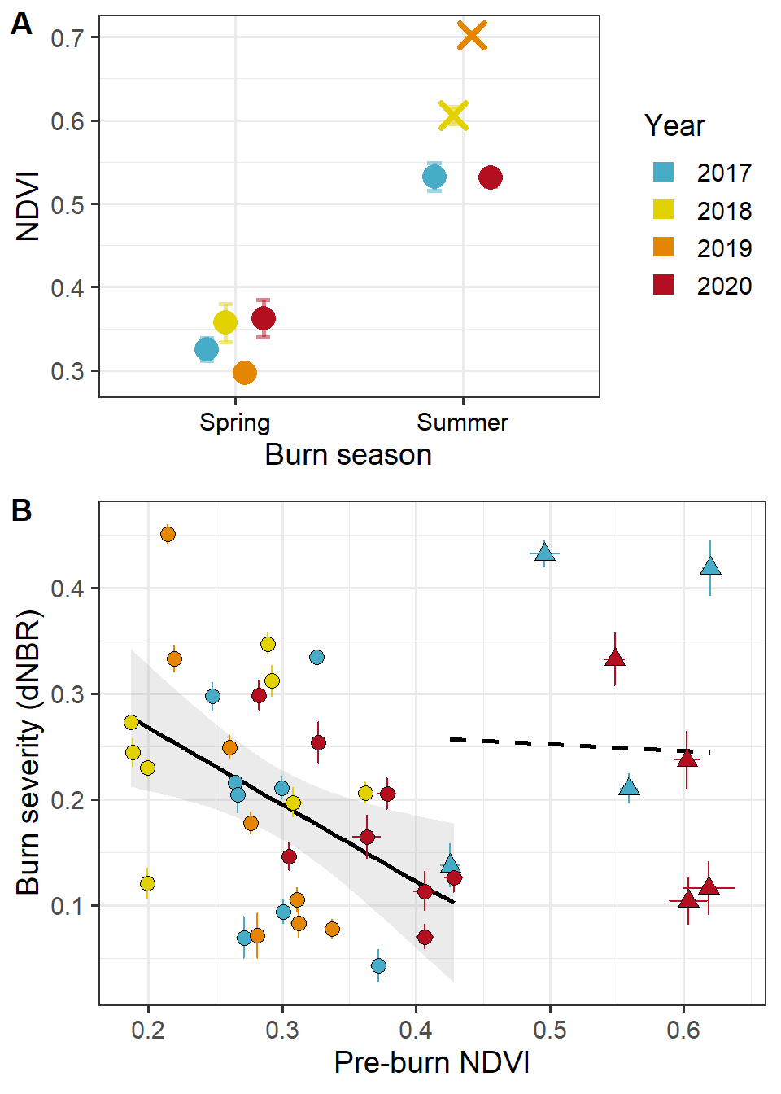

Fig. 1: Sentinel imagery summarized for the study years. A: Normalized Difference Vegetation Index (NDVI) from four adjacent unburned pastures avoids any confounding effects of prescribed burns. X denotes seasons in which burns were not completed. B: Burn severity (differenced Normalized Burn Ratio, dNBR) plotted against fuelbed greenness (NDVI) retrieved from the pre-burn Sentinel-2 image used for pre-fire NBR. Points represent mean for individual prescribed fires with associated standard error; circles and solid trendline indicate spring burns while broken trendline and triangles denote summer burns.

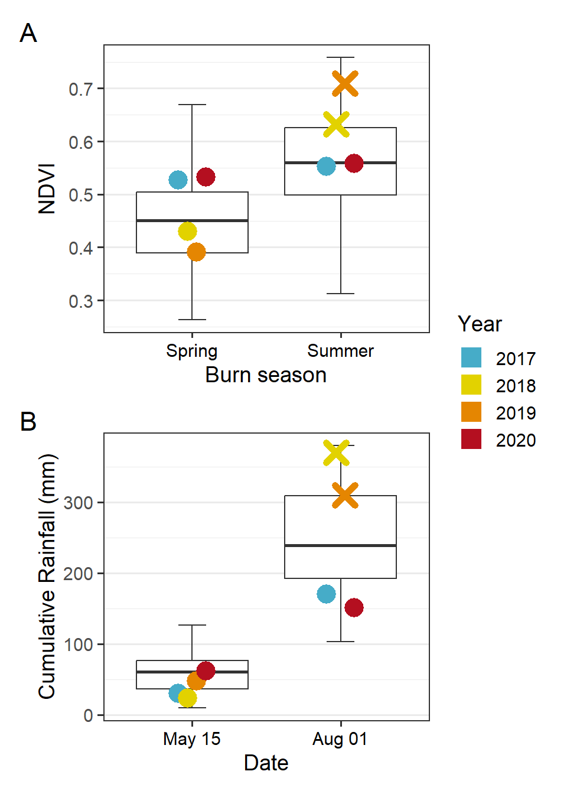

Fig. 2: Study season data (points) plotted within the context of 42-year historical trends (boxplots). X indicates seasons prescribed fires were not completed. A: Normalized Difference Vegetation Index (NDVI) data retrieved from Landsat imagery. B: Annual growing season rainfall accummulated by two specific dates associated with the spring and summer burn seasons, respectively.

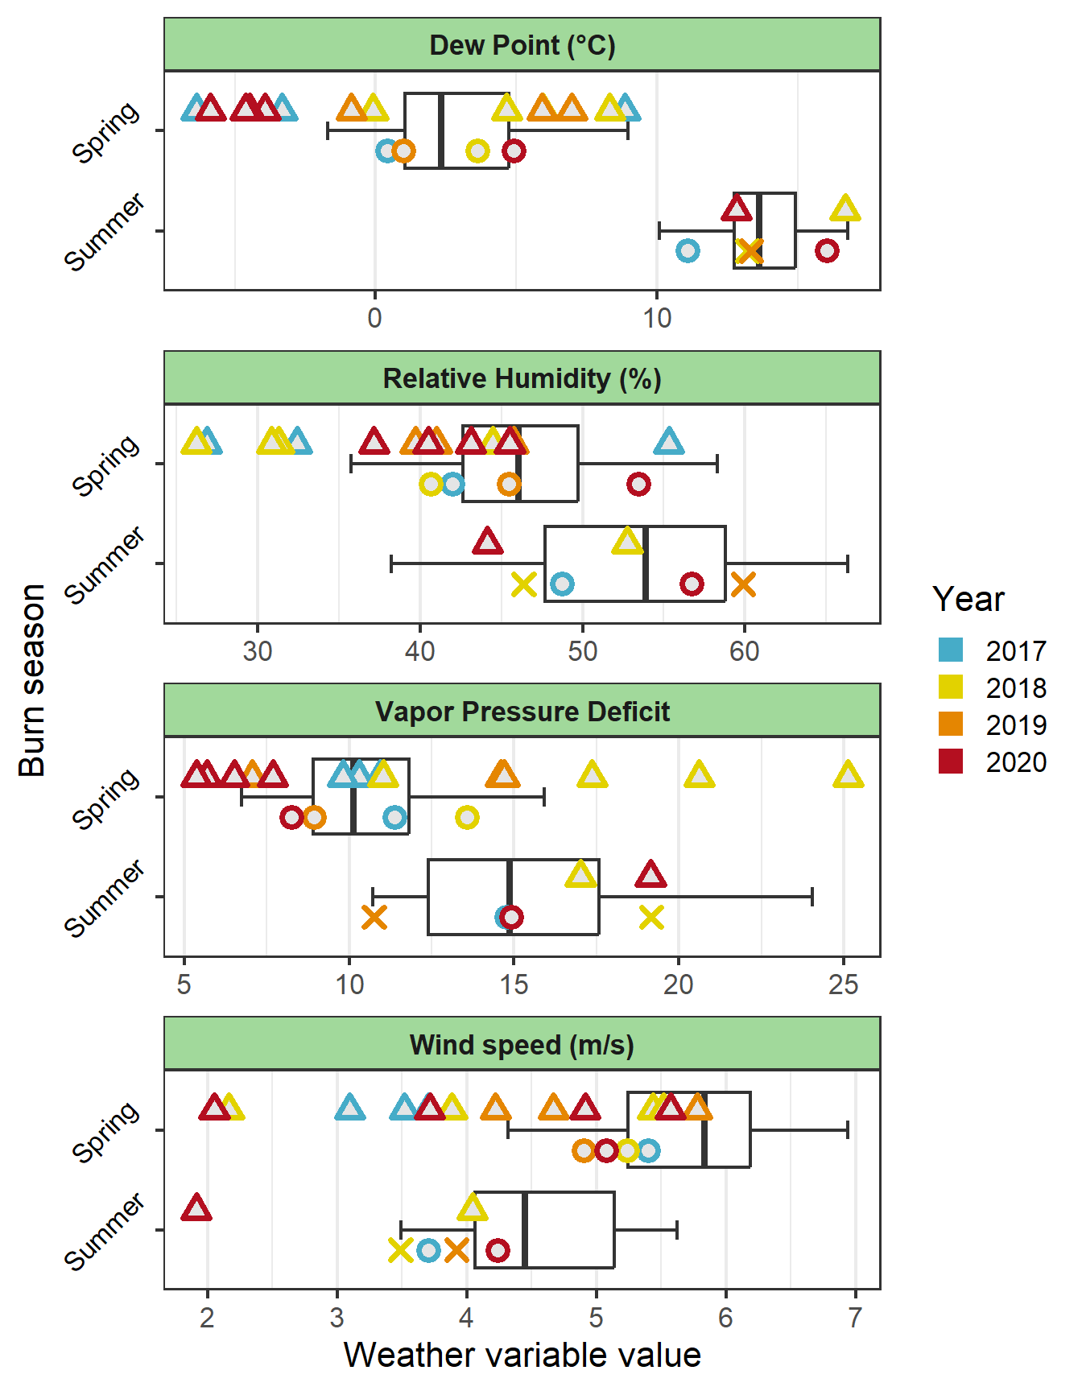

Fig. 3: Four fire weather variables plotted by burn day values (open triangles), study season means (open circles and X for seasons without completed burns), and 42-year historical trends (boxplots).

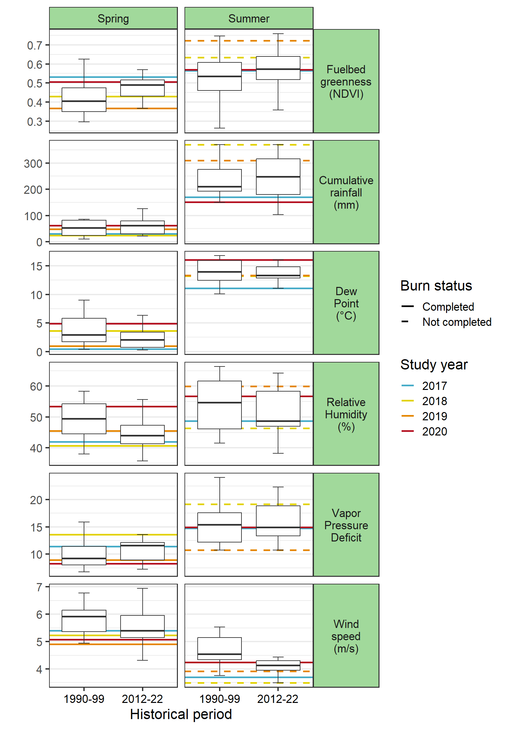

Fig. 4: Temporal trends in the phenology of the fire environment. Boxplots represent data from the first decade of the dataset used here (1990-1999) to the final decade (2012-2022), by burn season. Horizontal lines represent average conditions for the four study years (2017-2020).