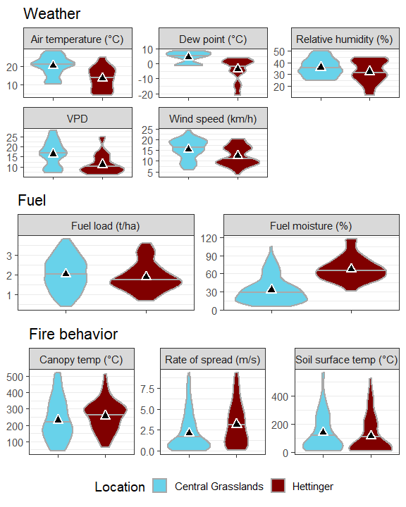Figure 1: Distribution of weather, fuel, and fire behavior data for fires in southwestern North Dakota (Hettinger, dark maroon) and central North Dakota (Central Grasslands, light blue) sampled from 2017 to 2019. Summary statistics include median (horizontal gray lines) and means (triangles).  
Figure 2: Principal Components Analysis of fire behavior data (response variables in blue; rate of spread (ROS), temperature above surface (canopy ºC), and temperature at soil surface (soil ºC) for prescribed burns on rangeland at Hettinger (H), in southwestern North Dakota, and Central Grasslands (CG), in central North Dakota. No difference between locations (P = 0.11). Total variance explained in these two axes = 86%. 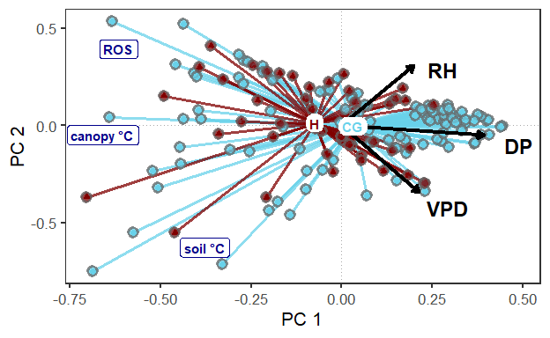

Figure 3: Regression coefficients and 95% confidence intervals for fuel and weather terms from models for maximum temperature at 15 cm above the soil surface (canopy), maximum temperature at the soil surface (soil) and rate of spread. 