Momentum Screening and Broker Recommendations in Indian Equities
Abstract—This paper compares research on price momentum, moving-average trading rules, and analyst recommendations, then applies those perspectives to a matched-date comparison of a rules-based stock strategy and broker Buy recommendations in India. The strategy requires price above the 50-day moving average, the 50-day average above the 200-day average, positive 126-session momentum, a bullish Moving Average Convergence Divergence (MACD) signal, and 14-period Average Directional Index (ADX) of at least 20. On each eligible report date, the strategy selects the highest-momentum qualifying stocks in a basket equal in size to the pooled broker basket. Across 77 matched dates, the strategy return was higher on 49 dates (63.6%); mean 60-session return was 18.5%, against 1.3% for broker baskets. These are preliminary in-sample results, not evidence of dependable future outperformance: the rule was selected using the same sample, holding windows overlap, one stock is repeatedly selected, and the broker and price samples are incomplete. The paper therefore treats the result as a hypothesis and specifies a frozen-rule, out-of-sample test.
Index Terms—price momentum, technical analysis, analyst recommendations, Indian stock market, backtest validation

I. INTRODUCTION
Investors can choose between discretionary stock recommendations and systematic rules based on past prices. Both approaches can look persuasive when presented through a small number of successful examples. A fair comparison instead applies the same entry dates, holding period, basket size, price data, and transaction-cost assumptions to both approaches. This paper reviews related academic findings and reports a preliminary comparison using the project’s broker-recommendation and daily-price data.
The study asks: on report dates with adequate data, does a six-month trend and momentum screen produce a higher equal-weight 60-session return than the pooled broker Buy basket? The current data show a higher strategy return on more dates and a larger mean return. The result is not a clean test of predictive ability, however, because the strategy rules were selected after examining these dates. The central conclusion is therefore limited: the observed sample favors the strategy, but the available evidence does not establish that it will continue to beat broker recommendations.
II. RELATED WORK
Prior studies ask different questions: whether past returns predict future returns, whether technical rules can be implemented after costs, and whether public analyst recommendations have investment value. Their samples and outcomes are not directly interchangeable. The comparisons below identify how each line of research informs the present matched-date design.
A. Price Momentum
Jegadeesh and Titman [1]. Their winner-minus-loser portfolios document return continuation over three-to-twelve-month holding periods. This project uses a related 126-session lookback and 60-session horizon, but takes long positions only and applies trend and indicator filters.
Sehgal, Pandey, and Sen [2]. Their Indian study compares six relative-, absolute-, and combined-strength approaches on NSE shares and reports that combined strength outperforms conventional price momentum in its sample. It provides a local momentum benchmark, but does not test the project’s same-date broker-basket comparison.
B. Technical Rules in India
Mitra [3]. The paper tests moving-average rules on four Indian stock indexes and notes that spreads and trading costs can reduce exploitable returns. The present study screens individual stocks and applies a uniform 0.2-percentage-point round-trip deduction, which may understate variation in actual execution costs.
C. Analyst Recommendations
Arun, Shankaran, and Jayadev [4]. Their study of more than 1,000 Indian recommendations reports a Buy-side bias and hit ratios below 50%. Chatterjee, Kumar, and Chatterjee [5] use event-study and survival-analysis methods to examine target-price fulfilment. The latter distinguishes target achievement from time-to-payoff; this project measures return at a fixed 60-session horizon.
D. Backtest Selection
Sullivan, Timmermann, and White [6]; Bailey et al. [7]. These papers address data snooping and backtest overfitting. Their methods are relevant because the current filter was selected after examining the same dates on which it is reported; a separate test period is needed to evaluate persistence.
Together, the literature motivates both the momentum hypothesis and a cautious interpretation. Momentum and technical rules have empirical support in some settings, but their returns depend on market, sample, and costs. Indian recommendation studies also show that analyst calls should be assessed with a defined event window and benchmark. The present project’s narrower contribution is to place the two approaches into matched-date baskets under a common 60-session return convention; it does not reproduce the larger cross-sectional designs in the cited papers.
III. DATA AND METHODS
A. Data and Sources
The project dataset contains 424 recommendation records from seven broker feeds, adjusted daily OHLC price histories for 458 mapped symbols, and ticker-resolution records. The comparison currently retains 77 report dates with a usable broker basket, sufficient price history, and enough qualifying strategy stocks to fill a basket of the same size. The matched dates run from 15 July 2025 to 13 July 2026. Broker records were collected from the project’s report archive; daily price histories were obtained from Yahoo Finance. The displayed results describe this collected sample, not the complete universe of broker research or all listed securities. Broker records were collected from the project report archive [8], and adjusted daily price histories were obtained from Yahoo Finance [9].
B. Strategy and Portfolios
At each report date, the strategy uses price history available before entry. A stock qualifies when its price is above its 50-session simple moving average, the 50-session average is above the 200-session average, its 126-session price momentum is positive, MACD is above its signal line, and ADX(14) is at least 20. Qualifying stocks are ranked by 126-session momentum. The strategy selects the same number of stocks as appear in the pooled, de-duplicated broker Buy basket for that date. Both portfolios are equal-weighted. The implementation enters on the next trading session and measures adjusted-close return after 60 sessions, subtracting a fixed 0.2 percentage-point round-trip cost from each basket.
For this comparison, Buy, Strong Buy, Accumulate, Add, and Outperform labels are treated as positive recommendations. When multiple broker feeds recommend the same stock on the same date, the project combines them into one stock position and records the relevant broker names. The matching sample is conditional on data availability and a fully populated strategy basket; dates that cannot be filled are not represented in the 77-date result.
IV. PRELIMINARY RESULTS
Across 77 matched report dates, the strategy basket had the higher return on 49 dates (63.6%), while broker baskets had the higher return on 28 dates (36.4%); no date fell within the project’s 0.05 percentage-point tie band. Mean 60-session return was 18.5% for the strategy and 1.3% for the broker baskets, a difference of 17.2 percentage points. These figures are simple averages of date-level basket returns. They are not compounded portfolio returns, annualized returns, or estimates of a live investor’s realized profit. Figs. 1 and 2 show the mean comparison and all date-level return gaps.
TABLE I
SUMMARY OF MATCHED-DATE RETURNS
Metric | Strategy | Broker
Wins | 49 / 77 (63.6%) | 28 / 77 (36.4%)
Mean 60-session return | 18.5% | 1.3%
Mean return gap | +17.2 pp | Reference
Holding period | 60 sessions | 60 sessions
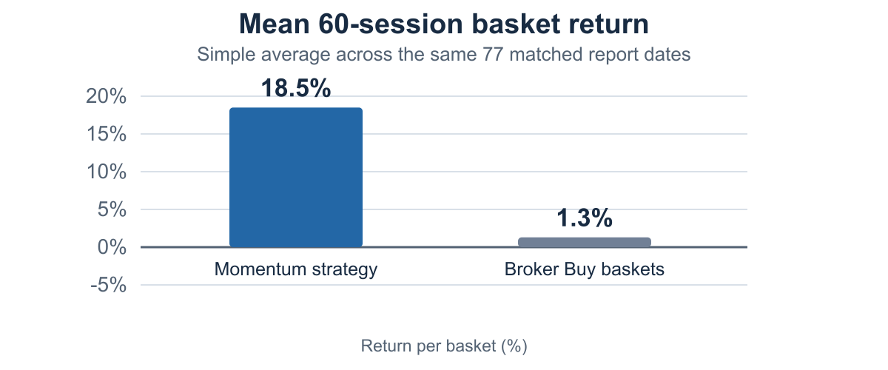
Fig. 1. Mean 60-session return by basket, using a simple average across the 77 matched dates. Values are not compounded.
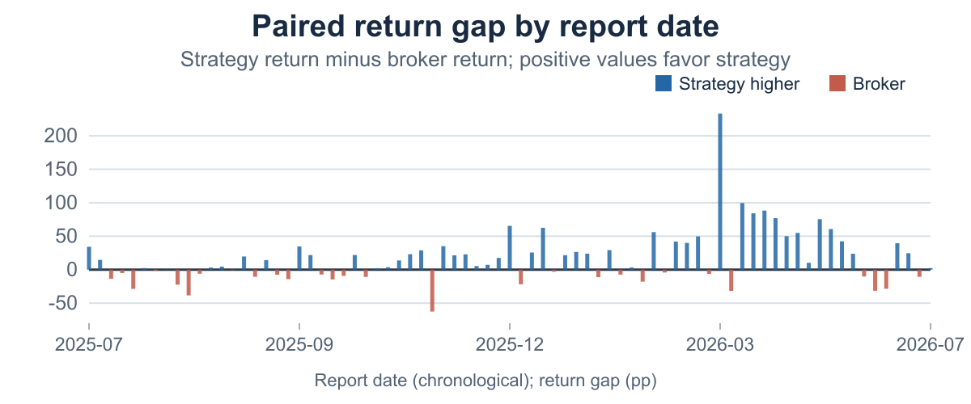
Fig. 2. Strategy-minus-broker return gap for each of the 77 matched dates, in chronological order. The 60-session holding windows overlap.
The result is striking but concentrated. The dashboard identifies Sterlite Technologies (STLTECH) as the most frequently selected strategy stock, appearing in 16 of the 77 date baskets. Multiple dates can therefore reflect the same underlying stock move rather than 16 independent successes. The 60-session windows also overlap, so adjacent report dates share much of their forward price path.
V. DISCUSSION AND LIMITATIONS
The current results are consistent with the hypothesis that a trend-and-momentum screen can outperform the pooled broker Buy basket in this sample. They do not prove that the indicator combination caused the difference, or that it will persist. The filter was selected using the same date range on which it is evaluated; this creates data-snooping and backtest-overfitting risk [6], [7]. Choosing thresholds or indicators because they improve these 77 observations would increase that risk.
Several additional limitations matter. First, overlapping holding windows and repeated stocks make the date-level observations dependent. Second, the price universe may have survivorship or coverage bias, and the broker archive is partial. Third, requiring enough qualifying names to match each broker basket changes which dates enter the analysis; the excluded-date count and reasons should be reported. Fourth, the fixed 0.2 percentage-point cost may not capture differences in taxes, spreads, slippage, liquidity, or turnover. Fifth, a one-year report-date sample does not span enough market regimes to support broad claims. Finally, the current comparison does not report risk-adjusted alpha, drawdown, volatility, or statistical uncertainty.
VI. OUT-OF-SAMPLE VALIDATION
The next test should freeze the strategy before evaluating new report dates. Keep the present sample as development data, write the full rule and cost assumptions into a dated protocol, and evaluate the unchanged rule on later dates that were not used to select it. If historical walk-forward testing is possible, choose an initial training period and roll forward chronologically; never use future prices to form signals or decide which securities belonged to the investable universe at the time.
For each test date, preserve the same entry date, 60-session exit, basket size, and eligible recommendation universe for both portfolios. Report coverage, including all broker dates that could not be matched and why. Show average and median return differences, the strategy win share, a benchmark-adjusted return, turnover, drawdown, volatility, and costs under more than one reasonable cost assumption. Because dates overlap and stocks repeat, estimate uncertainty with a time-block or date-clustered procedure rather than treating 77 rows as independent. Report results by broker feed as well as for the pooled basket, and disclose every strategy variant tried.
The strategy should be judged by the frozen out-of-sample results, even if brokers win. A rule that wins only after changing its thresholds to fit the test sample cannot establish a durable advantage. A prospective test is the clearest way to make a credible claim about future performance.
VII. CONCLUSION
Prior research supports studying momentum and technical trading rules, while Indian analyst-recommendation studies show why broker calls also need systematic evaluation. The project adds a direct, matched-date comparison: in the collected sample, its rules-based baskets outperform the pooled broker baskets on 49 of 77 dates and have higher mean 60-session return. However, the sample is short, the rule was selected in-sample, and returns are concentrated and dependent. The defensible conclusion is that the preliminary comparison favors the strategy in this dataset, not that it will always beat brokers. A frozen, out-of-sample test with realistic costs and dependence-aware uncertainty is required before making a stronger claim.
REFERENCES
[1] N. Jegadeesh and S. Titman, “Returns to buying winners and selling losers: Implications for stock market efficiency,” The Journal of Finance, vol. 48, no. 1, pp. 65–91, 1993, doi: 10.1111/j.1540-6261.1993.tb04702.x.
[2] S. Sehgal, A. Pandey, and S. Sen, “Relative, absolute or combined strength momentum strategies: What works for India?,” International Journal of Emerging Markets, vol. 20, no. 10, pp. 4288–4307, 2025, doi: 10.1108/IJOEM-09-2023-1518.
[3] S. K. Mitra, “How rewarding is technical analysis in the Indian stock market?,” Quantitative Finance, vol. 11, no. 2, pp. 287–297, 2011, doi: 10.1080/14697680903493581.
[4] S. Arun, B. Shankaran, and M. Jayadev, “Investment value of analyst recommendations: Evidence from the Indian stock market,” South Asian Journal of Management, vol. 23, no. 2, pp. 7–24, 2016.
[5] D. Chatterjee, S. Kumar, and P. Chatterjee, “Time to payoff: Efficacy of analyst recommendations in the Indian stock market,” IIMB Management Review, vol. 32, no. 2, pp. 153–165, 2020, doi: 10.1016/j.iimb.2019.10.002.
[6] R. Sullivan, A. Timmermann, and H. White, “Data-snooping, technical trading rule performance, and the bootstrap,” The Journal of Finance, vol. 54, no. 5, pp. 1647–1691, 1999, doi: 10.1111/0022-1082.00163.
[7] D. H. Bailey, J. M. Borwein, M. López de Prado, and Q. J. Zhu, “The probability of backtest overfitting,” Journal of Computational Finance, vol. 20, no. 4, pp. 39–69, 2017, doi: 10.21314/JCF.2016.322.
[8] Trendlyne, “Research reports archive.” [Online]. Available: https://trendlyne.com/research-reports/. Accessed: Oct. 19, 2026.
[9] Yahoo Finance, “Historical market data.” [Online]. Available: https://finance.yahoo.com/. Accessed: Oct. 19, 2026.

