GitHub Repository: https://github.com/devansai10/cs449-peg-solitaire

Sprint 0 Report
CS 449 Peg Solitaire BrainVita
For Sprint 0, I chose the tools I will use to develop Peg Solitaire BrainVita and prepared two small programs: a player-rating class with JUnit tests and a Swing interface for selecting game settings. These examples give me a starting point for the features required in later sprints.

1 Key Decisions of the Solitaire Project
Topic | Decision
Object-oriented programming language | Java 21. I chose Java because it is recommended for the course and supports the object-oriented design needed for different board types.
GUI library | Java Swing. It is included with Java and provides the controls needed for a standalone desktop application.
IDE | Visual Studio Code. I use it to view the project and run Maven tests in its terminal.
xUnit framework | JUnit Jupiter 5.10.3, with Maven Surefire 3.2.5 to run the tests.
Programming style guide | Google Java Style Guide. I will use it throughout the project.
Project hosting site | GitHub.com. My repository link is listed at the top of this report.
Build and dependency management | Maven. The pom.xml file stores the Java version, dependencies, and build settings.
Design approach | I will keep the game rules separate from the GUI so they can be tested and reused across board types.

Programming style practices
I chose the Google Java Style Guide to keep my code consistent and easy to read. The source uses two-space indentation, explicit imports, and braces around control statements. Class names use UpperCamelCase, while methods and variables use lowerCamelCase. I also keep one top-level class in each file and limit lines to 100 characters. [1]
For this sprint, I kept the work focused on tool selection, unit testing, and a basic GUI. I plan to add board initialization, manual play, autoplay, randomization, and record/replay in the later sprints specified in the project overview.

2 Unit Testing
I selected the JUnit 5 User Guide, version 5.10.3, as the tutorial for this section. Its Writing Tests and Assertions sections explain the features used here: @Test identifies a test, assertEquals checks a result, and assertThrows checks an expected exception. [2]
My unit-testing example is PlayerRating, a small class that returns a rating based on the number of pegs left. I used the ratings suggested in the project overview. The class rejects zero and negative counts because its input should represent at least one remaining peg. It does not decide when a game ends.
Test input | Expected outcome
1 peg | Outstanding
2 pegs | Very Good
3 pegs | Good
4 and 32 pegs | Average
0 pegs | IllegalArgumentException
-1 pegs | IllegalArgumentException
The tests were run using Maven in the VS Code terminal. All six passed, with no failures, errors, or skipped tests. The screenshot below shows the results from September 17, 2026.
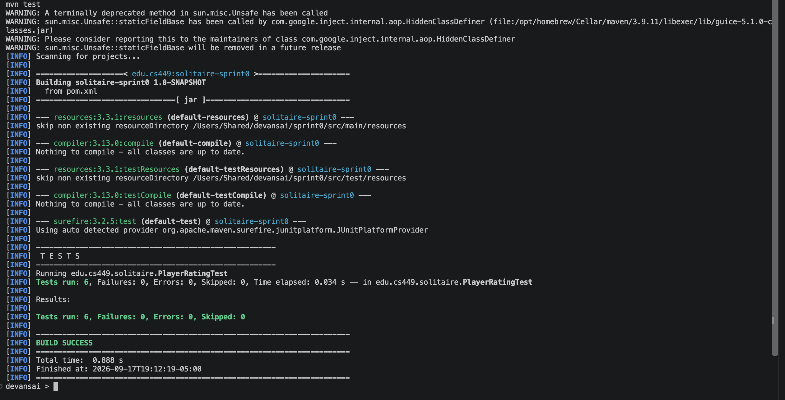
Figure 1. Six passing JUnit tests, run from /Users/Shared/devansai/sprint0, with no failures or errors.

Unit Testing Source Code

PlayerRating.java
package edu.cs449.solitaire;

/** Converts the number of pegs remaining into a player rating. */
public final class PlayerRating {
/** Returns a rating for a positive peg count; rejects zero and negative counts. */
public String rate(int pegsRemaining) {
if (pegsRemaining < 1) {
throw new IllegalArgumentException("At least one peg must remain.");
}
return switch (pegsRemaining) {
case 1 -> "Outstanding";
case 2 -> "Very Good";
case 3 -> "Good";
default -> "Average";
};
}
}

PlayerRatingTest.java
package edu.cs449.solitaire;

import static org.junit.jupiter.api.Assertions.assertEquals;
import static org.junit.jupiter.api.Assertions.assertThrows;

import org.junit.jupiter.api.Test;

class PlayerRatingTest {
private final PlayerRating rating = new PlayerRating();

@Test
void onePegReceivesOutstanding() {
assertEquals("Outstanding", rating.rate(1));
}

@Test
void twoPegsReceiveVeryGood() {
assertEquals("Very Good", rating.rate(2));
}

@Test
void threePegsReceiveGood() {
assertEquals("Good", rating.rate(3));
}

@Test
void fourOrMorePegsReceiveAverage() {
assertEquals("Average", rating.rate(4));
assertEquals("Average", rating.rate(32));
}

@Test
void zeroPegsAreRejected() {
assertThrows(IllegalArgumentException.class, () -> rating.rate(0));
}

@Test
void negativePegsAreRejected() {
assertThrows(IllegalArgumentException.class, () -> rating.rate(-1));
}
}

3 GUI Programming
For the GUI exercise, I chose a simple Solitaire settings window. It lets the user select a board type and a recording preference, then click Preview settings to display those choices. This is a Sprint 0 demonstration; the controls do not yet start a game or record moves.
Required element | Implementation
Text | JLabel title, instructions, board heading, and status message.
Lines | Two horizontal JSeparator components.
Check box | JCheckBox labeled Record game.
Radio buttons | English, Hexagon, and Diamond JRadioButton controls grouped in a ButtonGroup so only one is selected.
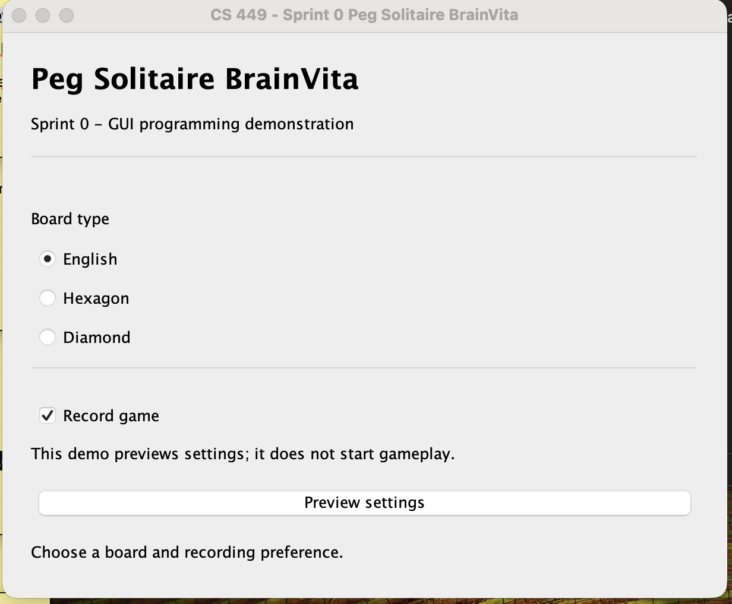
Figure 2. Screenshot of the running Swing settings window, showing text, separator lines, a check box, and radio buttons.
I used BorderLayout and GridLayout to organize the window. A ButtonGroup keeps the board choices mutually exclusive, while the check box provides an independent on/off setting. The Preview settings button calls updateStatus() to update the label. SwingUtilities.invokeLater creates the interface on Swing's event dispatch thread. [3, 4]

GUI Source Code
SolitaireSetupDemo.java, part 1 of 2
package edu.cs449.solitaire;

import java.awt.BorderLayout;
import java.awt.Dimension;
import java.awt.Font;
import java.awt.GridLayout;
import javax.swing.BorderFactory;
import javax.swing.ButtonGroup;
import javax.swing.JButton;
import javax.swing.JCheckBox;
import javax.swing.JFrame;
import javax.swing.JLabel;
import javax.swing.JPanel;
import javax.swing.JRadioButton;
import javax.swing.JSeparator;
import javax.swing.SwingUtilities;

/** Demonstrates Sprint 0 GUI components; full gameplay is added in later sprints. */
public final class SolitaireSetupDemo {
private final JLabel status = new JLabel("Choose a board and recording preference.");
private final JCheckBox recordGame = new JCheckBox("Record game", true);
private final ButtonGroup boardTypes = new ButtonGroup();

private void showWindow() {
JFrame frame = new JFrame("CS 449 - Sprint 0 Peg Solitaire BrainVita");
frame.setDefaultCloseOperation(JFrame.EXIT_ON_CLOSE);
JPanel content = new JPanel(new BorderLayout(16, 16));
content.setBorder(BorderFactory.createEmptyBorder(24, 24, 24, 24));

JPanel heading = new JPanel(new GridLayout(0, 1, 0, 8));
JLabel title = new JLabel("Peg Solitaire BrainVita");
title.setFont(title.getFont().deriveFont(Font.BOLD, 24f));
heading.add(title);
heading.add(new JLabel("Sprint 0 - GUI programming demonstration"));
heading.add(new JSeparator());
content.add(heading, BorderLayout.NORTH);

JPanel options = new JPanel(new GridLayout(0, 1, 0, 10));
options.add(new JLabel("Board type"));
for (String name : new String[] {"English", "Hexagon", "Diamond"}) {
JRadioButton button = new JRadioButton(name, name.equals("English"));
button.setActionCommand(name);
boardTypes.add(button);
options.add(button);

GUI Source Code Continued
SolitaireSetupDemo.java, part 2 of 2
}
options.add(new JSeparator());
options.add(recordGame);
options.add(new JLabel("This demo previews settings; it does not start gameplay."));
content.add(options, BorderLayout.CENTER);

JPanel footer = new JPanel(new GridLayout(0, 1, 0, 12));
JButton preview = new JButton("Preview settings");
preview.addActionListener(event -> updateStatus());
footer.add(preview);
footer.add(status);
content.add(footer, BorderLayout.SOUTH);

frame.setContentPane(content);
frame.setMinimumSize(new Dimension(610, 480));
frame.pack();
frame.setLocationRelativeTo(null);
frame.setVisible(true);
}

private void updateStatus() {
String board = boardTypes.getSelection().getActionCommand();
String recording = recordGame.isSelected() ? "on" : "off";
status.setText("Selected: " + board + " | Recording: " + recording);
}

/** Creates Swing components on the event dispatch thread. */
public static void main(String[] args) {
SwingUtilities.invokeLater(() -> new SolitaireSetupDemo().showWindow());
}
}

Build and run
To run the examples, open the project folder with JDK 21 and Maven available, then use these commands:
mvn test
java -cp target/classes edu.cs449.solitaire.SolitaireSetupDemo

References
[1] Google Java Style Guide. https://google.github.io/styleguide/javaguide.html
[2] JUnit 5 User Guide 5.10.3. https://docs.junit.org/5.10.3/user-guide/index.html
[3] Oracle Swing Tutorial: Buttons, Check Boxes, and Radio Buttons. https://docs.oracle.com/javase/tutorial/uiswing/components/button.html
[4] Oracle Swing Tutorial: Separators. https://docs.oracle.com/javase/tutorial/uiswing/components/separator.html

