**Student Name:** Devansh Akruvala

**Course:** SOEN 6841 Software Project Management

**Journal URL:** <https://github.com/devansh-akruvala/SOEN_6841_Software_Project_Management>

**Week 1:** 18/01/2024 – 25/01/2024

**Date:** 22/01/2024

**Key Concepts Learned:**

**Chapter 1**

* **Project:** Project is a set of activities with definite start and end time aimed to achieve some predefined goals.
* Project consumes resources, budget and time.
* After the project is finished, the unconsumed resources and budget should be released.
* Project management processes may include project initiation, project planning, project monitoring and control, and finally project closure. ¡e software engineering processes may include requirement development, software design, software construction, software testing, and software maintenance. These software engineering processes have to be somehow accommodated in project management processes.
* A goal of any software project management is to develop/maintain a software product by applying good project management principles as well as software engineering principles so that the software project is delivered at minimum cost, within minimum time, and with good product quality.
* Organization level Process > Project Process > Lifecycle process
* When software is developed for use by the organization itself, it is known as a software application. When software is developed for the purpose of selling to customers and not for use by the organization itself then it is known as a software product.
* Requirements for a successful software project manager: Understand project management, understand software engineering, understand technology and tools, Manage team, customer and suppliers, Work under organization framework.
* Software Project task: Requirement management, Design Management, Source Code building, Software testing, software deployment and software maintenance.
* Project management processes form the basis on which a project can be initiated, planned, monitored, controlled, and closed. On the other hand, software engineering processes define structure, steps, and procedures to do various tasks in software development. But these processes lack the ability to schedule, plan, and control themselves. It is the project management processes that do the job of scheduling, planning, and controlling software engineering processes.

1. Project Initialization:

* First among project management processes is the project initiation process.
* We can further divide the initiation process discussion into processes for application initiation, product initiation, and product implementation initiation.
* **Software project initiation tasks:** Initial schedule estimates, Project charter, Project scope, Project objectives, Initial effort estimates, Initial effort estimates.
* Software applications are specially built based on a limited set of user requirements. So, they have limited features to fulfill the specific needs of end users. Software products on the other hand are built with a large number of features to take care of the needs of different kinds of users
* development of software products does not start with end-user requirements. ¡e software vendor sees a market opportunity of developing such a product. He develops the software product and sells it or provides services using this software product to customers.
* So, whereas a software application is created based on end-user requirements, a software product is made using market research data.
* **Software product initiation tasks:** Market analysis, Product development cost estimate, Product features, Marketing channels, Product delivery method, Product or service.
* **Software product implementation initiation tasks:** Customization effort, Initial schedule estimates, Project charter, Project scope, Project objectives, Initial effort estimates, Initial cost estimates, Migration from legacy system.

1. Software Project Planning:

* Depending on the characteristics of a project, detailed project planning is done either after project initiation or after completion of project requirements. Generally, detailed project planning can be done only after the project team has complete requirements for the project since the requirements together with project scope determine effort, cost, and quality required. If complete details about these things are not available, a baseline for the project cannot be made. In project planning the main tasks that are to be planned are software life-cycle processes

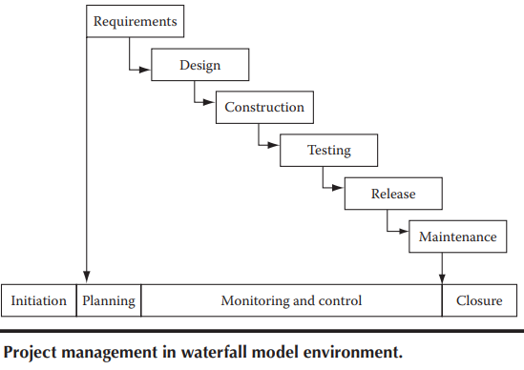 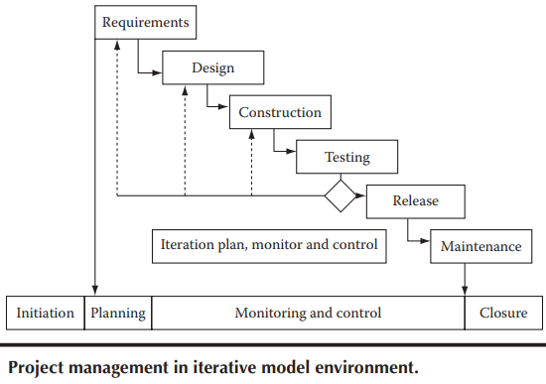

1. Software Project Monitoring and Control:

* Due to the inherently risky nature of software projects, constant monitoring and control is required to rectify any event that may jeopardize the project.

1. Software Project Closure:

* During project closure, all project artifacts are analyzed and completed. Data from these artifacts are transferred to central project repository so that these data can be used for future projects.
* Management Metrics Characteristics: Relevant, Meaningful Calibration ability, Activity level, Practical.
* Seven Tools of Quality: Check sheets, Histograms, Pareto charts, Cause and eff­ect diagrams, Scatter diagrams, Control charts, Graphs.

Chapter 2

* **Project charter:** The project charter is the place where a big picture of the effort, even beyond the project, is captured. It should include things like project goals, project objectives, major responsibilities allocation, etc.

**Example:** The project will provide a cutting-edge software solution to our sales team to provide excellent customer service for our customers so that all customer issues can be solved within 24hours of lodging of a complaint.

* **Project Scope:** The scope will include what functionalities are needed in the software product to be developed. It will also define level of quality needed in the software product.
* To deal with scope creep, it has to be ensured that the requirements are lucid and clear from the very start so that project effort estimation and project schedule are accurate.

**Example:** The project will be delivered within 15 months from the date of start of the project. The software product that will be made through this project will have features for customer complaint logging, issue resolution, and issue closure. The software product should have the capability of supporting our customer base of 10,000, who will be using the service through an Internet connection by logging into our web portal.

* **Project Objectives:** The project should have a set of well-defined objectives that must be met. If any of these objectives are not met upon completion of the project, then the project will be considered to be a failure. The stakeholders state and set the project objectives.
* Objectives should be **SMART** (Specific, Measurable, Achievable, Relevant, Time Constrained).

**Example:** The organization will be able to increase customer satisfaction to 99.5% from the existing level of 92%. This will help in reducing customer attrition, increasing repeat business from existing customers, and enhancing our brand value.

* **Estimate Initial Project Size:** At the project initiation stage, a rough project size should be estimated so that a sketch of the initial project plan can be realized. From the initial requirements a rough design estimate can be made which includes details about how the product can be broken down into parts. These parts can be sized from estimating, either the estimated number of lines of code required to build them or by using an estimated number of function points.
* **Estimate Initial Project Effort and Costs:** After preparing project charter and scope, an expert is hired who will make effort and cost estimate. Now bids are invited from software development companies for project planning & execution based on the effort & cost figured given by the expert.
* An initial budget is estimated for the project. As per the estimate a budget is sanctioned for the project. The budget includes costs to cover for salaries of people who will work on the software project, purchase of hardware, services, travel costs, management costs etc.
* The cost of the project is one of the most important considerations of stakeholders. If the project is going to cost more than they had anticipated and budgeted for, then most probably, the project will be called off.

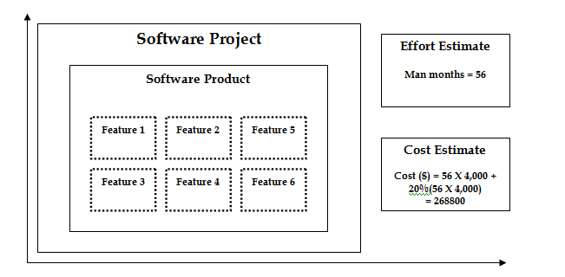

**Application in Real Projects:**

How to initialize the project once we have Goals and objectives in mind and how to do Initial estimation of cost.

**Peer Interactions:**

* Discussed case studies given at end of chapter 1 and chapter 2.
* Discussed about the course project assigned with the group.

**Challenges Faced:**

Identify any challenges encountered while studying this week.

Note specific areas that need further clarification or additional effort.

**Personal development activities:**

* Read about Software Management tools like Jira and revision on SDLC.

**Goals for the Next Week:**

* Start Working on the project
* Read upcoming chapters
* Read Chapter 3 and 4