**Student Name:** Devansh Akruvala

**Course:** SOEN 6841 Software Project Management

**Journal URL:** <https://github.com/devansh-akruvala/SOEN_6841_Software_Project_Management>

**Week 2:** 25/01/2024 – 01/02/2024

**Date:** 29/01/2024

**Key Concepts Learned:**

* Estimation techniques can be divided in to
  + Experience Based techniques
    - Estimation by Analogy
    - Estimation by judgement
      * FPA
      * Delphi
  + Algo Based techniques
    - COCOMO Model
* **Estimation By analogy:**  Estimate new projects by comparing them to similar past projects, preferably decomposing the estimate.
* **FPA:** FPA = UFP * VAF (CAF)

For Calculating UFP there is a table where there are 5 function types and for each type is ranked low, avg, high.

For calculating VAF there are 14 general system characteristics is rated on a scale from 0 to 5.

VAF = (TDI*0.01) + 0.65

* **DELPHI:** The process involves individual estimation by team members followed by a comparison meeting to discuss differences. The individual estimates are averaged to arrive at a agreement estimate accepted by the group. Finally, a range of effort estimation values is calculated based this agreement.
* **COCOMO:** 
  + Basic COCOMO:

Effort = 2.94 * EAF * (KLOC)E

Duration = 3.67 * (Effort)SE

* Intermediate COCOMO:

E = a(KLOC)(E)

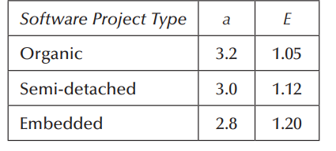

* When to use which technique:

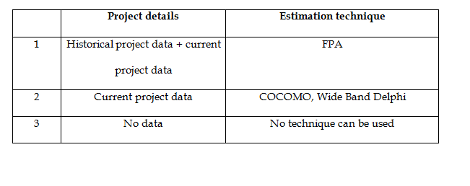

**Application in Real Projects:**

The Estimation Project Study helps in the initial phase by providing a rough estimate of the resources required for the project.

**Peer Interactions:**

* Discussed Case study with peers
* Started working on projects and discussed many points in problem Identification and Market Analysis.

**Challenges Faced:**

* COCOMO and FPA Calculations require some clarification.

**Personal development activities:**

* Read some articles on Project Management and continue learning the Project Management Tools

**Goals for the Next Week:**

* Finish Project
* Read Chapter 4 and 5