Project Deliverables Part 2 - Progress Report: Architecture Finalization & Initial Implementation
Members: An Hong Pham, Jason Chu, Devansh Chaudhary

1. Finalized Architectural Flow & System Design

A. System Architecture Overview
Our system is a speech-based ML classification pipeline that distinguishes between Parkinson's Disease (PD) and Traumatic Brain Injury (TBI) patients using acoustic features extracted from speech recordings. The components included in this project:
- ML/AI Pipeline: Full feature extraction -> training -> inference pipeline
- Data Ingestion Pipeline: Batch processing of audio folders (PD/TBI)
- External Libraries: Librosa, Parselmouth (Praat) and other helper Python libraries
The comprehensive flow overview is on the next page.

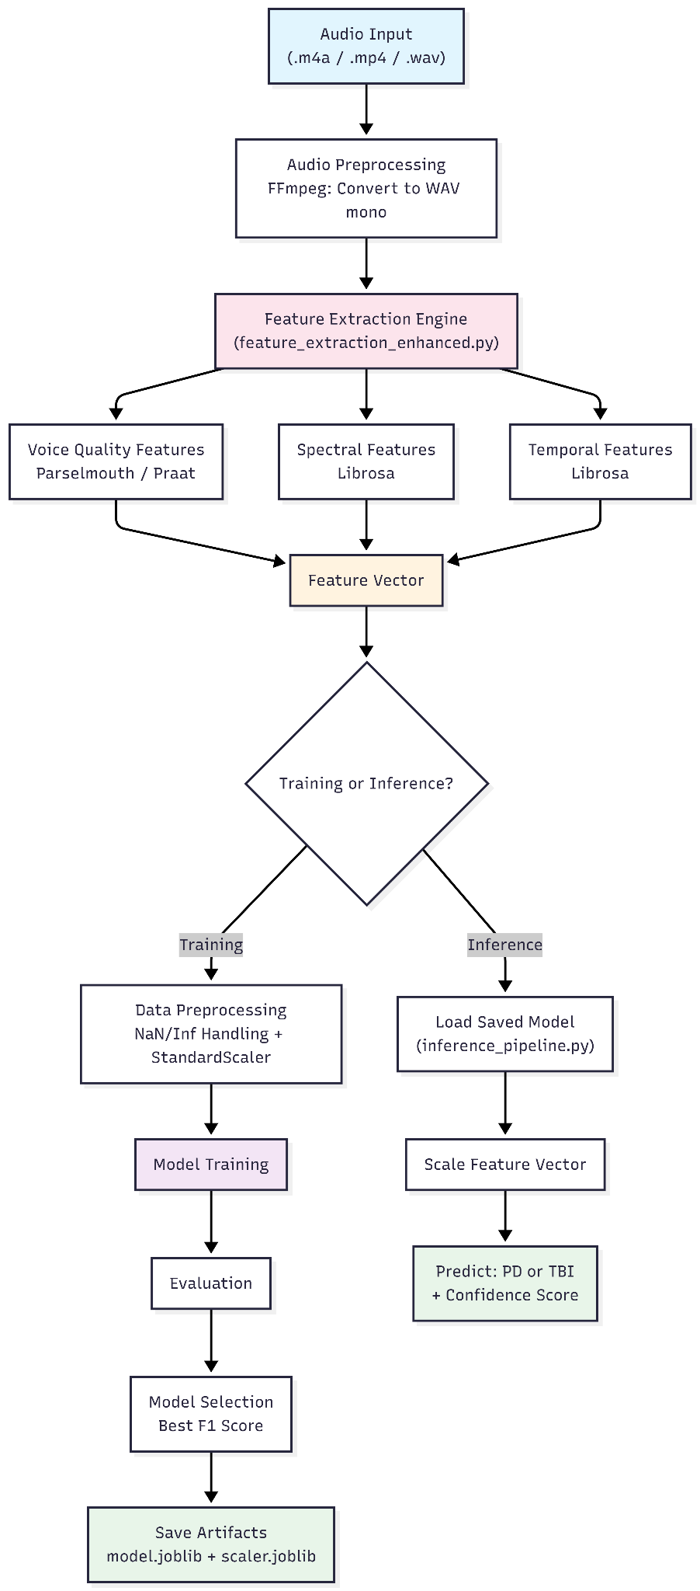

B. Component-Level Design Artifacts
The data ingestion pipeline handles audio file loading, format conversion, feature extraction, and CSV generation
- Data ingestion pipeline: implemented
Flow: Audio Files → Format Check → WAV Conversion (if .m4a/.mp4/.mp3) → Dual Loading [librosa.load() for spectral/temporal + parselmouth.Sound() for voice quality] → Extract Features → Append Label → Repeat for All Files → DataFrame → Save to csv file

- Model interaction flow: in progress
1. User calls predict("file_name.m4a")
2. Pipeline loads model artifacts (.joblib files)
3. Feature extractor processes audio → n-dimension feature dictionary
4. StandardScaler (python scikit) normalizes the feature vector
5. Model predicts class label (PD or TBI)
6. Model returns class probabilities [P(PD), P(TBI)]
7. User receives: "PD" or "TBI" + Confidence %

- Feature extraction engine: in progress
- Spectral: Librosa
- Temporal: Librosa
- Voice quality: Parselmouth (Praat)

- Training vs inference architecture: not started

2. Technology Stack (Implemented & In Use)

ML / AI Components
- Model selected:
  - Tree based: Random Forest, XGBoost, Decision Tree, Stochastic Gradient Descent and Gradient Boosting Classifier
  - Linear models: SVM, LDA, Logistic Regression
- Hosting strategy: Jupyter Notebook for prototyping and testing, saved as .joblib files, and inference by standalone Python script
- Integration method:
  - Google Drive for data storage
  - Google Colab / Jupyter Notebook for development
  - Joblib for model serialization
  - Python script for inference
- Cross-validation: Use 5-fold or 10-fold stratified cross-validation

3. Implementation Progress Summary
Status update:
- Completed: audio datasets collecting, feature extractions (54 features)
- Under development: ML training pipeline and inference pipeline
- Remains to be implemented: hyperparameter tuning, full model training once the datasets are available.
Screenshots:
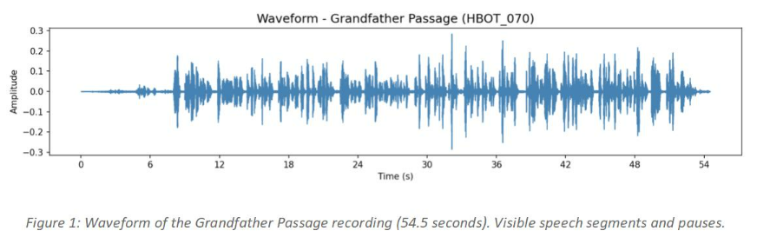
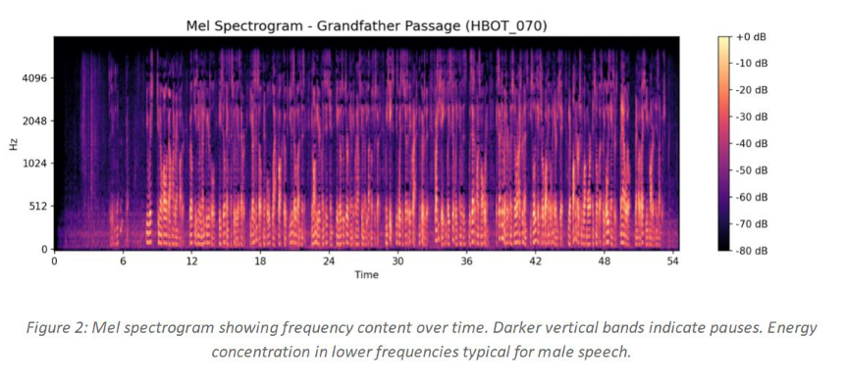

4. Updated Implementation Roadmap

Required Milestones + Updated Timeline:

Milestones | Status | Date
Initial code (23 features) | Completed | Mar 9th - 13th
Feature Extraction | Completed | Mar 16th - 19th
ML training pipeline | In progress | Mar 23th - 28th
Inference | Planned | Mar 23th - 28th
Full model training | Planned | Apr 21st - 24th
Final model selection + Report | Planned | Apr 30th - May 3rd

Individual Contributions:
- An: Report writing, models research, features extraction
- Devansh: Python scripts for graphing, features extraction
- Jason: Report Writing, Features Extraction

Technical risks:
Risk | Severity | Mitigation
Audio quality variation | Medium | Standardize to mono WAV and standardize
NaN/inf in features | Medium | Replace with median values, skip corrupted data

