SCH Deliverable 2 - PD vs TBI Classification using Speech Analysis

Smart and Connected Health

1. Finalized Architectural Flow & System Design

A. System Architecture Overview
Our system is a speech-based ML classification pipeline that distinguishes between Parkinson’s Disease (PD) and Traumatic Brain Injury (TBI) patients using acoustic features extracted from speech recordings.

System Architecture Diagram
graph TD
A["Audio Input\n(.m4a / .mp4 / .wav)"] --> B["Audio Preprocessing\nFFmpeg: Convert to WAV 16kHz mono"]
B --> C["Feature Extraction Engine\n(feature_extraction_enhanced.py)"]
C --> D["Voice Quality Features\nParselmouth / Praat\n15 features"]
C --> E["Spectral Features\nLibrosa\n32 features"]
C --> F["Temporal Features\nLibrosa\n7 features"]
D --> G["Feature Vector\n54 Features per Sample"]
E --> G
F --> G
G --> H{"Training or Inference?"}
H -->|Training| I["Data Preprocessing\nNaN/Inf Handling + StandardScaler"]
I --> J["Model Training\nRF / SVM / GB / KNN / LR"]
J --> K["Evaluation\nK-Fold CV + Metrics + Plots"]
K --> L["Model Selection\nBest F1 Score"]
L --> M["Save Artifacts\nmodel.joblib + scaler.joblib"]
H -->|Inference| N["Load Saved Model\n(inference_pipeline.py)"]
N --> O["Scale Feature Vector"]
O --> P["Predict: PD or TBI\n+ Confidence Score"]
O --> Q["Data Visualization\nPCA, LDA, t-SNE\n(Dimensionality Reduction)"]
style A fill:#e1f5fe
style G fill:#fff3e0
style P fill:#e8f5e9
style M fill:#e8f5e9
style C fill:#fce4ec
style J fill:#f3e5f5
style Q fill:#f3e5f5

Components Present in Our Project:
- ML/AI Pipeline - Full feature extraction -> training -> inference pipeline
- Data Ingestion Pipeline - Batch processing of audio folders (PD/TBI)
- External Libraries - Librosa, Parselmouth (Praat), scikit-learn

B. Component-Level Design Artifacts

i. ML/AI Pipeline (End-to-End)
graph LR
subgraph INPUT
A1["Raw Audio\n(.m4a/.mp4/.mp3/.wav)"]
end
subgraph PREPROCESSING
B1["FFmpeg\nConvert to 16kHz\nmono WAV"]
end
subgraph FEATURE_EXTRACTION
C1["Parselmouth\n(Voice Quality)"]
C2["Librosa\n(Spectral)"]
C3["Librosa\n(Temporal)"]
end
subgraph ML_PIPELINE
D1["StandardScaler\n(Normalization)"]
D2["Model Training\n(5 classifiers)"]
D3["Cross-Validation\n(Stratified K-Fold)"]
D4["Evaluation\n(Metrics + Plots)"]
end
subgraph OUTPUT
E1["Prediction\nPD or TBI"]
E2["Confidence\nScore (%)"]
end
A1 --> B1
B1 --> C1
B1 --> C2
B1 --> C3
C1 --> D1
C2 --> D1
C3 --> D1
D1 --> D2
D2 --> D3
D3 --> D4
D4 --> E1
D4 --> E2
Status: IMPLEMENTED - All modules functional

ii. Data Ingestion Pipeline
graph TD
A["Audio Files\n(PD/ folder + TBI/ folder)"] --> B{"File format?"}
B -->|".m4a / .mp4 / .mp3"| C["FFmpeg Conversion\nffmpeg -i input -ar 16000 -ac 1 output.wav"]
B -->|".wav"| D["Direct Load"]
C --> D
D --> E["librosa.load()\ny, sr = audio at 16kHz"]
D --> F["parselmouth.Sound()\nPraat sound object"]
E --> G["Extract Spectral Features\n(32 features)"]
E --> H["Extract Temporal Features\n(7 features)"]
F --> I["Extract Voice Quality Features\n(15 features)"]
G --> J["Combine into\n54-dim Feature Dict"]
H --> J
I --> J
J --> K["Append label\n(PD or TBI)"]
K --> L["Repeat for all files\nin both folders"]
L --> M["pd.DataFrame()"]
M --> N["Save to\nfeatures.csv"]
style A fill:#e1f5fe
style N fill:#e8f5e9
style J fill:#fff3e0
Status: IMPLEMENTED - feature_extraction_enhanced.py -> process_all_files()

iii. Model Interaction Flow
sequenceDiagram
participant User
participant InferencePipeline
participant FeatureExtractor
participant Scaler
participant Model
User->>InferencePipeline: predict("patient_audio.m4a")
InferencePipeline->>InferencePipeline: Load model artifacts (.joblib)
InferencePipeline->>FeatureExtractor: extract_all_features(file_path)
FeatureExtractor->>FeatureExtractor: convert_to_wav() if needed
FeatureExtractor->>FeatureExtractor: extract_voice_quality_features()
FeatureExtractor->>FeatureExtractor: extract_spectral_features()
FeatureExtractor->>FeatureExtractor: extract_temporal_features()
FeatureExtractor-->>InferencePipeline: 54-dim feature dict
InferencePipeline->>Scaler: scaler.transform(feature_vector)
Scaler-->>InferencePipeline: Scaled feature vector
InferencePipeline->>Model: model.predict(X_scaled)
Model-->>InferencePipeline: Class label (0 or 1)
InferencePipeline->>Model: model.predict_proba(X_scaled)
Model-->>InferencePipeline: [P(PD), P(TBI)]
InferencePipeline-->>User: "PD" or "TBI" + Confidence %
Status: IMPLEMENTED - inference_pipeline.py -> predict()

iv. Training vs Inference Architecture
graph TB
subgraph TRAINING_PHASE["TRAINING PHASE (ml_training_pipeline.py)"]
direction TB
T1["features.csv\n(PD + TBI labeled data)"] --> T2["load_and_preprocess()\nDrop NaN/Inf, Encode Labels"]
T2 --> T3["StandardScaler.fit_transform()\nLearn mean/std + normalize"]
T3 --> T4["Train 5 Models\nRandom Forest | SVM | GB | KNN | LR"]
T4 --> T5["Stratified K-Fold CV\n(5-fold / 10-fold)"]
T5 --> T6["Evaluate\nAccuracy, Precision, Recall, F1\nAUC-ROC Curve, Precision-Recall Curve"]
T6 --> T6b["Feature Importance Analysis\n(Permutation / Tree-based)"]
T6b --> T7["Select Best Model\n(highest F1)"]
T7 --> T8["Save Artifacts\nbest_model.joblib\nscaler.joblib\nlabel_encoder.joblib\nfeature_names.joblib"]
end
subgraph INFERENCE_PHASE["INFERENCE PHASE (inference_pipeline.py)"]
direction TB
I1["New Audio File\n(.m4a / .wav)"] --> I2["extract_all_features()\n54-dim vector"]
I2 --> I3["Load saved scaler.joblib"]
I3 --> I4["scaler.transform()\n(use learned mean/std)"]
I4 --> I5["Load saved best_model.joblib"]
I5 --> I6["model.predict()\nmodel.predict_proba()"]
I6 --> I7["Output:\nPD or TBI + Confidence %"]
end
T8 -.->|"Saved artifacts connect phases"| I3
T8 -.-> I5
style T1 fill:#e1f5fe
style T8 fill:#e8f5e9
style I1 fill:#e1f5fe
style I7 fill:#e8f5e9
Status: IMPLEMENTED - Both phases fully functional

v. Feature Extraction Engine - Internal Architecture
graph TD
subgraph VOICE_QUALITY["Voice Quality (Parselmouth/Praat) - 15 features"]
VQ1["Pitch Analysis\npitch_mean, pitch_std\npitch_min, pitch_max"]
VQ2["Jitter Analysis\njitter_local\njitter_rap, jitter_ppq5"]
VQ3["Shimmer Analysis\nshimmer_local\nshimmer_apq3, shimmer_apq5"]
VQ4["Harmonicity\nhnr"]
VQ5["Formant Analysis\nformant_f1, f2, f3, f4"]
end
subgraph SPECTRAL["Spectral (Librosa) - 32 features"]
SP1["MFCCs\nmfcc_1 to mfcc_13"]
SP2["Delta MFCCs\ndelta_mfcc_1 to delta_mfcc_13"]
SP3["Spectral Shape\ncentroid, bandwidth\nrolloff, flatness\ncontrast, chroma"]
end
subgraph TEMPORAL["Temporal (Librosa) - 7 features"]
TM1["Duration"]
TM2["ZCR + RMS Energy"]
TM3["Pause Analysis\nnum_pauses, pause_ratio"]
TM4["Rhythm\nspeech_rate, tempo"]
end
VQ1 --> OUT["54-dim Feature Vector"]
VQ2 --> OUT
VQ3 --> OUT
VQ4 --> OUT
VQ5 --> OUT
SP1 --> OUT
SP2 --> OUT
SP3 --> OUT
TM1 --> OUT
TM2 --> OUT
TM3 --> OUT
TM4 --> OUT
style VOICE_QUALITY fill:#e8eaf6
style SPECTRAL fill:#fce4ec
style TEMPORAL fill:#e0f2f1
style OUT fill:#fff3e0

vi. Model Comparison Architecture
graph TD
DATA["Scaled Feature Matrix\n(N samples x 54 features)"] --> RF["Random Forest\n100 trees, max_depth=10\nbalanced class weights"]
DATA --> SVM["SVM (RBF Kernel)\nC=1.0, gamma=scale\nbalanced class weights"]
DATA --> GB["Gradient Boosting\n100 estimators, max_depth=5\nlearning_rate=0.1"]
DATA --> KNN["KNN (Instance-Based)\nk=5, distance-weighted\nmetric=euclidean"]
DATA --> LR["Logistic Regression\nmax_iter=1000\nbalanced class weights"]
RF --> CV["5-Fold / 10-Fold Stratified\nCross-Validation"]
SVM --> CV
GB --> CV
KNN --> CV
LR --> CV
CV --> METRICS["Metrics per Model:\nAccuracy, Precision, Recall, F1\nAUC-ROC, Precision-Recall Curve"]
CV --> FI["Feature Importance\nAnalysis"]
METRICS --> SELECT{"Select Best\nby F1 Score"}
SELECT --> BEST["Best Model"]
BEST --> SAVE["Save as best_model.joblib"]
style DATA fill:#e1f5fe
style BEST fill:#e8f5e9
style SAVE fill:#c8e6c9

vii. Module Dependency Diagram
graph LR
subgraph INPUTS["Input Data"]
AUDIO["Audio Files\n(.m4a / .wav)"]
end
subgraph EXTRACTION["feature_extraction_enhanced.py"]
FE["extract_all_features()"]
BATCH["process_all_files()"]
end
subgraph DATA["Data Artifacts"]
CSV["features.csv"]
end
subgraph TRAINING["ml_training_pipeline.py"]
PREPROCESS["load_and_preprocess()"]
ANALYZE["analyze_features()"]
TRAIN["train_and_evaluate()"]
end
subgraph ARTIFACTS["Saved Model Artifacts"]
MODEL["best_model.joblib"]
SCALER["scaler.joblib"]
LE["label_encoder.joblib"]
FN["feature_names.joblib"]
end
subgraph INFERENCE["inference_pipeline.py"]
PREDICT["predict()"]
end
AUDIO --> FE
FE --> BATCH
BATCH --> CSV
CSV --> PREPROCESS
PREPROCESS --> ANALYZE
PREPROCESS --> TRAIN
TRAIN --> MODEL
TRAIN --> SCALER
TRAIN --> LE
TRAIN --> FN
MODEL --> PREDICT
SCALER --> PREDICT
LE --> PREDICT
FN --> PREDICT
AUDIO --> PREDICT
FE -.-> PREDICT
style AUDIO fill:#e1f5fe
style CSV fill:#fff3e0
style MODEL fill:#e8f5e9
style PREDICT fill:#c8e6c9

2. Technology Stack (Implemented & In Use)

ML / AI Components
Component | Technology | Status | Rationale
Feature Extraction (Voice Quality) | Parselmouth (Praat) v0.4+ | Implemented | Gold standard for voice analysis; extracts pitch, jitter, shimmer, HNR, formants
Feature Extraction (Spectral/Temporal) | Librosa v0.10+ | Implemented | Industry standard for audio feature extraction; MFCCs, spectral features, pause detection
Audio Conversion | FFmpeg | Implemented | Robust, handles m4a/mp4/mp3 to WAV conversion
ML Models | scikit-learn v1.3+ | Implemented | Random Forest, SVM, Gradient Boosting, KNN, Logistic Regression
Data Processing | NumPy, Pandas | Implemented | Feature vector assembly, CSV handling, NaN/Inf cleanup
Visualization | Matplotlib, Seaborn | Implemented | Waveforms, spectrograms, MFCCs, pitch contours, feature charts
Model Persistence | Joblib | Implemented | Serialization of trained model, scaler, encoder
Development Environment | Google Colab (Python 3) | Implemented | Free GPU, pre-installed libraries, easy collaboration

Model Selected
We train and compare 5 classifiers:
- Random Forest (100 trees, max_depth=10, balanced class weights) - Robust ensemble, handles high-dimensional feature spaces well
- SVM with RBF kernel (C=1.0, gamma=scale, balanced) - Strong on small datasets with high-dimensional features
- Gradient Boosting (100 estimators, max_depth=5, lr=0.1) - Sequential ensemble, strong on tabular data
- K-Nearest Neighbors (KNN) (k=5, distance-weighted, metric=euclidean) - Instance-based model, makes predictions based on similarity to nearest training samples
- Logistic Regression (balanced, max_iter=1000) - Interpretable linear baseline
The best model is automatically selected based on weighted F1 score.

Hosting Strategy
- Development: Google Colab notebooks for prototyping and training
- Model Artifacts: Saved as .joblib files, portable to any Python environment
- Inference: Standalone Python script (inference_pipeline.py) runnable locally or on any server

Integration Method
- Data Storage: Google Drive for storing audio datasets and shared team access
- Development Environment: Google Colab / Jupyter Notebook for interactive prototyping, training, and evaluation
- Model Serialization: Joblib for serializing trained models, scalers, label encoders, and feature name lists as .joblib artifacts
- Inference: Standalone Python script (inference_pipeline.py) loads serialized artifacts and runs predictions locally or on any server
- Feature extraction is self-contained (no external API calls during inference)

Current Performance Status
- Feature extraction successfully tested on real patient audio (HBOT_070 Grandfather Passage)
- 54 features extracted per audio file
- Model training pipeline ready; awaiting full labeled dataset (PD + TBI folders) to produce accuracy metrics

Pivots from Initial Plan
- Added 31 new features beyond the original 23 in the starter code (total: 54)
- Added multiple model comparison instead of a single model approach
- Added stratified k-fold cross-validation for more robust evaluation on small datasets

Cross-Validation Strategy
We use stratified K-fold cross-validation (5-fold and 10-fold) to ensure robust evaluation, especially given the small dataset size. Stratification preserves the PD/TBI class ratio in each fold, preventing biased splits. Both 5-fold and 10-fold results are reported to assess variance in model performance.

Feature Importance Analysis
Feature importance analysis is one of our core research questions — identifying which speech features are most discriminative between PD and TBI patients. We employ multiple methods: - Tree-based feature importance: Gini importance from Random Forest and Gradient Boosting models, ranking features by their contribution to classification splits - Permutation importance: Model-agnostic method that measures the decrease in model performance when each feature’s values are randomly shuffled - ANOVA F-test ranking: Statistical test comparing PD vs TBI group means for each of the 54 features - Top features are visualized as ranked bar charts to highlight which acoustic dimensions (voice quality, spectral, temporal) carry the most diagnostic value

Evaluation Metrics
All models are evaluated with the following comprehensive metrics: | Metric | Description | |——–|————-| | Accuracy | Overall proportion of correct predictions | | Precision | Proportion of predicted PD/TBI cases that are correct (per-class) | | Recall | Proportion of actual PD/TBI cases correctly identified (per-class) | | F1 Score | Harmonic mean of precision and recall (weighted) — primary model selection criterion | | AUC-ROC Curve | Area Under the Receiver Operating Characteristic curve — measures discrimination ability across all thresholds | | Precision-Recall Curve | Plots precision vs recall at various thresholds — especially informative for imbalanced datasets |
Additionally, confusion matrices are generated per model to visualize true/false positive/negative distributions.

3. Implementation Progress Summary

Completed
Module | File | Description
Enhanced Feature Extraction | feature_extraction_enhanced.py | Extracts 54 features (voice quality + spectral + temporal) from audio files
ML Training Pipeline | ml_training_pipeline.py | Full training pipeline: preprocessing, feature analysis, 4-model comparison, evaluation, model saving
Inference Pipeline | inference_pipeline.py | Loads saved model and predicts PD/TBI from new audio with confidence scores
Colab Notebook | PD_TBI_Classification_Notebook.ipynb | All-in-one notebook for end-to-end execution in Google Colab

Currently Under Development
- Collecting PD and TBI audio samples to build the full training dataset
- Hyperparameter tuning (grid search / Bayesian optimization)

Remains to Be Implemented
- Full model training once labeled PD + TBI datasets are available
- Integration with a frontend/mobile app (out of scope for ML deliverable)
- Real-time audio streaming inference

Demonstration Evidence

Feature Extraction Output (Real - HBOT_070 Sample)
54 features were successfully extracted from the sample audio file 20250319_141117_HBOT_070_Grandfather.m4a:
Feature | Value
pitch_mean | 119.68 Hz
pitch_std | 88.45 Hz
pitch_min | 73.25 Hz
pitch_max | 499.46 Hz
jitter_local | 0.0313
jitter_rap | 0.0145
jitter_ppq5 | 0.0164
shimmer_local | 0.1670
shimmer_apq3 | 0.0753
shimmer_apq5 | 0.1089
hnr | 7.67 dB
formant_f1 | 661.34 Hz
formant_f2 | 1891.99 Hz
formant_f3 | 2859.63 Hz
formant_f4 | 3858.63 Hz
mfcc_1 | -396.17
spectral_centroid | 1403.05 Hz
spectral_bandwidth | 1352.01 Hz
spectral_rolloff | 2796.81 Hz
duration | 54.53 s
num_pauses | 42
pause_ratio | 0.2969
speech_rate | 0.7886 seg/s
tempo | 98.68 BPM
(+ 30 more features)

Visualization Outputs (Real - from HBOT_070 audio)
The following plots were generated from the actual patient audio file:

1. Waveform
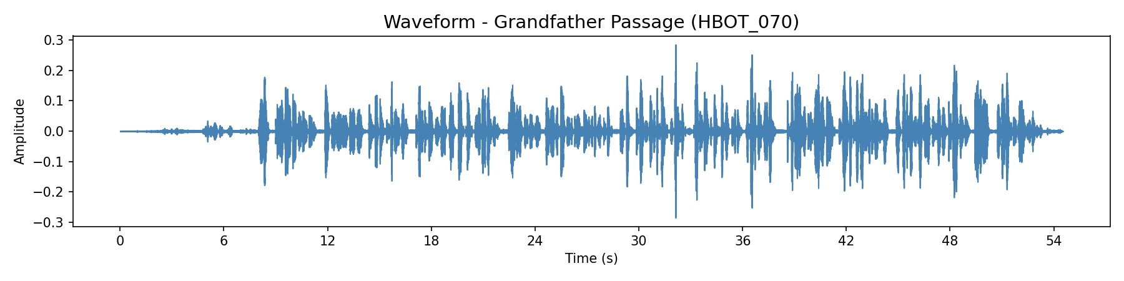 Shows the amplitude of the speech signal over the 54.5-second Grandfather Passage recording. Visible speech segments and pauses.

2. Mel Spectrogram
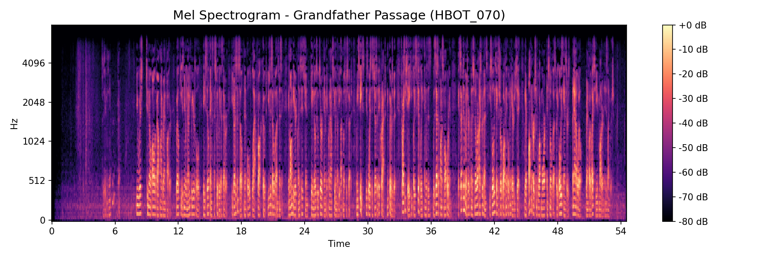 Frequency content over time. Darker vertical bands indicate pauses. Energy concentration in lower frequencies is typical for male speech.

3. MFCCs (13 Coefficients)
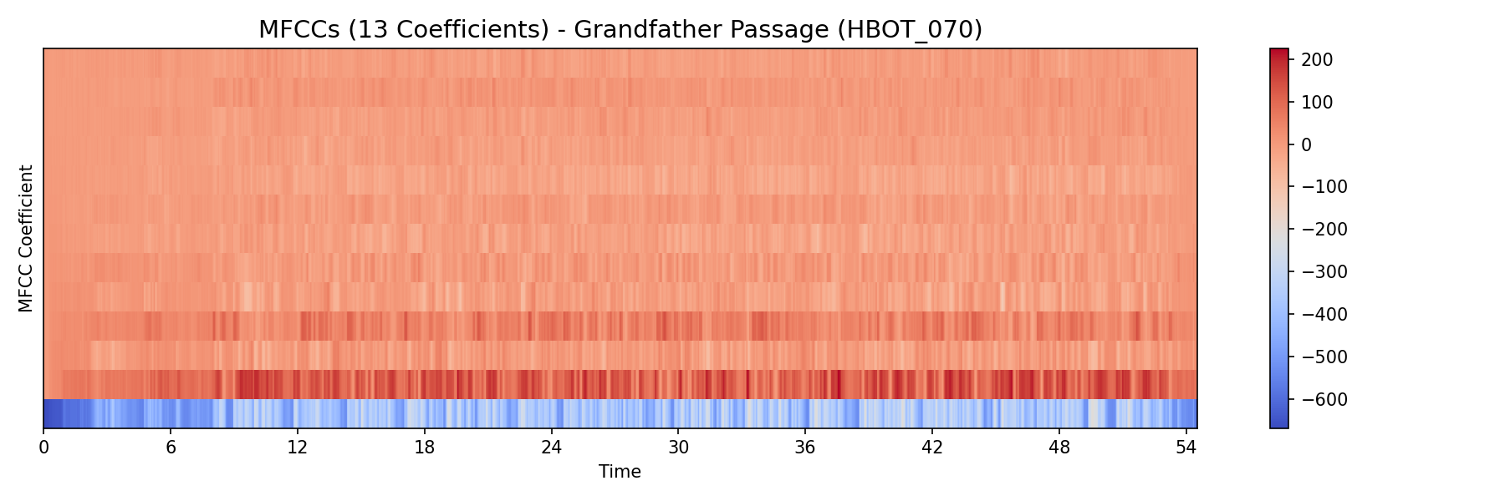 Mel-frequency cepstral coefficients over time. These capture the “voice texture” and are key features for speech classification.

4. Pitch Contour (F0)
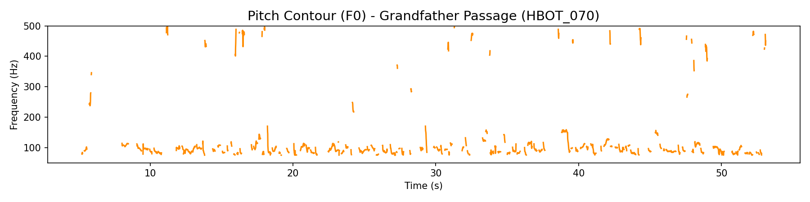 Fundamental frequency over time. Mean pitch ~120 Hz. Gaps indicate unvoiced segments or pauses. Note the pitch instability (high jitter = 0.031).

5. Feature Summary
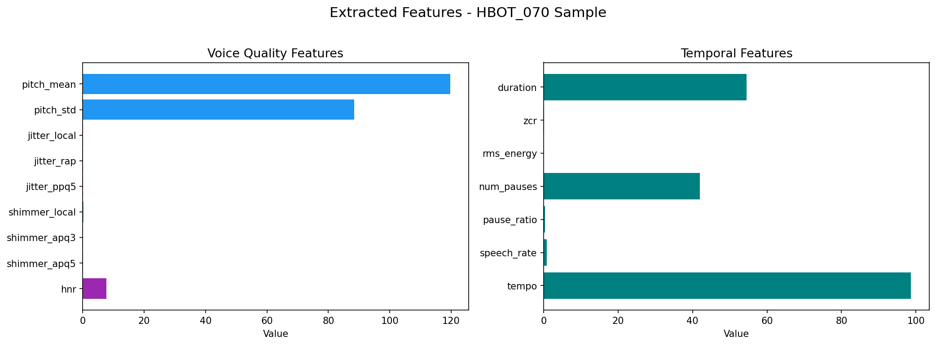 Bar chart of extracted voice quality features (left) and temporal features (right) for this sample.

6. Pause Detection
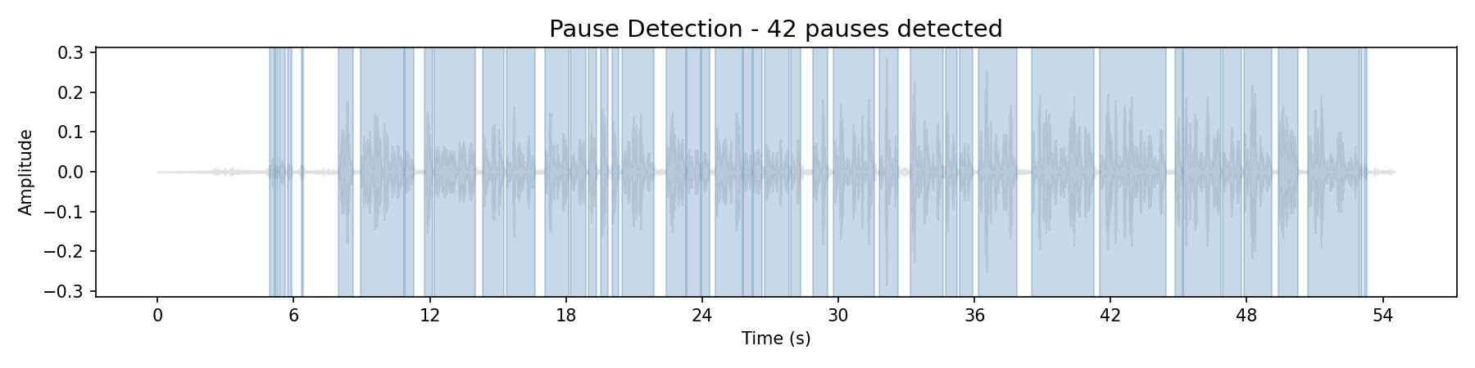 Blue shaded regions = detected speech segments. 42 pauses detected, pause ratio = 29.7% of total duration.

Code Architecture Overview
output/
|-- feature_extraction_enhanced.py # 54-feature extraction engine
|-- ml_training_pipeline.py # Training & evaluation pipeline
|-- inference_pipeline.py # Production inference
|-- PD_TBI_Classification_Notebook.ipynb # All-in-one Colab notebook
|-- SCH_Deliverable_2_Report.md # This deliverable report
|-- plot_waveform.png # Waveform visualization
|-- plot_spectrogram.png # Mel spectrogram
|-- plot_mfccs.png # MFCC heatmap
|-- plot_pitch_contour.png # Pitch (F0) contour
|-- plot_feature_summary.png # Feature bar charts
|-- plot_pause_detection.png # Pause detection overlay

4. Updated Implementation Roadmap

Core Component Completion
Milestone | Status | Date
Starter code (23 features) | Completed | Week 1
Enhanced feature extraction (54 features) | Completed | Week 2
ML training pipeline (5 models) | Completed | Week 3
Evaluation framework (CV, metrics, plots) | Completed | Week 3
Inference pipeline | Completed | Week 3
Colab notebook (all-in-one) | Completed | Week 3
Data collection (PD/TBI samples) | In Progress | Week 4
Full model training + evaluation | Planned | Week 4-5
Final model selection & report | Planned | Week 5

Dependencies Between Modules
graph TD
A["Audio Files (.m4a)"] -->|"input"| B["feature_extraction_enhanced.py"]
B -->|"produces"| C["features.csv"]
C -->|"consumed by"| D["ml_training_pipeline.py"]
D -->|"saves"| E["best_model.joblib"]
D -->|"saves"| F["scaler.joblib"]
D -->|"saves"| G["label_encoder.joblib"]
D -->|"saves"| H["feature_names.joblib"]
E -->|"loaded by"| I["inference_pipeline.py"]
F -->|"loaded by"| I
G -->|"loaded by"| I
H -->|"loaded by"| I
B -.->|"functions reused by"| I
A -->|"new audio input"| I
I -->|"outputs"| J["Prediction: PD or TBI + Confidence"]
style A fill:#e1f5fe
style C fill:#fff3e0
style E fill:#e8f5e9
style J fill:#c8e6c9
- feature_extraction_enhanced.py must run before training (produces the CSV)
- ml_training_pipeline.py must complete before inference (produces model artifacts)
- inference_pipeline.py depends on both feature extraction functions and saved model artifacts

Technical Risks Identified
Risk | Severity | Mitigation
Small dataset (few PD/TBI samples) | High | Use stratified K-fold CV, balanced class weights, data augmentation
Overfitting on limited data | High | Regularization (max_depth limits, C parameter), cross-validation
Audio quality variation across recordings | Medium | Standardize to 16kHz mono WAV; normalize with StandardScaler
NaN/Inf in extracted features (e.g., no pitch detected) | Medium | Replace with median values; skip corrupted files gracefully
Model generalizability to new patients | Medium | Reserve holdout test set from different patients

Updated Timeline
Week | Tasks
Week 1 (Completed) | Environment setup, audio basics, run starter code
Week 2 (Completed) | Enhanced feature extraction (54 features), batch processing
Week 3 (Completed) | ML pipeline, training code, evaluation code, inference pipeline
Week 4 (Current) | Data collection, run full training with labeled data
Week 5 | Final model selection, performance benchmarking, deliverable submission

5. Output File Descriptions

Python Source Files

feature_extraction_enhanced.py - Feature Extraction Engine
Extracts 54 speech features from any audio file (.m4a, .mp4, .mp3, .wav). Core signal processing module.
Function | Purpose
convert_to_wav(input_path) | Uses FFmpeg to convert non-WAV audio to 16kHz mono WAV
extract_voice_quality_features(sound) | Parselmouth/Praat: pitch (4), jitter (3), shimmer (3), HNR (1), formants (4)
extract_spectral_features(audio, sr) | Librosa: MFCCs (13), delta MFCCs (13), centroid, bandwidth, rolloff, flatness, contrast, chroma
extract_temporal_features(audio, sr) | Librosa: duration, ZCR, RMS energy, pause count, pause ratio, speech rate, tempo
extract_all_features(file_path) | Master function combining all three extractors into 54-feature dict
process_all_files(pd_folder, tbi_folder) | Batch processes PD and TBI folders, returns DataFrame

ml_training_pipeline.py - Model Training & Evaluation
Takes extracted features CSV, trains 5 classifiers, evaluates with cross-validation, saves best model.
Function | Purpose
load_and_preprocess(csv_path) | Load CSV, handle NaN/Inf, encode labels, fit StandardScaler
analyze_features(csv_path) | PD vs TBI group statistics, ANOVA F-test feature ranking, feature importance (permutation & tree-based), bar chart
train_and_evaluate(X, y, ...) | Train RF/SVM/GB/KNN/LR, 5-fold stratified CV, confusion matrix, ROC curve, PR curve, feature importance

inference_pipeline.py - Prediction on New Audio
Loads saved model artifacts and predicts PD vs TBI from a new audio recording.
Function | Purpose
load_model(model_dir) | Load best_model.joblib, scaler.joblib, label_encoder.joblib, feature_names.joblib
predict(file_path) | Extract features -> scale -> predict class + probability
batch_predict(folder_path) | Run predictions on all audio files in a folder

PD_TBI_Classification_Notebook.ipynb - All-in-One Colab Notebook
Single Google Colab notebook combining all modules into a runnable cell-by-cell workflow. Designed for the course’s Colab-based environment.

Appendix: Full Feature Reference (54 Features)

Voice Quality Features (15) - Parselmouth/Praat
# | Feature | Clinical Significance
1 | pitch_mean | Average fundamental frequency - gender/age marker
2 | pitch_std | Pitch variation - monotone speech detection (low in PD)
3 | pitch_min | Minimum pitch in utterance
4 | pitch_max | Maximum pitch in utterance
5 | jitter_local | Local pitch instability - strong PD indicator
6 | jitter_rap | Relative average perturbation - voice tremor
7 | jitter_ppq5 | 5-point pitch perturbation quotient
8 | shimmer_local | Local amplitude instability - weak voice
9 | shimmer_apq3 | 3-point amplitude perturbation
10 | shimmer_apq5 | 5-point amplitude perturbation
11 | hnr | Harmonics-to-noise ratio - breathiness/hoarseness
12 | formant_f1 | First formant - vowel openness
13 | formant_f2 | Second formant - tongue position
14 | formant_f3 | Third formant - lip rounding
15 | formant_f4 | Fourth formant - vocal tract length

Spectral Features (32) - Librosa
# | Feature | Description
16-28 | mfcc_1 to mfcc_13 | Mel-frequency cepstral coefficients - voice texture
29-41 | delta_mfcc_1 to delta_mfcc_13 | Rate of change of MFCCs - temporal dynamics
42 | spectral_centroid | Center of mass of spectrum (brightness)
43 | spectral_bandwidth | Frequency spread
44 | spectral_rolloff | Frequency below which 85% of energy lies
45 | spectral_flatness | Noise-like vs tone-like quality
46 | spectral_contrast | Peak-valley difference in spectrum
47 | chroma_mean | Pitch class energy distribution

Temporal Features (7) - Librosa
# | Feature | Description
48 | duration | Total audio length in seconds
49 | zcr | Zero crossing rate - noisiness indicator
50 | rms_energy | Root mean square energy - loudness
51 | num_pauses | Number of detected silences
52 | pause_ratio | Proportion of time spent in silence
53 | speech_rate | Speaking speed (segments per second)
54 | tempo | Estimated beat tempo

