SCH Deliverable 2
PD vs TBI Classification using Speech Analysis
Smart and Connected Health

1. Finalized Architectural Flow & System Design

A. System Architecture Overview
Our system is a speech-based ML classification pipeline that distinguishes between Parkinson's Disease (PD) and Traumatic Brain Injury (TBI) patients using acoustic features extracted from speech recordings.
The system architecture consists of the following major components:
- ML/AI Pipeline
- Full feature extraction → training → inference pipeline
- Data Ingestion Pipeline – Batch processing of audio folders (PD/TBI)
- External Libraries – Librosa, Parselmouth (Praat), scikit-learn

System Architecture Diagram:
The end-to-end pipeline flows as follows:
Audio Input (.m4a/.mp4/.wav) → Audio Preprocessing (FFmpeg: convert to WAV 16kHz mono) → Feature Extraction Engine → [Voice Quality Features (Parselmouth, 15 features) + Spectral Features (Librosa, 32 features) + Temporal Features (Librosa, 7 features)] → 54-dim Feature Vector → Training Path OR Inference Path

Training Path: Data Preprocessing (NaN/Inf handling + StandardScaler) → Model Training (RF/SVM/GB/LR) → Evaluation (K-Fold CV + Metrics) → Model Selection (Best F1) → Save Artifacts (.joblib)
Inference Path: Load Saved Model → Scale Feature Vector → Predict PD or TBI + Confidence Score

B. Component-Level Design Artifacts

i. Data Ingestion Pipeline
The data ingestion pipeline handles audio file loading, format conversion, feature extraction, and CSV generation:

Flow: Audio Files (PD/ + TBI/ folders) → Format Check → FFmpeg Conversion (if .m4a/.mp4/.mp3) → Dual Loading [librosa.load() for spectral/temporal + parselmouth.Sound() for voice quality] → Extract 54 Features → Append Label → Repeat for All Files → DataFrame → Save to features.csv

Status: IMPLEMENTED
File: feature_extraction_enhanced.py → process_all_files() function

ii. Model Interaction Flow
The inference sequence for a single audio file prediction:

1. User calls predict("patient_audio.m4a")
2. Pipeline loads model artifacts (.joblib files)
3. Feature extractor processes audio → 54-dim feature dict
4. StandardScaler normalizes the feature vector
5. Model predicts class label (PD=0 or TBI=1)
6. Model returns class probabilities [P(PD), P(TBI)]
7. User receives: "PD" or "TBI" + Confidence %

Status: IMPLEMENTED
File: inference_pipeline.py → predict() function

iii. Training vs Inference Architecture
Phase | Input | Process | Output
Training | features.csv (labeled) | Preprocessing → K-Fold CV → Model Fitting → Evaluation | best_model.joblib, scaler.joblib, evaluation plots
Inference | Single audio file | Feature extraction → Scaling → Prediction | PD/TBI label + confidence score

Status: IMPLEMENTED – Both phases fully functional

iv. Feature Extraction Engine – Internal Architecture
The feature extraction engine extracts 54 features across 3 categories:
Category | Library | Count | Features
Voice Quality | Parselmouth (Praat) | 15 | Pitch (4), Jitter (3), Shimmer (3), HNR (1), Formants (4)
Spectral | Librosa | 32 | MFCCs (13), Delta MFCCs (13), Centroid, Bandwidth, Rolloff, Flatness, Contrast, Chroma
Temporal | Librosa | 7 | Duration, ZCR, RMS Energy, Num Pauses, Pause Ratio, Speech Rate, Tempo

v. Model Comparison Architecture
Four classifiers are trained and compared using stratified K-fold cross-validation:
Model | Configuration | Strengths
Random Forest | 100 trees, max_depth=10, balanced weights | Robust ensemble, handles high-dim features
SVM (RBF) | C=1.0, gamma=scale, balanced weights | Strong on small datasets with many features
Gradient Boosting | 100 estimators, max_depth=5, lr=0.1 | Sequential ensemble, strong on tabular data
Logistic Regression | max_iter=1000, balanced weights | Interpretable linear baseline

The best model is automatically selected based on weighted F1 score.

vi. Module Dependency Diagram
Execution order and dependencies between modules:

Audio Files (.m4a) → feature_extraction_enhanced.py → features.csv → ml_training_pipeline.py → [best_model.joblib + scaler.joblib + label_encoder.joblib + feature_names.joblib] → inference_pipeline.py → Prediction (PD or TBI + Confidence)

- feature_extraction_enhanced.py
must run before training (produces the CSV)
- ml_training_pipeline.py
must complete before inference (produces model artifacts)
- inference_pipeline.py
depends on both feature extraction functions and saved model artifacts

2. Technology Stack (Implemented & In Use)

ML / AI Components
Component | Technology | Status | Rationale
Feature Extraction (Voice) | Parselmouth (Praat) v0.4+ | Implemented | Gold standard for voice analysis
Feature Extraction (Spectral) | Librosa v0.10+ | Implemented | Industry standard for audio features
Audio Conversion | FFmpeg | Implemented | Handles m4a/mp4/mp3 → WAV
ML Models | scikit-learn v1.3+ | Implemented | RF, SVM, GB, Logistic Regression
Data Processing | NumPy, Pandas | Implemented | Feature vectors, CSV, NaN cleanup
Visualization | Matplotlib, Seaborn | Implemented | Waveforms, spectrograms, plots
Model Persistence | Joblib | Implemented | Model serialization
Development Env | Google Colab (Python 3) | Implemented | Free GPU, collaboration

Hosting Strategy
- Development:
Google Colab notebooks for prototyping and training
- Model Artifacts:
Saved as .joblib files, portable to any Python environment
- Inference:
Standalone Python script runnable locally or on any server

Integration Method
- Audio files ingested from local filesystem or Google Drive
- Feature extraction is self-contained (no external API calls)
- Model artifacts serialized with joblib for portability

Current Performance Status
- Feature extraction successfully tested on real patient audio (HBOT_070)
- 54 features extracted per audio file
- Model training pipeline ready; awaiting full labeled PD + TBI dataset

Pivots from Initial Plan
- Added 31 new features beyond the original 23 in the starter code (total: 54)
- Added multiple model comparison instead of single model approach
- Added stratified k-fold cross-validation for robust evaluation on small datasets

3. Implementation Progress Summary

Completed
Module | File | Description
Enhanced Feature Extraction | feature_extraction_enhanced.py | Extracts 54 features from audio files
ML Training Pipeline | ml_training_pipeline.py | Preprocessing, 4-model comparison, evaluation, model saving
Inference Pipeline | inference_pipeline.py | Predicts PD/TBI from new audio with confidence
Colab Notebook | PD_TBI_Classification_Notebook.ipynb | All-in-one notebook for Google Colab

Currently Under Development
- Collecting PD and TBI audio samples to build the full training dataset
- Hyperparameter tuning (grid search / Bayesian optimization)

Remains to Be Implemented
- Full model training once labeled PD + TBI datasets are available
- Integration with a frontend/mobile app (out of scope for ML deliverable)
- Real-time audio streaming inference

Demonstration Evidence

Feature Extraction Output (Real – HBOT_070 Sample)
54 features were successfully extracted from the sample audio file 20250319_141117_HBOT_070_Grandfather.m4a:
Feature | Value | Feature | Value
pitch_mean | 119.68 Hz | shimmer_local | 0.1670
pitch_std | 88.45 Hz | shimmer_apq3 | 0.0753
pitch_min | 73.25 Hz | shimmer_apq5 | 0.1089
pitch_max | 499.46 Hz | hnr | 7.67 dB
jitter_local | 0.0313 | formant_f1 | 661.34 Hz
jitter_rap | 0.0145 | formant_f2 | 1891.99 Hz
jitter_ppq5 | 0.0164 | formant_f3 | 2859.63 Hz
spectral_centroid | 1403.05 Hz | formant_f4 | 3858.63 Hz
spectral_bandwidth | 1352.01 Hz | duration | 54.53 s
spectral_rolloff | 2796.81 Hz | num_pauses | 42
mfcc_1 | -396.17 | pause_ratio | 0.2969
rms_energy | 0.0155 | speech_rate | 0.789 seg/s
(+ 30 additional MFCC, delta MFCC, and spectral features)

Visualization Outputs (Real – from HBOT_070 audio)
The following plots were generated from the actual patient audio file:

1. Waveform
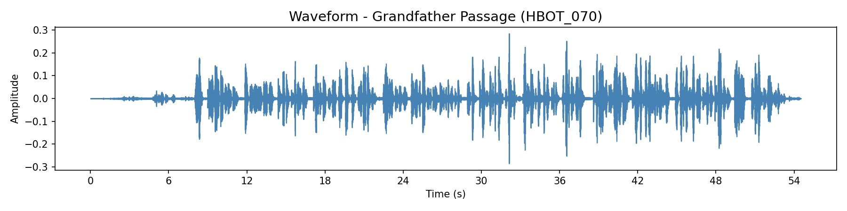
Figure 1: Waveform of the Grandfather Passage recording (54.5 seconds). Visible speech segments and pauses.

2. Mel Spectrogram
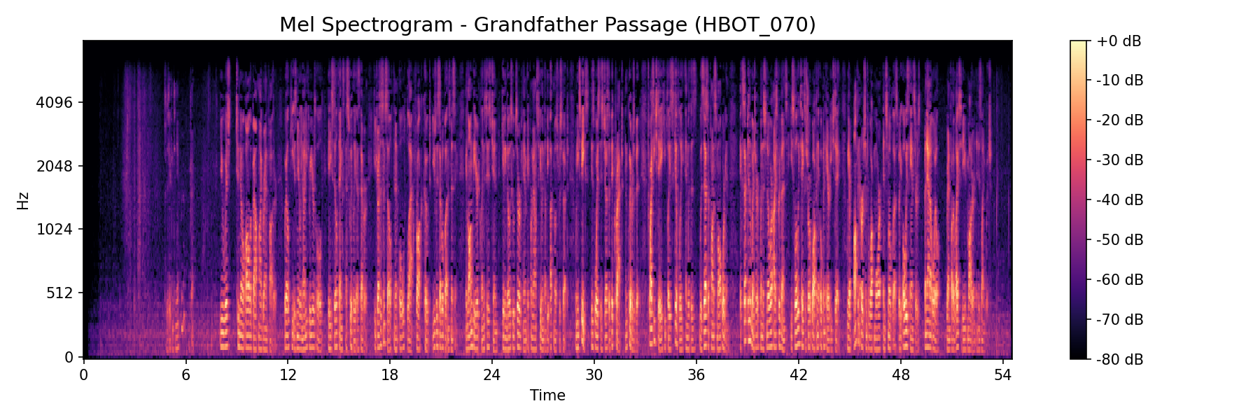
Figure 2: Mel spectrogram showing frequency content over time. Darker vertical bands indicate pauses. Energy concentration in lower frequencies typical for male speech.

3. MFCCs (13 Coefficients)
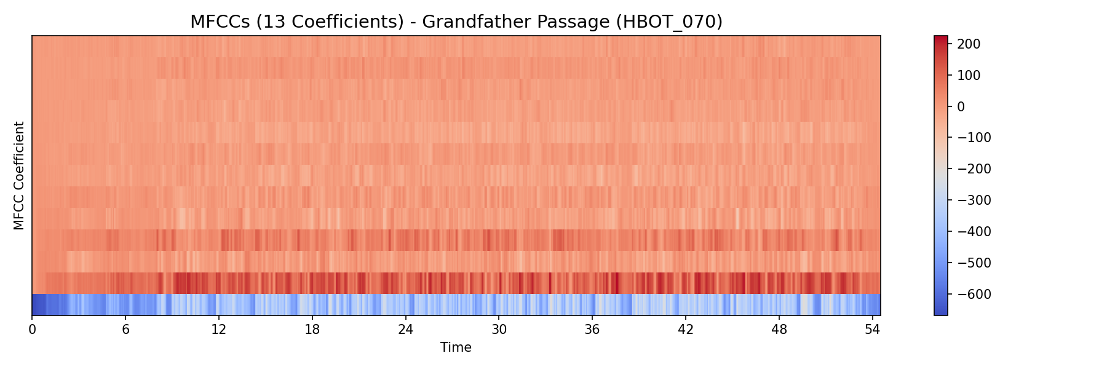
Figure 3: Mel-frequency cepstral coefficients over time. These capture "voice texture" and are key features for speech classification.

4. Pitch Contour (F0)
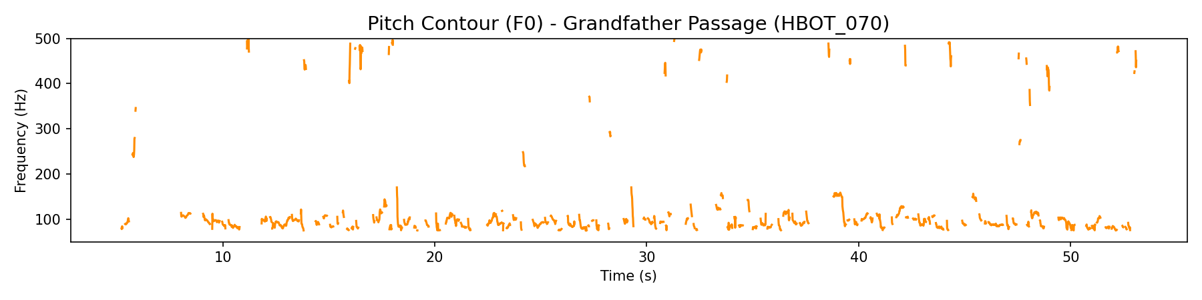
Figure 4: Fundamental frequency over time. Mean pitch ~120 Hz. Gaps indicate unvoiced segments. Note pitch instability (jitter = 0.031).

5. Feature Summary
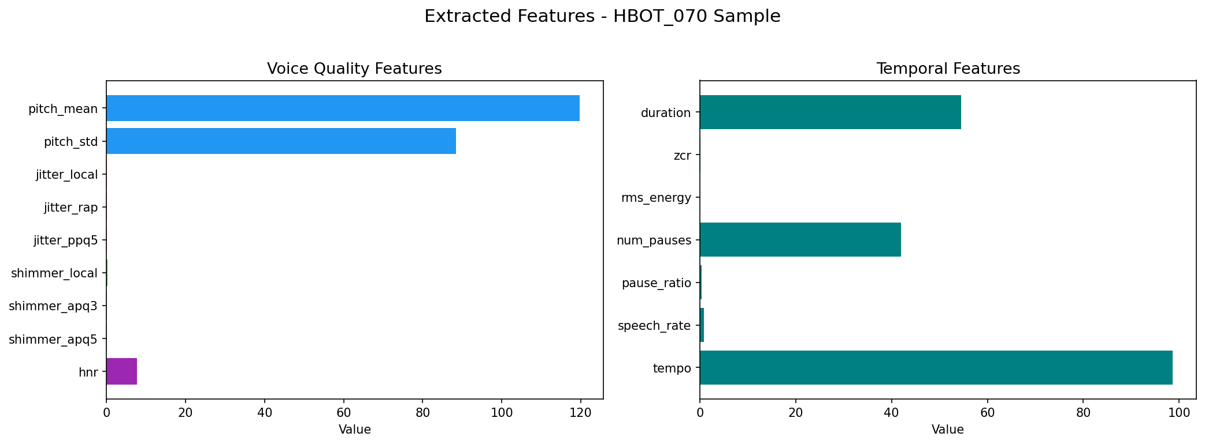
Figure 5: Bar chart of extracted voice quality features (left) and temporal features (right) for the HBOT_070 sample.

6. Pause Detection
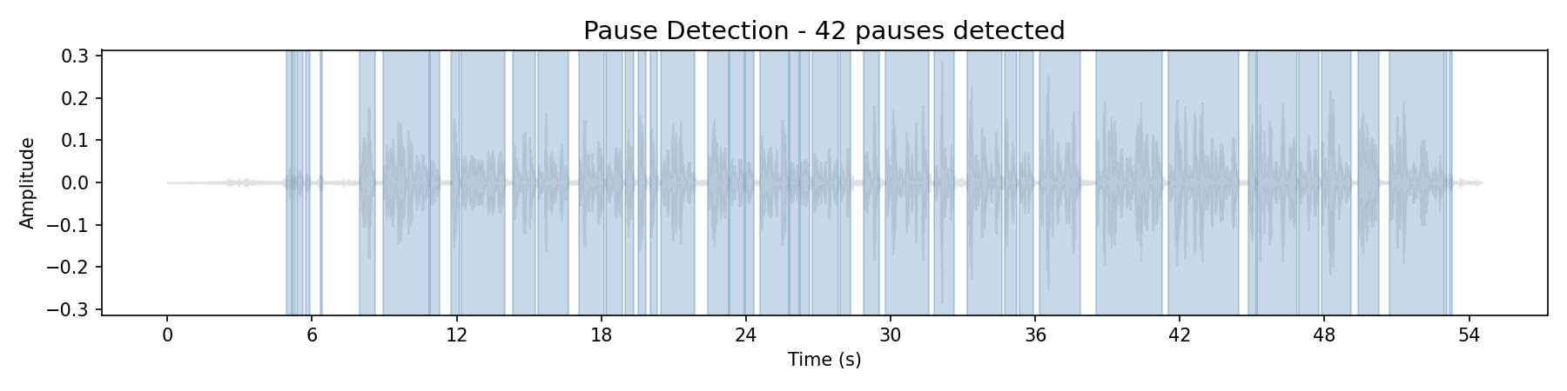
Figure 6: Blue shaded regions = detected speech segments. 42 pauses detected, pause ratio = 29.7% of total duration.

Code Architecture Overview
File | Purpose
feature_extraction_enhanced.py | 54-feature extraction engine (voice quality + spectral + temporal)
ml_training_pipeline.py | Training & evaluation pipeline (4 models, CV, metrics, plots)
inference_pipeline.py | Production inference (load model → predict PD/TBI)
PD_TBI_Classification_Notebook.ipynb | All-in-one Google Colab notebook
SCH_Deliverable_2_Report.md | This deliverable report (markdown source)
plot_*.png (6 files) | Visualization outputs from real audio analysis

4. Updated Implementation Roadmap

Core Component Completion
Milestone | Status | Date
Starter code (23 features) | Completed | Week 1
Enhanced feature extraction (54 features) | Completed | Week 2
ML training pipeline (4 models) | Completed | Week 3
Evaluation framework (CV, metrics, plots) | Completed | Week 3
Inference pipeline | Completed | Week 3
Colab notebook (all-in-one) | Completed | Week 3
Data collection (PD/TBI samples) | In Progress | Week 4
Full model training + evaluation | Planned | Week 4-5
Final model selection & report | Planned | Week 5

Technical Risks Identified
Risk | Severity | Mitigation
Small dataset (few PD/TBI samples) | High | Stratified K-fold CV, balanced class weights, data augmentation
Overfitting on limited data | High | Regularization (max_depth, C param), cross-validation
Audio quality variation | Medium | Standardize to 16kHz mono WAV; StandardScaler normalization
NaN/Inf in features | Medium | Replace with median values; skip corrupted files
Model generalizability | Medium | Reserve holdout set from different patients

Updated Timeline
Week | Tasks
Week 1 (Completed) | Environment setup, audio basics, run starter code
Week 2 (Completed) | Enhanced feature extraction (54 features), batch processing
Week 3 (Completed) | ML pipeline, training code, evaluation code, inference pipeline
Week 4 (Current) | Data collection, run full training with labeled data
Week 5 | Final model selection, performance benchmarking, submission

Appendix: Full Feature Reference (54 Features)

Voice Quality Features (15) – Parselmouth/Praat
# | Feature | Clinical Significance
1 | pitch_mean | Average fundamental frequency – gender/age marker
2 | pitch_std | Pitch variation – monotone speech detection (low in PD)
3 | pitch_min | Minimum pitch in utterance
4 | pitch_max | Maximum pitch in utterance
5 | jitter_local | Local pitch instability – strong PD indicator
6 | jitter_rap | Relative average perturbation – voice tremor
7 | jitter_ppq5 | 5-point pitch perturbation quotient
8 | shimmer_local | Local amplitude instability – weak voice
9 | shimmer_apq3 | 3-point amplitude perturbation
10 | shimmer_apq5 | 5-point amplitude perturbation
11 | hnr | Harmonics-to-noise ratio – breathiness/hoarseness
12 | formant_f1 | First formant – vowel openness
13 | formant_f2 | Second formant – tongue position
14 | formant_f3 | Third formant – lip rounding
15 | formant_f4 | Fourth formant – vocal tract length

Spectral Features (32) – Librosa
# | Feature | Description
16-28 | mfcc_1 to mfcc_13 | Mel-frequency cepstral coefficients – voice texture
29-41 | delta_mfcc_1 to delta_mfcc_13 | Rate of change of MFCCs – temporal dynamics
42 | spectral_centroid | Center of mass of spectrum (brightness)
43 | spectral_bandwidth | Frequency spread
44 | spectral_rolloff | Frequency below which 85% of energy lies
45 | spectral_flatness | Noise-like vs tone-like quality
46 | spectral_contrast | Peak-valley difference in spectrum
47 | chroma_mean | Pitch class energy distribution

Temporal Features (7) – Librosa
# | Feature | Description
48 | duration | Total audio length in seconds
49 | zcr | Zero crossing rate – noisiness indicator
50 | rms_energy | Root mean square energy – loudness
51 | num_pauses | Number of detected silences
52 | pause_ratio | Proportion of time spent in silence
53 | speech_rate | Speaking speed (segments per second)
54 | tempo | Estimated beat tempo

