Cross-Request Prefix Caching and the Cost of Short Forward Passes in On-Device LLM Classification
Devansh Gaur
University of Waterloo, Waterloo, ON, Canada
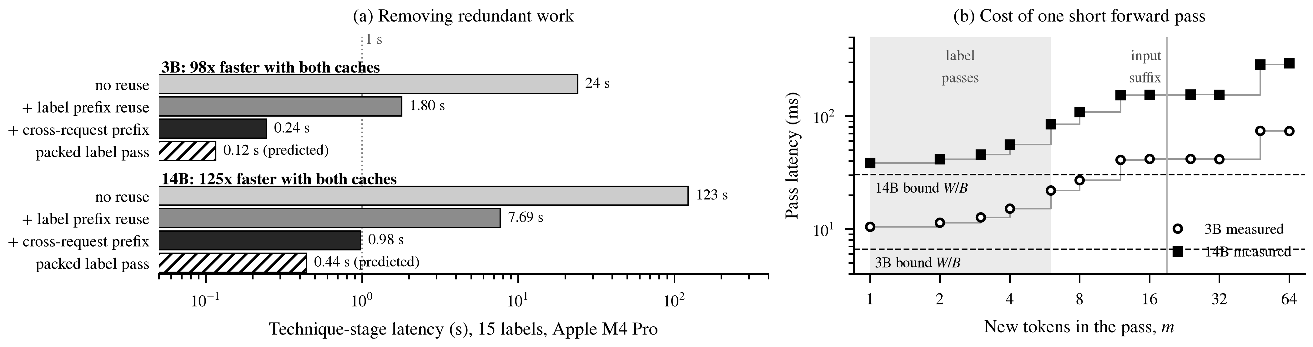
Fig. 1. (a) Latency of the 15-label technique stage as each source of repeated computation is removed (medians over 10 inputs; no-reuse over 3). The hatched bars are predicted from (b), not measured. (b) Measured latency of a single forward pass of m new tokens over a cached 1.4k-token prefix (median of 9). Dashed lines: the bandwidth bound of Eq. (3). Short passes do not sit on that bound; their cost rises in steps.

Abstract: A local language model used as a closed-set classifier spends most of its time repeating work it has already done. Here, about 99% of every prompt is identical across inputs, and 15 candidate labels are each scored against it. We remove the two redundancies in turn, reusing the prefix across labels and then across requests, and measure the effect on 3B and 14B models running on an Apple M4 Pro. A 14B classification falls from 14.1 s to 1.1 s with unchanged decisions. What remains is a series of forward passes of one to six tokens, and their cost does not follow the bandwidth roofline: an 8-token pass costs 2.8 times a 1-token pass, while every pass of 12 to 32 tokens costs the same. This step-shaped cost accounts for the residual latency to within 11% and predicts a further 2.2-fold gain from packing all labels into one pass.
Index Terms: Large language models, KV cache, prefix caching, on-device inference, roofline model.
I. Introduction
An instruction-tuned language model can classify text without generating any. The prompt holds the task definition, worked examples and the input, and the classifier asks how probable each candidate label is as the continuation [1]. The system examined here uses this method to name the persuasion technique in a passage of text, entirely on the user's laptop. Its prompt is 1446 tokens long. The passage being classified typically occupies about 19 of them.
That ratio is the subject of this paper. Everything before the passage is the same for every request, and everything before a label is the same for every label, yet a direct implementation recomputes both. The deployed 14B model needed 14 s per classification, which is why it was never made the default despite being 20 points more accurate than the 3B. We ask where those 14 s go, and how much of that time is necessary.
We show that caching the input-independent prefix across requests, on top of reuse across labels, cuts 14B latency 12.4-fold without changing a decision. We then measure the short passes that remain, find a step-shaped cost the roofline does not predict, and use it to explain why batching the labels barely helped and what would help more.
II. Related Work
Reusing attention state is established practice in LLM serving. PagedAttention [2] shares KV blocks between sequences, SGLang [3] keeps prefixes in a radix tree, Prompt Cache [4] precomputes the attention state of reusable prompt modules, and Hydragen [5] batches attention over a shared prefix. These systems target throughput across many users. Here there is one user on a laptop, the metric is single-request latency, and the shared prefix is known in advance.
III. Classification by Label Scoring
For input x and each label y ∈ 𝒴, the classifier computes the length-normalized log-likelihood
$s(y∣x)=\frac{1}{|y|}\sum_{t=1}^{|y|}{logp_{θ}(y_{t}∣x,y_{<t})}$ (1)
and returns the arg max, with a tempered softmax (τ=0.25) for confidence. A gate first scores yes and no for the question of whether the text is manipulative; only text that passes reaches the technique stage, which scores K=15 labels of 1 to 7 tokens (62 tokens in total). Both stages run Llama-3.2-3B-Instruct [6] or Qwen2.5-14B-Instruct [7] with 4-bit weights under MLX [8] on an Apple M4 Pro with 24 GB of unified memory and 273 GB/s of memory bandwidth (Table I).
TABLE I
Models and Prompt Composition
Model | L | H_{kv} | W (GB) | KiB/tok | Shared / total tok
Llama-3.2-3B | 28 | 8 | 1.81 | 112 | 1446 / 1465
Qwen2.5-14B | 48 | 8 | 8.31 | 192 | 1427 / 1446

IV. Removing Redundant Work
Across labels. Under a causal mask, the keys and values of the P prompt tokens do not depend on anything that follows them. The deployed scorer therefore prefills the prompt once, appends each label, reads its log-probabilities and trims the cache back to length P. Relative to K independent passes, the number of forwarded tokens falls by
$S(K)=\frac{K(P+\bar{ℓ})}{P+K(\bar{ℓ}−1)}$ (2)
where ℓ̄ is the mean label length. For P=1446 and K=15, Eq. (2) predicts 14.6×. On identical inputs, the measured ratios were 14.9× (3B) and 15.8× (14B). They exceed the prediction because Eq. (2) counts tokens, while each repeated prefill also pays attention cost that grows quadratically with P.
Across requests. Label reuse still prefills the full prompt for every request, and 98.7% of that prompt (98.5% for the gate) never changes. We prefill the shared part once at startup and keep its cache resident. Each request then forwards only its own suffix (the passage and the closing chat template), scores the labels, and trims the cache back to the shared length. Table II gives the result. Under this scheme the gate, whose labels are single tokens, reduces to one forward pass of about 19 tokens.
TABLE II
Median Latency per Stage (s), 10 Inputs
Stage | 3B base | 3B cached | 14B base | 14B cached
Gate, 2 labels | 1.37 | 0.042 | 6.39 | 0.154
Technique, 15 labels | 1.80 | 0.245 | 7.69 | 0.981
Both stages | 3.17 | 0.287 | 14.08 | 1.135
One-time prefill | n/a | 3.06 | n/a | 12.18
Base: label reuse only. Cached: plus the cross-request prefix cache.

The arg max agreed on all 10 inputs for both models and both stages. The largest score difference was 0.063 nats, which we attribute to half-precision accumulation order. Every decision was unchanged.
V. The Cost of a Short Pass
Once both redundancies are removed, the technique stage consists of one 19-token suffix pass followed by 14 label passes of 1 to 6 tokens. A pass over very few tokens must still read every weight once, which gives the familiar bandwidth bound [9], [10]:
$t_{pass}(m)≥\frac{W}{B}$ (3)
Eq. (3) gives 30.4 ms for the 14B and 6.6 ms for the 3B. Single-token passes measured 38.6 and 10.5 ms, which correspond to 79% and 63% of peak bandwidth. Beyond one token the roofline stops describing the data (Fig. 1b). Cost rises steeply between 1 and 12 tokens: an 8-token pass costs 2.8 times a 1-token pass. It then stays flat up to 32 tokens and doubles at 48. This pattern is consistent with a matrix-vector kernel at small m handing over to MLX's tiled matrix-matrix kernel, whose row tile is 32.
Summing the measured cost of each pass in the stage (interpolating m=5) predicts 239 ms for the 3B and 878 ms for the 14B, against 245 and 981 ms measured. The label passes therefore account for almost all of the residual time.
We expected that running all 15 labels as a single padded batch would help. It saved nothing on the 3B and 15% on the 14B. Padding turns 47 label tokens into 90 query rows, each attending over its own copy of the prefix. The staircase points to a better layout: all 47 label tokens packed into one sequence under a tree-shaped attention mask, as in tree-based speculative decoding [11]. That pass costs about t(48), giving a predicted 0.12 s (3B) and 0.44 s (14B). It is not yet implemented.
VI. Memory
Each token's cache entry occupies
$M_{tok}=2LH_{kv}d_{h}b$ (4)
bytes, for L layers, H_{kv} key-value heads of dimension d_{h} and b bytes per element. Both models use grouped-query attention [12] with H_{kv}=8, so the static caches for both stages occupy only 0.31 GB (3B) and 0.53 GB (14B). The batched experiment holds 15 copies of the prefix, 4.2 GB on the 14B; under multi-head attention (H_{kv}=40) the copies alone would need 21 GB and the total would exceed the machine (Fig. 2). The packed pass needs a single copy.
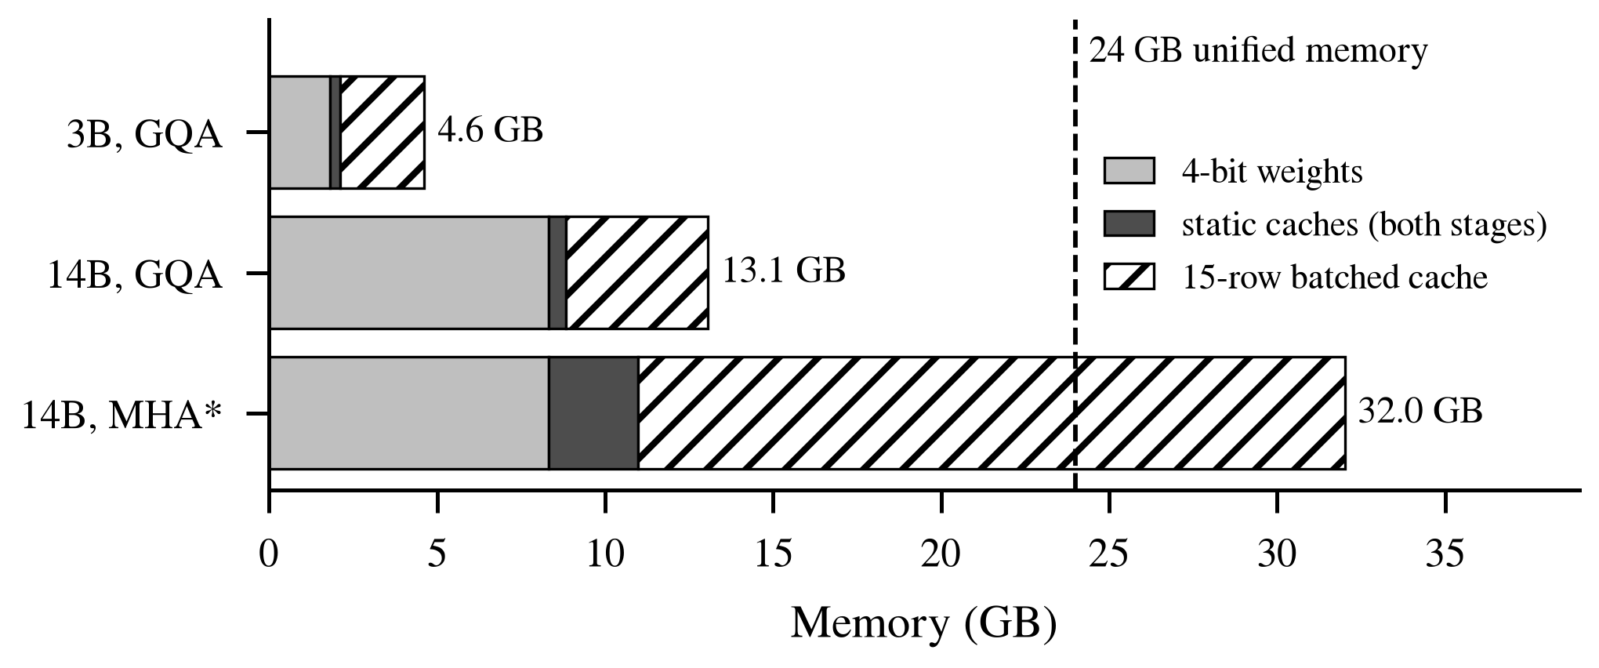
Fig. 2. Unified-memory budget. *MHA is a counterfactual 14B with H_{kv}=40; its weights are left unchanged for comparison.
VII. Consequences
With both caches, the 14B classifies in 1.14 s, compared with 3.2 s for the uncached 3B. On 300 externally labeled examples from public dark-pattern [13], logical-fallacy [14] and clickbait [15] corpora, the 14B with few-shot examples reached 82.3% top-1 accuracy (95% CI 77.6 to 86.2 [16]), against 62.7% for the 3B. Half of these examples were used to tune decision thresholds, so the numbers compare configurations rather than estimate field accuracy. The accuracy case for the larger model was already established. The latency case against it no longer holds.
Generation is the expensive alternative. The 14B decodes at 37 ms per token, so a whole cached classification costs about as much as 31 generated tokens. A distilled reasoning model [17] that reasons before labeling averaged 35 s, roughly 950 tokens, and was not more accurate.
VIII. Limitations and Conclusion
Latencies are medians over 10 inputs on one machine; the first call after a workload switch occasionally took up to 2.2 s. The packed pass is a prediction, and the benchmark covers five of the 14 techniques. Nearly all of a local LLM classifier's time goes to recomputing one prompt; once that is removed, the remainder is set by how the hardware treats very short passes.
References
[1] Z. Zhao, E. Wallace, S. Feng, D. Klein, and S. Singh, “Calibrate before use: Improving few-shot performance of language models,” in Proc. ICML, 2021.
[2] W. Kwon et al., “Efficient memory management for large language model serving with PagedAttention,” in Proc. SOSP, 2023.
[3] L. Zheng et al., “SGLang: Efficient execution of structured language model programs,” in Proc. NeurIPS, 2024.
[4] I. Gim et al., “Prompt Cache: Modular attention reuse for low-latency inference,” in Proc. MLSys, 2024.
[5] J. Juravsky et al., “Hydragen: High-throughput LLM inference with shared prefixes,” arXiv:2402.05099, 2024.
[6] A. Grattafiori et al., “The Llama 3 herd of models,” arXiv:2407.21783, 2024.
[7] Qwen Team, “Qwen2.5 technical report,” arXiv:2412.15115, 2024.
[8] A. Hannun et al., “MLX: Efficient and flexible machine learning on Apple silicon,” GitHub repository, ml-explore/mlx, 2023.
[9] R. Pope et al., “Efficiently scaling transformer inference,” in Proc. MLSys, 2023.
[10] S. Williams, A. Waterman, and D. Patterson, “Roofline: An insightful visual performance model for multicore architectures,” Commun. ACM, vol. 52, no. 4, pp. 65‑76, 2009.
[11] X. Miao et al., “SpecInfer: Accelerating large language model serving with tree-based speculative inference and verification,” in Proc. ASPLOS, 2024.
[12] J. Ainslie et al., “GQA: Training generalized multi-query transformer models from multi-head checkpoints,” in Proc. EMNLP, 2023.
[13] Y. Yada et al., “Dark patterns in e-commerce: A dataset and its baseline evaluations,” in Proc. IEEE BigData, 2022.
[14] Z. Jin et al., “Logical fallacy detection,” in Findings of EMNLP, 2022.
[15] A. Chakraborty, B. Paranjape, S. Kakarla, and N. Ganguly, “Stop clickbait: Detecting and preventing clickbaits in online news media,” in Proc. ASONAM, 2016.
[16] E. B. Wilson, “Probable inference, the law of succession, and statistical inference,” J. Amer. Statist. Assoc., vol. 22, no. 158, pp. 209‑212, 1927.
[17] DeepSeek-AI, “DeepSeek-R1: Incentivizing reasoning capability in LLMs via reinforcement learning,” arXiv:2501.12948, 2025.

