Litmus: KV-Cache Reuse and the Accuracy-Latency Frontier of On-Device Manipulation Detection
Devansh Gaur
University of Waterloo, Waterloo, ON, Canada
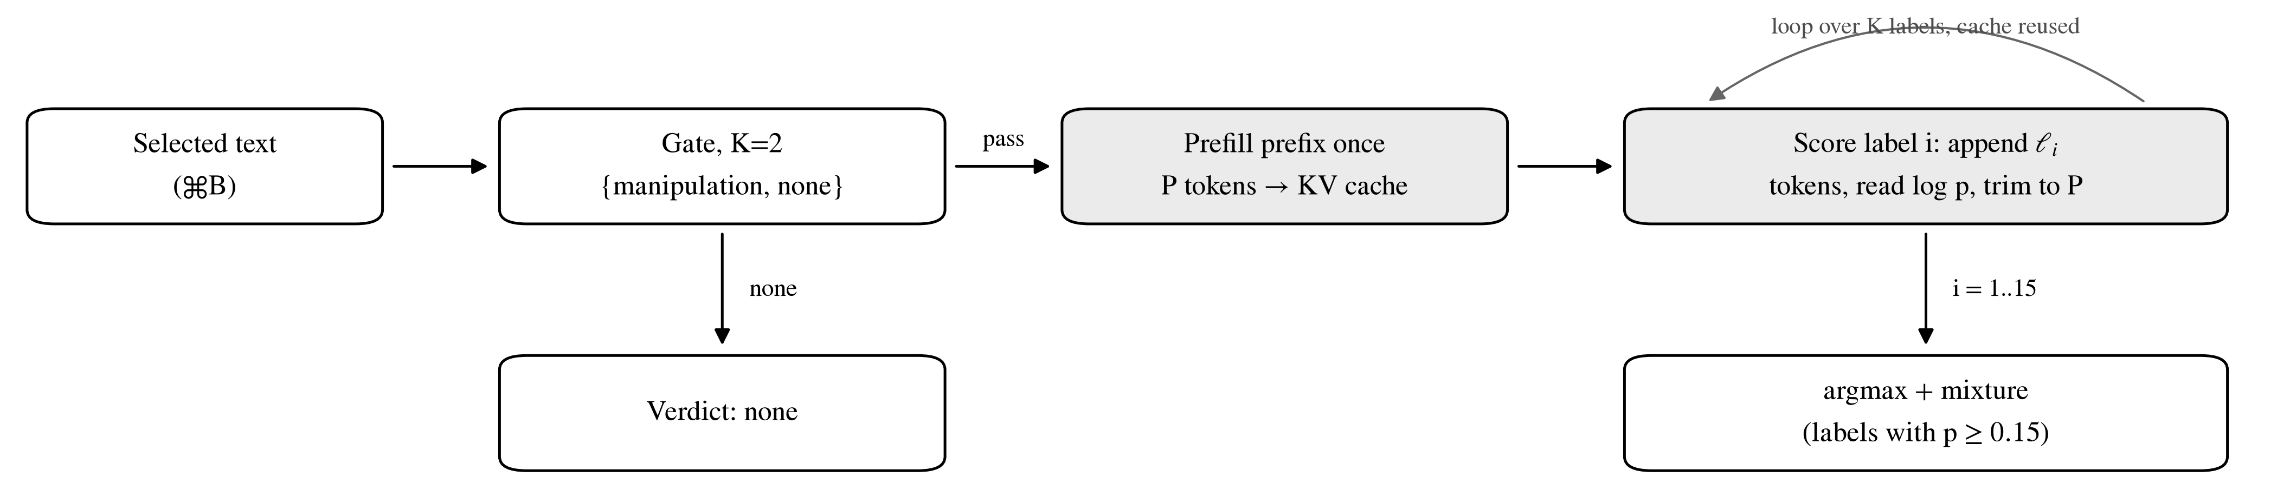
Fig. 1. Litmus inference path. A two-label gate rejects benign text. Text that passes is scored against 15 candidate labels; the shared prompt prefix is prefilled once into the KV cache (shaded), and each label is scored by appending its tokens and trimming the cache back to the prefix length P.

Abstract: Litmus is an on-device macOS utility that labels a selected passage with one of 14 persuasion techniques, or none, by scoring candidate labels under a local 4-bit large language model. No text is generated and no data leaves the device. This paper analyzes three inference effects that set the design: the key-value (KV) cache footprint under grouped-query attention, the computation saved by reusing the prefix KV state across labels, and the bandwidth bound on autoregressive decoding. On a 300-example external benchmark, top-1 accuracy rose from 62.7% (3B) to 82.3% (14B, few-shot), and prefix reuse cut median latency by a factor of 9.0.
Index Terms: Large language models, KV cache, grouped-query attention, on-device inference, roofline model.
I. Introduction
Litmus lets a user select any passage and press one shortcut (⌘B) to see the persuasion technique it applies. The selected text may be private, so inference runs entirely on the device, and the verdict must appear within about one second. An instruction-tuned large language model (LLM) is therefore used as a closed-set scorer rather than a generator. The cost of inference then depends on memory traffic and repeated computation, not on output length. This paper models both from each model's published configuration and measures the resulting accuracy-latency frontier for 3B, 8B and 14B models.
II. System Overview
A local server runs the model through Apple MLX [1] with 4-bit weights (Fig. 1). A gate first scores the labels manipulation and none; text classified as none exits immediately. Otherwise the technique stage scores K=15 labels: 14 techniques and none. The default model is Llama-3.2-3B-Instruct [2]; Llama-3.1-8B and Qwen2.5-14B [3] are selectable. All measurements used an Apple M4 Pro with 24 GB of unified memory.
III. Scoring as Constrained Decoding
For input x and each label y ∈ 𝒴, the scorer computes the length-normalized log-likelihood
$s(y∣x)=\frac{1}{|y|}\sum_{t=1}^{|y|}{logp_{θ}(y_{t}∣x,y_{<t})}$ (1)
Normalization by |y| removes the preference for short labels (1 to 7 tokens). A tempered softmax converts the scores into confidences,
$c_{i}=\frac{exp(s_{i}/τ)}{\sum_{j}{exp(s_{j}/τ)}}$ (2)
with τ=0.25. The verdict is the arg max, and every label with c_{i} ≥ 0.15 joins a mixture field.
IV. KV-Cache Memory
Each attention layer caches a key and a value vector for every processed token. The cache size per token is
$M_{tok}=2LH_{kv}d_{h}b$ (3)
with L layers, H_{kv} key-value heads, head dimension d_{h} and b bytes per element. Grouped-query attention (GQA) [4] shares each key-value head across H/H_{kv} query heads, which divides the cache by that factor relative to multi-head attention (MHA). Table I lists each checkpoint's configuration.
TABLE I
Model Configurations (4-bit Weights, fp16 KV Cache)
Model | L | H | H_{kv} | W (GB) | KiB/token
Llama-3.2-3B | 28 | 24 | 8 | 1.81 | 112
Llama-3.1-8B | 32 | 32 | 8 | 4.52 | 128
Qwen2.5-14B | 48 | 40 | 8 | 8.31 | 192

The 1446-token few-shot prompt occupies 271 MiB on the 14B, against 1.32 GiB under MHA (Fig. 2). Beside 8.31 GB of weights the cache is minor, and the 14B left about 44% of memory free. Capacity did not limit model choice; latency did.
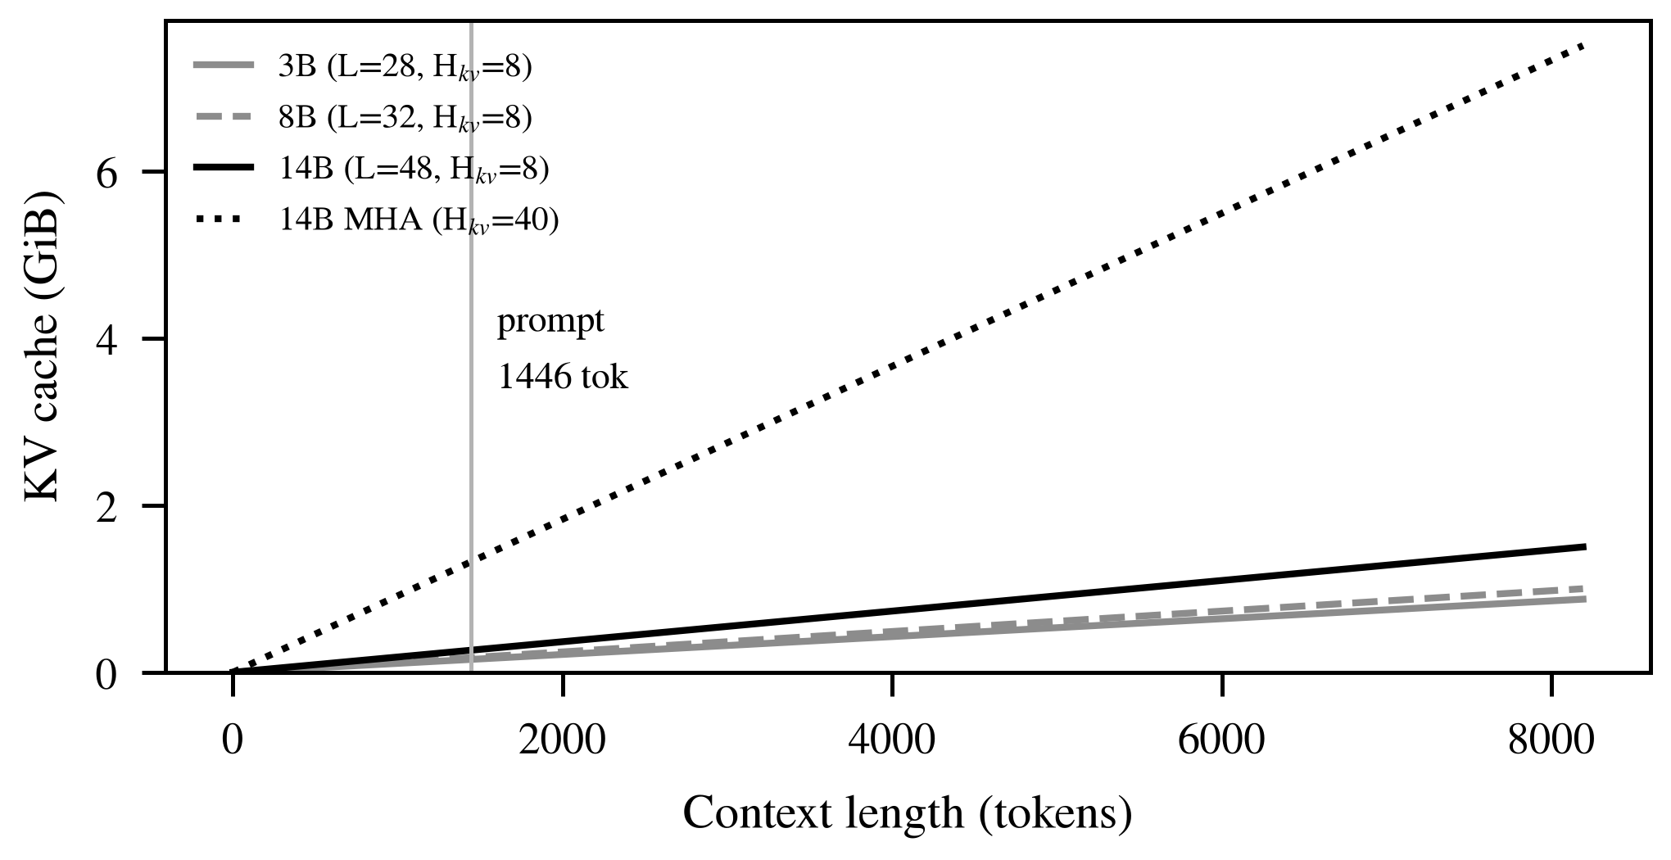
Fig. 2. KV-cache size from Eq. (3). Dotted: counterfactual 14B with MHA. Vertical line: deployed prompt length.
V. Prefix KV Reuse
All labels share a prefix of P tokens. Under a causal mask the prefix keys and values depend only on earlier prefix tokens, so they are identical for every label. The deployed scorer prefills the prefix once, appends label i, reads its log-probabilities, and trims the cache back to length P. The result is numerically identical to K independent passes, and forwarded tokens fall by
$S(K)=\frac{K(P+\bar{ℓ})}{P+K(\bar{ℓ}−1)}$ (4)
For P=1446 the scorer forwards 1493 tokens instead of 21,752 (14.6×). When measured (K=12, P ≈ 350), Eq. (4) predicted 11.0× and median latency fell from 4014 to 446 ms, a factor of 9.0 (Fig. 3). The gap reflects fixed per-call overhead and label tokens attending over the full prefix.
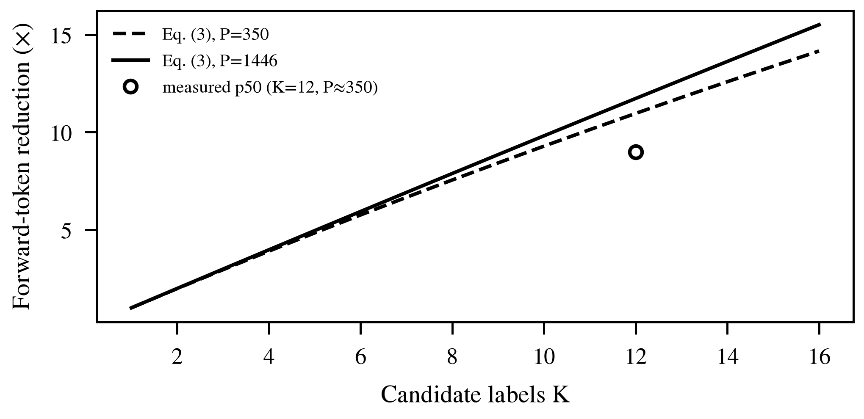
Fig. 3. Forward-token reduction from Eq. (4) against the measured median speedup.
VI. Prefill Versus Decode
Prefill processes all prompt tokens in parallel, reusing each weight read across many tokens, and is compute-bound [5]. Decode emits one token per step and must stream every weight per step, so in roofline terms [6] it is bandwidth-bound:
$t_{dec}(n)≥\frac{nW}{B}$ (5)
With W=8.31 GB and B=273 GB/s the 14B needs at least 30.4 ms per token (3B: 6.6 ms). Log-prob scoring decodes nothing. DeepSeek-R1-Distill-Qwen-14B [7] must decode a chain of thought first; it averaged 35 s per scan, which bounds its mean chain at about 1150 tokens (Fig. 4).
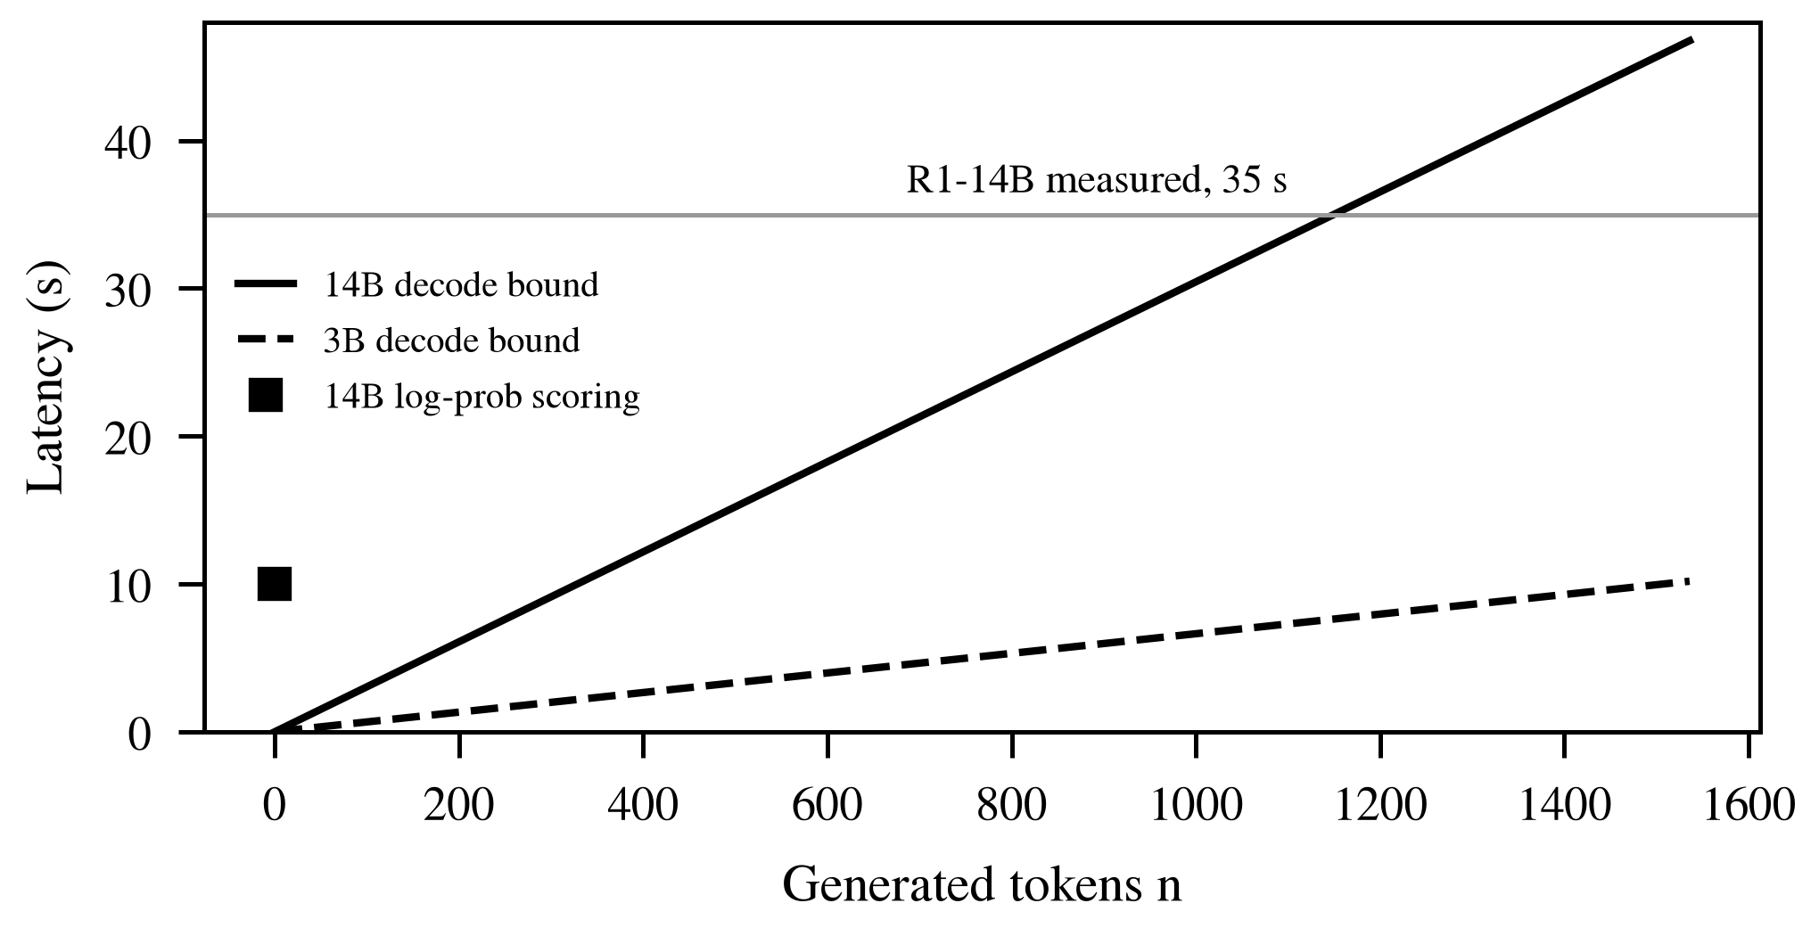
Fig. 4. Decode lower bound from Eq. (5). The 14B scorer sits at n=0.
VII. Experimental Results
The benchmark holds 300 externally labeled examples from dark-pattern, logical-fallacy and clickbait corpora, none authored or tuned on. Intervals are Wilson 95% [8]; MCC is reported because classes are imbalanced (Table II, Fig. 5).
TABLE II
Held-Out Benchmark (N=300), All On-Device
Configuration | Top-1 | 95% CI | MCC | Lat. (s)
3B, few-shot (shipped) | 62.7 | 57.1, 67.9 | 0.55 | 0.6
3B, gate fix, cleaned | 66.9 | 61.3, 72.1 | n/a | 0.6
8B, zero-shot | 69.0 | 63.6, 74.0 | 0.634 | 7.4
14B, zero-shot | 79.3 | 74.4, 83.5 | 0.752 | 12.7
14B, few-shot | 82.3 | 77.6, 86.2 | 0.787 | 7 to 13
14B, LoRA (partial)† | 78.9 | n/a | n/a | n/a
R1-Distill-14B‡ | 76.2 | 61.5, 86.5 | n/a | 35
N=290 after removing 10 mislabeled items. †123 of 300. ‡Balanced 42-example subset.

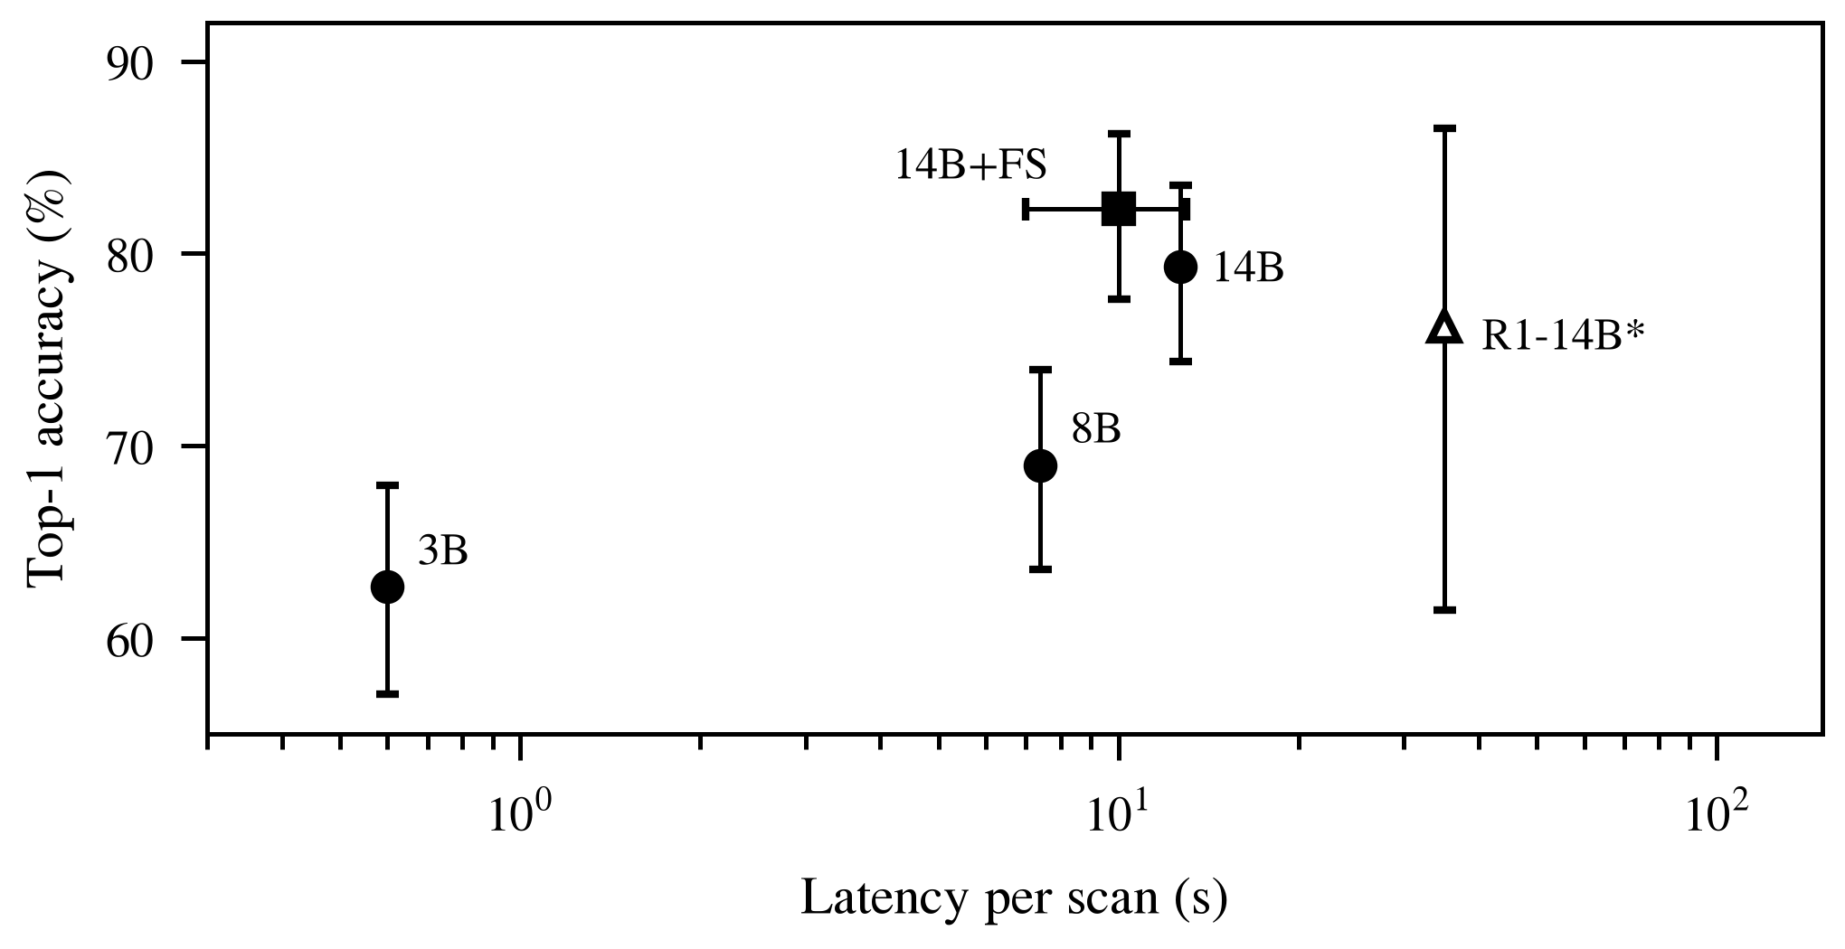
Fig. 5. Top-1 accuracy against latency. Hollow marker: balanced 42-example subset.
Accuracy rose monotonically with size (62.7%, 69.0%, 79.3%), so the 3B result is a capacity limit. Few-shot exemplars [9] added three points on the 14B but tied on the 3B. LoRA [10] on 503 imbalanced examples did not beat few-shot, and self-consistency voting [11] gained nothing once labels were cleaned. On the 3B, top-2 accuracy is 73.0% against 64.0% top-1, so most errors name a co-present technique.
VIII. Limitations and Conclusion
R1 used a balanced subset, the LoRA run was partial, and the benchmark covers six of 14 techniques. Likelihood scoring removes decode, prefix reuse removes most repeated prefill, and GQA keeps the cache small. The 3B serves the 0.6 s shortcut and the 14B an opt-in deep scan at 82.3%.
References
[1] A. Hannun et al., “MLX: Efficient and flexible machine learning on Apple silicon,” GitHub repository, ml-explore/mlx, 2023.
[2] A. Grattafiori et al., “The Llama 3 herd of models,” arXiv:2407.21783, 2024.
[3] Qwen Team, “Qwen2.5 technical report,” arXiv:2412.15115, 2024.
[4] J. Ainslie et al., “GQA: Training generalized multi-query transformer models from multi-head checkpoints,” in Proc. EMNLP, 2023.
[5] R. Pope et al., “Efficiently scaling transformer inference,” in Proc. MLSys, 2023.
[6] S. Williams, A. Waterman, and D. Patterson, “Roofline: An insightful visual performance model for multicore architectures,” Commun. ACM, vol. 52, no. 4, pp. 65‑76, 2009.
[7] DeepSeek-AI, “DeepSeek-R1: Incentivizing reasoning capability in LLMs via reinforcement learning,” arXiv:2501.12948, 2025.
[8] E. B. Wilson, “Probable inference, the law of succession, and statistical inference,” J. Amer. Statist. Assoc., vol. 22, no. 158, pp. 209‑212, 1927.
[9] T. Brown et al., “Language models are few-shot learners,” in Proc. NeurIPS, 2020.
[10] E. J. Hu et al., “LoRA: Low-rank adaptation of large language models,” in Proc. ICLR, 2022.
[11] X. Wang et al., “Self-consistency improves chain of thought reasoning in language models,” in Proc. ICLR, 2023.

