Real-Time Study Session & Collaboration Platform
Project Report
Integrated Mtech Artificial Intelligence

Submitted By
Name: Devansh Singhal
Reg. No.: 25MIM10120

Department of [Department Name]
SCAI [ SCHOOL OF COMPUTATION AND ARTIFICIAL INTELLIGENCE ]
Academic Session: 2026–2027

Project Website
FIND A MATE — Live Demo

CERTIFICATE
This is to certify that Devansh Singhal, bearing Registration No. 25MIM10120, has successfully completed the project entitled “FIND A MATE – Real-Time Study Session & Collaboration Platform” as a part of the academic requirements for the completion of SCAI during the academic session 2026–2027.
The project has been developed under my guidance and supervision. The work presented in this report is based on the student's effort and demonstrates the application of concepts related to web application development, real-time collaboration, session management, moderation, and AI-assisted learning.
Date: 12/09/2026

DECLARATION
I, Devansh Singhal, bearing Registration No. 25MIM10120, hereby declare that the project entitled “FIND A MATE – Real-Time Study Session & Collaboration Platform” is my original work carried out as part of the academic requirements for Integrated Mtech AI during the academic session 2026–2027.
I confirm that this project report has not been submitted previously, in whole or in part, to any other institution or university for the award of any degree or qualification.

ACKNOWLEDGEMENT
I would like to express my sincere gratitude to everyone who supported and guided me throughout the development of my project, “FIND A MATE – Real-Time Study Session & Collaboration Platform.”
I am also grateful to the SCHOOL OF COMPUTATION AND ARTIFICIAL INTELLIGENCE and VIT BHOPAL UNIVERSITY for providing the necessary resources and learning environment required to complete this project.
I would also like to thank my teachers and classmates for their valuable suggestions, feedback, and encouragement during the development and testing phases.
Finally, I would like to express my gratitude to my family and friends for their continuous encouragement and support, which motivated me to successfully complete this project.

ABSTRACT
FIND A MATE – Real-Time Study Session & Collaboration Platform is a web-based platform developed to provide students with a simple and interactive environment for finding study partners and participating in collaborative study sessions.
The platform enables users to create or join study sessions in real time, allowing students to communicate and collaborate with other learners. It supports anonymous participation, making it easier for students to interact without unnecessarily sharing personal information.
To maintain a productive and controlled study environment, FIND A MATE provides moderation features such as join approval, mute controls, participant management, and anti-spam protection. Users can communicate through real-time messaging and share supported media during study sessions.
An optional AI assistance feature is also incorporated to provide learning support and help students understand study-related topics more effectively.
The project demonstrates the practical application of modern web development concepts, real-time communication, session management, user interaction, moderation mechanisms, and AI-assisted learning. Overall, FIND A MATE aims to make collaborative studying more accessible, interactive, organized, and productive for students.

TABLE OF CONTENTS
S. No. | Chapter / Section | Page No.
 | Chapter 1 – Introduction | 7
 | Chapter 2 – Existing & Proposed System | 9
 | Chapter 3 – System Analysis | 11
 | Chapter 4 – System Design | 13
 | Chapter 5 – Implementation | 16
 | Chapter 6 – Testing | 19
 | Chapter 7 – Results & Screenshots | 22
 | Chapter 8 – Advantages & Limitations | 27
 | Chapter 9 – Future Scope | 28
 | Chapter 10 – Conclusion | 29
 | References | 30
 | Appendix | 31

CHAPTER 1 — INTRODUCTION

1.1 Background
In today's digital learning environment, students increasingly depend on online platforms for communication, knowledge sharing, and collaborative learning. However, finding suitable study partners and organizing focused study sessions can still be challenging.
FIND A MATE is developed as a real-time web platform that enables students to easily find study partners, create study sessions, and join sessions created by other learners. The platform focuses on making collaboration simple, interactive, and accessible.
It also provides features such as anonymous participation, real-time messaging, media sharing, join approval, mute controls, and anti-spam protection to create a controlled and productive study environment. Optional AI assistance further supports students during their learning activities.

1.2 Problem Statement
Students often face difficulty in finding suitable study partners and maintaining effective communication during collaborative study.
Existing general-purpose communication platforms may not provide features specifically designed for student study sessions, such as controlled session access, participant moderation, anonymous participation, and anti-spam mechanisms.
Therefore, there is a need for a platform that provides students with a simple, real-time, and moderated environment for finding study partners and collaborating online.

1.3 Motivation
The main motivation behind developing FIND A MATE is to make collaborative learning easier for students.
The project aims to provide a platform where students can quickly connect with other learners, participate in study sessions, communicate in real time, and share useful resources without unnecessary complexity.
The inclusion of moderation features and optional AI assistance further improves the overall learning and collaboration experience.

1.4 Objectives
The major objectives of the project are:
- To provide a platform for finding suitable study partners.
- To enable students to create and join study sessions.
- To support real-time communication and collaboration.
- To allow anonymous participation.
- To provide session moderation features.
- To implement join approval and mute controls.
- To reduce unwanted communication through anti-spam protection.
- To support media sharing.
- To provide optional AI-based learning assistance.
- To create a productive and interactive study environment.

1.5 Scope of the Project
FIND A MATE is designed primarily for students who want to collaborate with other learners through online study sessions.
The platform can be used for:
- Individual and group study sessions.
- Finding study partners.
- Real-time academic discussions.
- Sharing study-related messages and media.
- Managing participants through moderation.
- Receiving optional AI-based learning assistance.
In the future, the platform can be extended with features such as subject-based matching, scheduled sessions, notifications, voice/video communication, AI-powered recommendations, progress tracking, and mobile application support.

CHAPTER 2 — EXISTING & PROPOSED SYSTEM

2.1 Existing System
Students currently use general-purpose platforms such as messaging applications, social media platforms, and online meeting tools for study-related communication. These platforms allow users to communicate and share information, but they are not specifically designed for finding study partners and managing collaborative study sessions.
In many cases, students need to manually find suitable study partners and create separate communication groups. General platforms may also provide limited control over anonymous participation, session access, moderation, and spam prevention.

2.2 Limitations of Existing System
The major limitations of existing approaches are:
- Difficulty in finding suitable study partners.
- Lack of dedicated study-session functionality.
- Limited anonymous participation.
- Limited participant moderation.
- No integrated join-approval mechanism for study sessions.
- Unwanted messages and spam can affect communication.
- Study resources and conversations may be scattered across different platforms.
- AI-based learning assistance may not be integrated into the study environment.

2.3 Proposed System
FIND A MATE is proposed as a dedicated real-time platform for student collaboration and study-partner discovery.
The system allows students to create or join study sessions and interact with other participants in real time. It combines communication, session management, moderation, media sharing, anti-spam protection, and optional AI assistance within a single platform.
The proposed system provides a more organized and student-focused environment for collaborative learning.

2.4 Advantages of Proposed System
The proposed system provides the following advantages:
- Easy study-partner discovery.
- Quick creation and joining of study sessions.
- Real-time communication.
- Anonymous participation.
- Controlled session access through join approval.
- Participant moderation using mute controls.
- Anti-spam protection.
- Media sharing for collaborative learning.
- Optional AI-powered learning assistance.
- Centralized platform for study collaboration.

CHAPTER 3 — SYSTEM ANALYSIS

3.1 Functional Requirements
The system should provide the following major functionalities:
- Users can create study sessions.
- Users can browse and join available sessions.
- Users can participate anonymously.
- Users can communicate through real-time messaging.
- Users can share supported media.
- Session hosts can approve or reject join requests.
- Hosts/moderators can mute participants.
- The system should provide anti-spam protection.
- Users can access optional AI-based learning assistance.
- The system should maintain and manage active study sessions.

3.2 Non-Functional Requirements
The system should satisfy the following requirements:
- Usability: The interface should be simple and easy to understand.
- Performance: Real-time interactions should respond quickly.
- Reliability: Sessions and communication should work consistently.
- Security: User and session information should be handled securely.
- Scalability: The platform should be capable of supporting multiple study sessions.
- Responsiveness: The interface should work across different screen sizes.
- Maintainability: The system should be easy to update and improve.

3.3 Hardware Requirements
The project does not require specialized hardware.
Requirement | Minimum
Processor | Dual-Core Processor
RAM | 4 GB or above
Storage | 500 MB+ available space
Internet | Stable Internet Connection
Display | 1280 × 720 or above

3.4 Software Requirements
Requirement | Details
Operating System | Windows / Linux / macOS
Browser | Chrome / Edge / Firefox
Development Environment | Replit / Local Development Environment
Internet | Required
AI Service | OpenAI API (if AI feature is enabled)

3.5 Feasibility Analysis

Technical Feasibility
The project can be developed and deployed using commonly available web-development technologies and cloud-based development platforms. The required infrastructure is accessible and does not require specialized hardware.

Economic Feasibility
The project can be developed with relatively low infrastructure costs by using available development and cloud services. Basic functionality can be operated with minimal resources.

Operational Feasibility
The platform is designed with a simple user workflow, making it easy for students to create, join, and participate in study sessions without extensive technical knowledge.

CHAPTER 4 — SYSTEM DESIGN

4.1 System Architecture
The architecture of FIND A MATE consists of different components working together to provide a real-time collaborative study environment.
The major components are:
- User Interface: Provides pages and controls through which users interact with the platform.
- Session Management: Handles creation, joining, and management of study sessions.
- Real-Time Communication: Enables participants to exchange messages and collaborate during sessions.
- Moderation Module: Provides join approval, mute, participant management, and anti-spam functionality.
- Media Sharing: Allows participants to share supported media during sessions.
- AI Assistance: Provides optional AI-based learning support.
- Backend Services: Handles application logic, session information, communication, and other requests.

System Architecture Flow

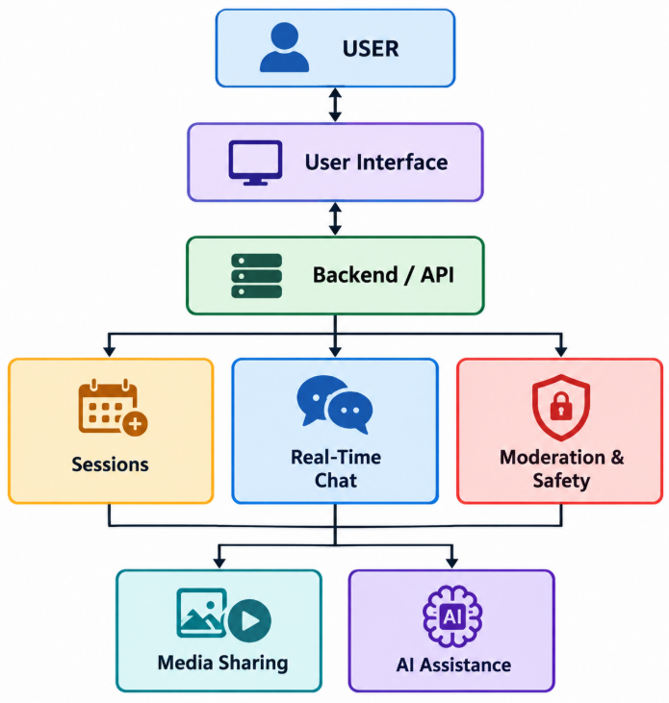

4.2 System Workflow
The overall working process of the system is:
Start
↓
Open FIND A MATE
↓
Create or Join Study Session
↓
Join Request / Session Access
↓
Session Host Approval
↓
Enter Study Session
↓
Real-Time Communication
↓
Message / Media Sharing
↓
Moderation & Anti-Spam
↓
Optional AI Assistance
↓
Collaborative Learning
↓
End Session

4.3 User Flow
The user flow of FIND A MATE can be represented as:
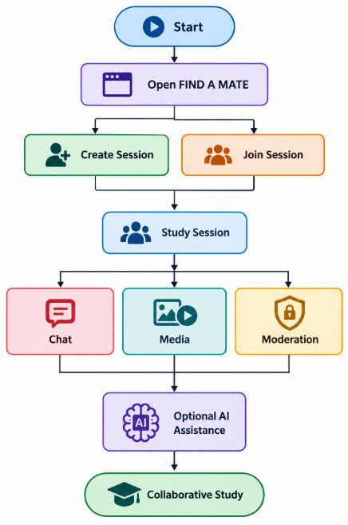

4.4 Module Description

1. User Management Module
Handles user participation and supports anonymous interaction within the platform.

2. Study Session Module
Allows users to create, discover, join, and manage study sessions.

3. Real-Time Communication Module
Provides real-time messaging and interaction between participants in a study session.

4. Moderation Module
Provides session hosts with controls such as join approval, participant management, and mute functionality.

5. Media Sharing Module
Allows users to share supported media during collaborative study sessions.

6. Anti-Spam Module
Helps control excessive or unwanted messages and maintains a productive communication environment.

7. AI Assistance Module
Provides optional AI-based learning support for students during their study activities.

CHAPTER 5 — IMPLEMENTATION

5.1 Introduction
The FIND A MATE platform was implemented as a web-based application focused on real-time student collaboration. The implementation combines study-session management, real-time communication, moderation, media sharing, anti-spam functionality, and optional AI assistance.
The application is designed with a simple and interactive interface so that students can easily create or join study sessions and collaborate with other participants.

5.2 User Interface Implementation
The user interface provides the main interaction point between students and the platform.
The interface allows users to:
- Access the FIND A MATE platform.
- Create or join study sessions.
- View available sessions.
- Participate in active study rooms.
- Send messages and share supported media.
- Access available moderation controls.
- Use optional AI assistance.
The interface is designed to be simple, responsive, and easy to navigate.

5.3 Study Session Implementation
The study-session module manages the creation and participation of study sessions.
A user can create a session and allow other students to request access. Users can also browse available sessions and join a suitable session.

The general process is:
Create Session
↓
Session Becomes Available
↓
Student Requests to Join
↓
Host Reviews Request
↓
Approve / Reject
↓
Student Enters Session

5.4 Real-Time Communication
Real-time communication enables participants to interact during an active study session.
The messaging functionality allows users to:
- Send study-related messages.
- Receive messages in real time.
- Communicate with multiple participants.
- Discuss academic topics.
- Collaborate during an active session.
This functionality helps students communicate without depending on separate messaging platforms.

5.5 Moderation Implementation
The moderation system helps session hosts maintain a controlled and productive environment.
Major moderation features include:
- Join Approval: Hosts can approve or reject requests.
- Mute Control: Hosts/moderators can mute participants when required.
- Participant Management: Session participation can be managed by authorized users.
- Anti-Spam Protection: Excessive or unwanted communication can be controlled.
These features help maintain a focused study environment.

5.6 Media Sharing
The platform supports sharing of supported media during study sessions.
Media sharing can be useful for:
- Sharing study resources.
- Discussing visual information.
- Sharing educational material.
- Collaborating on study-related content.
This feature makes the platform more suitable for collaborative learning.

5.7 Anti-Spam Implementation
Anti-spam mechanisms are implemented to reduce unwanted or excessive communication within study sessions.
The purpose of this functionality is to:
- Reduce message flooding.
- Maintain focused communication.
- Prevent misuse of the chat functionality.
- Improve the overall user experience.

5.8 AI Assistance
FIND A MATE includes an optional AI assistance feature to provide additional learning support.
Students can use AI assistance for study-related activities such as:
- Understanding concepts.
- Asking academic questions.
- Getting explanations.
- Supporting the learning process.
The AI feature is optional, allowing users to use the core study-session functionality without depending on AI.

5.9 Overall Implementation Flow
FIND A MATE
↓
User Interface
↓
Create / Join Session
↓
Session Management
↓
┌─────────┼─────────┐
↓ ↓ ↓
Chat Media Moderation
│ │ │
└─────────┼─────────┘
↓
Collaborative Study
↓
Optional AI Support

CHAPTER 6 — TESTING

6.1 Introduction
Testing is an important phase of the development of FIND A MATE. It was performed to verify that the major features of the platform work correctly and provide the expected user experience.
The testing focused on session management, real-time communication, moderation, media sharing, anti-spam functionality, and optional AI assistance.

6.2 Testing Methodology
The project was tested using functional and user-interface testing approaches.
The major testing areas were:
- User interface and navigation
- Creating study sessions
- Joining study sessions
- Join approval
- Real-time messaging
- Media sharing
- Mute and moderation controls
- Anti-spam protection
- AI assistance
- Session management

6.3 Test Cases
Test Case | Test Description | Expected Result | Status
TC-01 | Open the website | Website loads successfully | Pass
TC-02 | Create a study session | New session is created | Pass
TC-03 | Join an available session | User can request/join session | Pass
TC-04 | Approve join request | Approved user enters session | Pass
TC-05 | Reject join request | User is prevented from entering | Pass
TC-06 | Send a message | Message appears in the session chat | Pass
TC-07 | Share supported media | Media is shared successfully | Pass
TC-08 | Mute a participant | Selected participant is muted | Pass
TC-09 | Test anti-spam | Excessive/unwanted messages are controlled | Pass
TC-10 | Use AI assistance | AI provides learning support | Fail / Pending

6.4 Functional Testing
Functional testing was performed to verify that each major feature performs its intended operation.
The following functionalities were checked:
Session Management:
Creation and joining of study sessions were tested.
Communication:
Real-time messaging between participants was tested.
Moderation:
Join approval, participant management, and mute functionality were tested.
Media Sharing:
Supported media-sharing functionality was tested within study sessions.
Anti-Spam:
The system was tested against excessive or unwanted messaging.
AI Assistance:
The optional AI feature was tested for providing study-related assistance.

6.5 User Interface Testing
The user interface was tested to ensure that:
- Navigation works correctly.
- Buttons and controls respond properly.
- Session-related pages load correctly.
- Chat functionality is accessible.
- The interface is easy to understand.
- Important errors and states are handled appropriately.

6.6 Testing Results
The testing process confirmed that the major functionalities of FIND A MATE operate as intended. The platform successfully supports study-session creation and participation along with real-time communication and moderation features.
The AI assistance module is currently under development and requires further configuration and testing. The remaining core functionalities of the platform were tested successfully.
The testing also helped identify and resolve issues related to user interaction, session management, and real-time functionality.

CHAPTER 7 — RESULTS & SCREENSHOTS

7.1 Introduction
After implementation and testing, the FIND A MATE platform was deployed as a web application. The developed system provides students with a platform to create or join study sessions and collaborate with other participants.
The major implemented features were tested and the results were documented through screenshots of the application.

7.2 Home Page
The home page provides the main entry point to the FIND A MATE platform.
It introduces the purpose of the platform and allows users to proceed toward creating or joining study sessions.
Figure 7.1: FIND A MATE Home Page
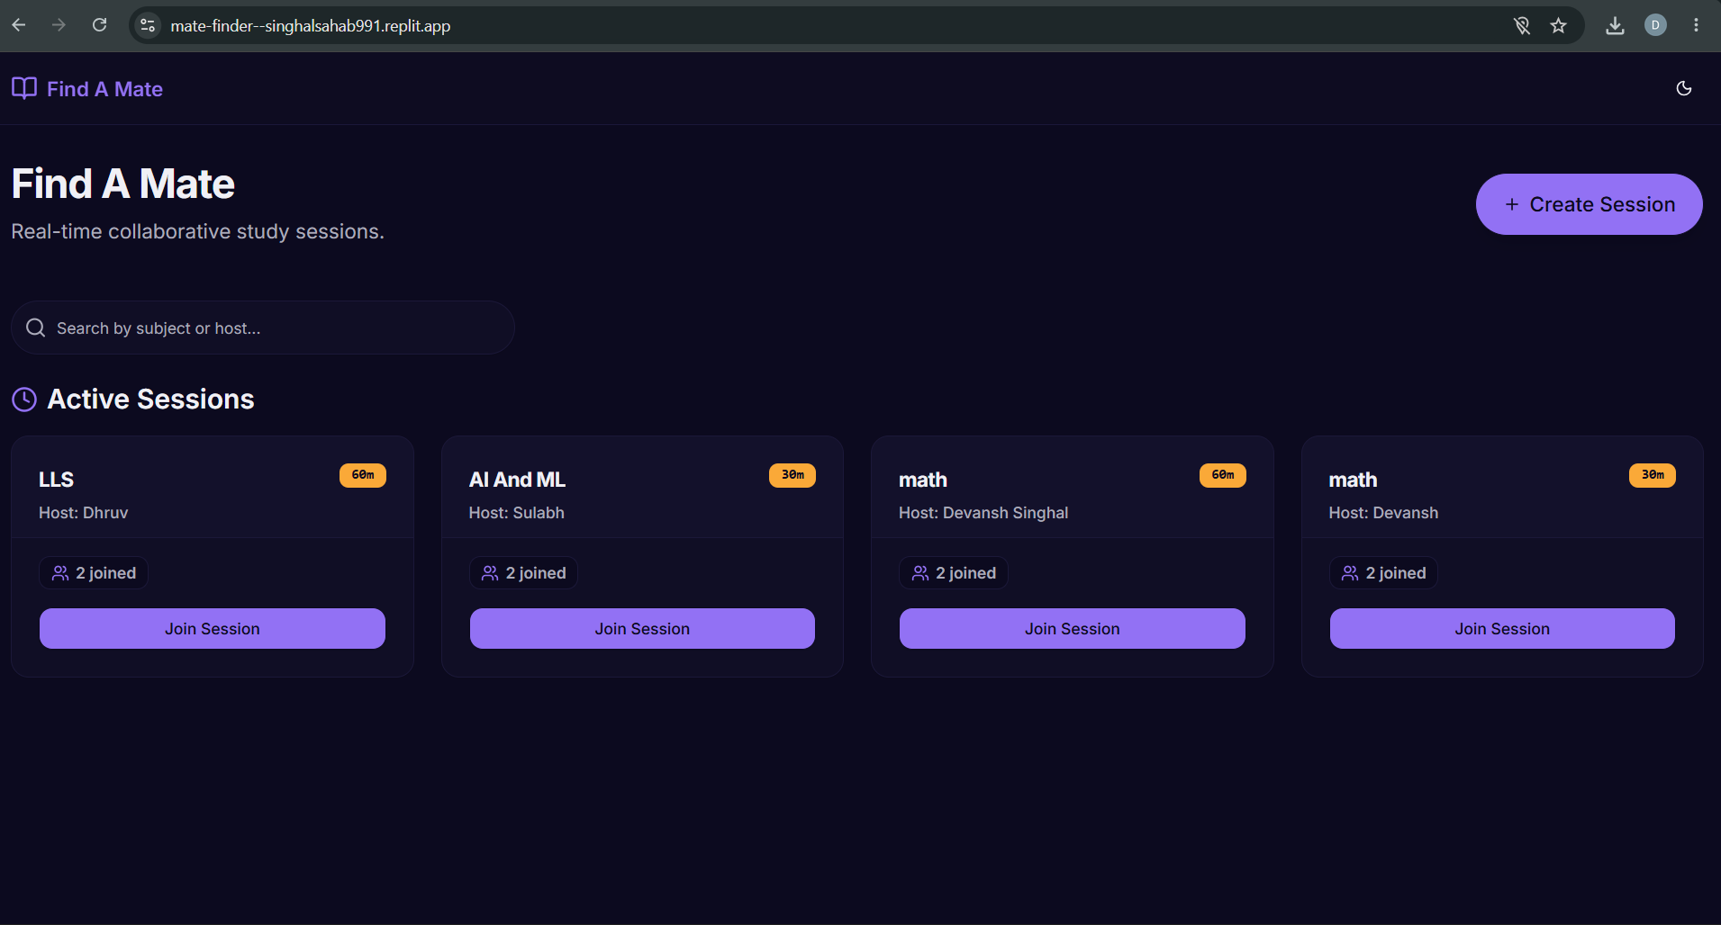

7.3 Create / Join Study Session
The platform provides options for users to create a new study session or join an existing session.
Figure 7.2: Create / Join Study Session
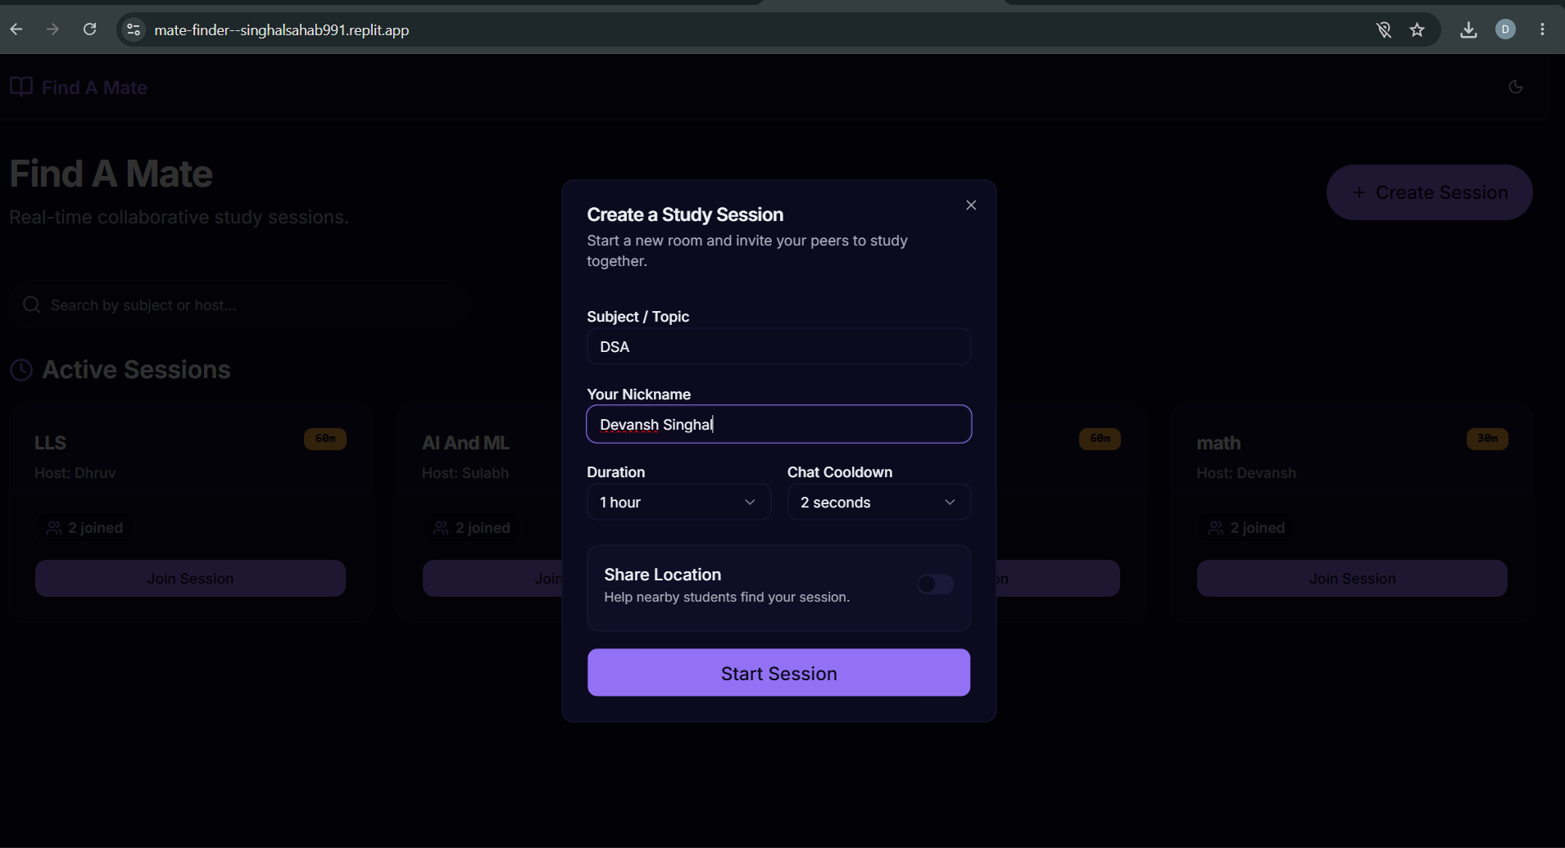

7.4 Study Session
After joining a session, participants can interact and collaborate in the study environment.
The session provides access to communication and other available collaboration features.
Figure 7.3: Study Session Interface
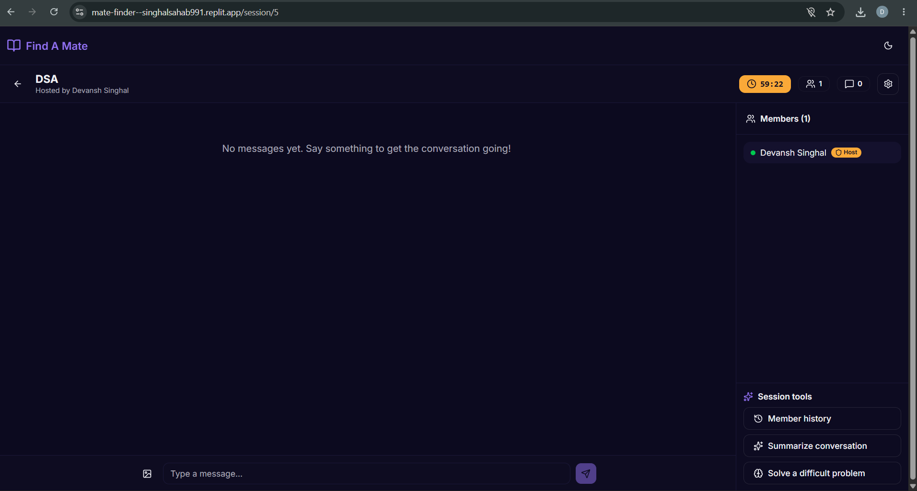

7.5 Real-Time Chat
The real-time chat functionality allows participants to communicate with other members of the study session.
Figure 7.4: Real-Time Chat
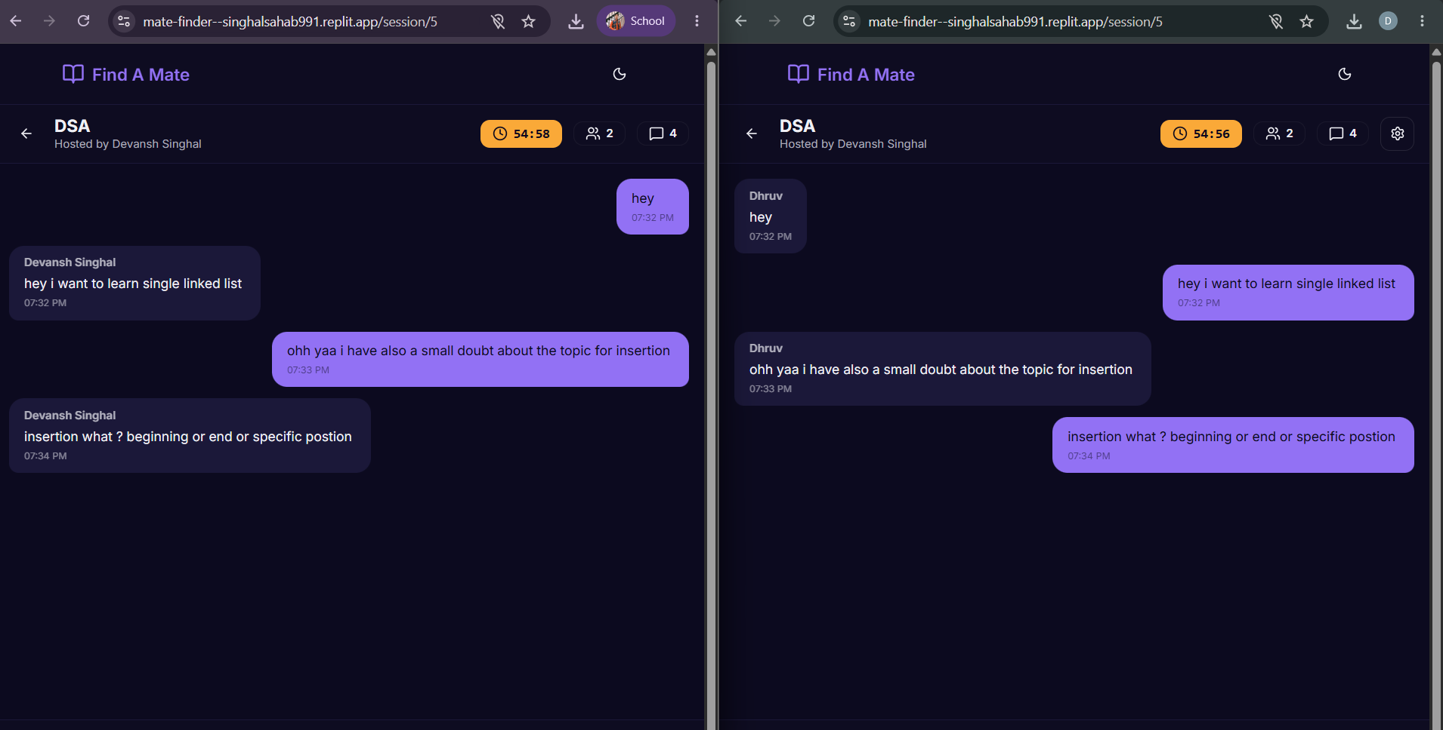

7.6 Moderation Features
The platform provides moderation features that help session hosts manage participants and maintain a productive environment.
These include:
- Join approval
- Mute controls
- Participant management
- Anti-spam protection
Figure 7.5: Moderation Features
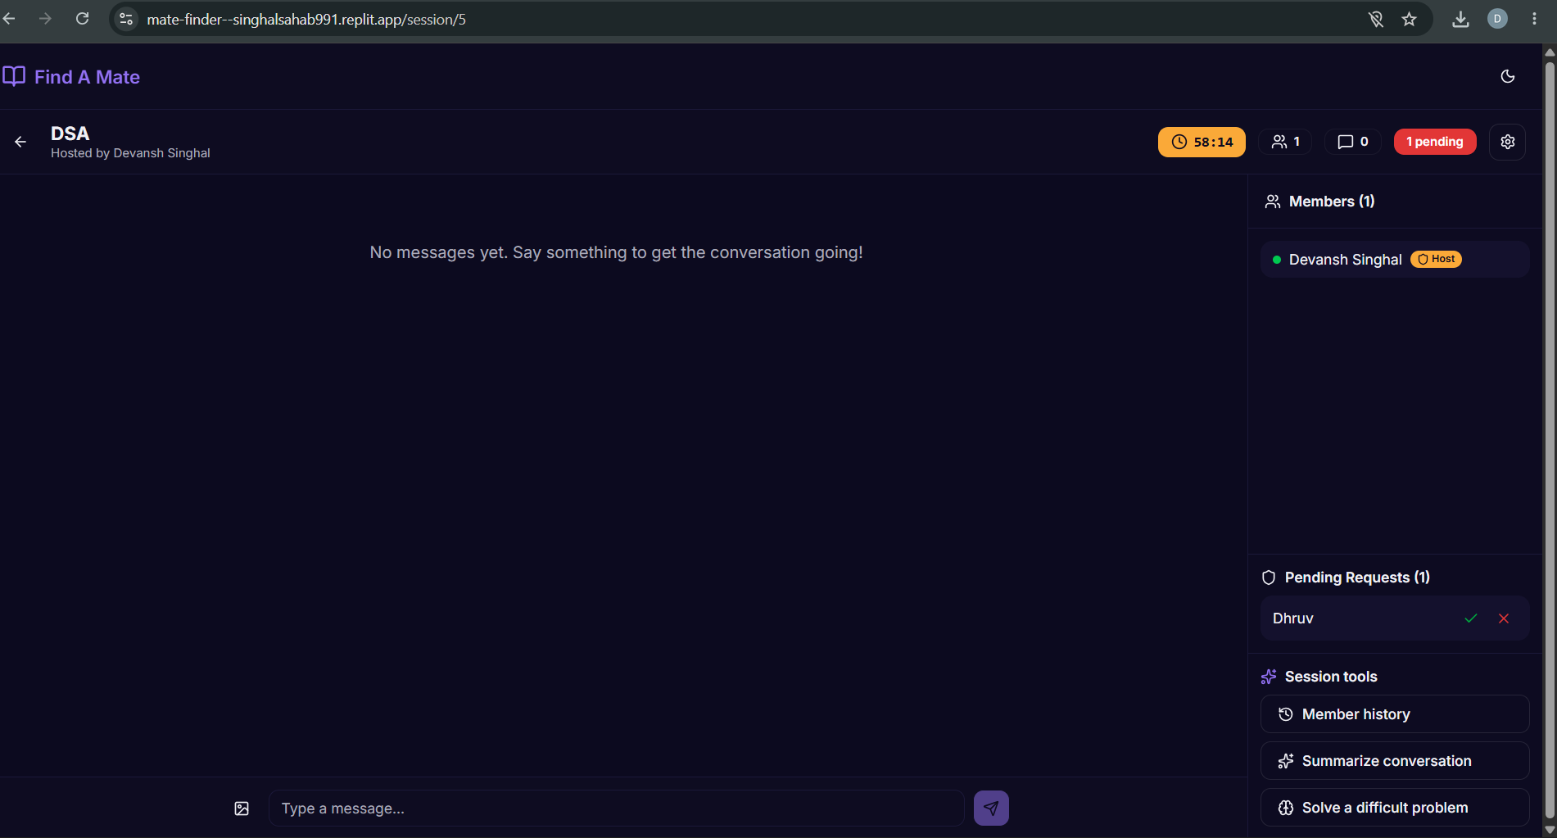

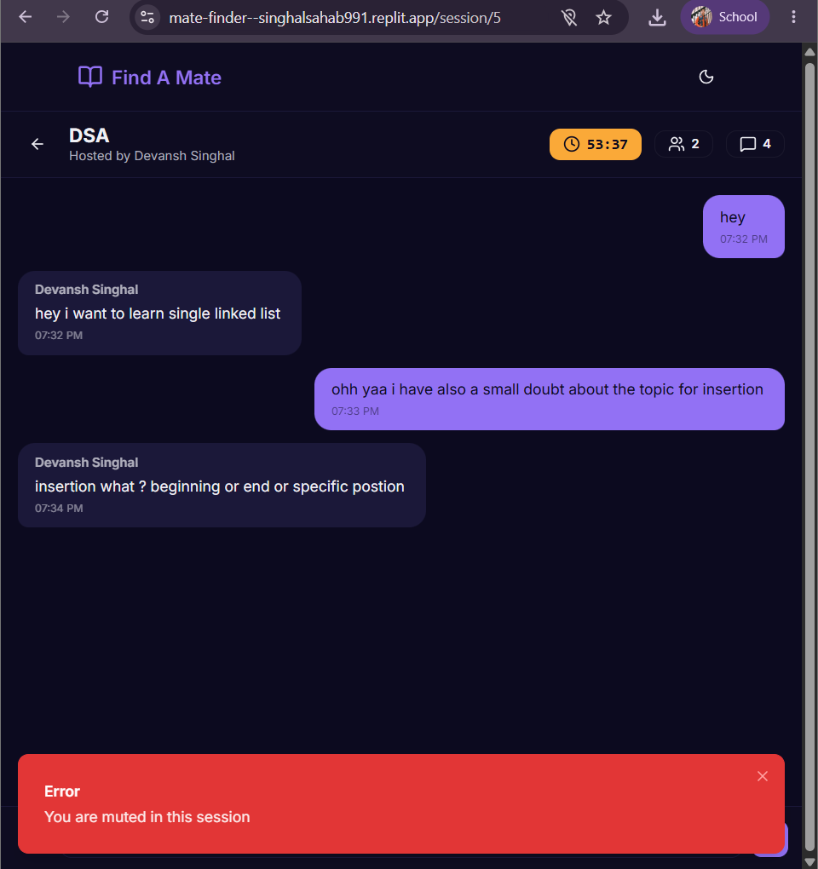

7.7 Media Sharing
Participants can share supported media within the study session for collaborative learning and discussion.
Figure 7.6: Media Sharing
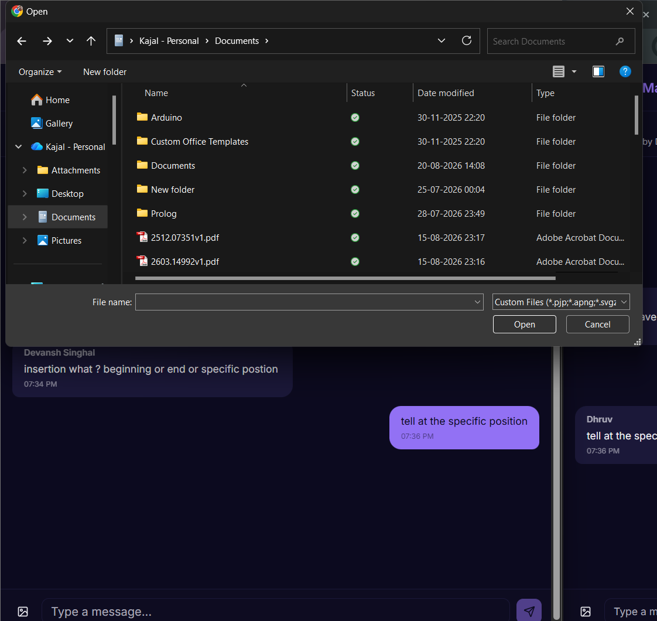

7.8 AI Assistance
The platform includes an optional AI assistance feature intended to provide learning support.
Current Status: The AI assistance feature is currently under development / pending configuration and was not marked as successfully tested in the testing phase.
Figure 7.7: AI Assistance Interface
It is not avaliable now , due to some inconvinence it is not working now but it will work after some time

CHAPTER 8 — ADVANTAGES & LIMITATIONS

8.1 Advantages
The major advantages of FIND A MATE are:
- Easy Study Partner Discovery: Helps students find suitable study partners.
- Real-Time Collaboration: Enables students to communicate and collaborate during active sessions.
- Simple Session Management: Users can easily create and join study sessions.
- Anonymous Participation: Allows users to participate without unnecessarily revealing personal information.
- Moderation: Hosts can manage participants using join approval and mute controls.
- Anti-Spam Protection: Helps maintain a clean and focused communication environment.
- Media Sharing: Supports sharing of useful study-related media.
- Centralized Platform: Combines study sessions and collaboration in one place.
- Optional AI Assistance: Provides additional support for learning when configured and available.

8.2 Limitations
Although FIND A MATE provides several useful features, the current version has some limitations:
- The platform requires a stable internet connection for real-time functionality.
- The quality of collaboration depends on the number of active participants.
- Anonymous participation may provide limited information about other users.
- Moderation features depend on proper use by session hosts.
- Media sharing may be subject to supported formats and platform limitations.
- The AI assistance module is currently under development/configuration and is not fully operational.
- The current version may require further testing with a larger number of simultaneous users.

CHAPTER 9 — FUTURE SCOPE

9.1 Future Enhancements
The current version of FIND A MATE provides the basic foundation for real-time student collaboration. The platform can be further enhanced with the following features:
- Subject-Based Matching: Match students according to their subjects and study interests.
- Smart Study Recommendations: Recommend suitable study sessions or study partners.
- AI-Powered Learning: Improve the AI assistant to provide explanations, summaries, quizzes, and study guidance.
- Scheduled Sessions: Allow students to schedule study sessions for a specific date and time.
- Notifications: Provide notifications for new join requests, messages, and upcoming sessions.
- Voice & Video Communication: Add integrated voice and video communication.
- Study Progress Tracking: Allow students to track their study goals and progress.
- Advanced Moderation: Add reporting, blocking, and improved content moderation.
- Mobile Application: Develop dedicated Android and iOS applications.
- Gamification: Introduce points, achievements, and collaborative study goals to encourage participation.
- Scalability Improvements: Optimize the platform to support a larger number of simultaneous users and sessions.

9.2 Future Vision
The long-term vision of FIND A MATE is to develop it into a complete collaborative learning ecosystem where students can discover suitable study partners, attend organized study sessions, communicate, share resources, receive AI-powered learning support, and track their academic progress through a single platform.

CHAPTER 10 — CONCLUSION

10.1 Conclusion
FIND A MATE – Real-Time Study Session & Collaboration Platform was developed to provide students with a simple and interactive environment for finding study partners and participating in collaborative study sessions.
The platform successfully implements its core functionalities, including creating and joining study sessions, anonymous participation, real-time communication, media sharing, join approval, mute controls, participant management, and anti-spam protection.
The project demonstrates how a dedicated web platform can improve the process of connecting students and supporting collaborative learning. Instead of relying on multiple general-purpose communication platforms, students can use FIND A MATE as a centralized environment for study-related interaction.
The project also includes an optional AI assistance module. At the current stage, this module is under development/configuration and requires further testing before being considered fully operational.
Overall, FIND A MATE provides a strong foundation for a student-focused collaborative learning platform. With future enhancements such as intelligent study-partner matching, advanced AI assistance, scheduled sessions, voice/video communication, notifications, and mobile support, the platform can be further developed into a comprehensive digital learning ecosystem.

10.2 Final Outcome
The project achieves its primary objective of providing students with a real-time, collaborative, moderated, and accessible study environment. The successful implementation of the core features demonstrates the practical application of modern web-development and collaborative-system concepts.

REFERENCES
For the final report, you can keep this section simple:
- Official documentation of the technologies and frameworks used in the project.
- OpenAI API documentation, where applicable.
- Replit documentation and deployment resources.
- Web development and real-time communication documentation.
- Relevant academic resources related to online collaborative learning.

APPENDIX
The appendix can contain supporting material such as:
- Project screenshots
- Important UI screens
- Test-case results
- Sample inputs and outputs
- Project workflow diagrams
- Additional implementation details
- Live project link
Live Project: FIND A MATE

