Program for Predicting
Real Estate House Prices

By:
Devansh Singhal
(25MIM10120)
Table Of Content
- Project Overview and Details
- Data Collection and Acquisition
- Modules Used
- Data Graphs
- Visualization
- Steps Of Program Functions
- Results

Project Overview And Details

1. Title and Goal of Project
- Title: Real Estate Price Prediction Model (California Housing Data)
- Primary Goal: To accurately predict the median house value for various districts using geographical, socioeconomic, and housing structural features. This is a Supervised Regression machine learning task.

2. Business Value and Application
- Investor Insight: Provides estimated property values to assist real estate investors in identifying undervalued or overvalued investment opportunities.
- Buyer/Seller Guidance: Offers a data-driven benchmark price, helping both buyers and sellers set realistic expectations during transactions.
- Feature Importance: Determines which features (e.g., location, median income) have the greatest influence on property prices.

3. Methodology Snapshot
- Data Cleansing: Handling of missing values and removal of duplicates.
- Feature Engineering: Creation of insightful ratio features like "rooms per household" to improve model predictive power.
- Model: Random Forest Regressor, selected for its high prediction accuracy and robustness against overfitting.
- Evaluation: Assessed using standard regression metrics (RMSE, R² Score) and a derived accuracy metric (100 - MAPE). Classification metrics (Precision, Recall, F1 Score) were also used by converting the problem to a "High/Low Value" prediction.

4. Key Performance Highlights (Test Set)
- Root Mean Squared Error (RMSE): $49,554.49 (Approx)
- R² Score: 0.8191(Approx)

Data Collection and Acquisition
This section outlines the origin and characteristics of the dataset used to train the Real Estate Price Prediction model.

1. Source Data
The entire project is built upon the data contained in the file "Housing.csv". This dataset is a version of the widely used California Housing Dataset, which is a highly referenced benchmark for regression tasks in machine learning.
Link:- https://www.kaggle.com/code/ahmedmahmoud16/california-housing-prices

2. Collection Context
The data represents aggregated demographic and housing statistics for various census tracts (districts) in California, United States.
- Collection Method: The original data was compiled from the 1990 California Census. While the data reflects historical records, it remains highly valuable for training and testing regression models due to the clear relationship between the features and the target variable.
- Unit of Observation: Each row in the dataset represents a district (a geographical block group or census tract), not an individual house. All values, such as total rooms , population and median income of people are aggregated values for that specific district.

3. Data Structure
The raw dataset contains 20,641 records and 10 attributes, including the target variable.
Category | Key Attributes
Geographic | longitude , latitude , ocean_proximity
Socioeconomic | median_income , population
Housing | housing_median_age , total_rooms , total_bedrooms , households
Target | median_house_value

4. Data Acquisition Steps
The data was acquired and loaded directly from the provided CSV file:
- File Input: The data was read into the Python environment using the pandas library.
- Initial Assessment: An initial inspection confirmed the data types (primarily float64 for numerical data and object for the categorical ocean_proximity) and identified the presence of missing values in the total_bedrooms column, necessitating the subsequent cleansing steps.

Modules Used
This project utilizes a standard stack of Python libraries designed for data science and machine learning. Below is a comprehensive list of the modules imported and their specific applications within the code.

1. Core Data Science Libraries
- Pandas (import pandas as pd)
  - Usage: The backbone of the project for data manipulation.
  - Key Functions: Loading the CSV file (pd.read_csv), handling the DataFrame structure, filling missing values (fillna), creating new features (e.g., df['rooms_per_household']), and dropping duplicates.
- NumPy (import numpy as np)
  - Usage: Used for high-performance numerical calculations.
  - Key Functions: Calculating square roots for RMSE (np.sqrt), computing means (np.mean), and handling array operations for data splitting and transformation.
- Matplotlib (import matplotlib.pyplot as plt)
  - Usage: The primary library for creating static visualizations.
  - Key Functions: Generating scatter plots (plt.scatter), histograms (plt.hist), bar charts (plt.bar), and saving the final output images.

2. Machine Learning Library: Scikit-Learn (sklearn)
This is the primary library used for modeling, preprocessing, and evaluation.
- Model Selection (sklearn.model_selection)
  - train_test_split: Used to randomly partition the data into training (95%) and testing (5%) sets to ensure unbiased evaluation.
- Preprocessing (sklearn.preprocessing)
  - OneHotEncoder: Used to convert the categorical text column ocean_proximity into a numerical binary format that the model can process.
- Pipeline Construction (sklearn.pipeline , sklearn.compose)
  - Pipeline: Wraps the preprocessing and modeling steps into a single object to prevent data leakage and simplify code structure.
  - ColumnTransformer: Allows different preprocessing steps to be applied to different columns (e.g., encoding categorical data while passing numerical data through).
- Ensemble Methods (sklearn.ensemble)
  - RandomForestRegressor: The specific machine learning algorithm used. It combines multiple decision trees to produce a more accurate and stable prediction.
- Metrics (sklearn.metrics)
  - Regression Metrics: mean_squared_error, r2_score (used to quantify how close predictions are to actual prices).
  - Classification Metrics: precision_score, recall_score, f1_score, accuracy_score (used to evaluate the model's ability to distinguish between "High Value" and "Low Value" properties).
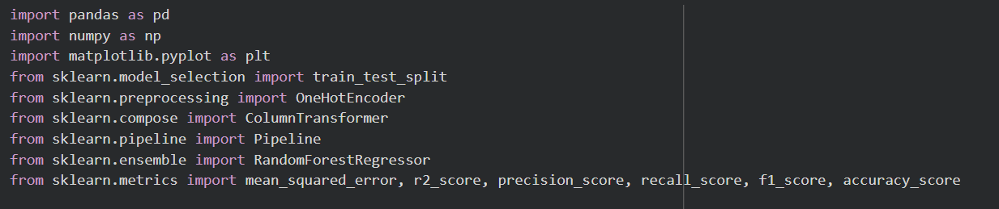

Data Graphs
  - Longitude
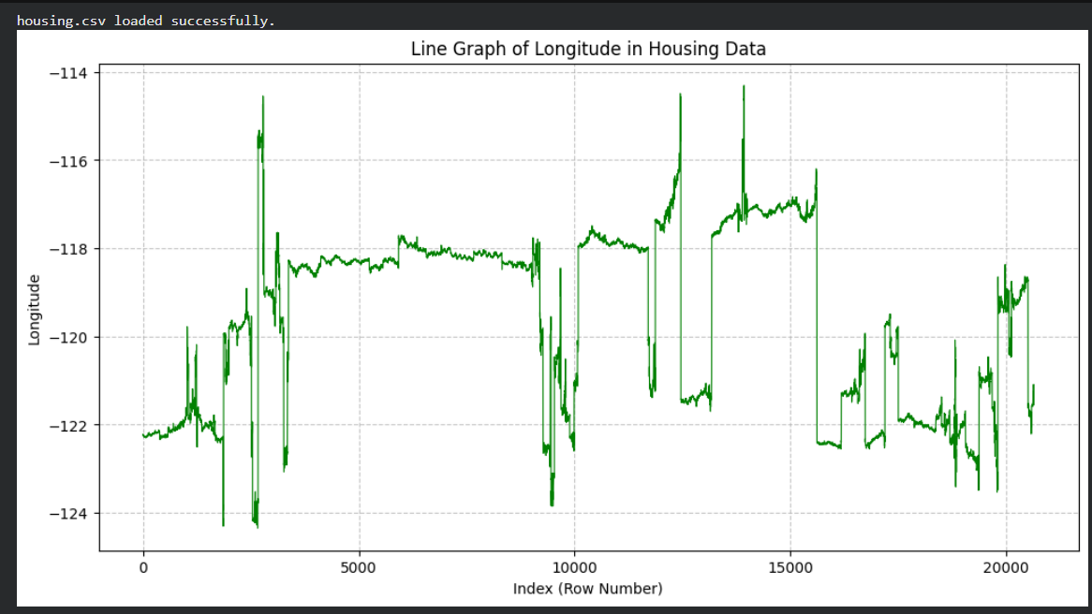
  - Latitude

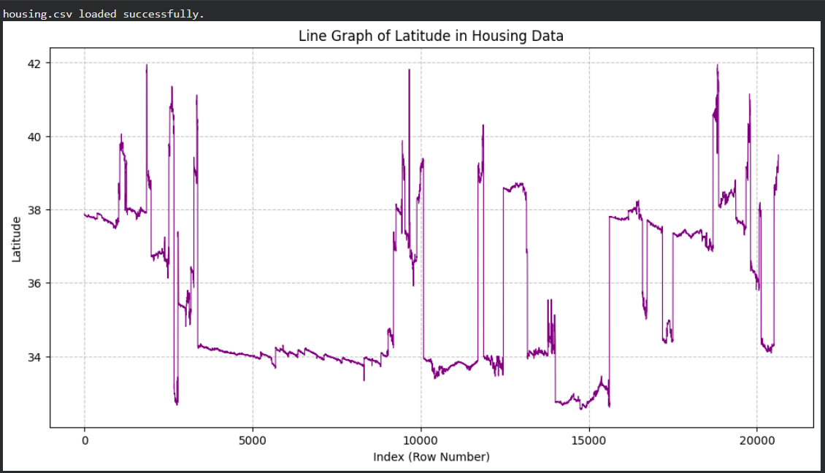

  - Housing Median Age
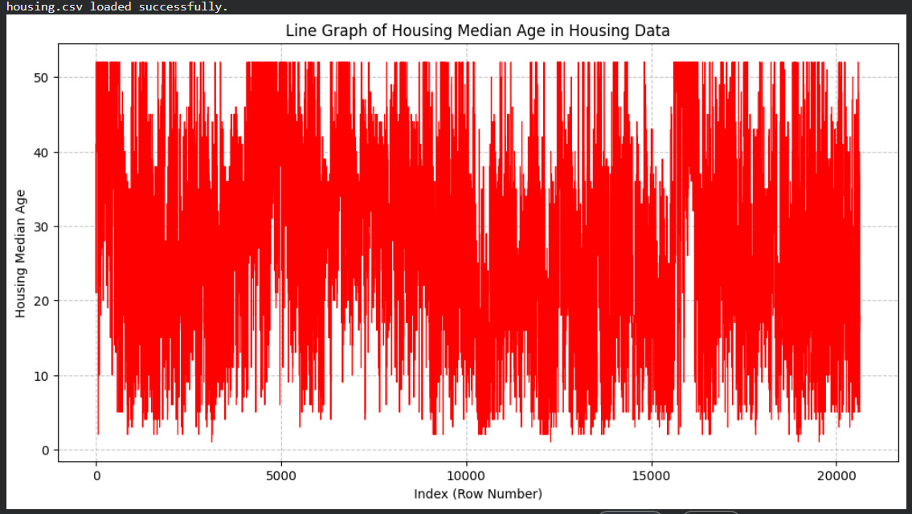
  - Total Rooms
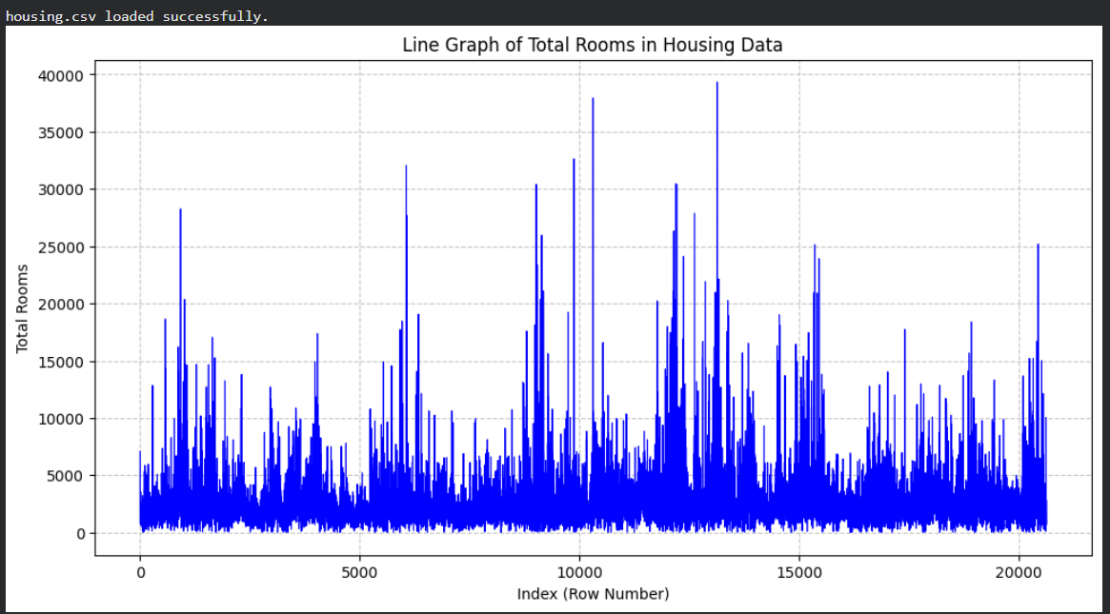

  - Total Bedrooms
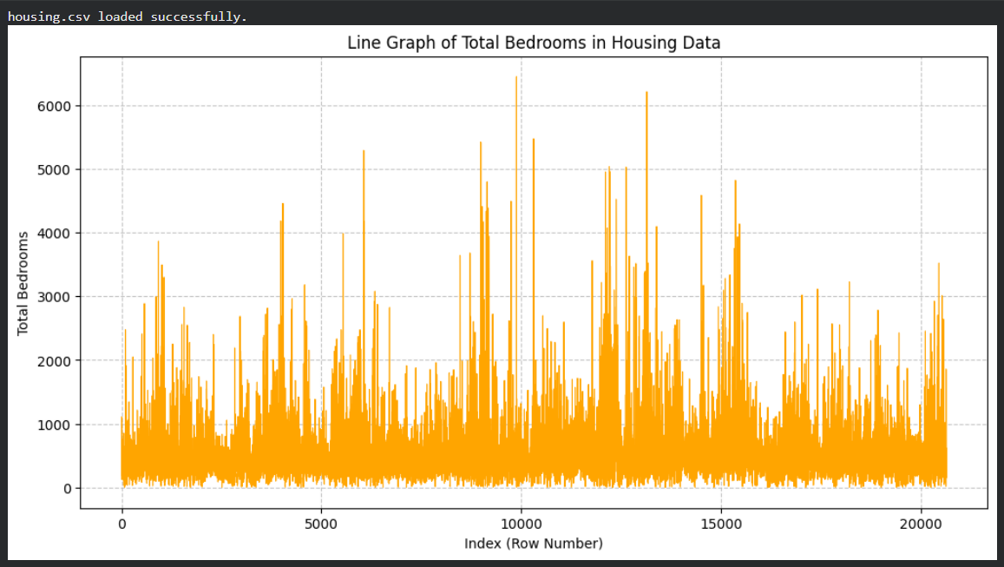
  - Population
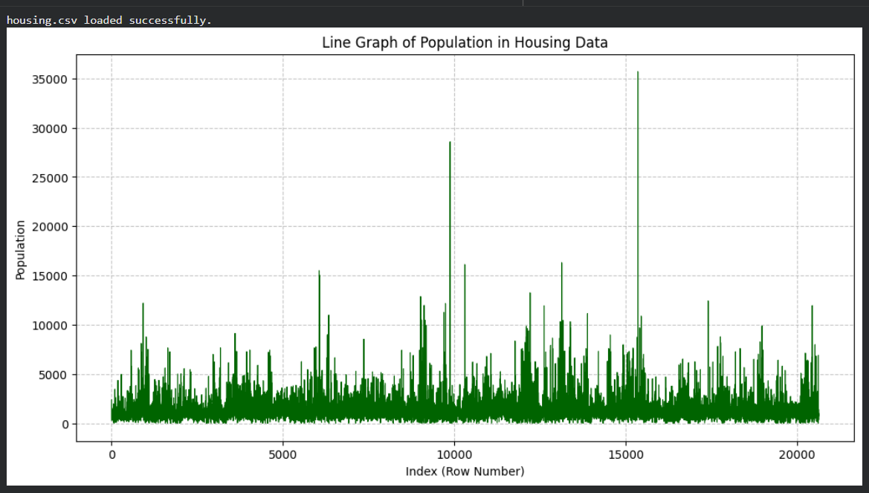

  - Households
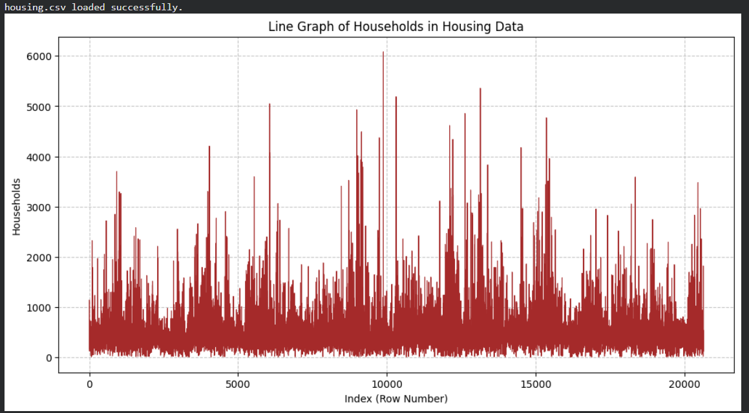
  - Median Income
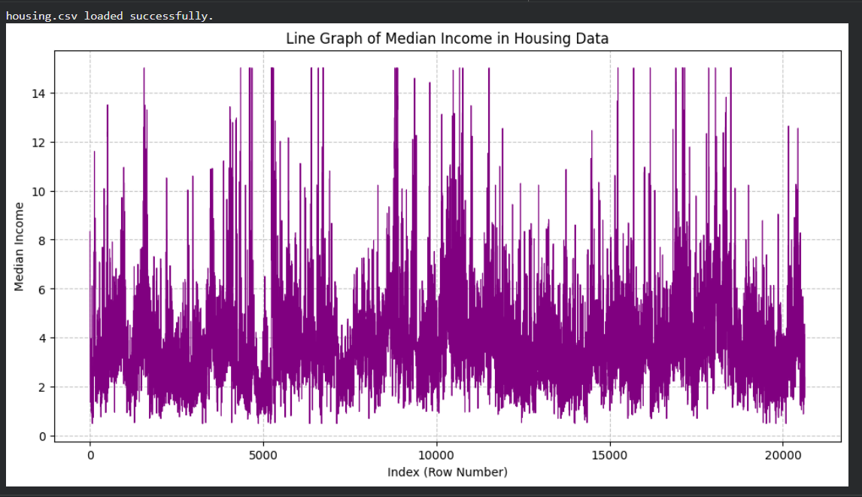

  - Ocean Proximity
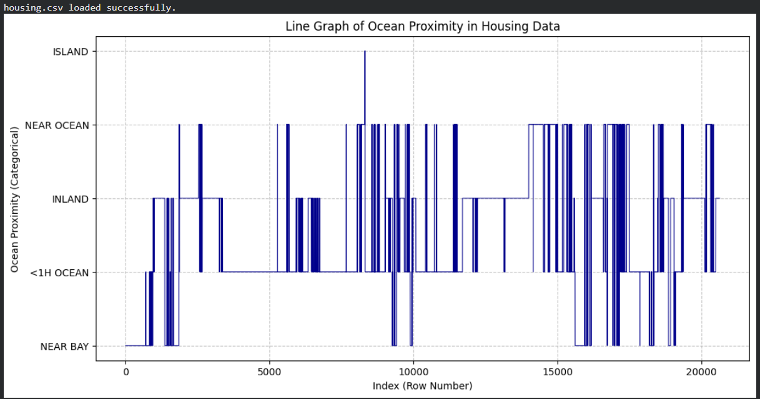

Visualization
Visualizations play a critical role in understanding the underlying patterns in the real estate market and evaluating the performance of the predictive model. This section outlines the key visual tools employed in this project.

Model Performance Visualization
After training the Random Forest Regressor, we visualized the results to assess prediction quality.
- Actual vs Predicted Scatter Plot
Type: Scatter Plot with Ideal Line (Identity Line) X-Axis: Actual Median House Value Y-Axis: Predicted Median House Value
Description:
- Each blue dot represents a specific district from the test set.
- The dashed line (diagonal) represents a perfect prediction where Predicted Price = Actual Price.
- Interpretation:
  - Points on the line are perfect predictions.
  - Points above the line indicate the model over-predicted the price.
  - Points below the line indicate the model under-predicted the price.
  - Tight clustering around the diagonal line confirms the model's high accuracy (R² = 0.81(Approx)).

Visualization Tools Used
- Matplotlib (pyplot): Used for generating all static charts, setting figure dimensions (figsize), and adding gridlines for readability.

Steps of Program Functions
- Loading Data
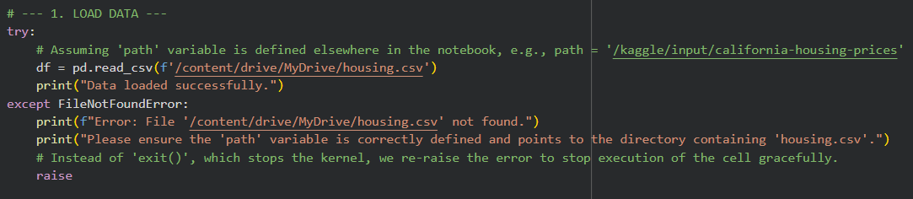
- Data Cleansing
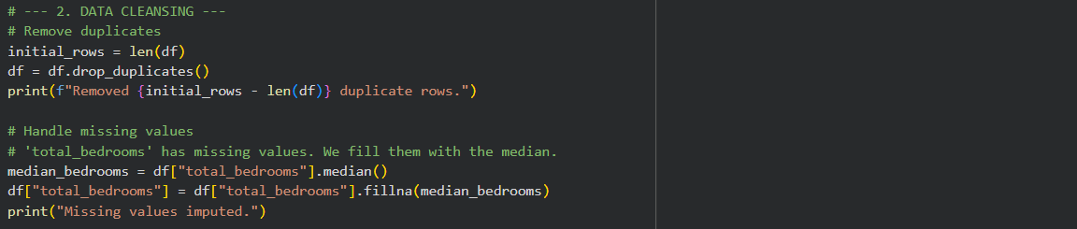
- Feature Engineering
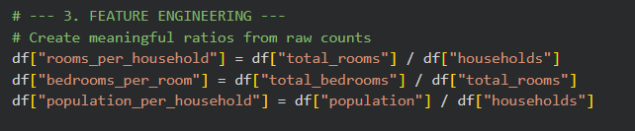
- Pre-Processing Pipeline
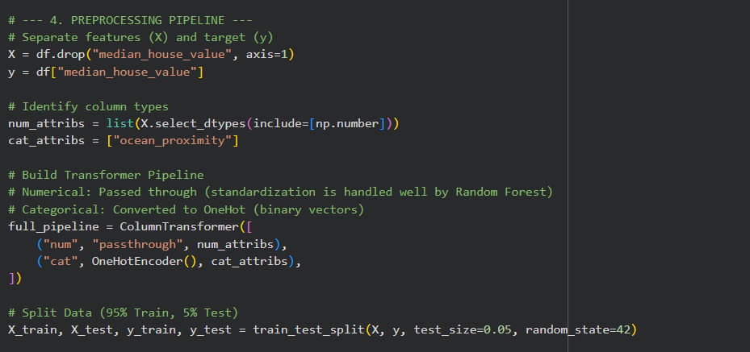

- Train Model
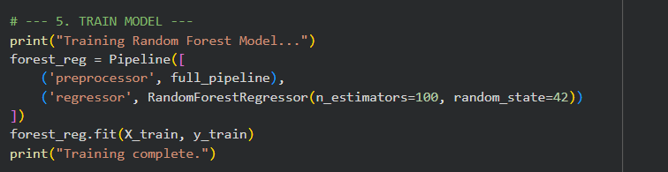
- Evaluation(Regression)
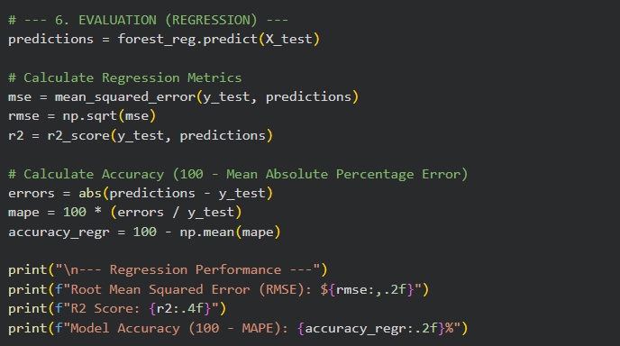
- Evaluation(Classification)
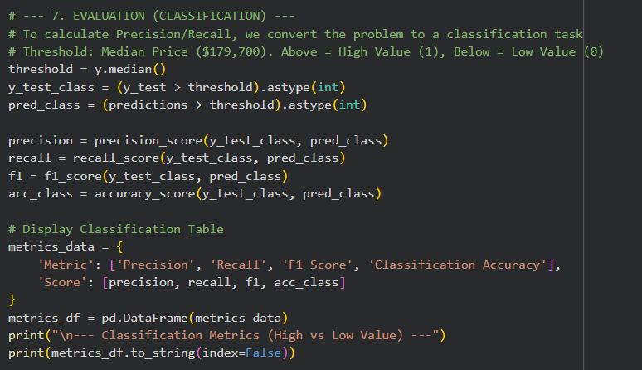

- Visualization
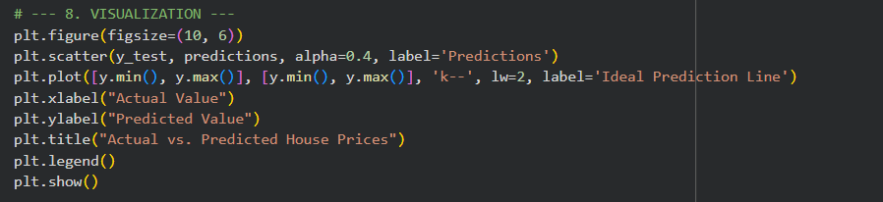
- User Prediction Function
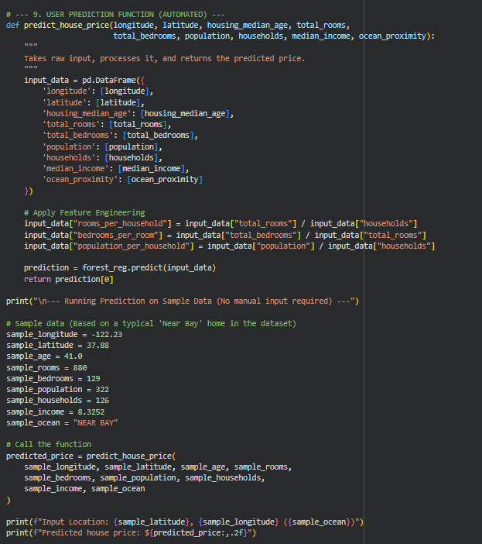

Results
On the Basis OF Data Entered in it :-
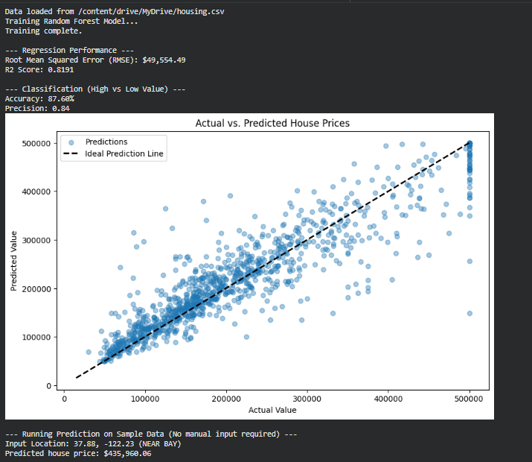
The Results shows us that
- Root Mean Square Error(RMSE) : $49554.49
- R² Score : 0.8191
- Accuracy : 87.60%
- Precision : 0.84
- Predicted House Value : $435960.06(As per Data Input)

