ASSIGNMENT



**Subject:** Mad

**Subject Code:** CAT-351

Practical: 8

***Submitted to***: ***Submitted by***:

***Prof****:* Apoorva Bansal Devan Thakur

***UID****- 17BCA1569*

***Branch/sec:*** *BCA 6D*

Practical 8: Implementation of Fragment (using tabbed Activity) in your respective project that is allocated.

Ans

## activity_main.xml

*<?*xml version="1.0" encoding="utf-8"*?>*

<LinearLayout xmlns:android=["http](http://schemas.android.com/apk/res/android):[//schemas.android.com/apk/res/android](http://schemas.android.com/apk/res/android) "

xmlns:app[="h](http://schemas.android.com/apk/res-auto)tt[p://schemas.android.com/apk/res-auto"](http://schemas.android.com/apk/res-auto) android:layout_width="match_parent" android:layout_height="match_parent" android:orientation="vertical"><include layout="@layout/app_bar"

/><android.support.design.widget.TabLayout android:id="@+id/tabLayout" android:layout_width="match_parent" android:layout_height="wrap_content" android:minHeight="?actionBarSize" app:tabGravity="fill" app:tabIndicatorColor="@color/white" app:tabIndicatorHeight="4dp" app:tabBackground="@color/colorPrimary"

app:tabMode="fixed"></android.support.design.widget.TabLa yout><android.support.v4.view.ViewPager android:id="@+id/viewPager" android:layout_width="match_parent" android:layout_height="match_parent"></android.support.v4. view.ViewPager></LinearLayout>

## TabAdapter.java

package com.example.demoproject;

import android.support.annotation.Nullable; import android.support.v4.app.Fragment;

import android.support.v4.app.FragmentManager;

import android.support.v4.app.FragmentStatePagerAdapter; import java.util.ArrayList;

import java.util.List;public class TabAdapter extends FragmentStatePagerAdapter {

private final List<Fragment> mFragmentList = new ArrayList<>(); private final List<String> mFragmentTitleList = new ArrayList<>();TabAdapter(FragmentManager fm) {

super(fm);

}@Override

public Fragment getItem(int position) { return mFragmentList.get(position);

}public void addFragment(Fragment fragment, String title) { mFragmentList.add(fragment);

mFragmentTitleList.add(title);

}@Nullable @Override

public CharSequence getPageTitle(int position) { return mFragmentTitleList.get(position);

}@Override

public int getCount() { return mFragmentList.size();

}

}

## DemoActivity.java

package com.example.demoproject; import android.os.Bundle;

import android.support.design.widget.TabLayout; import android.support.v4.view.ViewPager;

import android.support.v7.app.AppCompatActivity; import android.view.LayoutInflater;

import android.view.View;

import android.widget.TextView;public class DemoActivity extends AppCompatActivity {private TabAdapter adapter;

private TabLayout tabLayout;

private ViewPager viewPager;@Override

protected void onCreate(Bundle savedInstanceState) { super.onCreate(savedInstanceState); setContentView(R.layout.activity_demo);

viewPager = (ViewPager) findViewById(R.id.viewPager); tabLayout = (TabLayout) findViewById(R.id.tabLayout);adapter = new TabAdapter(getSupportFragmentManager(), this); adapter.addFragment(new Tab1Fragment(), "Home"); adapter.addFragment(new Tab2Fragment(), "Medicine"); adapter.addFragment(new Tab3Fragment(), "Time");viewPager.setAdapter(adapter); tabLayout.setupWithViewPager(viewPager);highLightCurrent Tab(0); // for initial selected tab viewviewPager.addOnPageChangeListener(new ViewPager.OnPageChangeListener() {

@Override

public void onPageScrolled(int position, float positionOffset, int positionOffsetPixels) {

}@Override

public void onPageSelected(int position) { highLightCurrentTab(position); // for tab change

}@Override

public void onPageScrollStateChanged(int state) {

}

});

}private void highLightCurrentTab(int position) { for (int i = 0; i < tabLayout.getTabCount(); i++) { TabLayout.Tab tab = tabLayout.getTabAt(i); assert tab != null;

tab.setCustomView(null); tab.setCustomView(adapter.getTabView(i));

}TabLayout.Tab tab = tabLayout.getTabAt(position); assert tab != null;

tab.setCustomView(null); tab.setCustomView(adapter.getSelectedTabView(position));

}

}

# Output:

**Tab 1**

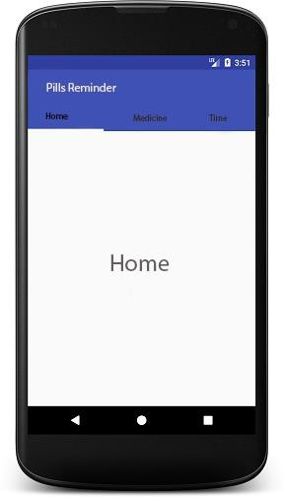

**Tab 2**



**Tab 3**

