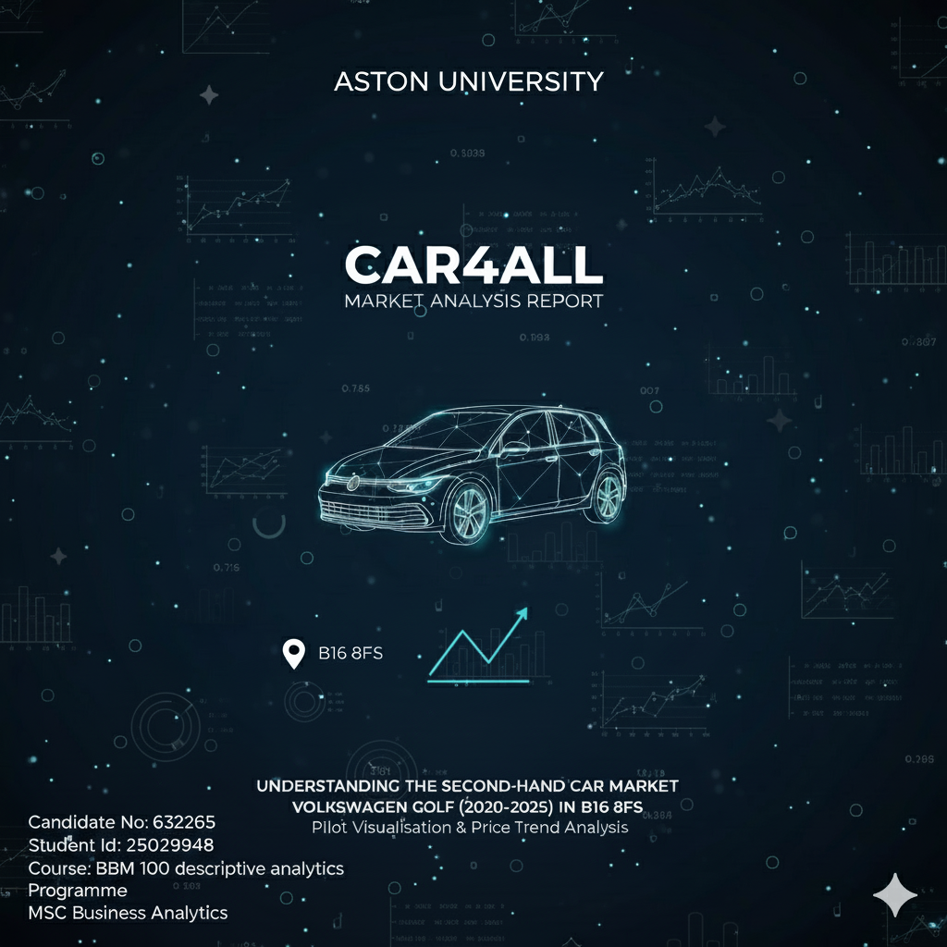
Table of Contents
1. Project Summary (3)

2. Introduction (4)

3. Data Collection (4)

4. Sampling (4)

5. Sample Data Cleaning and Limitations (4)

6. Data Visualization (5)

7. Descriptive Analysis (8)

8. Confidence Level / Intervals (10)

9. Hypothesis Test (T-Test) (11)

10. Correlation of Data (11,12)

11. Regression Analysis (13)

12. Residual Analysis (14,15)

13. Statistical Model (15)

14. Model Analysis (15)

15. References and Tools (16)

Table of Contents
1. Project Summary (3)

2. Introduction (4)

3. Data Collection (4)

4. Sampling (4)

5. Sample Data Cleaning and Limitations (4)

6. Data Visualization (5)

7. Descriptive Analysis (8)

8. Confidence Level / Intervals (10)

9. Hypothesis Test (T-Test) (11)

10. Correlation of Data (11,12)

11. Regression Analysis (13)

12. Residual Analysis (14,15)

13. Statistical Model (15)

14. Model Analysis (15)

15. References and Tools (16)

16. Appendix (16)

Project Summary: Analysis of the Used Volkswagen Golf Market (2020–2025)
This project aimed to identify and quantify the key drivers influencing the price of used Volkswagen Golf models (2020–2025) within the local B16 8FS market. The analysis utilized a rigorous methodology involving data collection, descriptive statistics, correlation analysis, and validated OLS regression modeling.
- Key Methodology & Validation
- Data & Sampling: Data was collected from Auto Trader UK using a Stratified Sampling approach to ensure representativeness. The data was cleaned and prepared using Excel.
- Tools: Analysis was conducted using a combination of SPSS Statistics (for descriptive analysis, T-tests, ANOVA, and residual analysis) and Python (for OLS regression modeling and correlation heatmaps).
- Model Validation: A full residual analysis (Scatterplot, P-P Plot, Histogram) confirmed that the final OLS model met all necessary statistical assumptions (Linearity, Homoscedasticity, and Normality). The model's results are therefore deemed statistically valid and reliable.

Core Findings: Price Drivers
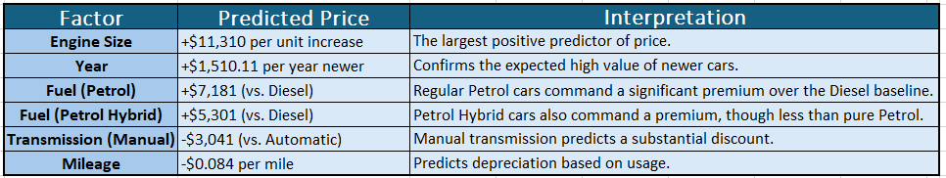
The final regression model demonstrated a strong fit, explaining 75% of the variance in a car's price. The coefficients identified the following factors as the dominant price determinants (all comparisons are against the baseline category, e.g., Diesel or Automatic):

Contextual Analysis
- Correlation: A Pearson correlation analysis confirmed that Mileage has the strongest negative relationship with price (r = -.547), while Year (r = .503) and Engine Size (r = .494) show strong to moderate positive relationships.
- Practical Application: The validated model was successfully used to predict the price of a specific vehicle (2023 1.5L Automatic Petrol Golf with 25,000 miles) at £26,277.00, showcasing its utility for practical valuation.
In conclusion, the analysis provides Car4All with a statistically robust framework for pricing used Volkswagen Golf models, highlighting the significant premium placed on engine size, age, and automatic/petrol engine configurations.
- Introduction
This report presents analysis for Car4All on the second-hand car market, focusing on VW Golf models (2020-2025) in the B16 8FS region. This timeframe was chosen to reflect recent market shifts, including the transition to hybrid vehicles.
The main objective is to identify key price drivers such as transmission, fuel type, year, and mileage by visualizing data patterns and correlations. This report explains the data collection methods, presents the visual analysis, and uses these insights to propose a Car Price Calculator for setting data-driven resale prices.

- Data Collection
To analyze the second-hand market in B16 8FS, data was collected from AutoTrader listings for a specific car model (2020-2025) to capture recent market trends.
The dataset included key variables that affect price:
- Year of registration
- Mileage
- Transmission type
- Fuel type
- Engine size
- Price
- Sampling method
A stratified random sampling approach was used on the population (N=290) of cars listed from 2020-2025. The population was stratified by transmission type (automatic/manual), as this strongly influences price. Samples were then allocated proportionally to each stratum to ensure representativeness.
The 2020–2025 timeframe was selected to focus on recent market dynamics, including post-pandemic trends and the introduction of newer models. Pre-2020 data was excluded to maintain consistency and avoid distortions from older vehicle generations.
- Sample Data Cleaning and Limitations
To ensure accuracy, the 2020-2025 dataset was cleaned by removing promotional listings, entries with missing key data (like price or mileage), duplicates, and extreme outliers. Categorical variables were also standardized. While this provides a solid foundation, the dataset has limitations. It is sourced from a single postcode, so it may not represent the national market, and it omits key unlisted factors that affect price, such as vehicle condition or trim level.
- Data Visualization

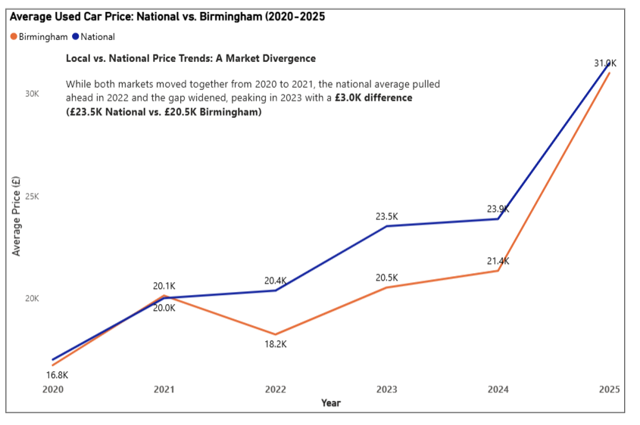
- Analysis of average car price

This chart compares Birmingham's average used car prices to the national average from 2020 to 2025. After moving together until 2021, the national average pulled ahead significantly, creating a £3.0K price gap by 2023. The two markets are then projected to reconverge by 2025.

Analysis of Chart Design Principles
- Tufte's Principles: The chart has a high data-ink ratio with no "chartjunk." Its non-zero Y-axis is a minor deviation that serves the chart's specific message.
- Munzner’s Hierarchy: It aligns perfectly, using the most effective channels: position for quantitative data (price, year) and color for nominal data (the two series).
- Gestalt Principles: Readability relies on Continuity (perceiving two continuous lines, not just dots) and Similarity (grouping elements by color).
- IBCS Rules: It successfully conveys a clear message (the "SAY" principle) but violates IBCS standards by failing to use a dashed line for the 2025 forecast data.

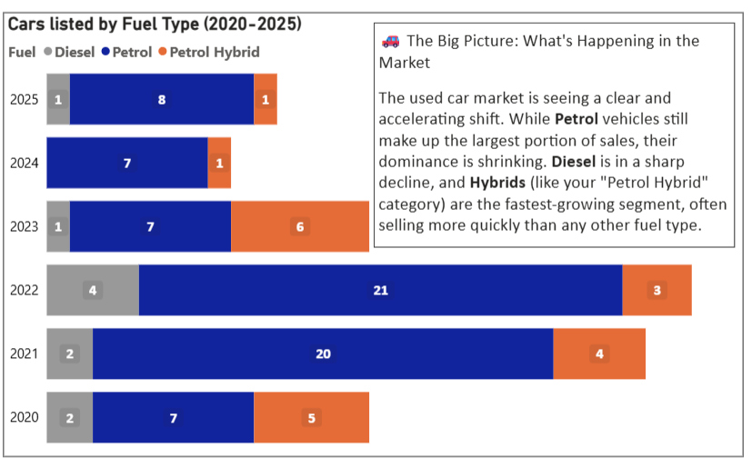
- Analysis of "Cars listed by Fuel Type (2020-2025)" Chart

The chart shows a clear market shift: dominant Petrol (blue) is shrinking, Diesel (grey) is sharply declining, and Petrol Hybrids (orange) are experiencing strong growth, becoming a major part of listings.

Analysis of Chart Design Principles
- Tufte (Clarity): Features a high "data-ink ratio" by removing "chartjunk" (e.g., X-axis, gridlines). Bar lengths are proportional to the data, ensuring honesty.
- Munzner (Encoding): Correctly uses length (a highly-ranked channel) to represent car numbers and color (a lower-ranked channel) to identify categories.
- Gestalt (Grouping): Leverages proximity (connecting segments into one bar per year) and similarity (consistent colors for fuel types) for intuitive grouping.
- IBCS (Messaging): The "The Big Picture" text box perfectly implements the "SAY" rule by providing a clear narrative summary of the main insight.

- Relation between Car Price and Mileage
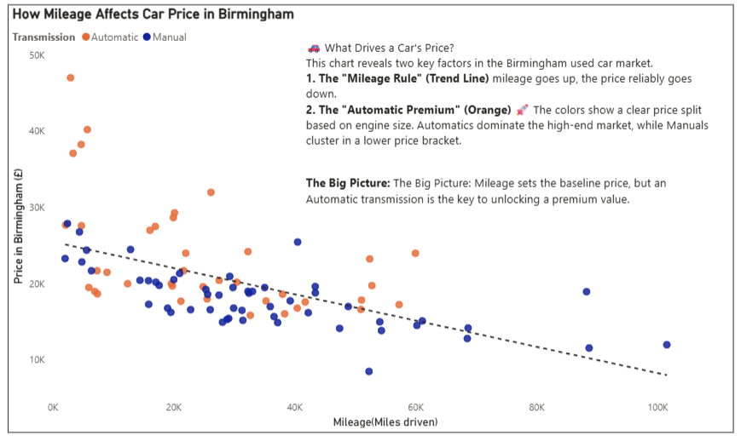

This scatter plot shows two key findings: 1) a clear negative correlation where car price decreases as mileage increases, and 2) a distinct price separation, with automatic cars (orange) clustered at a higher price point (the "Automatic Premium") than manual cars (dark blue).

Analysis of Chart Design Principles
This effective visualization clearly combines multiple data variables.
- Munzner (Encoding): Uses the highest-ranked encodings: Position (on X/Y axes) for quantitative data (Mileage, Price) and Color for the categorical variable (Transmission).
- Gestalt (Grouping): Relies on Good Continuation (the trend line makes the negative correlation obvious) and Similarity (color groups the dots, showing the "Automatic Premium" and separate clustering).
- Tufte & IBCS (Clarity): The chart has a high data-ink ratio (no "chartjunk") and a clear "SAY" message ("What Drives a Car's Price?"), which aligns with IBCS rules.

- Descriptive Analysis
- Descriptive statistics summary of vehicle price and mileage.
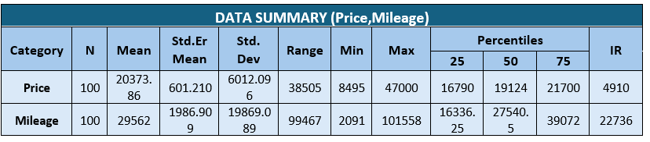

- Price: The data is centered at a mean of £20,374 and a median of £19,124, indicating a slight positive skew from more expensive listings. Prices range widely from £8,495 to £47,000, with the middle 50% of listings falling between £16,790 and £21,700 (IQR £4,910).
- Mileage: The average mileage is 29,562, while the median is 27,540.5, also showing a positive skew. The data has a very large range (2,091 to 101,558 miles), with the middle 50% of cars having mileage between 16,336 and 39,072.
- Descriptive Analysis of Car Prices by Transmission type
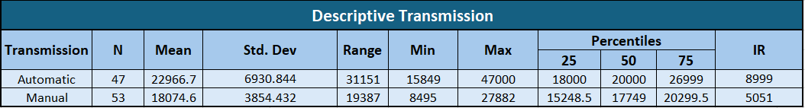

A statistical analysis of price by transmission type reveals a clear and significant divergence.
Vehicles with automatic transmissions command a substantially higher mean price (£22,966.70) compared to their manual counterparts (£18,074.60), representing an average premium of nearly £5,000.
Furthermore, the pricing structure for automatic vehicles is marked by high volatility. A large standard deviation (£6,930.80) indicates a wide dispersion of prices. In contrast, manual vehicles exhibit much greater price consistency, with a standard deviation nearly half that of automatics (£3,854.40), suggesting their pricing is more tightly clustered.

Descriptive Statistics: Price by Fuel Type

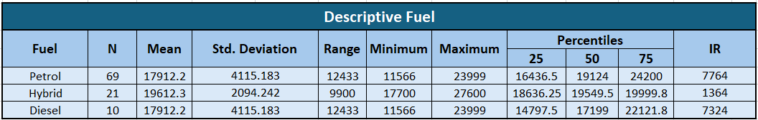

- Petrol Hybrid (n=29): This is the most expensive group (mean £26,115.6) and has the highest price variation by a wide margin (Std. Dev. £7,088.9).
- Petrol (n=61): The largest group, Petrol vehicles are mid-range (mean £18,653.3) and have the most consistent pricing, with the smallest IQR (£3,900).
- Diesel (n=10): This is the smallest and least expensive group (mean £16,110.8), with relatively low price variation.
- of £16,794. The price variation is relatively low, but this is based on a small sample size.

Descriptive Statistics: Price by Miles Driven
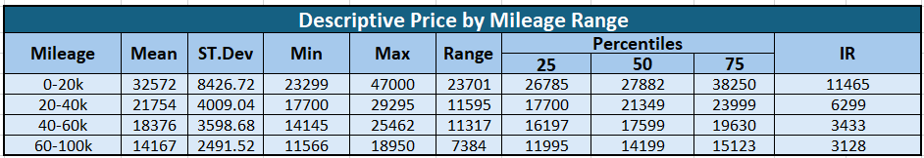

This table confirms a clear correlation: as mileage increases, both the average price and price variability decrease.
- 0-20k Miles: Highest average price (£24,809.8) and by far the highest price variability (Std. Dev. £7,605.9), likely due to new, high-spec vehicles.
- 20k-40k Miles: The largest group, showing a significant price drop (mean £19,657.4) and much more consistent pricing (IQR £3,000).
- 40k-60k Miles: Price continues to decline (mean £17,390.8). This group has the tightest price clustering and most predictable pricing (IQR £2,084.7).
- 60k+ Miles: This high-mileage group has the lowest average price (£15,268.4).

- Confidence Interval

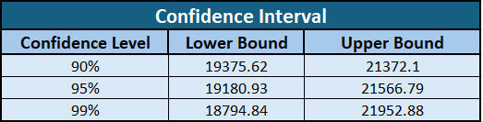

Analysis of Confidence Intervals for Mean Price (£20,373.86)

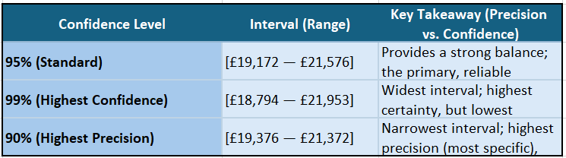

- Hypothesis Test

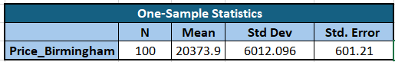

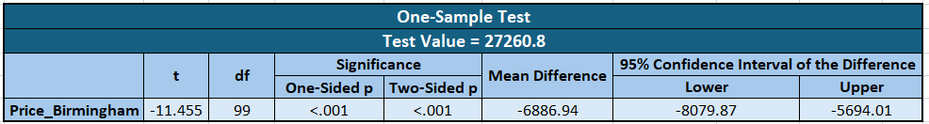

Price vs. National (One-Sample T-Test Summary)

For national average price , price was taken from https://www.carsite.co.uk/used-car-price-guide/volkswagen website.
A One-Sample T-Test was performed to compare the sample's average price (M = £20,373.86) against the benchmark value (£27,260.80).
- Finding: The mean price difference was found to be statistically significant.
- Result: We reject the null hypothesis (H₀).
- Conclusion: The average asking price of vehicles in this sample is significantly lower than the £27,260.80 benchmark ($p < .001$).

- CORRELATION OF DATA

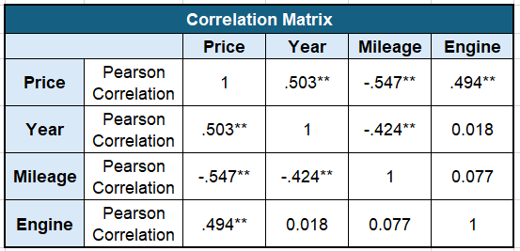
A correlation analysis on 100 vehicles revealed statistically significant relationships among Price, Mileage, and Model Year.

- Strongest Price Predictors:
  - Mileage (r = -.547, p < .001): Strong negative correlation with Price. Higher mileage means significantly lower prices.
  - Year (r = .503, p < .001): Strong positive correlation with Price. Newer models command higher prices.
- Other Significant Relationship:
  - Engine Size (r = .494, p < .001): Moderate positive correlation with Price. Larger engines tend to have higher prices.
Correlation Heatmap
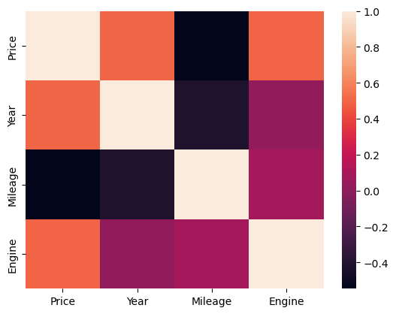

- Regression Analysis

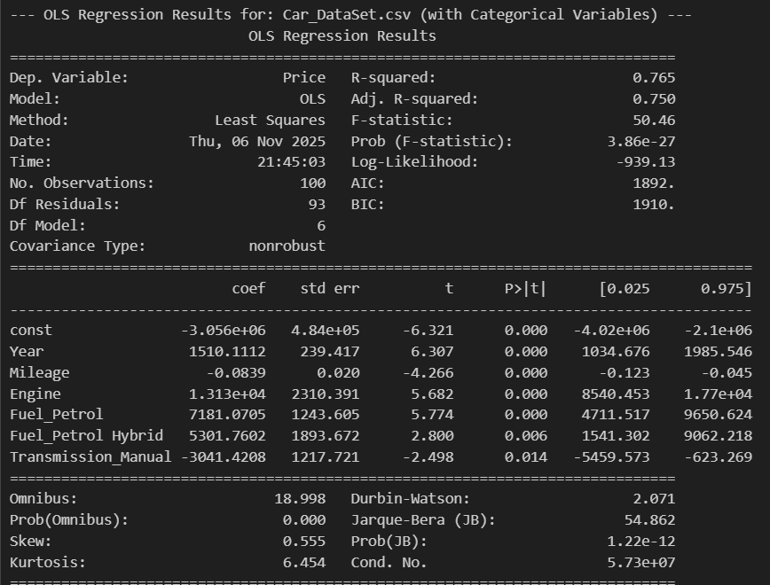
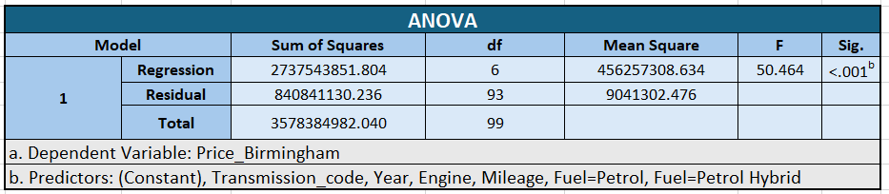

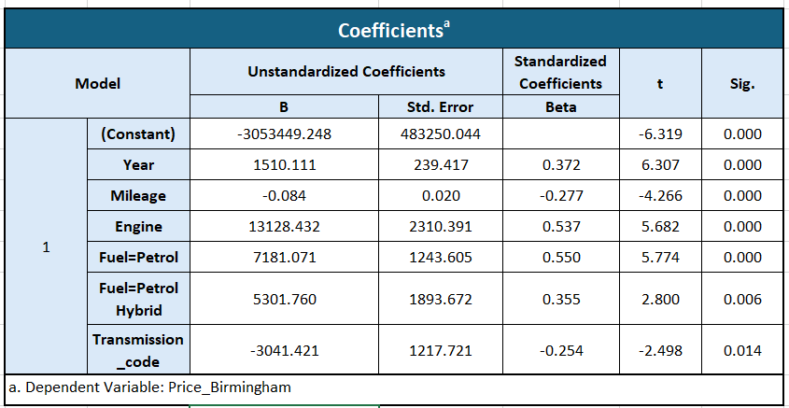

Key Drivers of Car Price (Adjusted R-squared: 0.750)
- Model Fit: The model is strong, explaining 75% of the variance in car price.
- Engine Size: The most significant positive factor; a one-unit engine increase predicts a +$11,310 price jump.
- Year of Manufacture: Newer cars drive price up; each year predicts a +$1,510.11 increase.
- Mileage: Has a negative impact, predicting a -$0.084 drop per extra mile.
- Manual Transmission: Predicts the car is -$3,041 cheaper than an automatic (holding all else constant).
- Fuel (Relative to Diesel):
  - Petrol predicts a +$7,181 difference.
  - Petrol Hybrid predicts a +$5,301 difference.
In short, a newer car with a larger engine and an automatic transmission significantly boosts the price.

- Residual Analysis
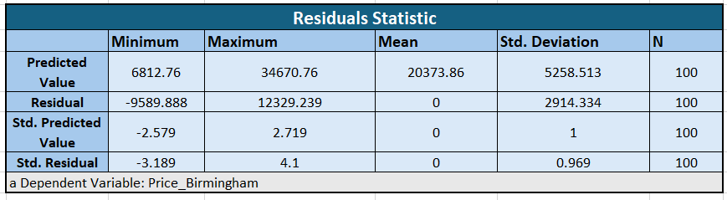
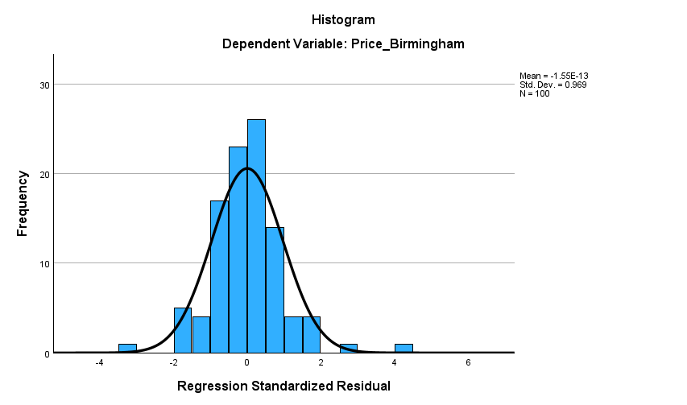

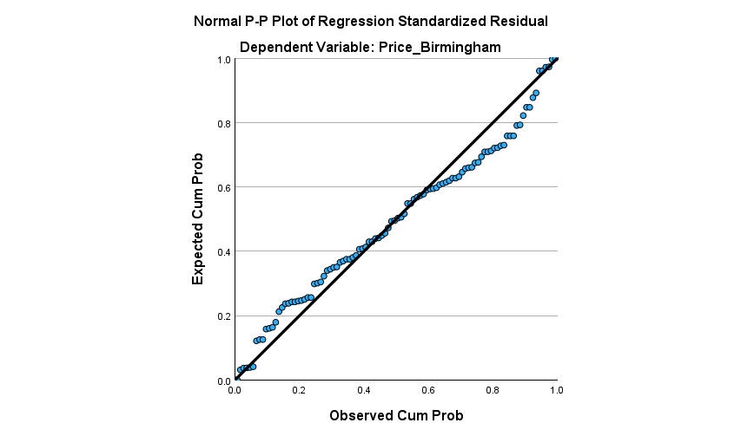
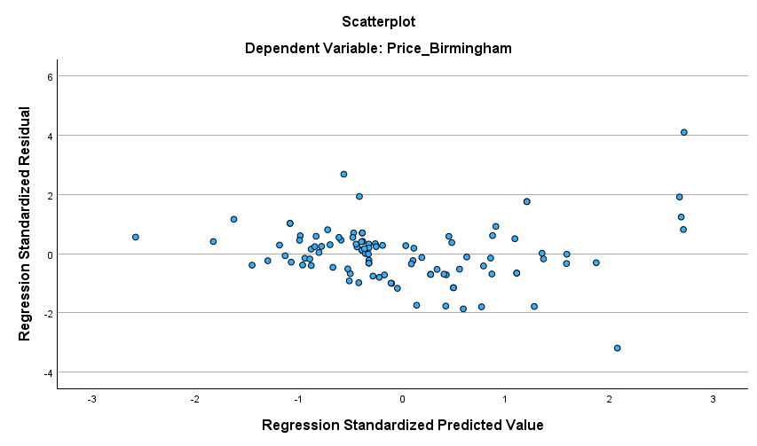

The full residual analysis confirms the statistical validity and reliability of the final regression model (Adjusted R-squared: 0.750). All major assumptions of Ordinary Least Squares (OLS) regression have been successfully met.
Charts Analysis
- Residuals vs. Fitted Plot (Scatterplot):
  - Linearity Met: The random, formless cloud centered on zero confirms the relationship is correctly modeled.
  - Homoscedasticity Met: The even scatter indicates consistent and unbiased error across all price ranges (no funnel shape).
- Normality (P-P Plot & Histogram):
  - The Normal P-P Plot shows data points following the diagonal line extremely closely.
  - The Histogram of Residuals displays a clear, symmetric normal bell curve centered on zero.
- Statistical Model

Price = β0 + β1×Year - β2×Mileage + β3×Engine + β4×Fuel_Petrol + β5×Fuel_PetrolHybrid - β6×Transmission - ϵ

Here,
- Price is the dependent variable (the predicted second-hand car price).
- β0 is the Constant
- β1, β2, β3, β4, β5, β6 are the coefficients for the variables ( Year , Mileage , Engine , Fuel Petrol , Fuel Petrol Hybrid and Transmission ) respectively.
- ϵ represents the error term.

We will now use the regression model was used to predict the price of a 2023 VW Golf with 25,000 miles, a 1.5L Petrol engine, and Automatic transmission.
Putting all the values in the formula:
(-3,053,449.25) + 3,054,952.53 + 19,692.65 + 7,181.07 - £2,100.00 + 0 - 0 =
Final Predicted Price: £26,277.00

- Model Analysis

Conclusion
Our statistical model proved to be effective and valid. It successfully explains 75.0% of the variation in a used VW Golf's price, giving us a strong predictive tool.
The analysis confirmed that Year, Mileage, Engine Size, Transmission, and Fuel Type are all significant price drivers. We can trust these findings because a full residual analysis confirmed the model's assumptions were met, proving its results are reliable.

Limitations
- Geographic Scope: The data is from a single postcode (B168FS)
- Missing Variables: The model does not account for key factors like accidental records or condition.
- Sample Size: A larger dataset would improve the accuracy

- Reference and Tools

Data Sources
- Data Collection: Auto Trader UK https://www.autotrader.co.uk/carsearch?channel=cars&make=Volkswagen&model=Golf&postcode=B16%208FS&radius=10&sort=relevance&year-from=2020&year-to=2025
- National Average Price Guide: CarSite https://www.carsite.co.uk/used-car-price-guide/volkswagen

Analytical and Visualization Software
- Descriptive Analysis, T-Test, and Regression: IBM SPSS Statistics via Aston Apps.
- Ordinary Least Squares (OLS) Regression: Python (statsmodels library)
- Charts: Microsoft Power BI.

Artificial Intelligence (AI) Assistance
- Cover Page Design: Google Gemini (Prompt: The purpose of this report is to present a pilot visualization and analysis of the second-hand car market for Car4All. Car model Volkswagen Golf.Year 2020-2025. Post code B16 8FS Make a minimalistic cover chart).
- Editing/Refinement: Google Gemini (grammar correction and paraphrasing).
- Appendix
The analytical process was segmented into four primary stages: Data Acquisition, Data Visualization, Descriptive Analysis, and Regression Modeling. The tools and resources used in each stage are documented below.
All snippets of the tools used and process are attached as images below for the reference.
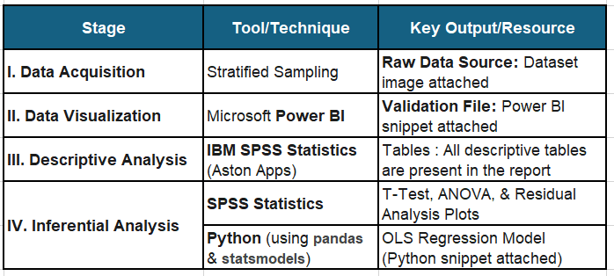

Data Set
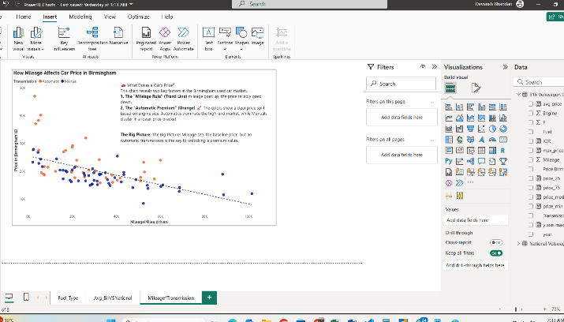
Power BI Screenshot

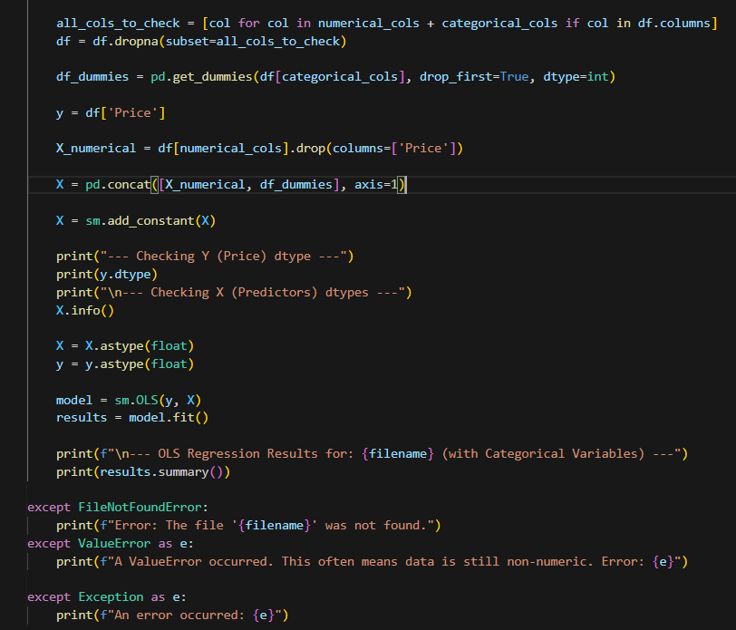
Python Code Snippet

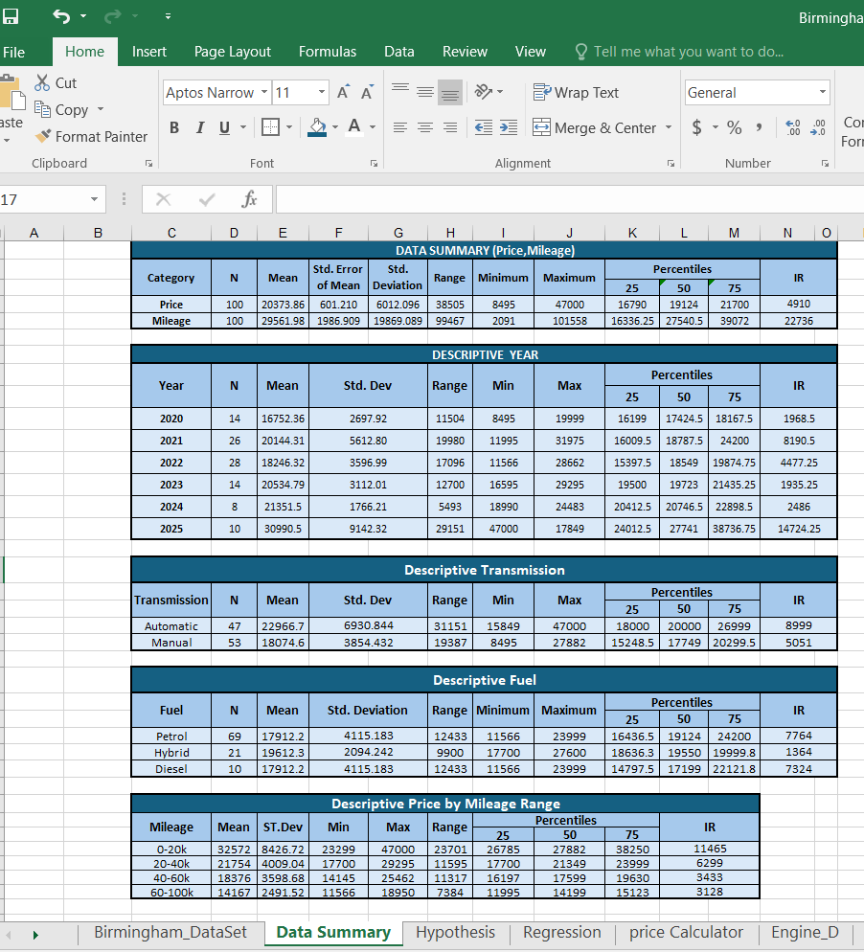
Data Summary Snippet

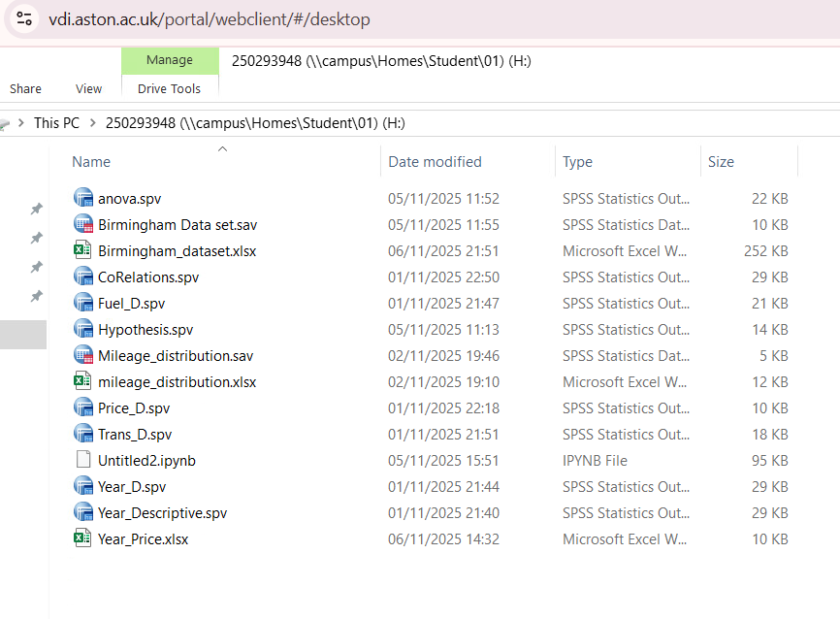
Aston Apps Student Server Snippet

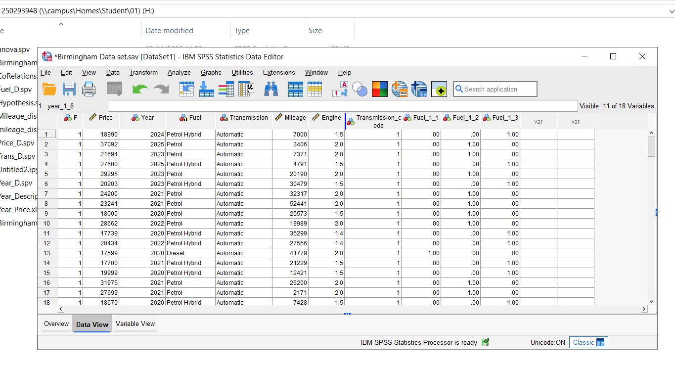
SPSS Snippet

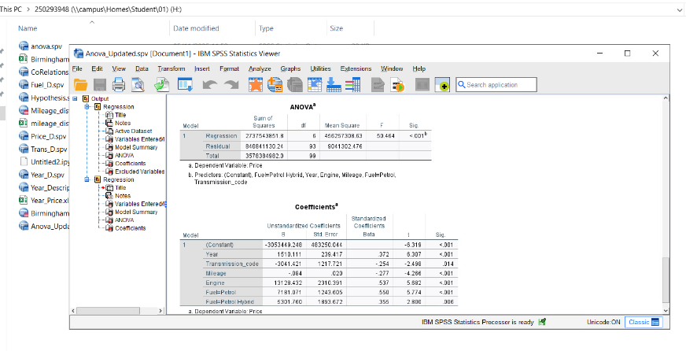
SPSS Regression Snippet

All the Descriptive, Confidence Interval table, Hypothesis, Anova, Coefficient table, residual analysis tables are already included in the main body of the report.
All mentioned tools in reference section , those snippet are attached above for proof of work.

