**Mini Project Report on**



**FOOD ORDERING SYSTEM**



**Submitted in partial fulfillment of the requirement for the award of the degree of**

**BACHELOR OF TECHNOLOGY**

**IN**

**COMPUTER SCIENCE & ENGINEERING**

**Submitted by:**

**Devansh Bisht** **2018778**

***Under the Mentorship of***

**Mr. Pramod Mehra**

**Associate Professor**



**Department of Computer Science and Engineering**

**Graphic Era (Deemed to be University)**

**Dehradun, Uttarakhand**

**July-2024**



**CANDIDATE’S DECLARATION**

I hereby certify that the work which is being presented in the project report entitled **Food Ordering System** in partial fulfillment of the requirements for the award of the Degree of Bachelor of Technology in Computer Science and Engineeringof the Graphic Era (Deemed to be University), Dehradun shall be carried out by the under the mentorship of **Mr. Pramod Mehra, Associate Professor**, Department of Computer Science and Engineering, Graphic Era (Deemed to be University), Dehradun.

Devansh Bisht 2018778 **Devansh Bisht**

**Table of Contents**

|  |  |  |
| --- | --- | --- |
| **Chapter No.** | **Description** | **Page No.** |
| Chapter 1 | Introduction | **1-3** |
| Chapter 2 | Literature Survey | **4-5** |
| Chapter 3 | Methodology | **6-8** |
| Chapter 4 | Result and Discussion | **9-10** |
| Chapter 5 | Conclusion and Future Work | **11-12** |
|  | References | **13** |

**Chapter 1**

**Introduction**

In the contemporary digital era, the way we access services has undergone a significant transformation. The food industry, in particular, has seen a dramatic shift towards online platforms that facilitate food ordering and delivery. The convenience of ordering food from the comfort of one's home, workplace, or while on the go has led to a surge in the popularity of online food ordering systems. These systems not only offer ease of access to a variety of cuisines but also provide a seamless experience that saves time and enhances customer satisfaction.

The rapid growth of the food delivery market is driven by the increasing penetration of smartphones, the internet, and changing consumer preferences. However, traditional food ordering methods, such as phone orders or in-person visits, are plagued with several inefficiencies. Customers often face long wait times, order inaccuracies, and limited access to menu information, which can result in dissatisfaction and lost business for restaurants. Therefore, there is a pressing need for an efficient, reliable, and user-friendly online food ordering application.

This report details the development of an online food ordering application using HTML, CSS, and PHP. The application aims to bridge the gap between customers and restaurants by providing a streamlined platform for browsing menus, placing orders, and making payments. It focuses on creating an intuitive user experience, ensuring secure transactions, and facilitating effective order management for restaurant owners.

Benefits of Using Food Ordering Applications

Convenience and Accessibility:

Food ordering applications provide unparalleled convenience by allowing customers to order their favorite meals from the comfort of their homes, workplaces, or even while on the go. This ease of access is available 24/7, making it possible to satisfy cravings or hunger at any time.

Time Efficiency:

These applications significantly reduce the time spent on placing orders. Customers no longer need to wait in long lines or on hold over the phone. With just a few clicks, orders can be placed swiftly, and delivery times are often quicker due to streamlined processes.

Expanded Menu Options:

Unlike traditional menus, which can be limited or outdated, online food ordering apps offer comprehensive and up-to-date menu listings. Customers can view detailed descriptions, photos, and sometimes even reviews of dishes, helping them make informed choices.

Customization and Special Requests:

Food ordering apps typically allow for easy customization of orders. Customers can add special instructions or dietary preferences directly within the app, ensuring their meals meet their specific needs and preferences.

Promotions and Discounts:

Many food ordering applications provide exclusive deals, discounts, and promotional offers. These can include first-time user discounts, referral bonuses, and periodic promotions that help customers save money while enjoying their favorite foods.

Real-Time Tracking:

One of the major advantages of using food ordering apps is the ability to track orders in real time. Customers can see the status of their order, from preparation to delivery, giving them a clear expectation of when their food will arrive.

Improved Accuracy:

Digital orders are less prone to errors compared to phone or in-person orders. The ability to review the order before finalizing reduces the likelihood of mistakes, ensuring customers receive exactly what they ordered.

Payment Flexibility:

Food ordering applications offer multiple payment options, including credit/debit cards, digital wallets, and sometimes even cash on delivery. This flexibility caters to different customer preferences and makes transactions more convenient.

Customer Reviews and Ratings:

These apps often feature customer reviews and ratings, providing insights into the quality of food and service. This transparency helps customers choose the best options available and encourages restaurants to maintain high standards.

Enhanced Restaurant Management:

For restaurant owners, food ordering apps provide tools for managing orders efficiently, tracking sales, and analyzing customer preferences. This data can be invaluable for optimizing operations, improving service, and increasing profitability.

**Chapter 2**

**Literature Survey**

**User Acceptance of Mobile Food Ordering Applications: An Empirical Study; Y. Yeo, J. Goh**: Journal of Hospitality and Tourism Technology, 2020

This study explores the factors influencing user acceptance of mobile food ordering applications.

**Impact of Mobile Food Ordering Apps on Customer Satisfaction and Loyalty; S. Lee, H. Lee**: International Journal of Hospitality Management, 2019

This paper examines how mobile food ordering apps affect customer satisfaction and loyalty.

**The Rise of Food Delivery Apps: Market Trends and Consumer Preferences; R. Kumar, M. Gupta**: Journal of Retailing and Consumer Services, 2021

This research focuses on the growing popularity of food delivery apps and the evolving preferences of consumers.

**Consumer Behavior Towards Online Food Delivery Services: An Exploratory Study;**

**P. Singh, A. Singh**: Journal of Foodservice Business Research, 2020

This paper investigates consumer behavior and preferences regarding online food delivery services.

**Transforming the Food Service Industry Through Digital Ordering Systems; J. Park, K. Kim**: International Journal of Contemporary Hospitality Management, 2018

This article discusses how digital ordering systems, including food ordering apps, are transforming the food service industry.

**The Economic Impact of Food Delivery Platforms on Restaurants; L. Chen, Y. Zhang**: Journal of Economic Perspectives, 2022

This study examines the economic impact of food delivery platforms on restaurant businesses.

**Advancements in Food Ordering Technologies: AI and Beyond; M. Li, X. Zhao**: Journal of Food Engineering and Technology, 2021

This paper explores the latest technological advancements in food ordering applications, focusing on the role of artificial intelligence (AI) and machine learning.

**The Future of Food Ordering: From Mobile Apps to Smart Kitchens; H. Wang, J. Lee**: Future Internet, 2022

This article provides an overview of emerging trends in food ordering, from mobile apps to smart kitchens.

**Enhancing User Experience in Food Ordering Applications Through User Interface Design; T. Johnson, E. Smith**: Journal of Human-Computer Interaction, 2019

This study focuses on the importance of user interface (UI) design in food ordering applications.

**Privacy Concerns and Consumer Trust in Food Delivery Apps; L. Wong, J. Tan**: Computers in Human Behavior, 2020

This study explores privacy concerns related to food delivery apps and their impact on consumer trust.

**Business Models of Food Delivery Platforms: A Comparative Analysis; C. Li, D. Wang**: Journal of Business Research, 2021

This paper provides a comparative analysis of various business models used by food delivery platforms.

**Chapter 3**

**Methodology**

We are building a website with frontend and backend connected to save the admin data and where admin can make changes in all the categories and orders of the restaurant and also a attractive frontend so that user can easily choose the items they require and will tempted to visit the site once again.

**Introduction to the Technologies Used**

**HTML (Hyper-Text Markup Language)** serves as the foundational language for creating and structuring web pages. It uses tags to define the structure and layout of content, including text, images, links, and multimedia elements. As a markup language, HTML provides a standardized way to format and present information on the internet, ensuring compatibility across different web browsers and devices. Its simplicity and versatility make it accessible to beginners while offering robust capabilities for advanced web development, supporting the creation of dynamic and interactive web experiences.

**CSS (Cascading Style Sheets)** is a stylesheet language used to describe the presentation and formatting of HTML elements in web pages. It enables web developers to control the layout, design, and appearance of multiple web pages simultaneously by applying styles such as fonts, colors, margins, and spacing. By separating content from presentation, CSS enhances the flexibility and maintainability of web projects. It plays a crucial role in creating visually appealing and user-friendly websites, adapting seamlessly to different screen sizes and devices for a consistent user experience.

**PHP (Hypertext Preprocessor)** is a server-side scripting language widely used for web development. It is especially suited for creating dynamic web pages and interactive web applications. PHP scripts are executed on the server, generating HTML content that is then sent to the client's web browser. This enables developers to build dynamic websites that can interact with databases, handle forms, manage sessions, and perform various server-side tasks. PHP's versatility, extensive documentation, and large community support make it a popular choice for developing robust and scalable web applications.

**XAMPP** which is developed by Apache Friends is an free and open-source cross-platform web server solution stack package. It consists of Apache HTTP Server, MariaDB database, and interpreters for scripting languages such as PHP and Perl. XAMPP facilitates local web development and testing by providing a pre-configured environment that includes all necessary components to run web applications on a personal computer. It is widely used by developers for creating and testing dynamic websites and web applications before deploying them to live servers, offering convenience and efficiency in the development process.

**Steps taken for making the website:**

**Creating the front-end:**

At start we created the frontend using HTML and CSS. Here we created the front page which shows the different categories and food items. Then we added different pages with each other as we made different pages so that it will be easy for the customer to choose their preferences from all the different menu items available. Then we created a order page in which customer specify their orders and provide other details such as quantity, servings

and also fill their details so that there won’t be any problem to deliver their food.

**Adding the tables in PHP my admin server in XAMMP:**

After creating the front-end we created 4 different tables in my admin so that we can store information in our server by using the database.

These tables include admin table where admin details will be stored so that only authorized users can access the database.

Categories table where different categories of food will be stored so that it will be easy for customers to sort out the food using category.

Food table where it shows different food items served by the restaurant.

Order table where all the order details and status of the order is stored which is being ordered by the customer.

**Creating the back-end:**

Then by using PHP we created the backend which is being connected with the database.

Here we created the option to add admin and update their details if they want to remove an admin. For adding different categories present in our restaurant and also able to update the categories or remove them. We added food items so that they can be added category wise so they will be easily accessible to the user. Added the option where we can change the order details if requested by the customer and also change the order status accordingly so that restaurant will know if the order is delivered or not.

**Integrating the back-end with front-end:**

We integrate the back-end with front-end as we change all the HTML files in front-end to PHP files so that they can connect with database so they show all the options available in the database to the customers and admin can easily make changes in the website accordingly.

We also made a dashboard which shows the admin total categories present currently and total food items which are being served by the restaurant. It also shows total orders the restaurant got and total earning it did by calculating all the order values which had been delivered by adding all the order total prices.

**Chapter 4**

**Result and Discussion**

We have obtained an interactive user-friendly food ordering website using web tools from which they can place their orders from the variety of categories and food options.

In backend we obtained a stable database where we can store the admin information, different food categories different food options according to different categories present.

It is also easy to trace the orders and their current status and at dashboard we get the complete information about the productivity of the restaurant.

The development and implementation of our online food ordering application yielded significant positive outcomes, both in terms of functionality and user satisfaction. Through rigorous testing and user feedback.

Here are some snippets of our website and database:

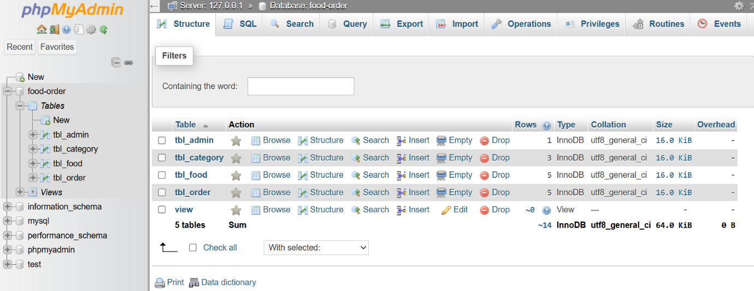

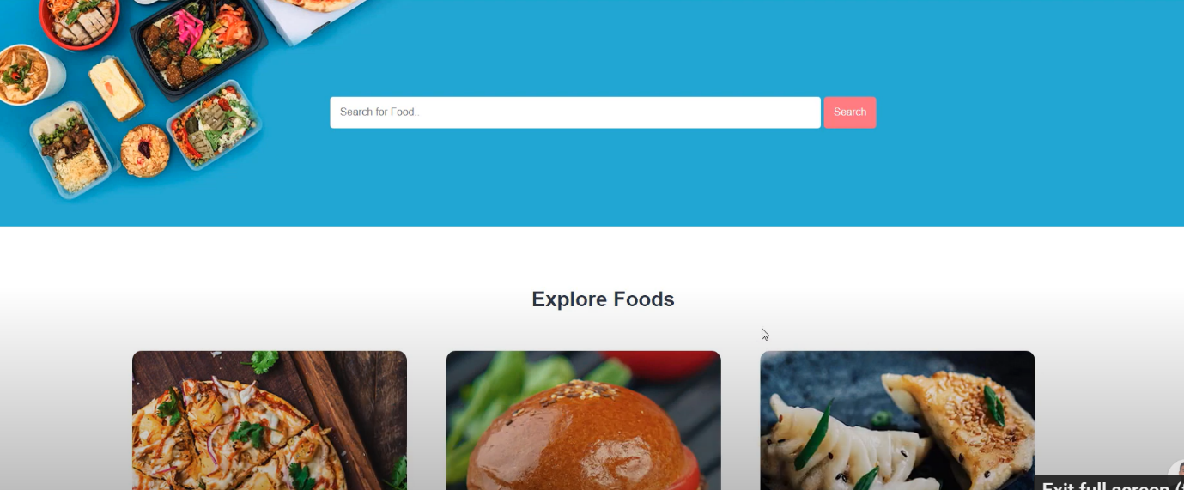

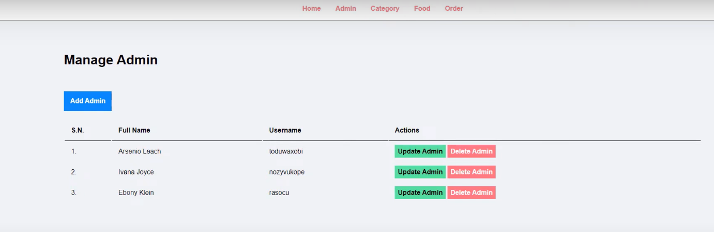

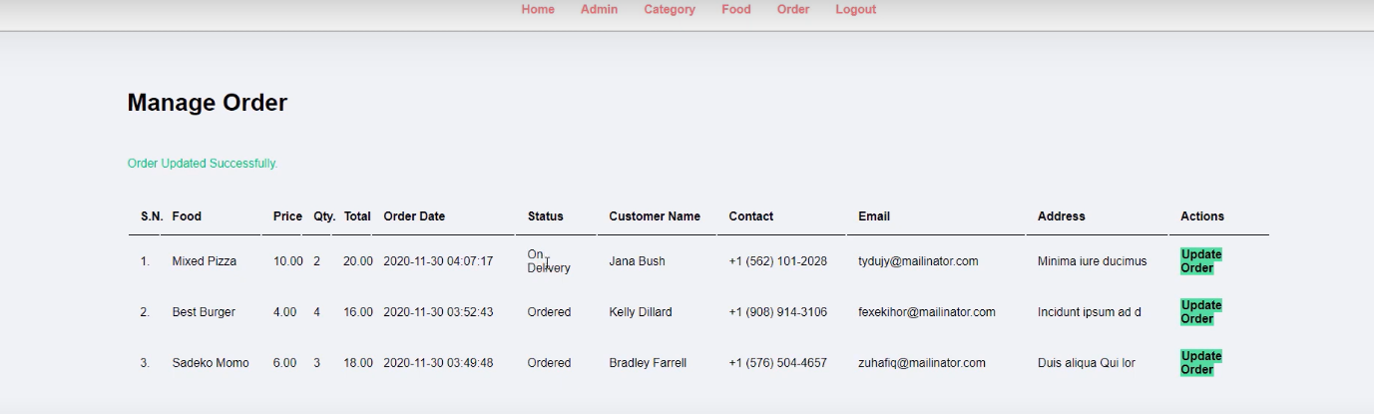

**Chapter 5**

**Conclusion and Future Work**

In conclusion, the development of an online food ordering application using XAMPP, PHP, HTML, and CSS has demonstrated significant potential to transform the food service industry. By addressing key issues such as order accuracy, customer convenience, and efficient restaurant management, this application enhances the overall dining experience for users and operational efficiency for restaurant owners. Future enhancements, including personalized recommendations, real-time order tracking, and advanced security features, can further elevate the app’s functionality and appeal. As digital solutions continue to evolve, this application stands poised to meet the growing demand for seamless and reliable food ordering services.

Real-Time Order Tracking

Implementing real-time order tracking using GPS technology can enhance transparency and improve customer trust.

AI-Driven Chatbots for Customer Support

Integrating AI-driven chatbots can provide immediate assistance to users, addressing common queries and issues without the need for human intervention.

Multi-Language Support

To cater to a broader audience, the application can be expanded to support multiple languages. Loyalty Programs and Reward Systems

Developing a comprehensive loyalty program can encourage repeat business and enhance customer retention. Features such as reward points for each purchase, exclusive discounts, and special promotions for loyal customers can be integrated into the app. Gamification elements, such as achievement badges and levels, can also be introduced to make the loyalty program more engaging.

Advanced Analytics and Reporting

Implementing advanced analytics and reporting tools can provide valuable insights for restaurant owners.

Sustainability Features

Introducing features that promote sustainability can attract environmentally conscious consumers. Options such as eco-friendly packaging, the ability to opt out of disposable utensils, and information on the environmental impact of menu items can be included.

Offline Functionality

Developing offline functionality can ensure that the application remains usable even in areas with poor internet connectivity.

Enhanced Payment Security

Continuous improvements in payment security are crucial to maintaining user trust. Implementing advanced security measures such as two-factor authentication, encryption of payment information, and compliance with the latest PCI-DSS standards can protect users from fraud and data breaches. Regular security audits and updates can ensure the application remains secure against evolving threats.

**References**

[1] “PHP”:

https://www.youtube.com/playlist?list=PLu0W_9lII9aikXkRE0WxDt1vozo3hnmtR

https://www.w3schools.com/php/

[2] “HTML”,“CSS” :

https://www.youtube.com/playlist?list=PLwgFb6VsUj_mtXvKDupqdWB2JBiek8vYYB

https://www.w3schools.com/html/default.asp

https://www.w3schools.com/css/default.asp

[3] ] “Online website using PHP programming by Vishal”:

https://www.youtube.com/watch?v=x6ZeMNU8yvg&list=PLWCLxMult9xeARrYUNDyt599W4bE9mSOQ

[4] ] “PHP projects by Code with Harry”:

https://www.youtube.com/PLu0W_9lII9aikXkRE0WxDt1vozo3hnmtR&index=51

[5] “Food Delivery Apps by frontiers paper”:

https://www.frontiersin.org/journals/nutrition/articles/10.3389/fnut.2020.00014/full

[6] “Online Food Delivery App ‘Foodie’ paper”:

www.researchgate.net/publication/353474489_Online_Food_Delivery_App_'Foodie'

[7] “Factors Associated with Food Delivery App use”:

https://www.ncbi.nlm.nih.gov/pmc/articles/PMC10163566/