**Homework-6**

Devanshi Patel (UID: 504945601)

Q-4: For comparing R vs Cpp, QR vs sweep, please use spline regression, where the number of predictors is large. You can just report the time for you to finish the spline regression using the competing methods.

For p=1000 predictors, following is the time needed to finish the spline regression.

**mySweep**

> system.time(mySpline(x,Y,lambda))

user system elapsed

2338.06 0.35 2357.19

**mySweepC**

> system.time(mySpline(x,Y,lambda))

user system elapsed

4.79 0.02 4.85

**myQR**

> system.time(mySpline(x,Y,lambda))

user system elapsed

22.78 1.71 24.62

**myQRC**

> system.time(mySpline(x,Y,lambda))

user system elapsed

7.85 2.89 10.83

From the above tables, it is clear that mySweep has the worst performance. Also, the Rcpp functions perform much better than corresponding R functions.

5) Plots of the fitted ridge regression and spline regression curves on top of the observed data points for different lambdas. Also plot the training and testing errors over a range of lambda values.

**Fitted spline regression curves**

**Lambda=0.0001**

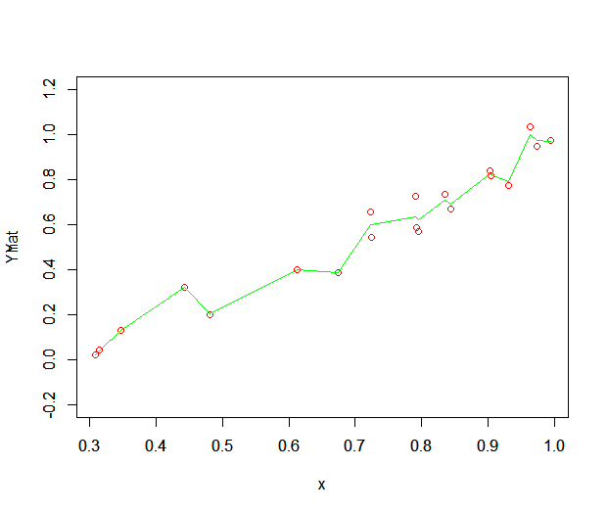**Lambda=0.001**

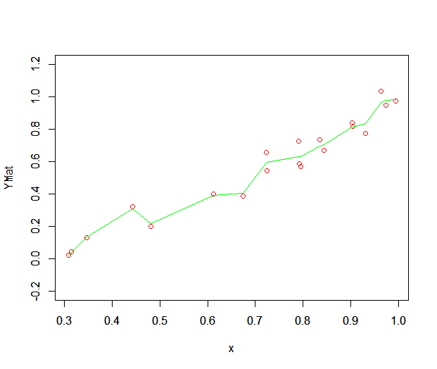

**Lambda=0.01**

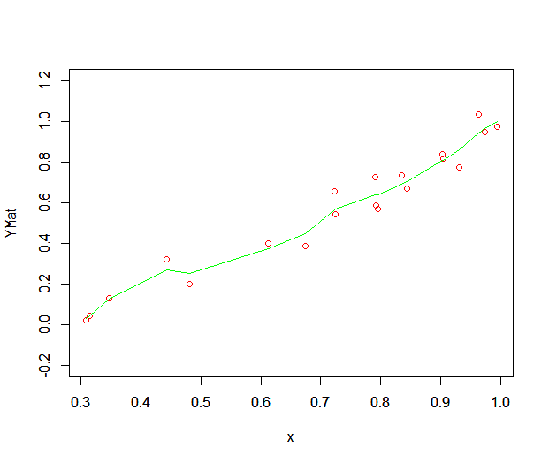

**Lambda=0.1**

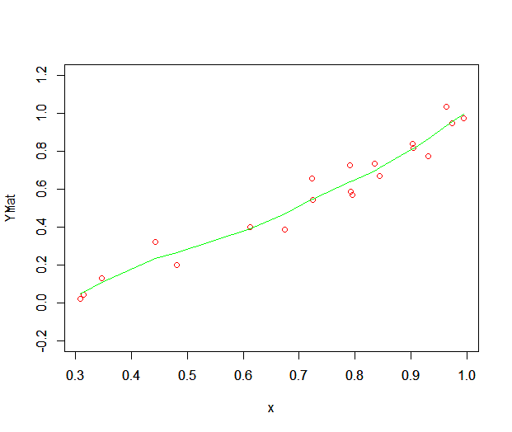

**Lambda=0.5**

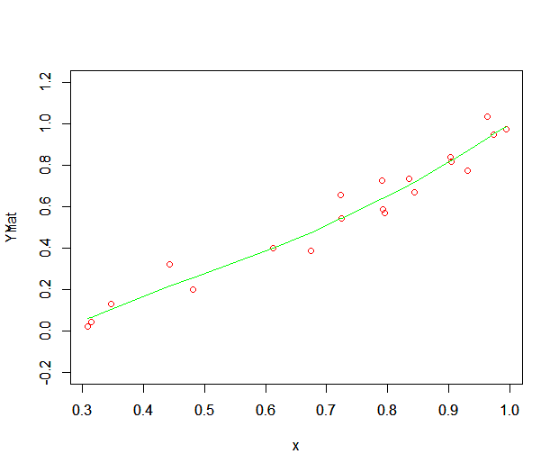**Lambda=1**

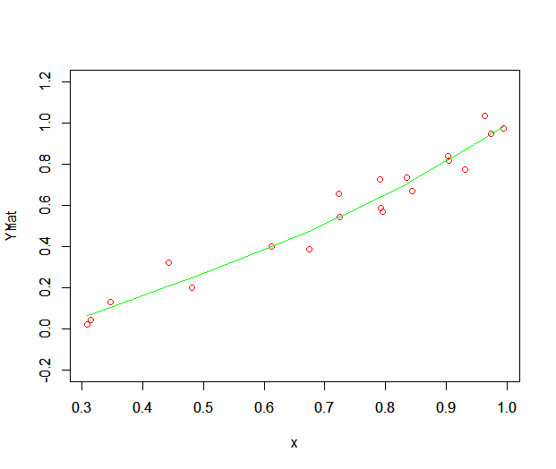

**Lambda=10**

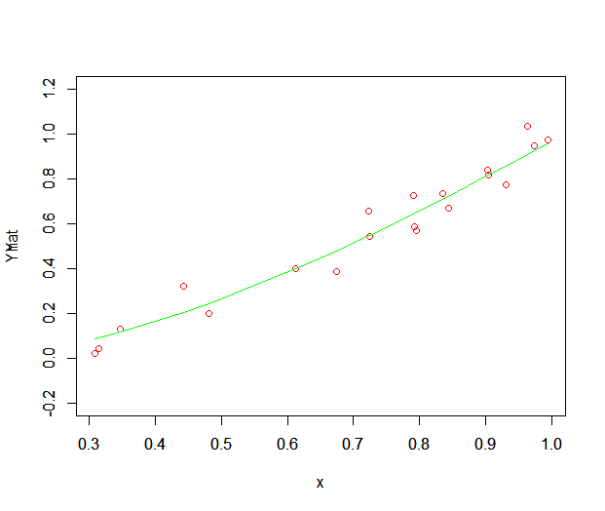**Lambda=50**

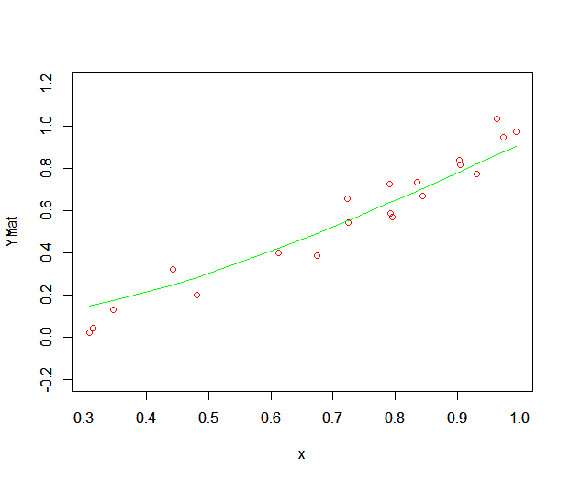

**Lambda=100**

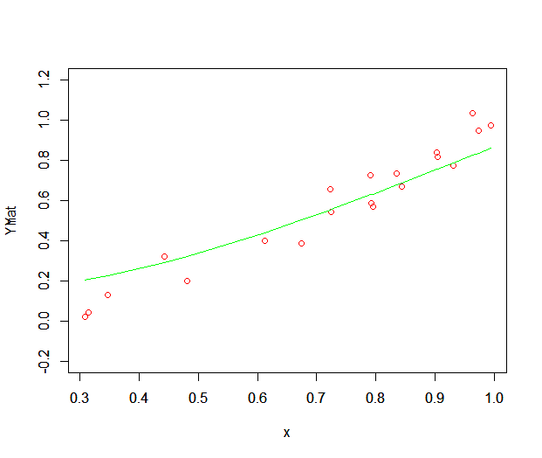

**Training and Testing errors for Spline**

When we take p=500, the following plot is obtained for training and testing errors for lambda ranging from 1 to 100.

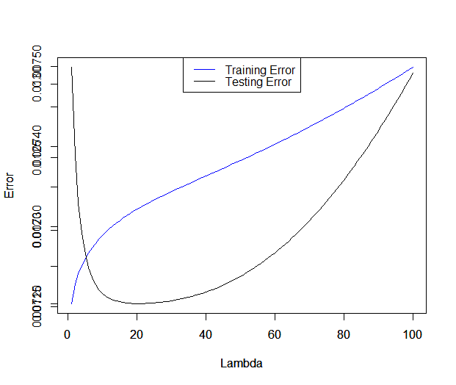

From the above plot, it is clear that at lower values of lambda, the model overfits the data. After this stage, the model improves with the increase in value of lambda. If we further increase lambda then, the model starts underfitting.

**Fitted ridge regression curves**

**Lambda=0.0001**

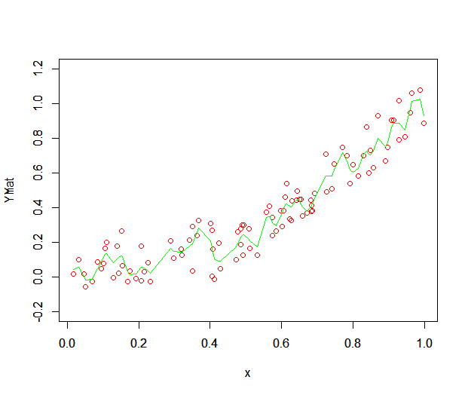

**Lambda=0.001**

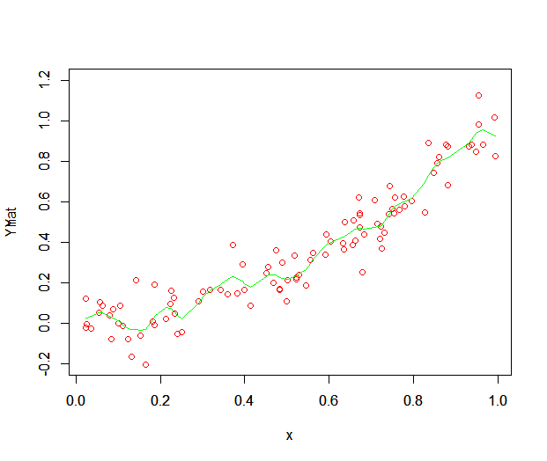

**Lambda=0.01**

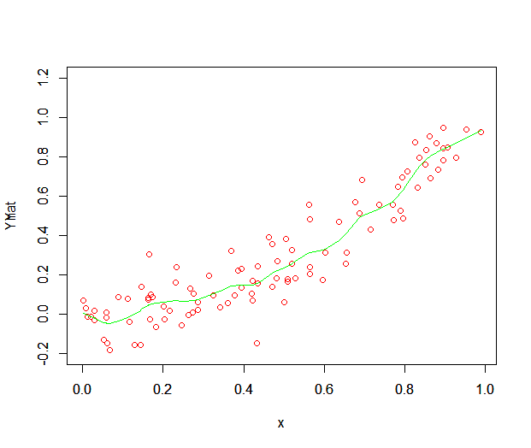

**Lambda=0.1**

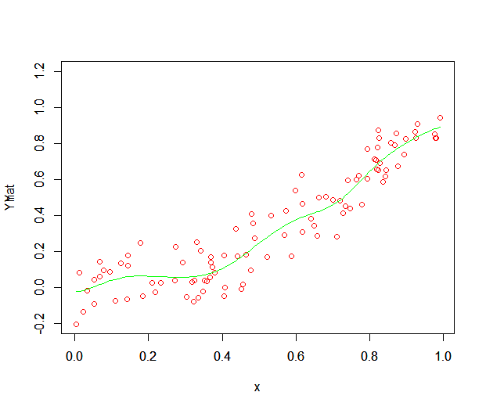

**Lambda=0.5**

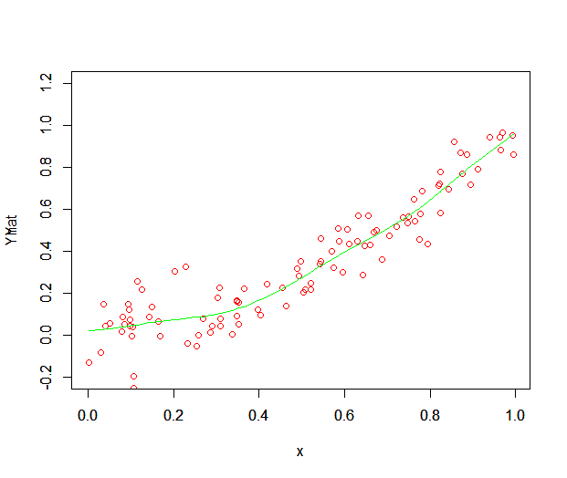

**Lambda=1**

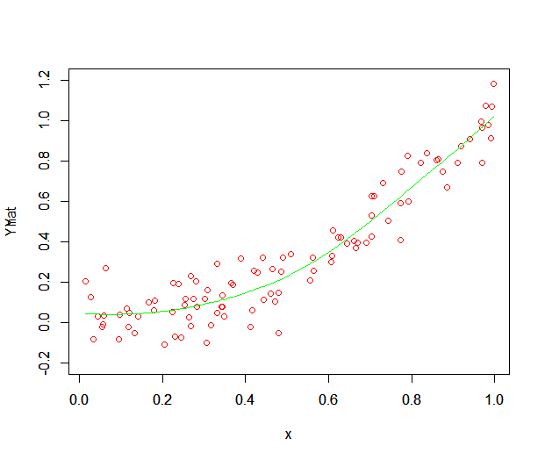

**Lambda=10**

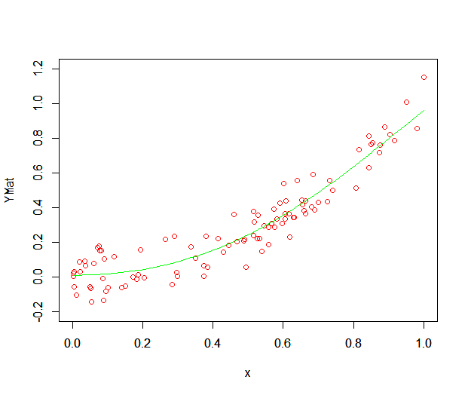

**Lambda=100**

