**Homework-9**

Devanshi Patel (UID: 504945601)

**SVM**

The first plot is obtained when we plot Training accuracy and Testing accuracy for digits data with lambda as 0.01, learning rate as 0.1 and 100 iterations.

The second plot is obtained when we plot Training accuracy and Testing accuracy with lambda as 0.1, learning rate as 0.01 and 1000 iterations.

Thus, from the plots it can be said that as we increase regularization parameter and decrease the learning rate, the difference in training and testing accuracy increases slightly.

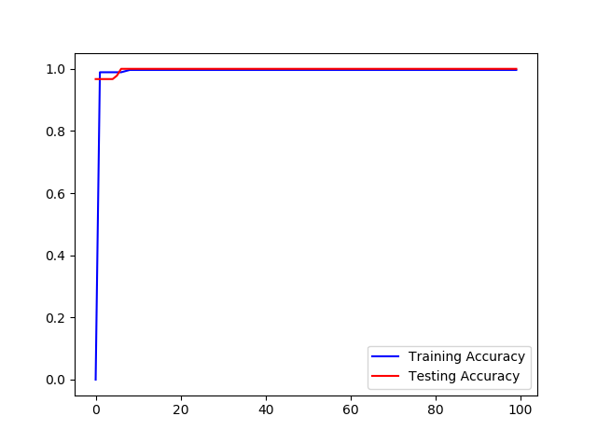

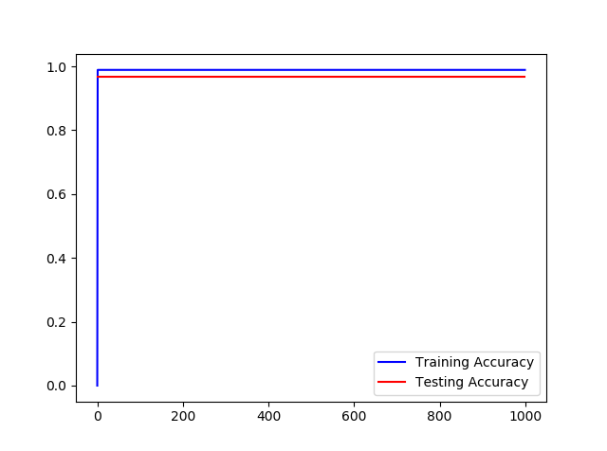

**Adaboost**

The following plots are obtained when we plot Training accuracy and Testing accuracy for digits data with 50 and 200 iterations respectively.

As seen from the plot, there is a spike in Testing accuracy in the initial iterations. Also, there is a big enough margin in the training and testing accuracy which proves that Adaboost never overfits.

